**Problem Statement:**

Write a program that accepts the job_id as argument and returns a custom counter and a system counter (total records input to the map tasks) associated with that job.

**Solution:**

**Driver Class:**

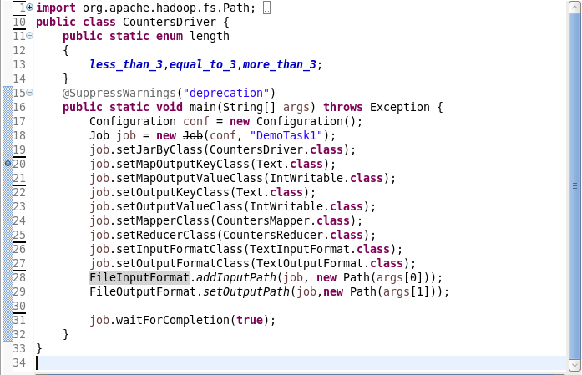

**Mapper Class:**

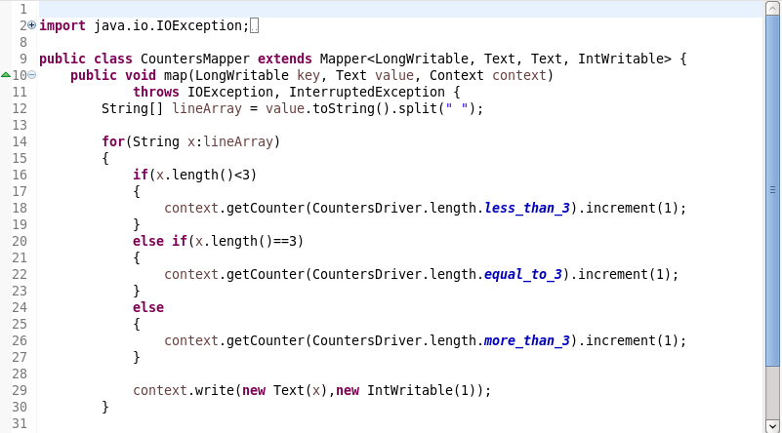

**Reducer Class:**

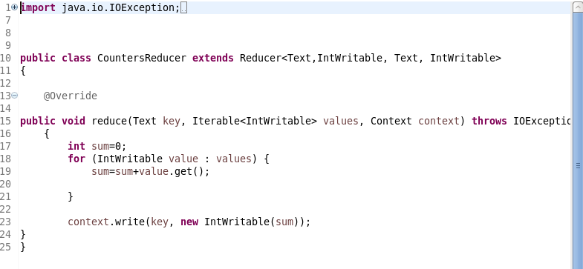

**Job_id Class**:

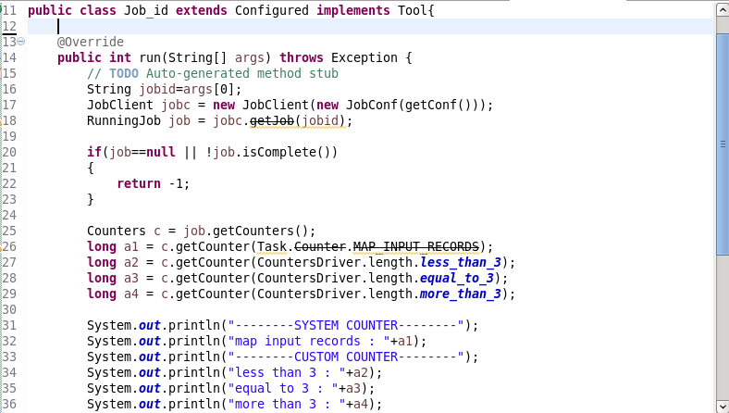

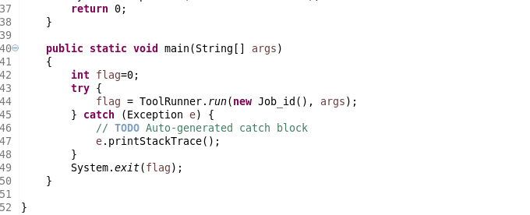

**Execution Command:**

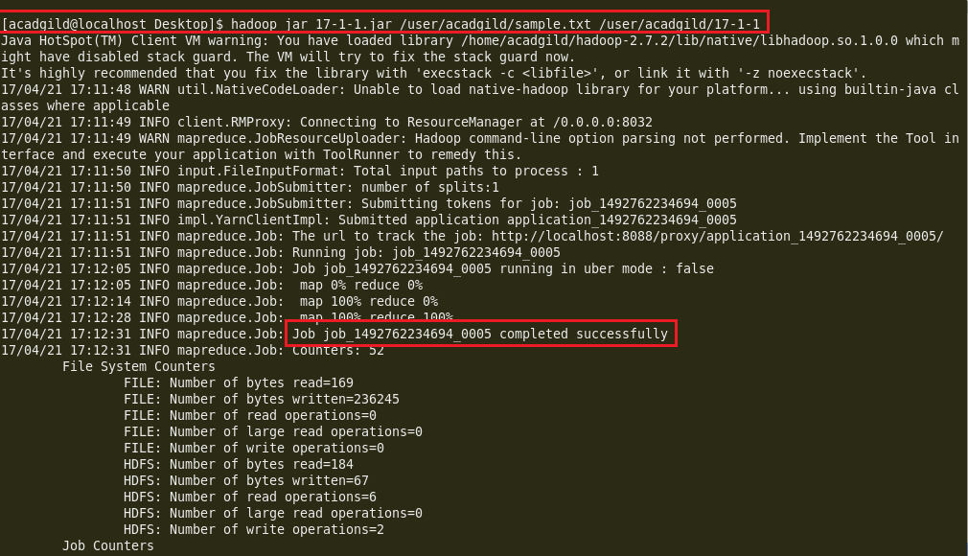

**Custom counters used in job.**

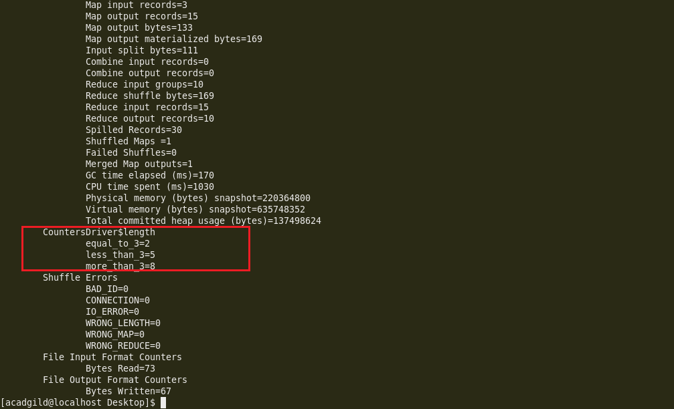

Job_id of previous job is given as input and custom counters as well as system counters are displayed as output.

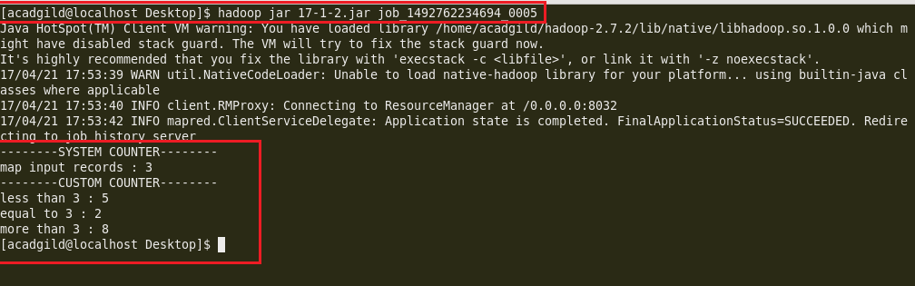

Job history server to verify the values of counters

