Problem Statement

Write a secondary sort program to generate the top 2 maximum temperatures corresponding to every year from the temperature dataset.

**Solution**:

**Driver Class:**

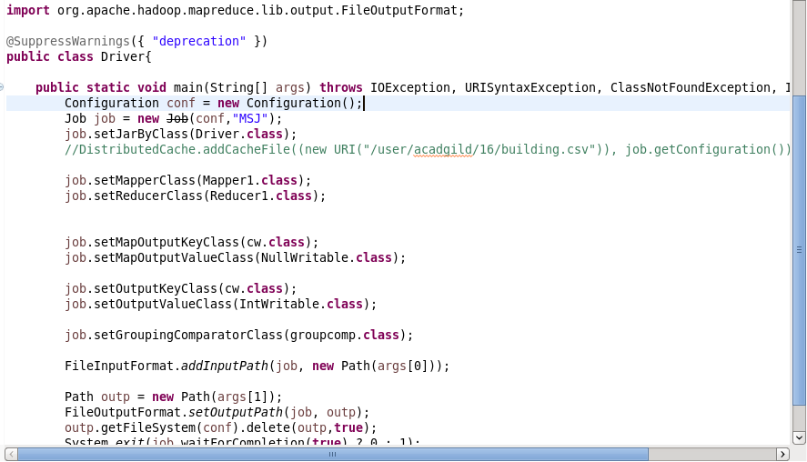

**Mapper class:**

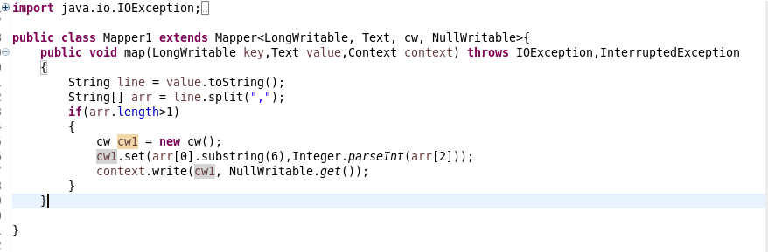

**Writable Comparable Class:**

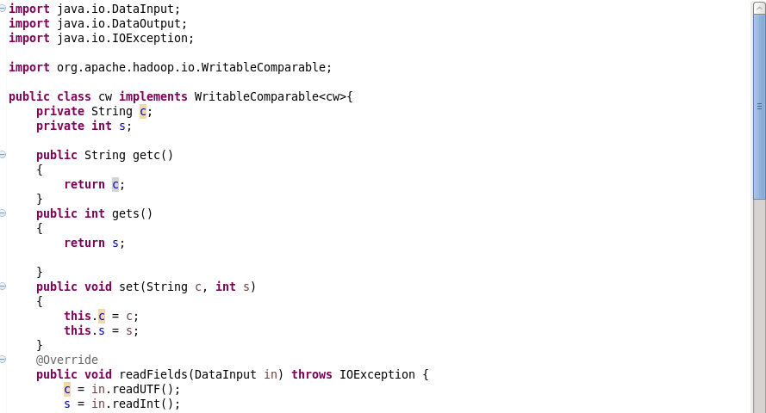

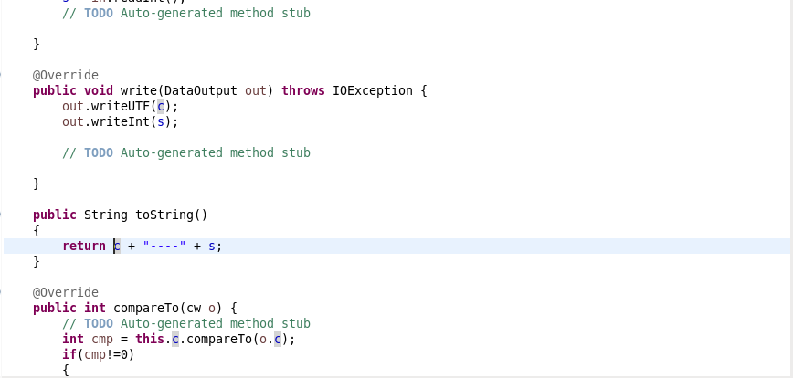

**Group Comparator Class:**

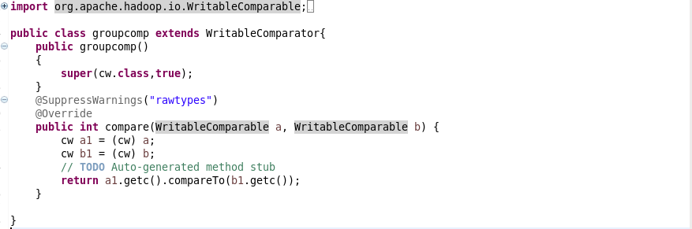

**Reducer Class:**

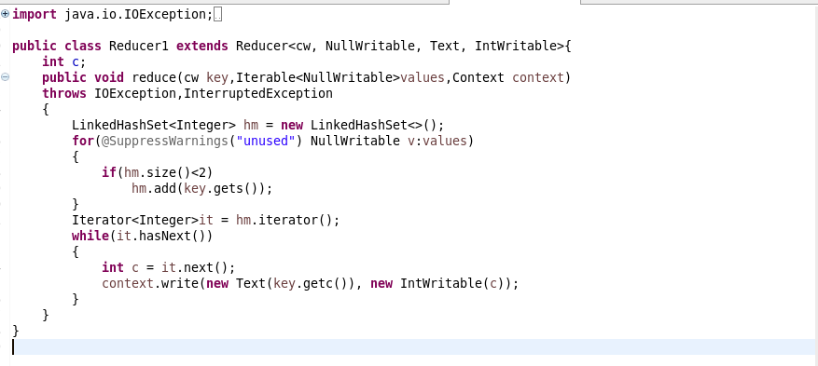

**Execution Command:**



**Output:**

