**Problem Statement**

Write a mapreduce job that takes configuration from command line (min.word.count). Based on the configuration, it should perform count of words from a document and produce only those words in the output whose count is greater than or equal to the configuration.

**Solution:**

**Driver Class:**

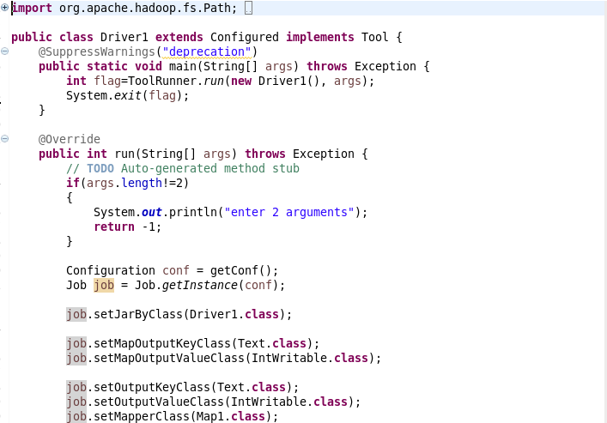

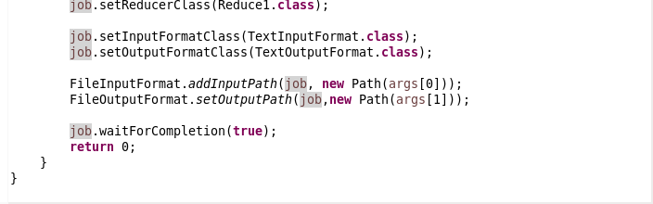

**Mapper Class:**

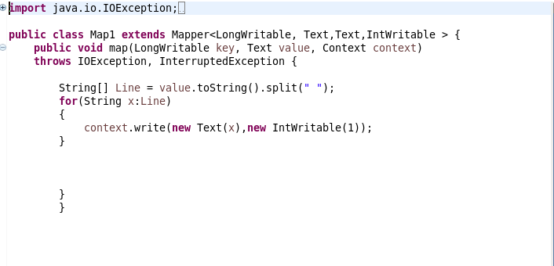

**Reducer Class:**

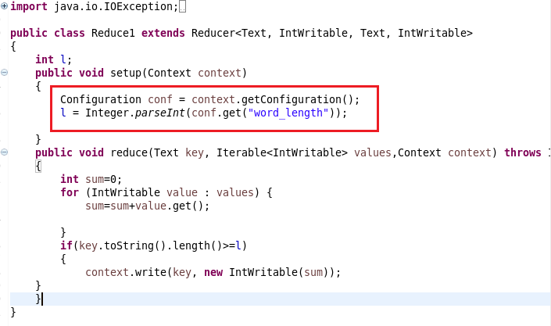

**Execution Command:**

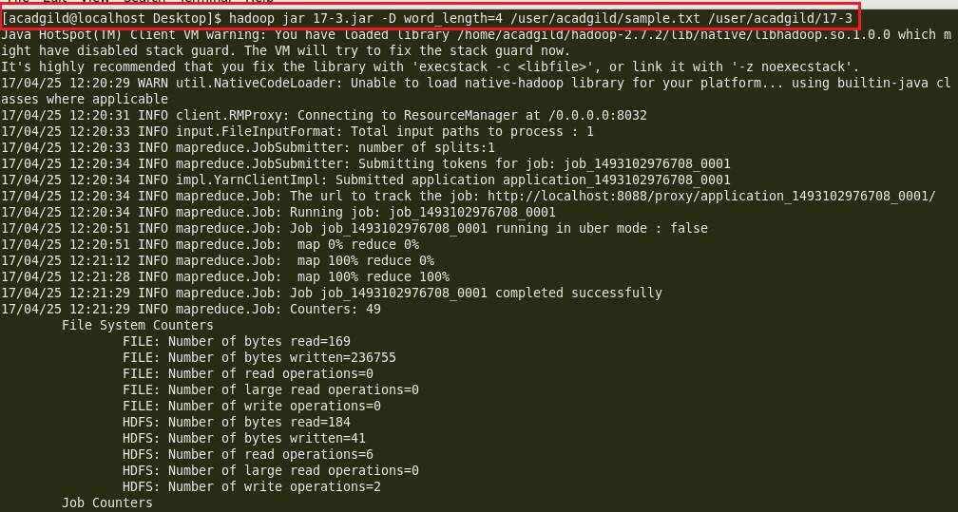

**Output:**

