Problem Statement:

Write a map reduce program to desing a custom counter to count number of people are affected with 'PULMONARY' disease and 'BRONCHITIS & ASTHMA' in the state 'CA'.

Solution:

Driver Class:

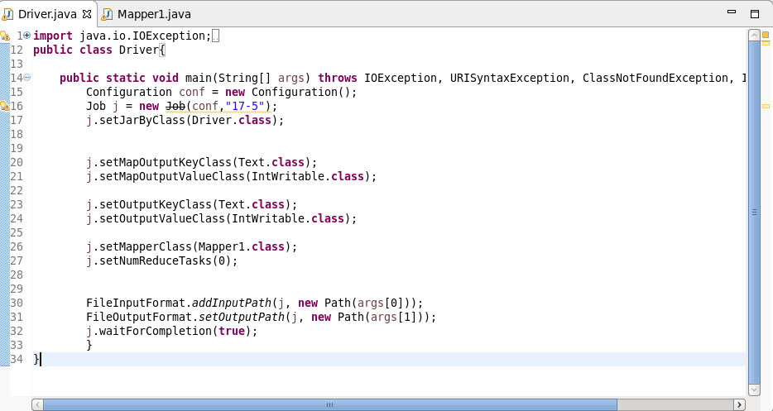

Mapper Class:

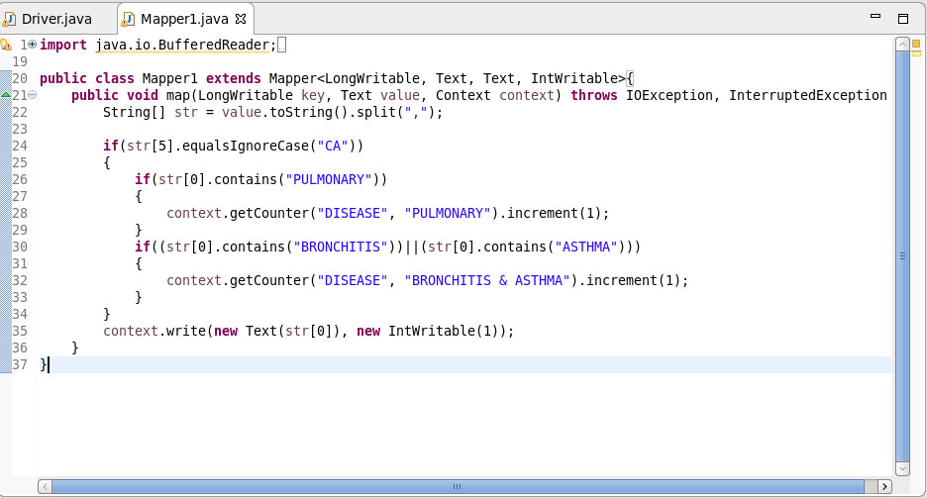

Execution Command:

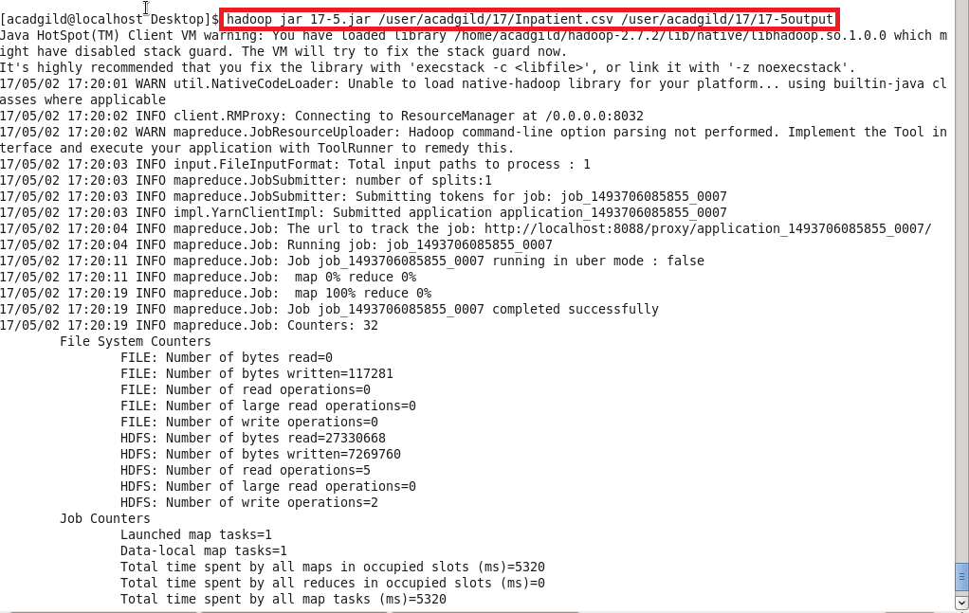

Output:

