**Problem Statement:**

Convert XML File into JSon File Format.

**Solution:**

**Program:**

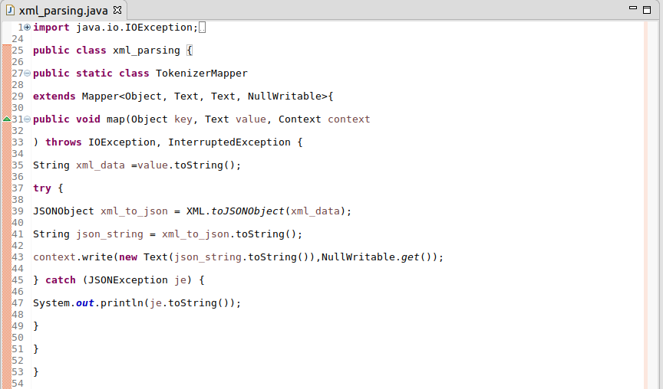

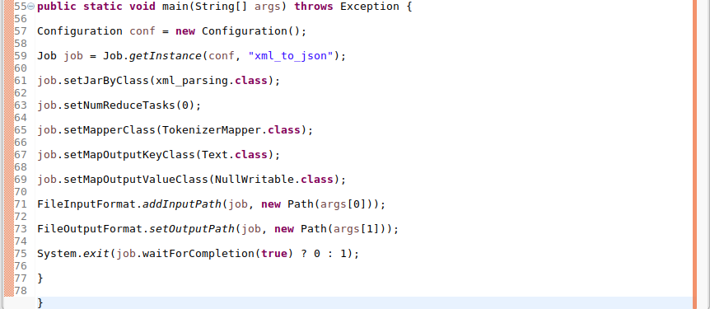

**Execution command:**

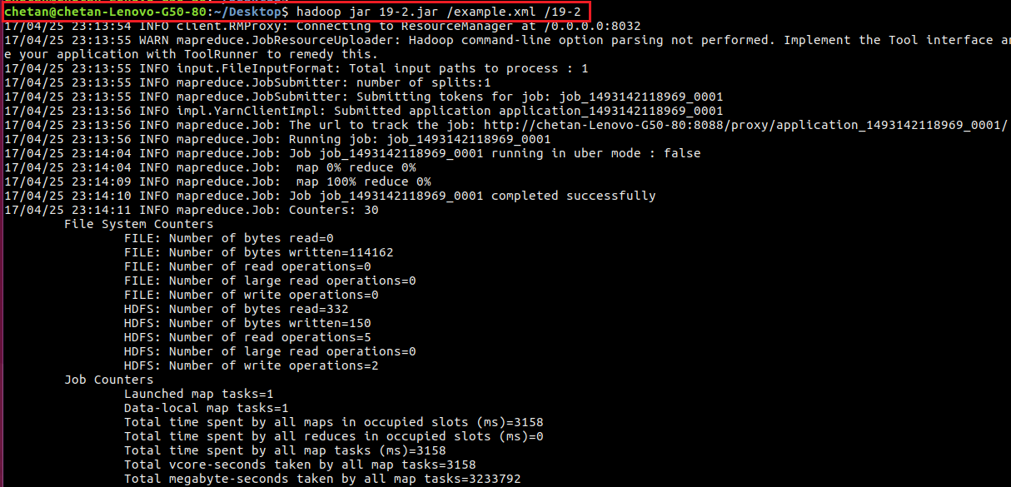

**Output:**

