**Problem Statement:**

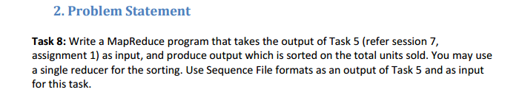

**Solution:**

**Driver Class:**

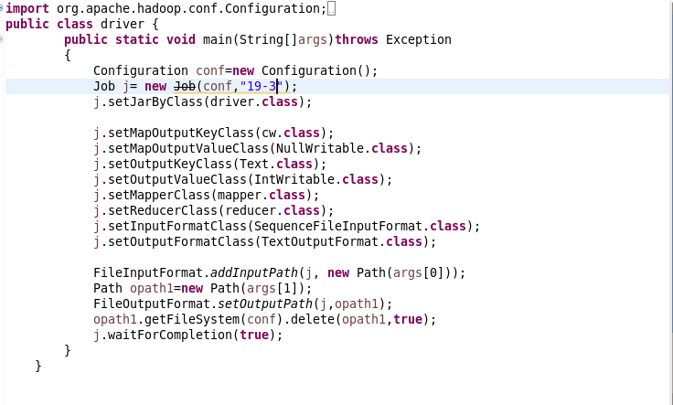

**Mapper Class:**

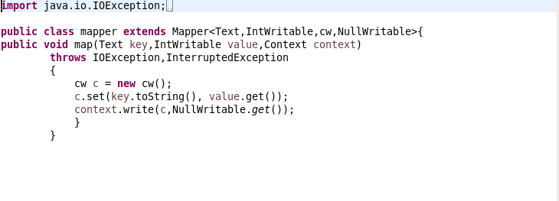

**Reducer Class:**

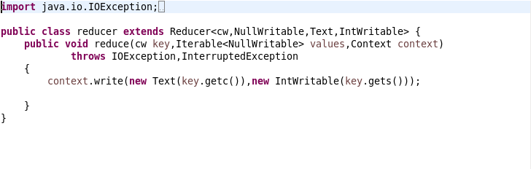

**CustomKey Class:**

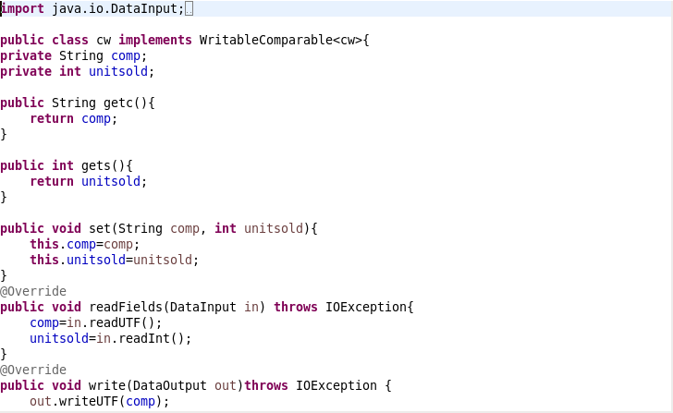

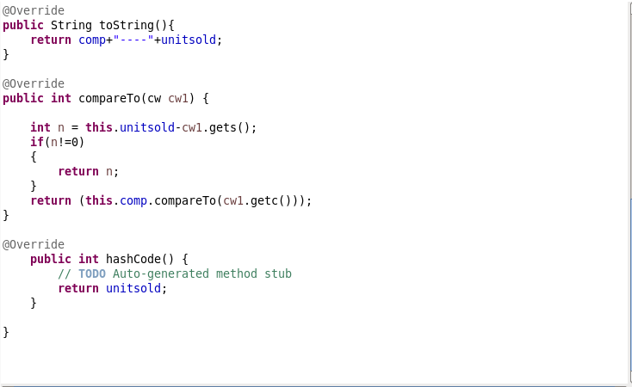

**Execution Command:**

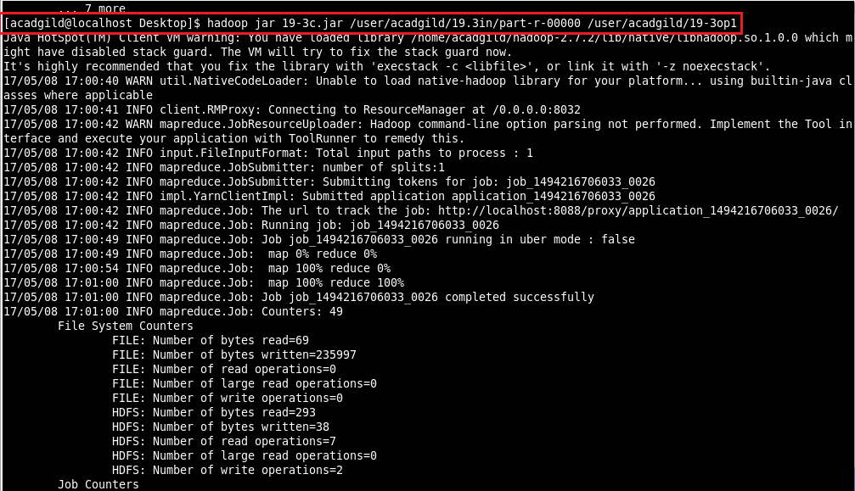

**Output:**

