Problem Statement :

Task 10: Enhance the task 8 (refer session 19, assignment 1) to calculate the top 3 state-wise sales for each company. You may use multiple reducers for this activity.

Solution:

Driver Class:

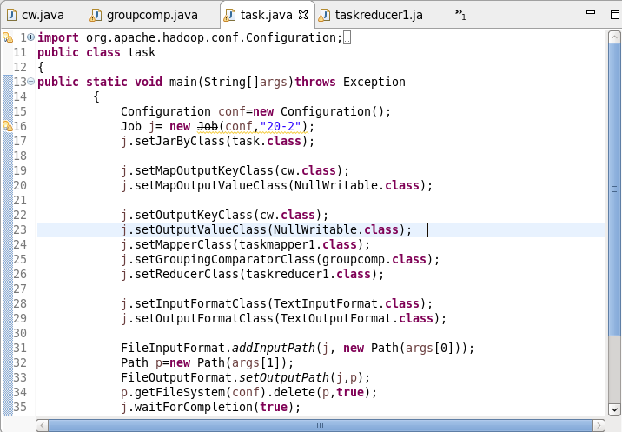

Mapper Class:

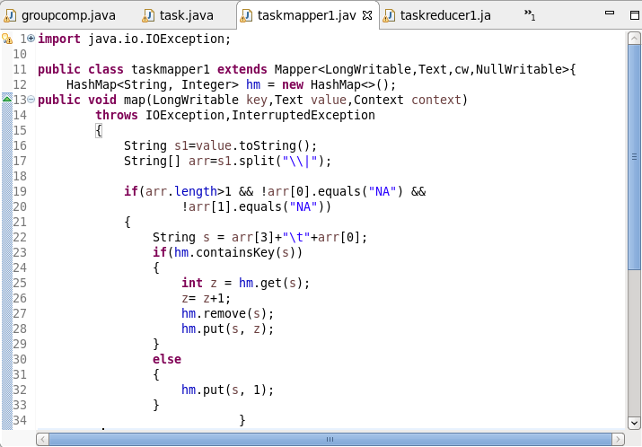

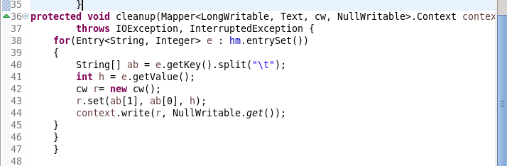

Reducer Class:

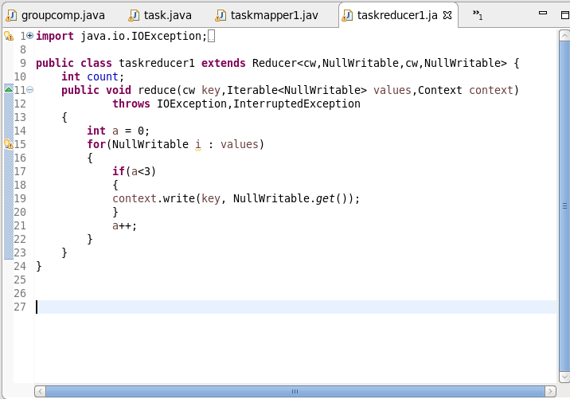

Writable Comparator Class: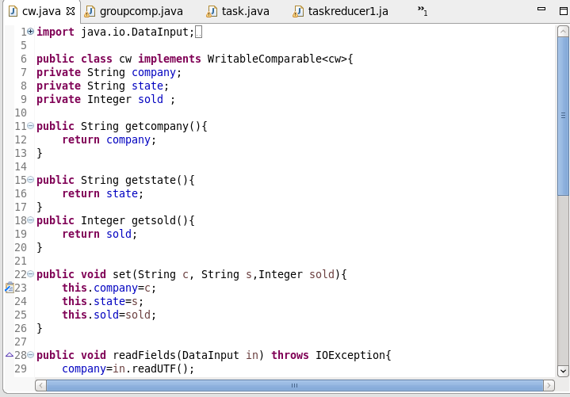:

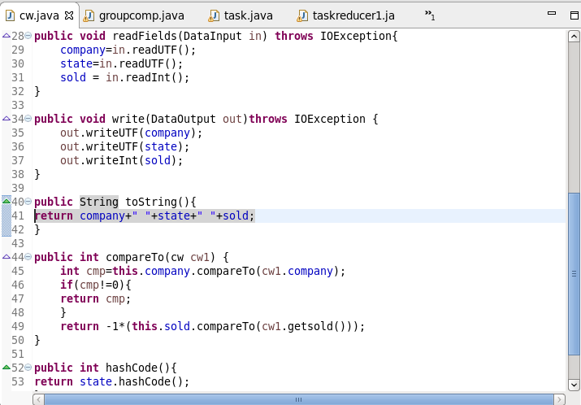

Group Comparator Class:

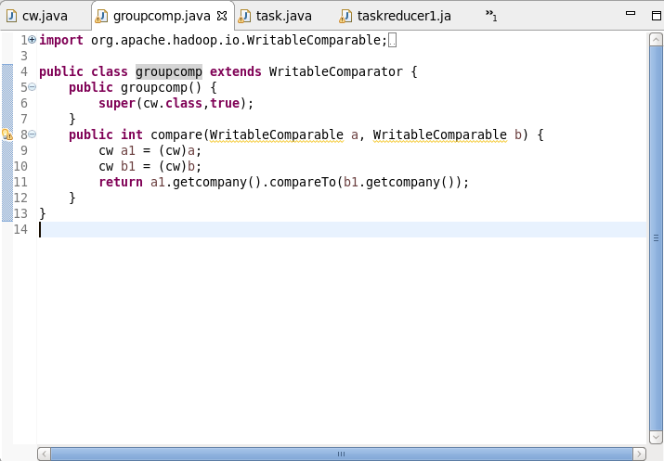

Execution Command:

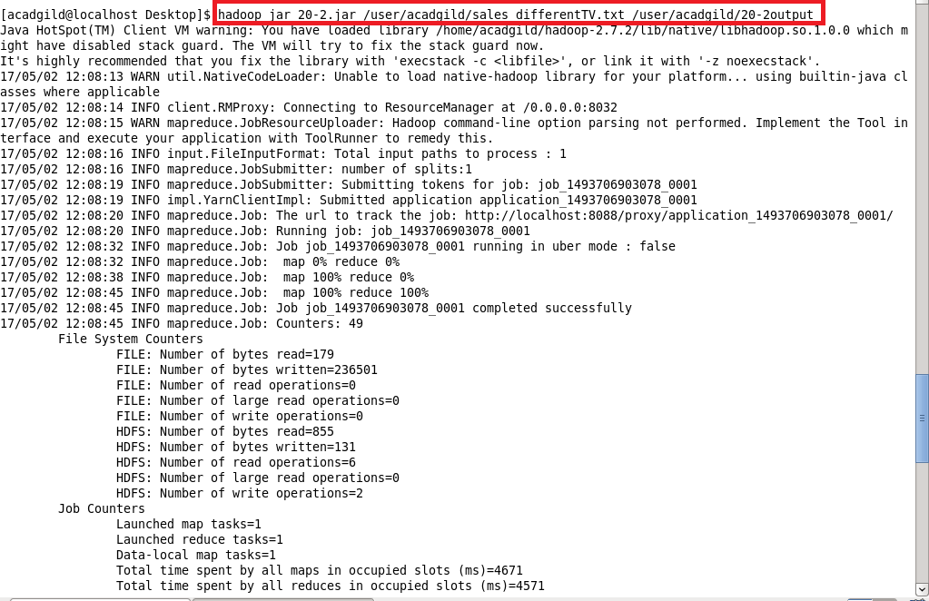

Output:

