Problem Statement:

Create a database named 'custom'.

Create a table named temperature_data inside custom having below fields: 1. date (mm-ddyyyy) format 2. zip code 3. temperature

The table will be loaded from comma-delimited file. Load the dataset.txt (which is ',' delimited) in the table.

Solution:

Database named custom is created.

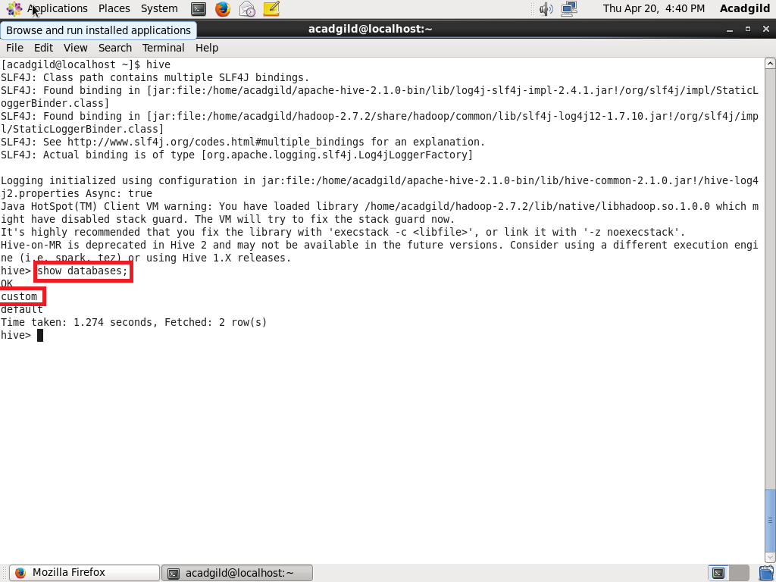

Create the table and load the values into the table.

