Problem Statement:

Explain with an example in brief.

1. Hive Data Definitions

**Solution:**

-It includes commands that define the different structures in a database.

-HDL is a subset of Hive SQL statements that describe the data structure in Hive by creating, deleting, or altering schema objects such as databases, tables, views.

-The commands are:

CREATE, DROP, TRUNCATE, DESCRIBE, AND ALTER.

Syntax:

CREATE TABLE HIVE_TABLE (abc INT, xyz STRING); // creating tables

DROP ‘TABLE NAME’; // deleting the table or database

TRUNCATE – used to delete the structure of the table.

ALTER - used to change the structure of the table.

1. Hive Data Manipulations

**Solution:**

-It includes commands used to modify the values in the table or to extract the data from the table.

-The commands are:

LOAD, INSERT, UPDATE, DELETE

-LOAD :- load the data into a table.

-Update :- change the entries in the table.

3) HiveQL Manipulations

**Solution:**

HiveQL Manipulations are of three types:

a) Select where

b) Select order by /sort by

c) Select group by

Select where :- used to filter the dataset with the where clause and apply the conditions.

Select order by clause :- used to arrange the dataset in the ascending or descending order by one field or multiple fields.

Select group by :- used to form subsets of the database using different fields of the data.

**Example:**

Create and load command:

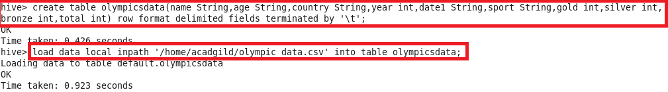

Select and describe command:

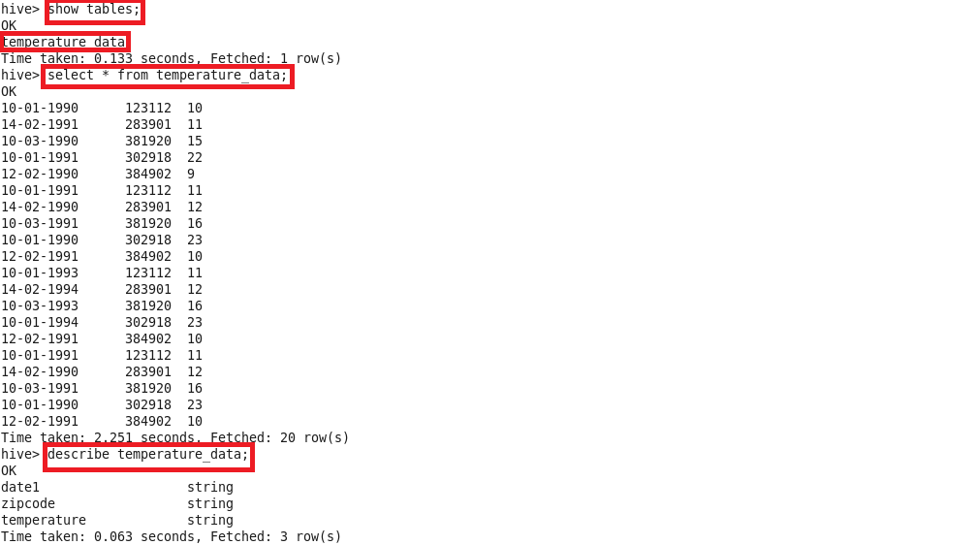

Select where command & select group by command:

