Creating the table and loading the data

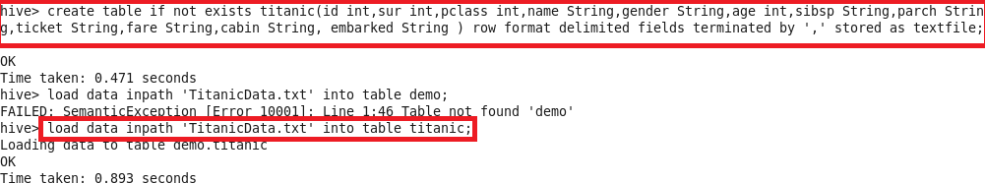

1.Write a hive query find the average age of male and female persons died in the titanic tragedy

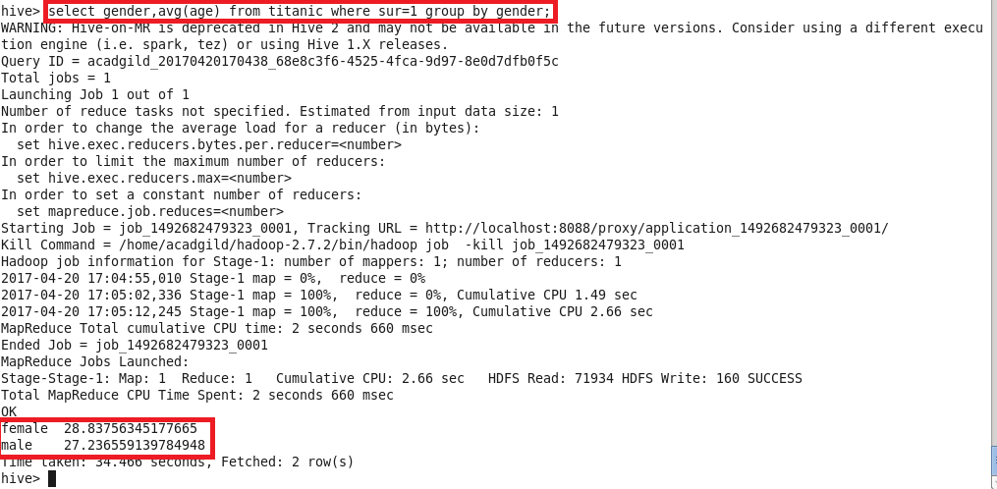

2.Write a hive query to find the number of people died and survived in each class

