Problem Statement:

1. Write a hive query to find the top 20 destination people travel the most: Based on the given data

Hive Query:

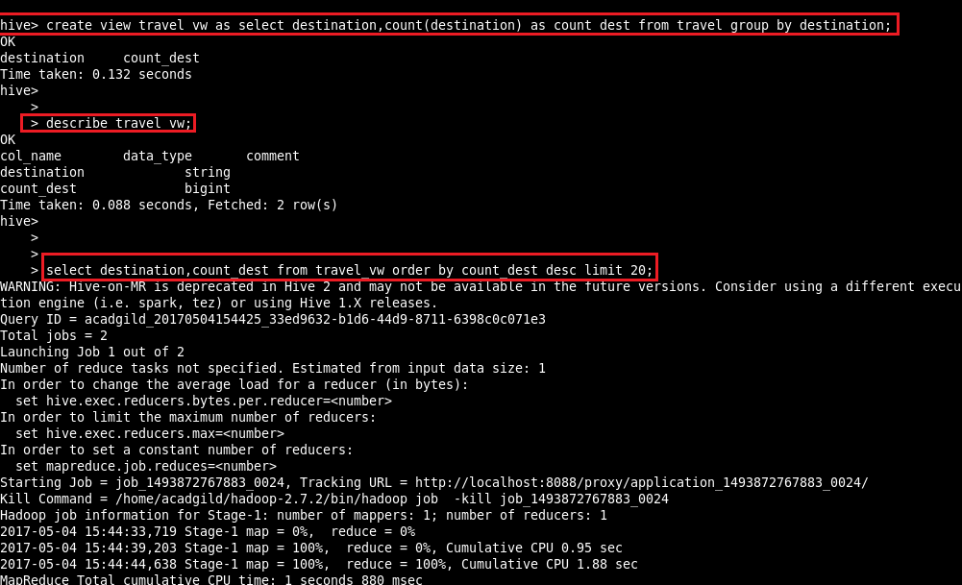

Output:



1. Write a hive query to find the top 20 locations from where people travel the most

Hive Query:

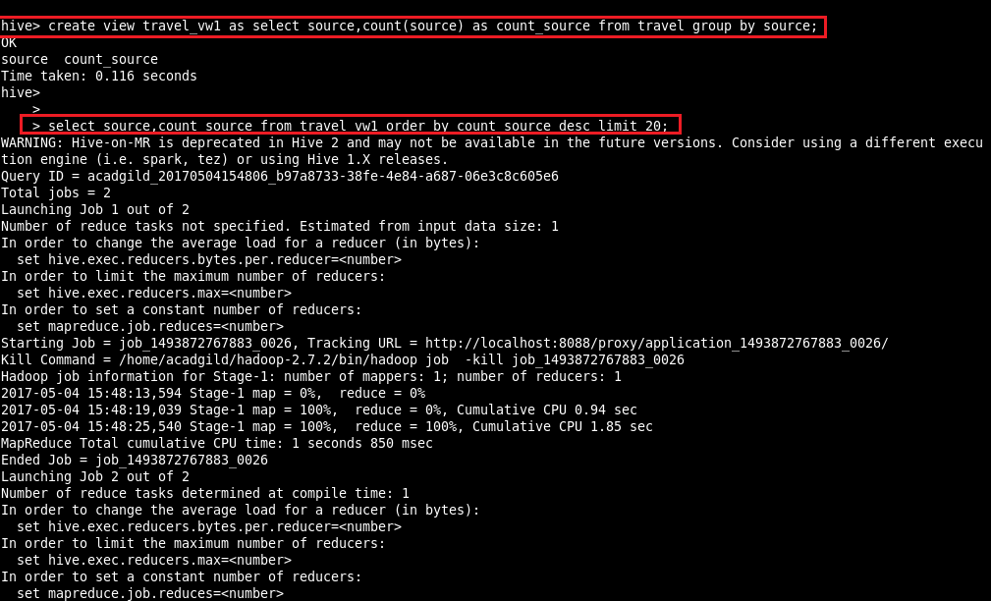

Output:

