Creating table realestate and loading the data into the table:

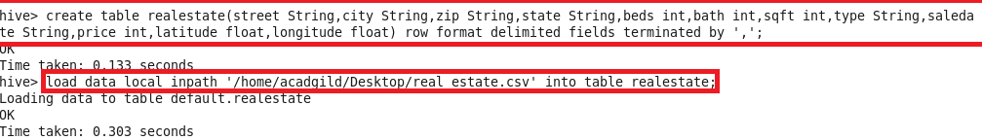

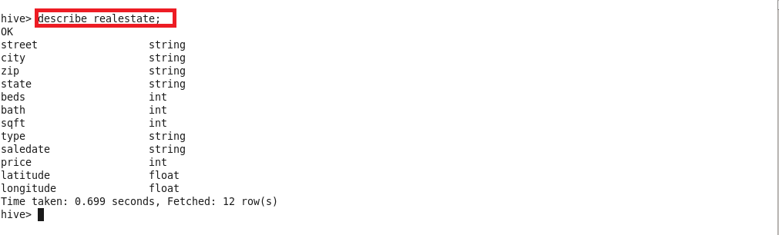

Creating partitioned table estate2:

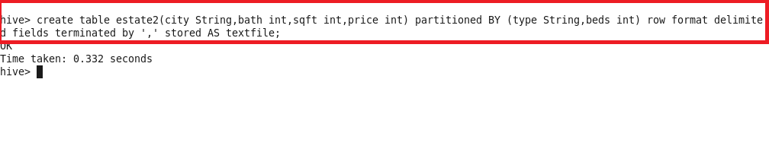

Loading the data into partitioned table:

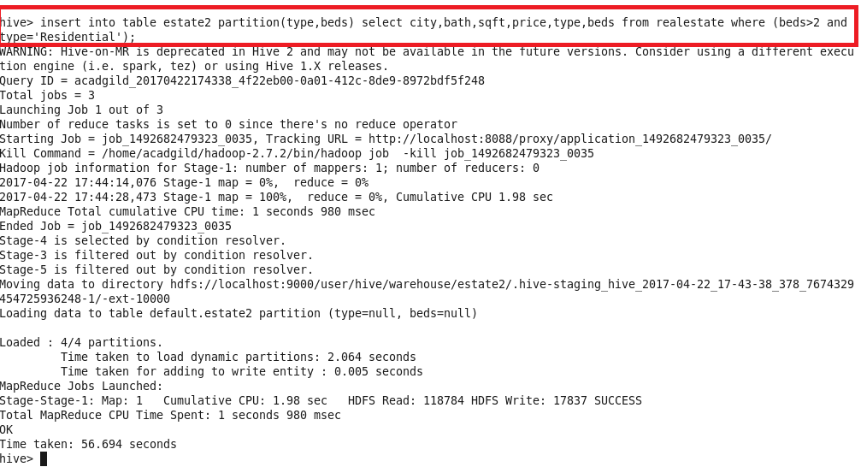

Separate directories created for each beds dynamically by hive

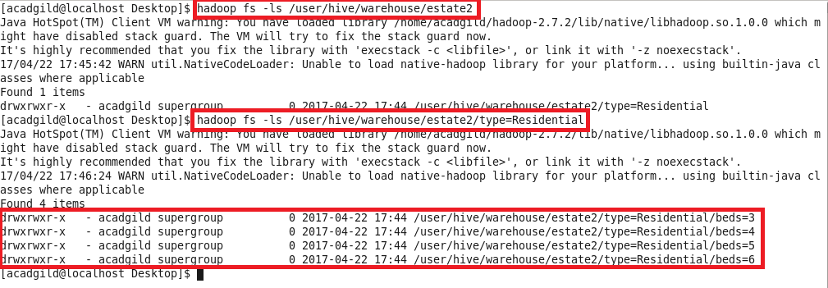

Output:

