Problem Statement:

Implement view in hive by following the steps in the below blog

<https://acadgild.com/blog/hive-view-introduction/>

Solution:

Dataset:

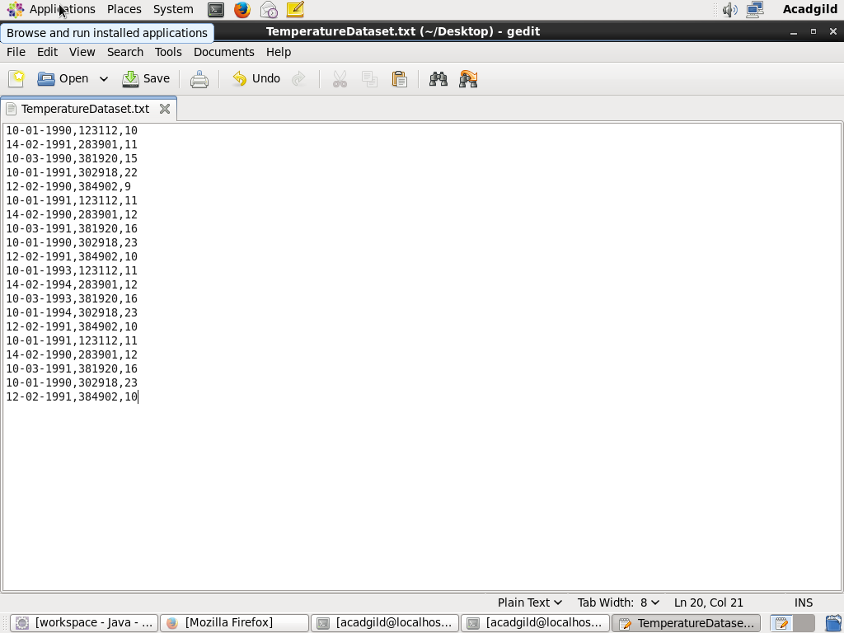

Creating the view named as temperature_data and displaying the values in the view

