1. Explain the differences between static and dynamic partitioning in hive and their working procedures.

**Solution:**

**Static partition in hive:**

* Insert input data files individually into a partition table is Static Partition
* Usually when loading files (big files) into [Hive tables](http://www.hadooptpoint.com/hive-create-table-examples/) static partitions are preferred
* Static Partition saves your time in loading data compared to dynamic partition
* “Statically” add a partition in table and move the file into the partition of the table.
* We can alter the partition in static partition
* We can get the partition column value form the filename, day of date etc without reading the whole big file.
* If we want to use Static partition in hive we should set property set hive.mapred.mode = strict This property set by default in hive-site.xml
* Static partition is in Strict Mode
* We should use where clause to use limit in static partition
* We can perform Static partition on Hive Manage table or external table.

**Dynamic partition in hive:**

* Single insert to partition table is known as dynamic partition
* Usually dynamic partition load the data from non partitioned table
* Dynamic Partition takes more time in loading data compared to static partition
* When we have large data stored in a table then Dynamic partition is suitable.
* If we want to partition number of column but you don’t know how many columns then also dynamic partition is suitable
* Dynamic partition there is no required where clause to use limit.
* We can’t perform alter on Dynamic partition
* We can perform dynamic partition on hive external table and managed table
* If we want to use Dynamic partition in hive then mode is in nonstrict mode
* Here is hive dynamic partition properties you should allow

1. Use static partitioning in hive and evaluate the below problem statements –

* Find the number of medals india won year wise

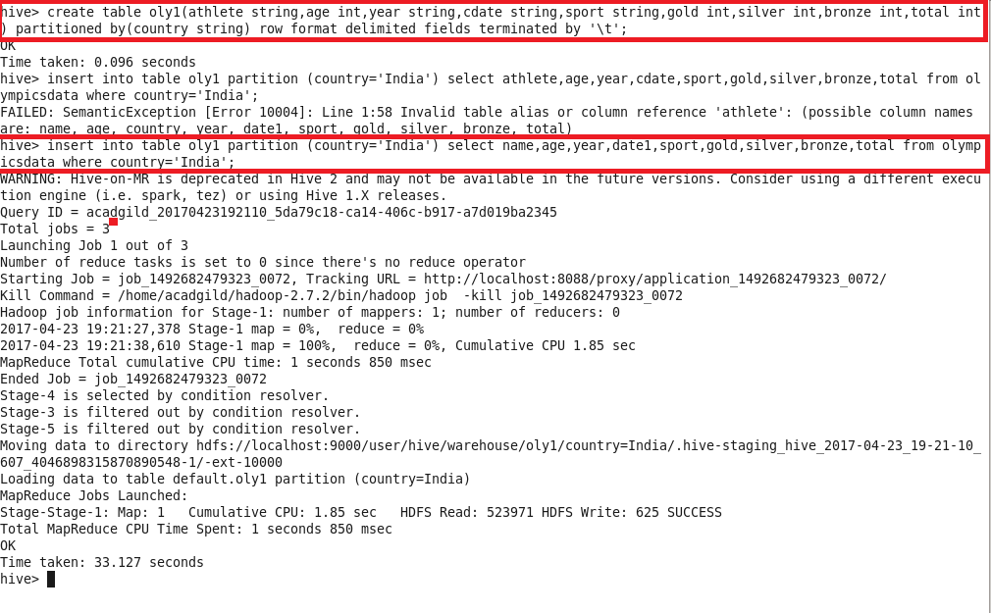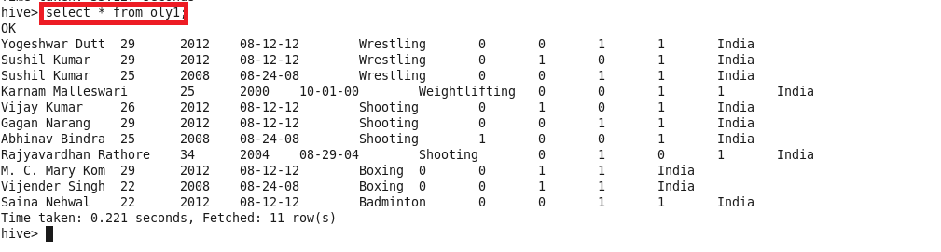

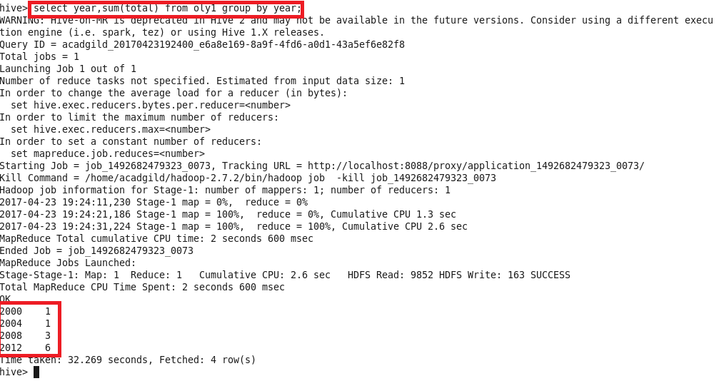

* Find the number of medals india won in swimming year wise

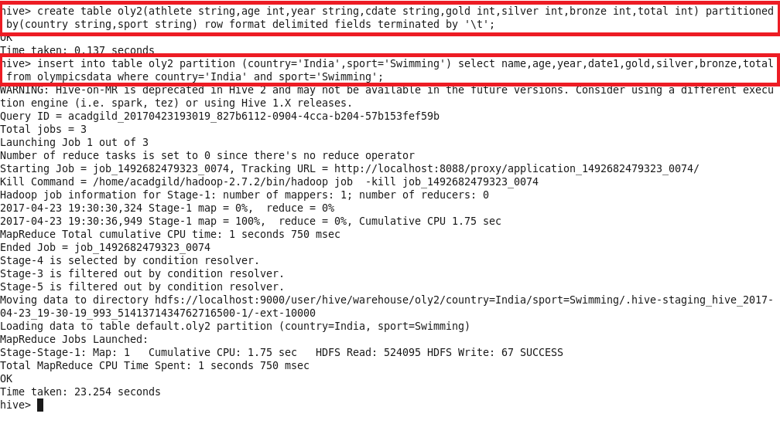

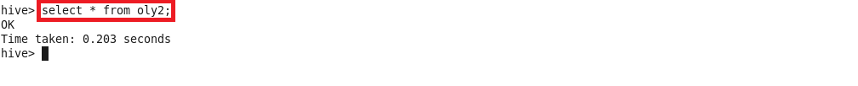

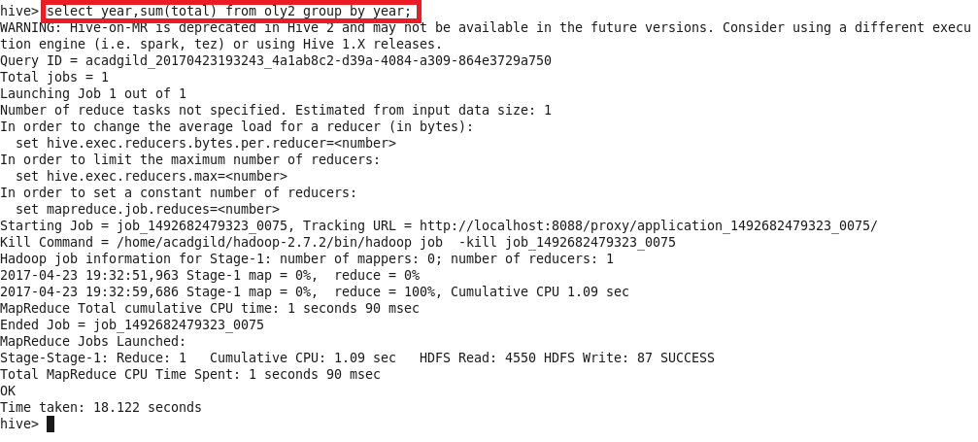

* Find the number of gold and silver medals india won year wise

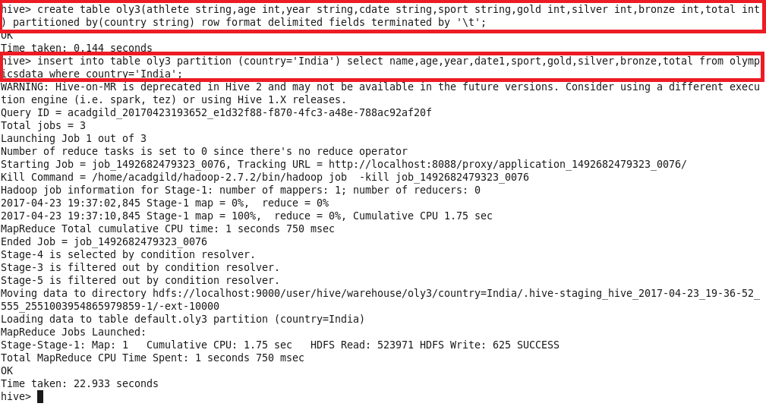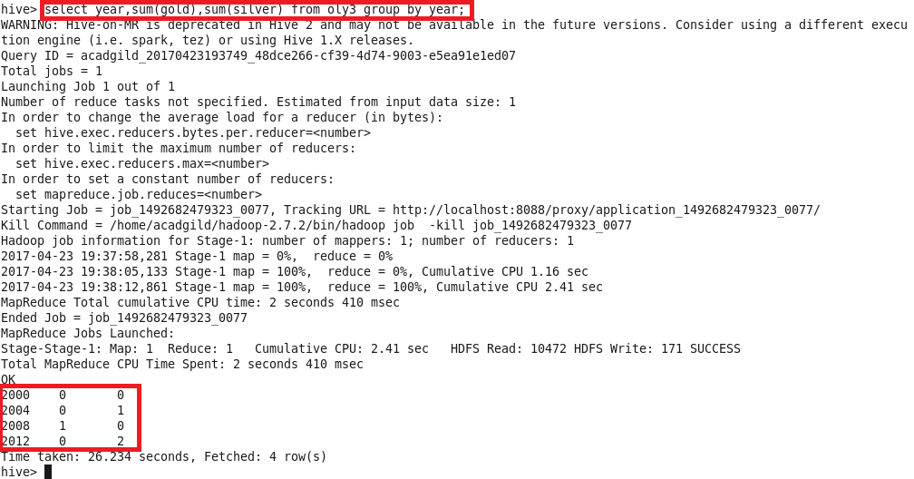

1. Use dynamic partitioning in hive and evaluate the below problem statements

* Find the total number of medals won by each country

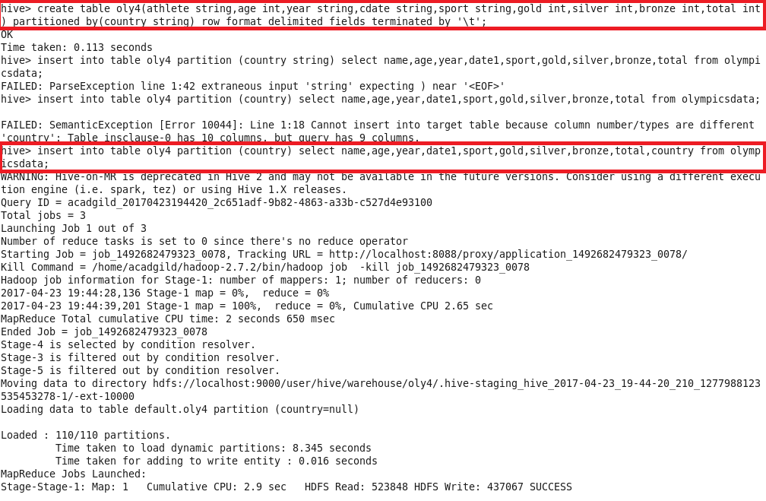

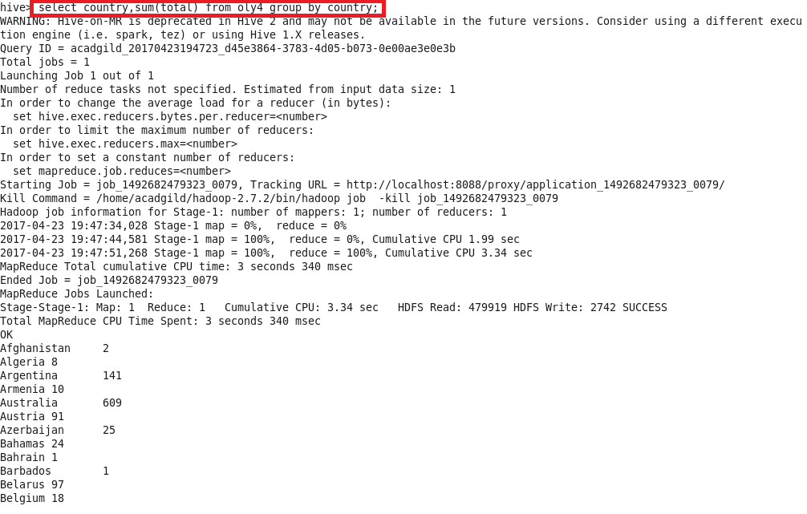

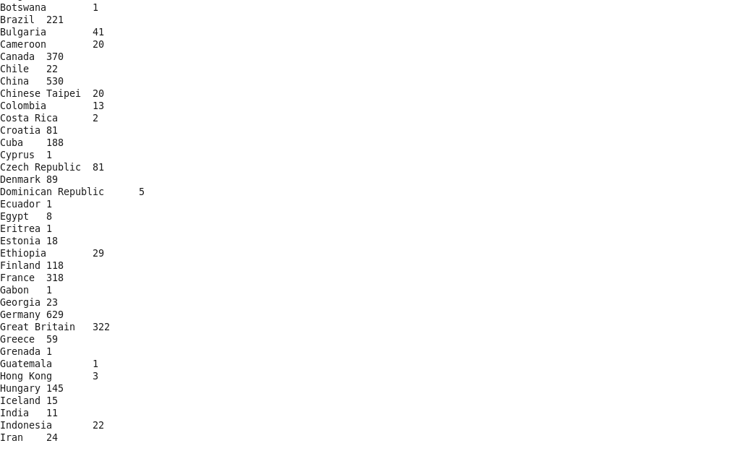

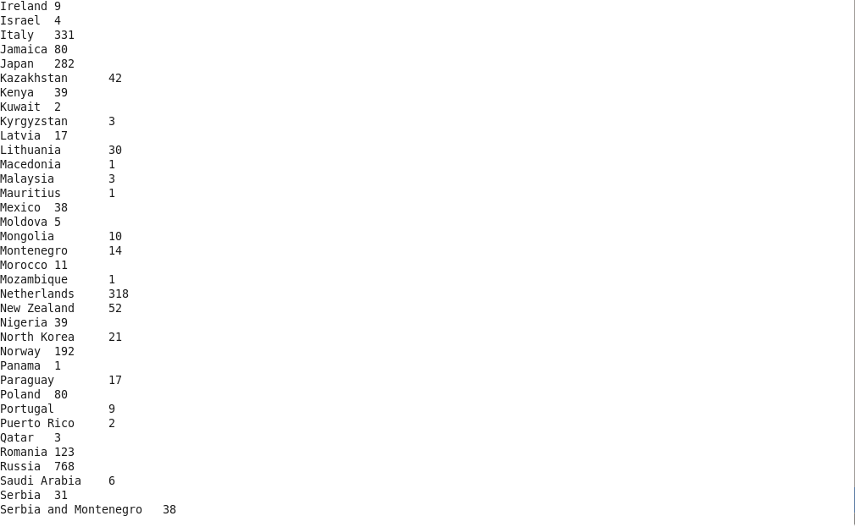

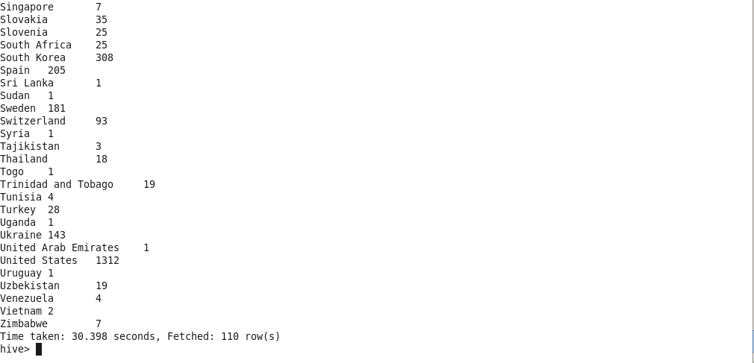

* Find the number of medals each country won in Athletics year wise



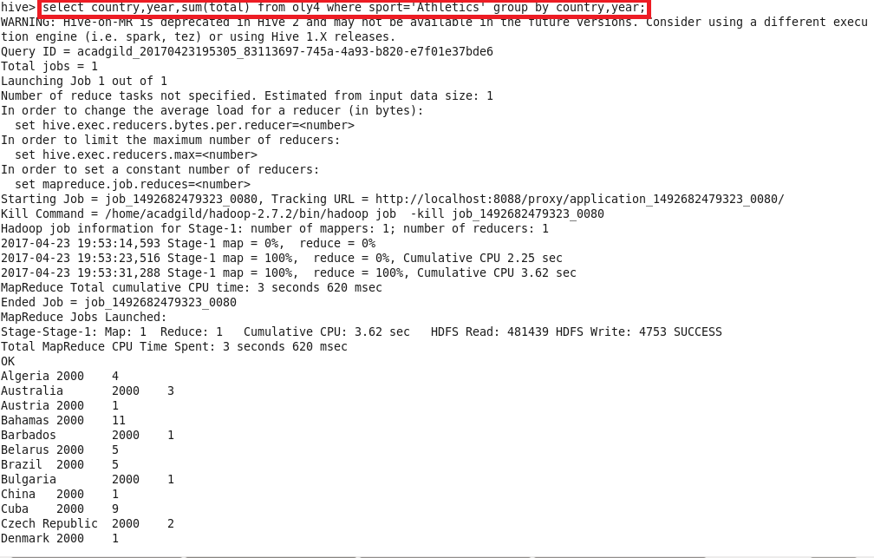

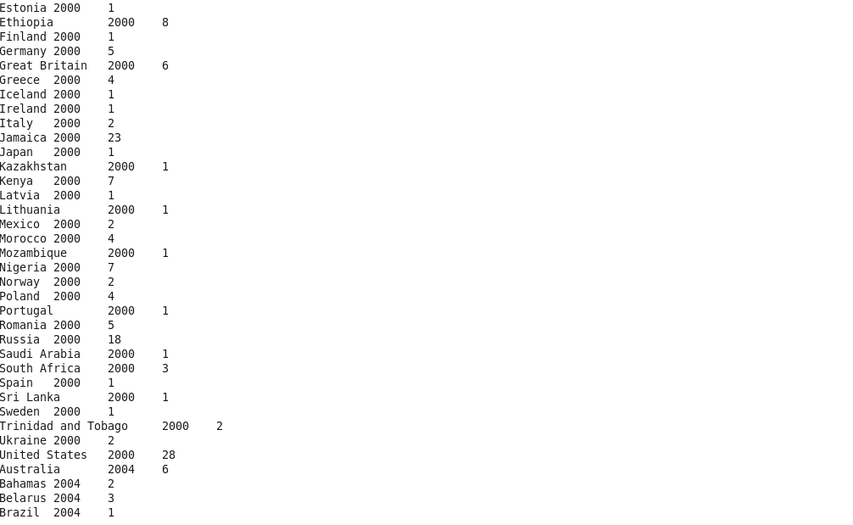

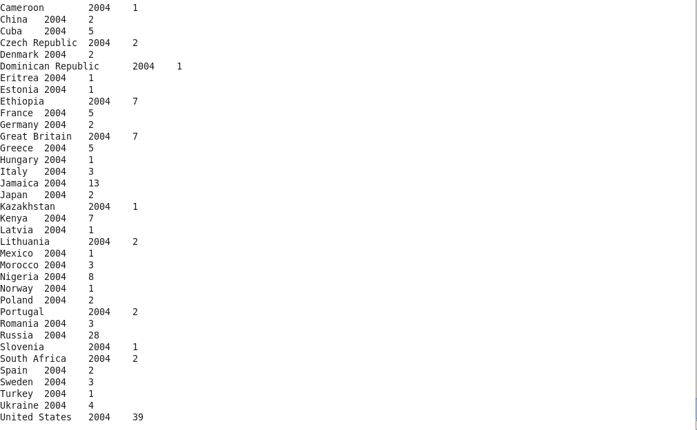

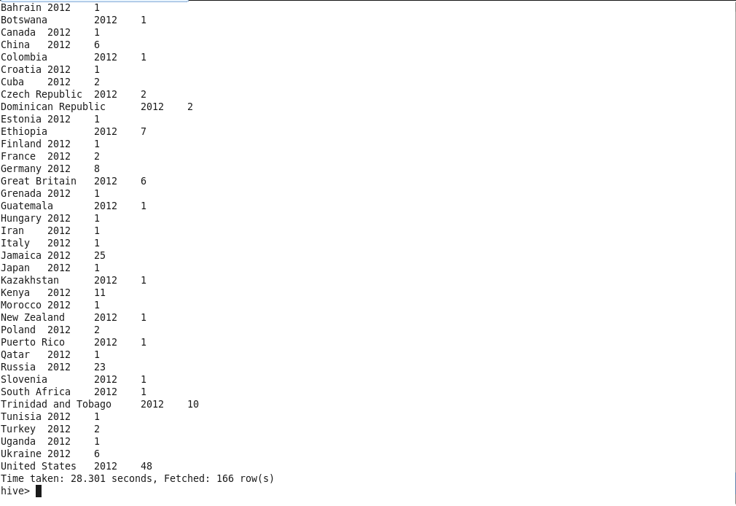

* Find the average age of atheltes participated from each country in olympics year wise



