Run parallel jobs in hive by following the steps in the below blog link

<https://acadgild.com/blog/hive-parallel-jobs/>

**Solution:**

Creating 4 tables for perfoming joins

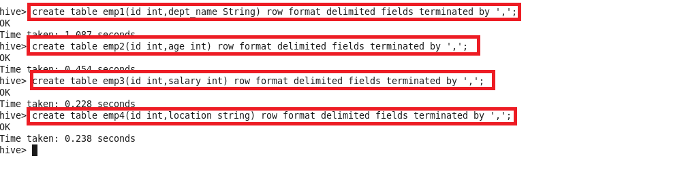

Loading data in these 4 tables

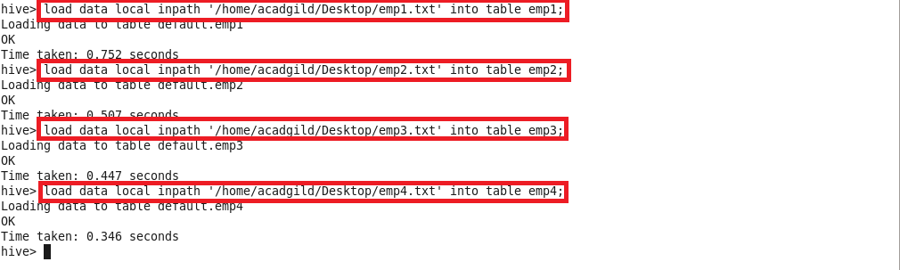

Contents of all 4 tables:

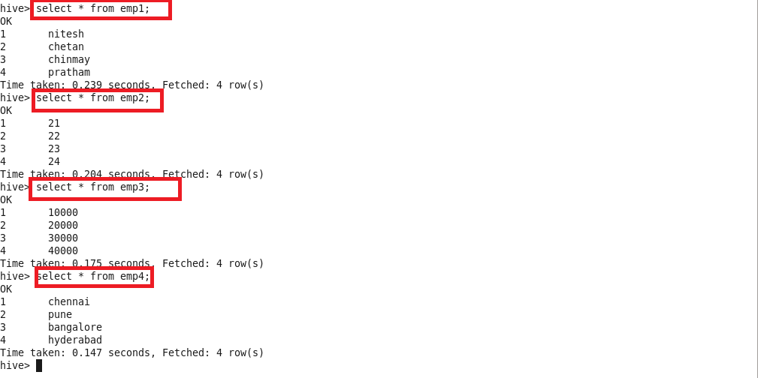

Running parallel job:

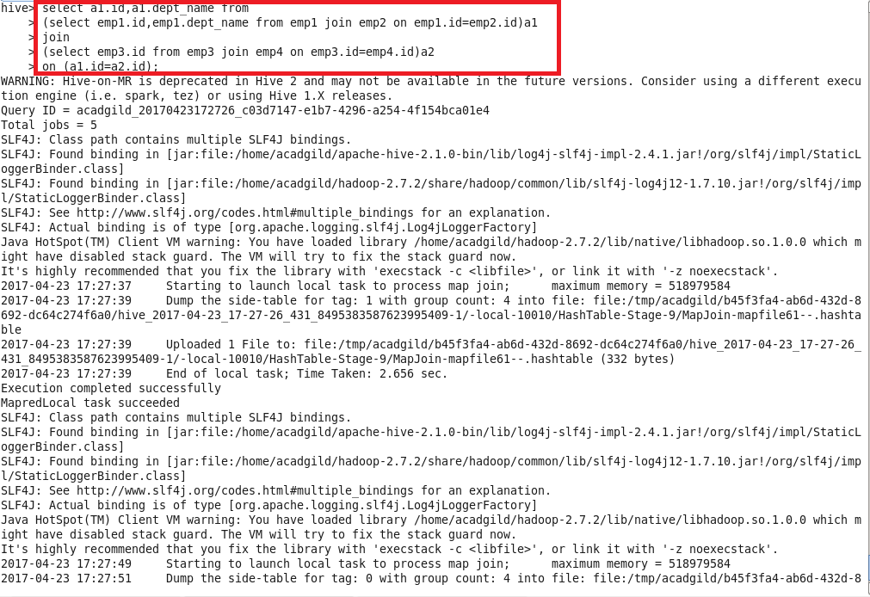

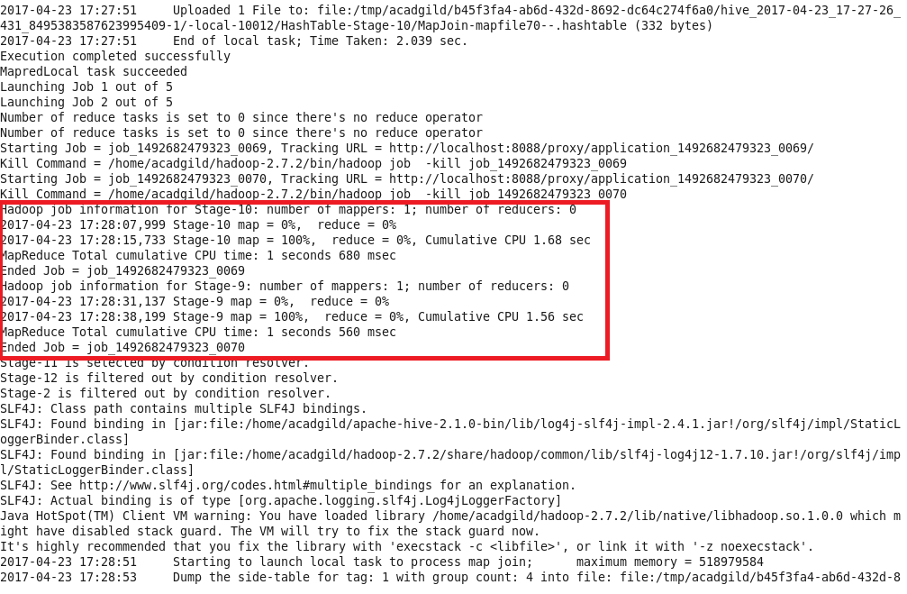

**Output:**

