* What are ACID properties and Explain Transactions in Hive.

Solution:

ACID represents the transaction properties of the hive transactions.

A – Atomicity

Atomicity means a transaction should complete successfully or else it should fail completely i.e. it should not be left partially.

C- Consistency

Consistency ensures that any transaction will bring the database from one valid state to another state.

I – Isolation

Isolation states that every transaction should be independent of each other i.e. one transaction should not affect another.

D- Durability

Durability states that if a transaction is completed, it should be preserved in the database even if the machine state is lost or a system failure might occur.

Transactions of the HIVE

There are 3 transactions that can be performed

1. INSERT

2) UPDATE

3) DELETE

INSERT – This command is used to insert the data into the hive table. This transaction does not need requirement of the switching on the transactions in hive

UPDATE – This is used to update the already present data in the hive table.

DELETE –This is used to delete the record from the hive table.

Creating Table that supports hive transactions:

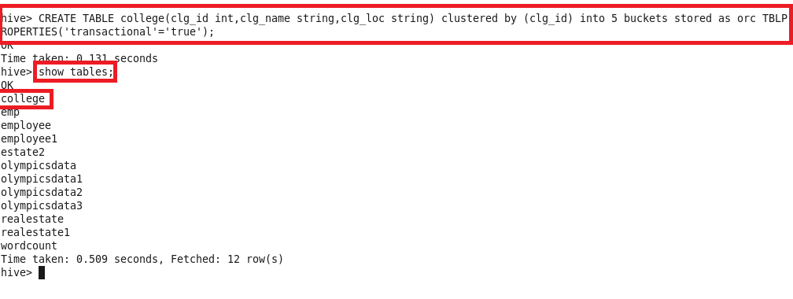

Inserting data into hive table:

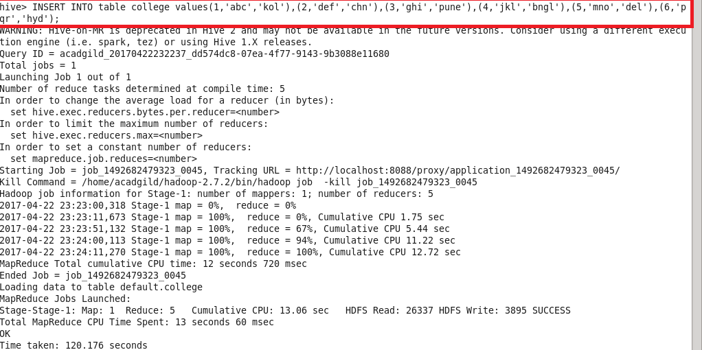

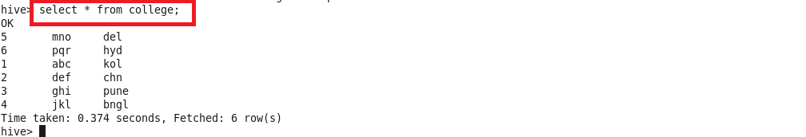

Updating the data in hive table:

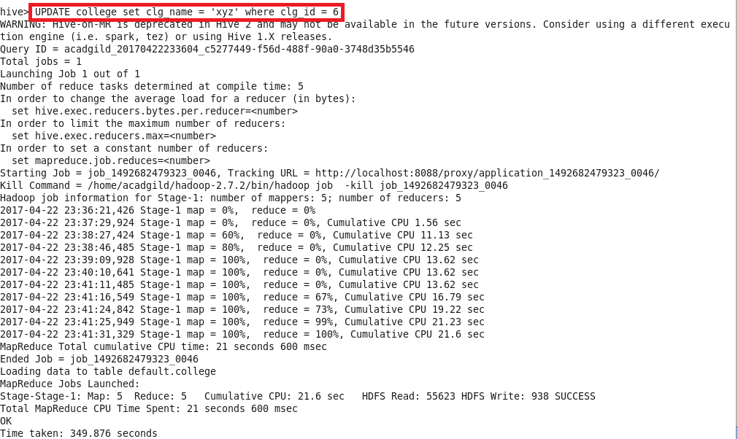

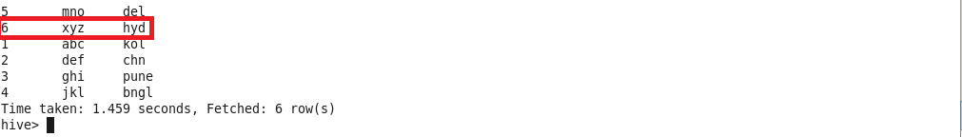

Deleting a row from hive table:

