**Problem Statement:**

● Write a Java client API to perform following operations:

● Use HBaseAdmin class and create the table named company with one column family name details.

● Create the method name insert and use put class to insert records to company table.

**Solution:**

**CreateHbaseTable class:**

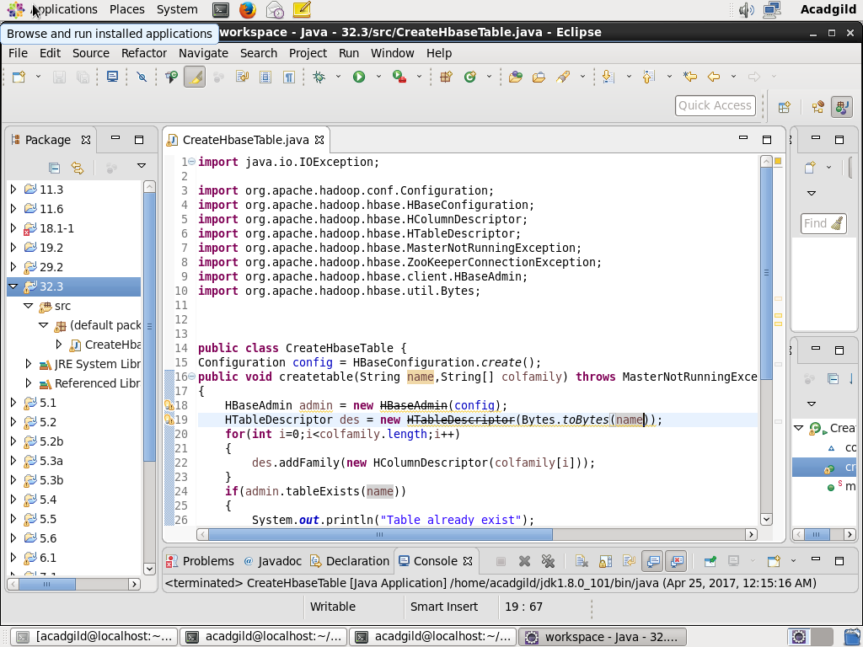

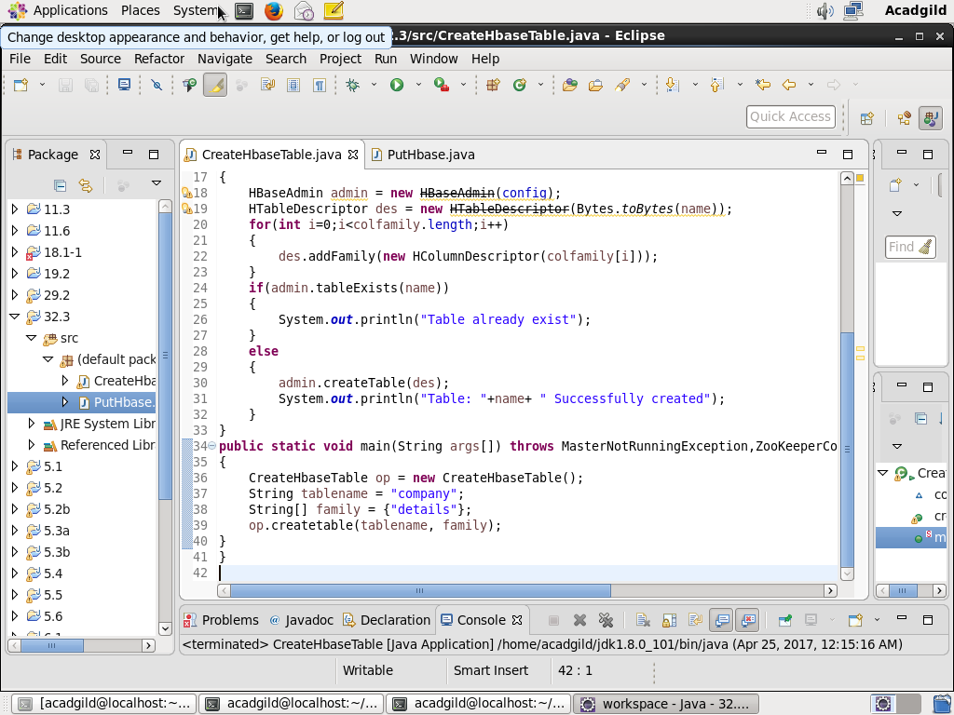

**Console output:**

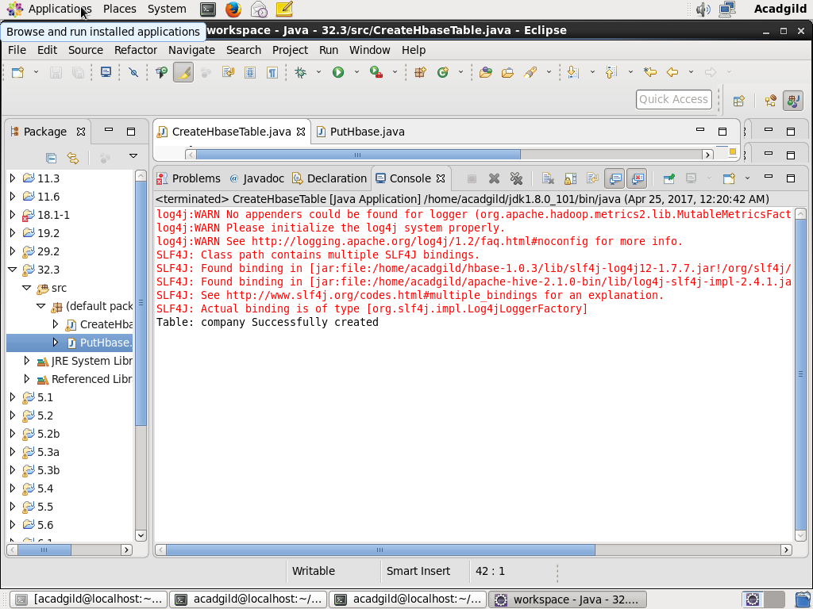

**Hbase shell output:**

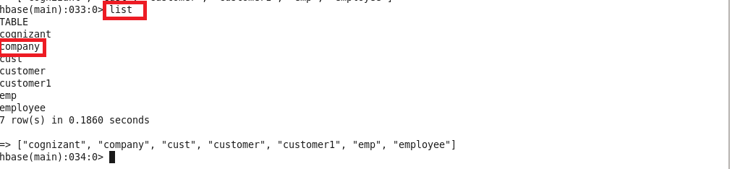

**PutHbase Class:**

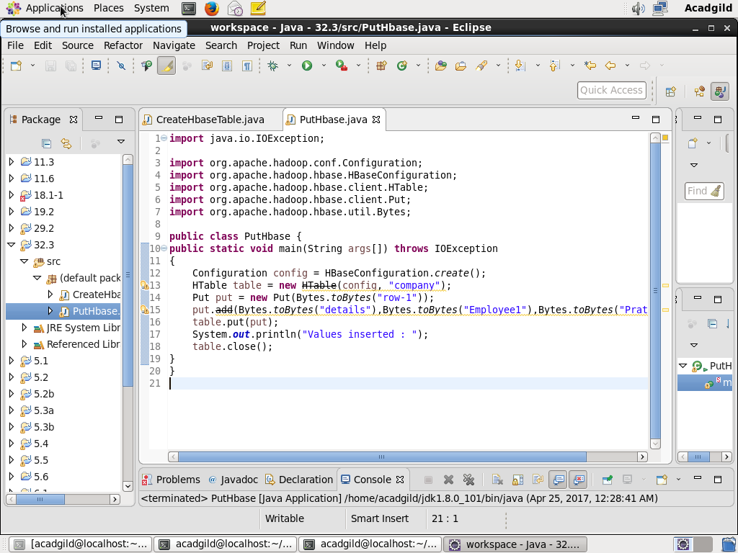

**Console output:**

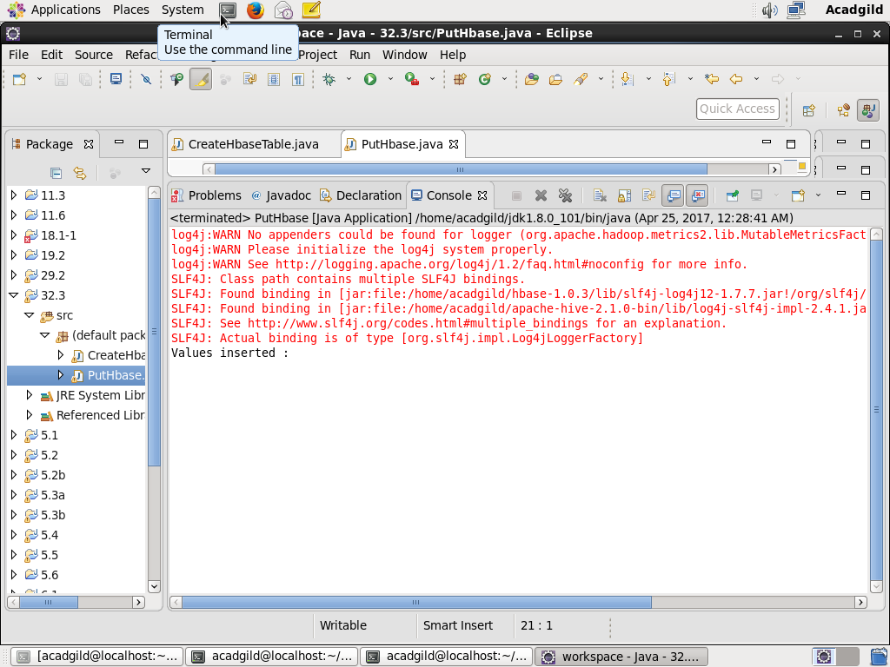

**Hbase Shell output:**

