Write Java client API to perform following operations:

● Create the method name get record and use get class to retrieve one record at a time record from company table.

**Solution:**

**Java program:**

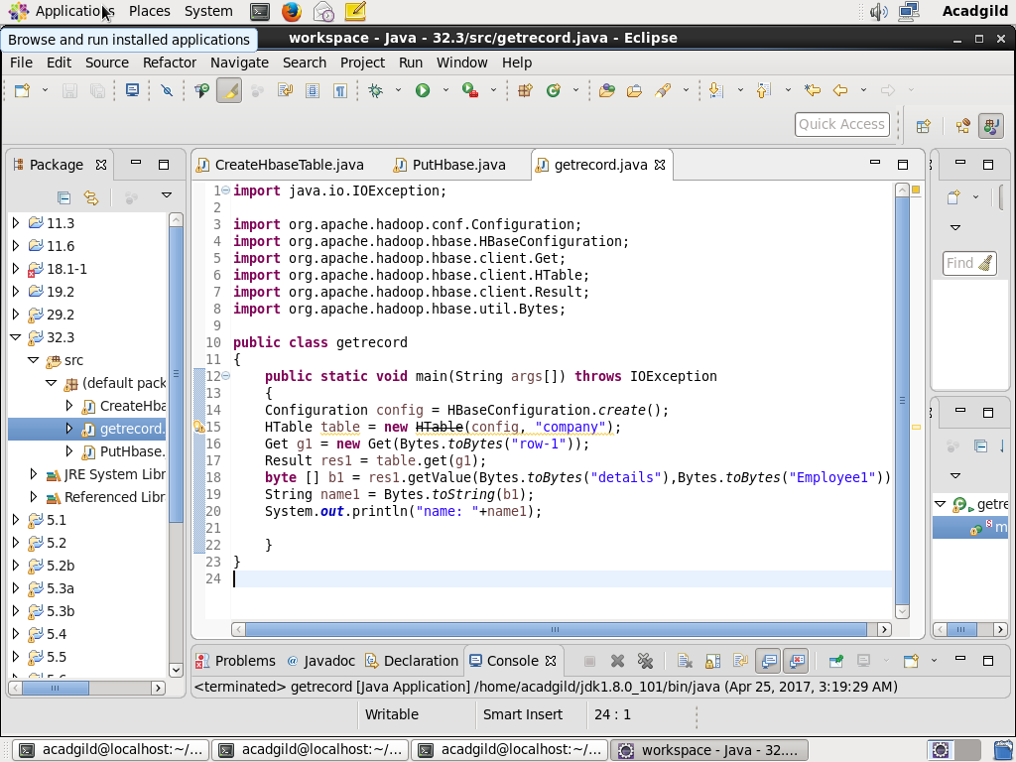

**Console output:**

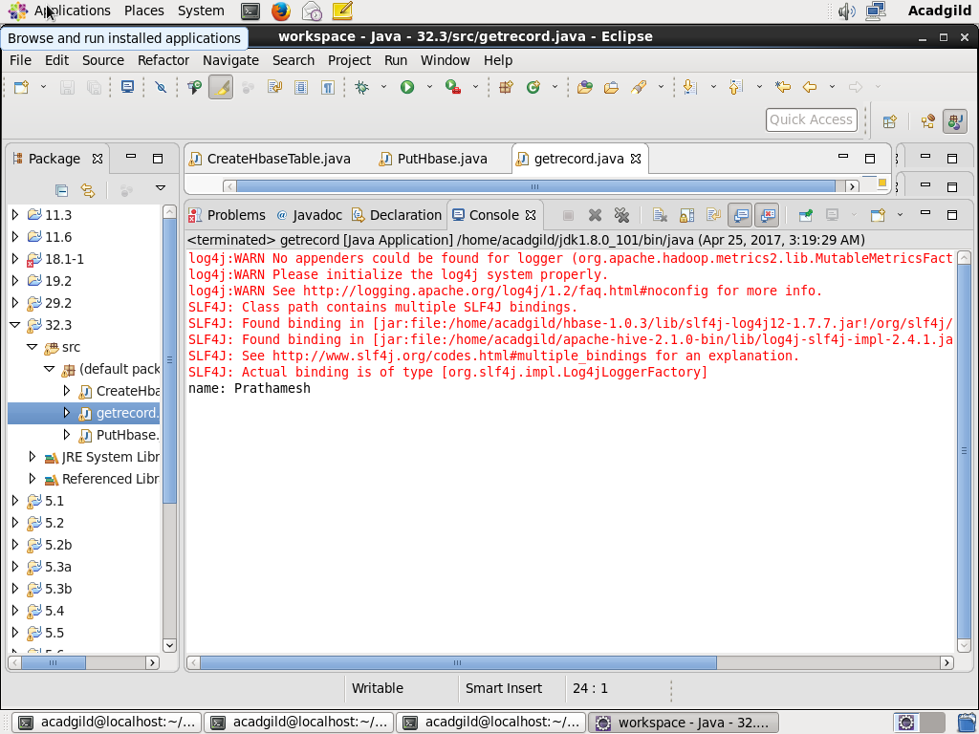

**Checking contents of company table using scan command:**

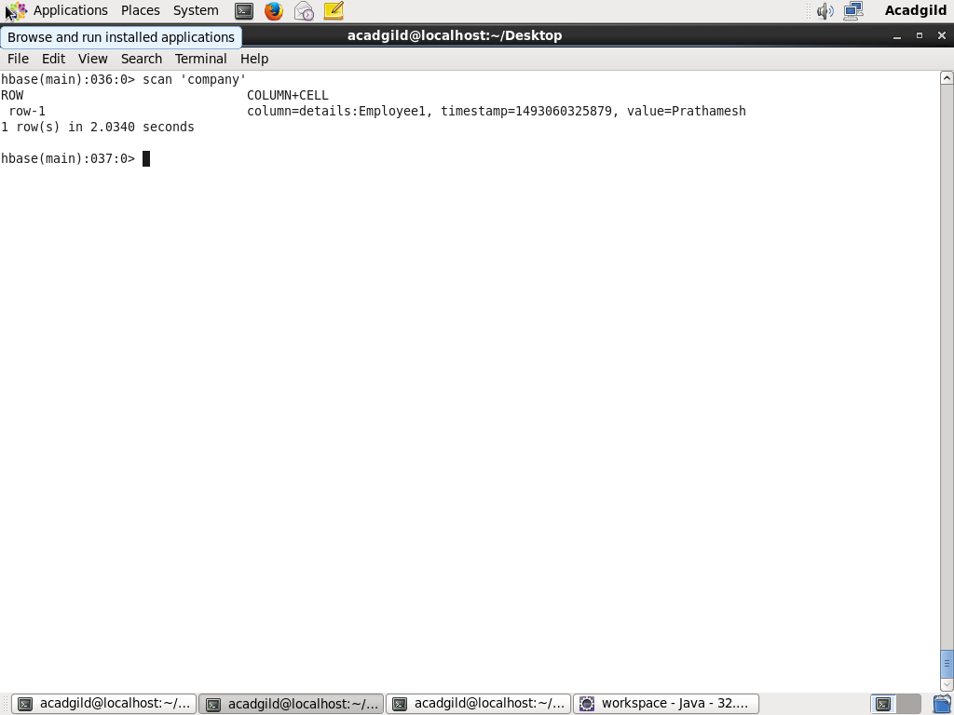

● Create the method name display and use scan class to display all records from company table.

**Solution:**

**Java program:**

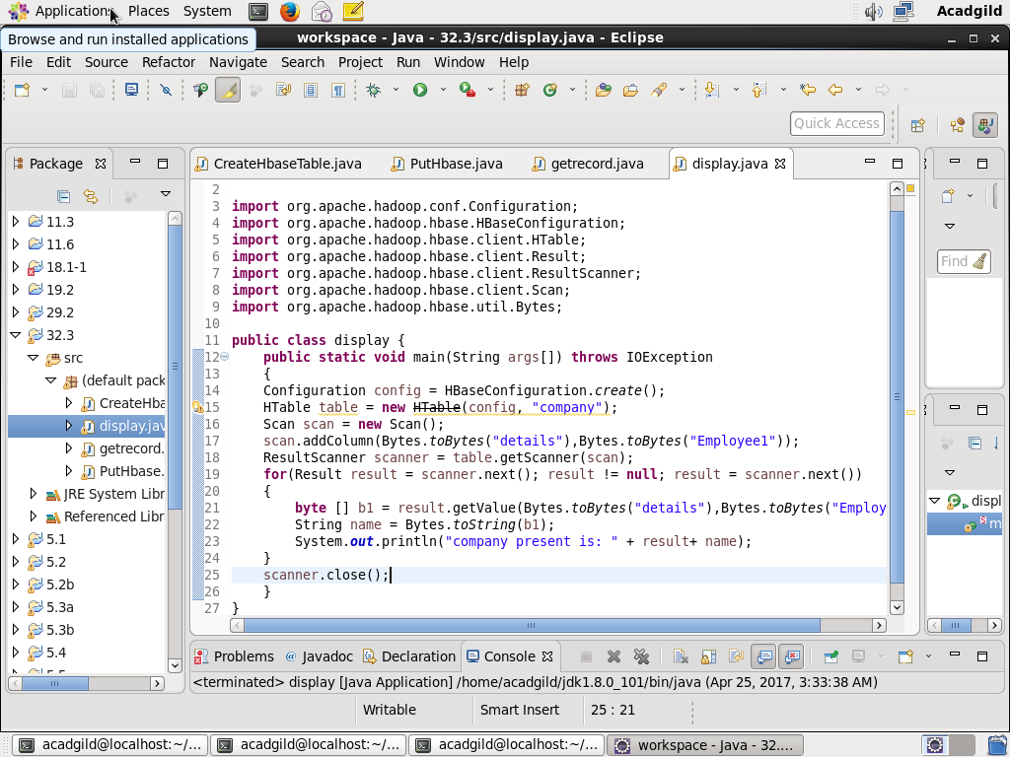

**Console output:**

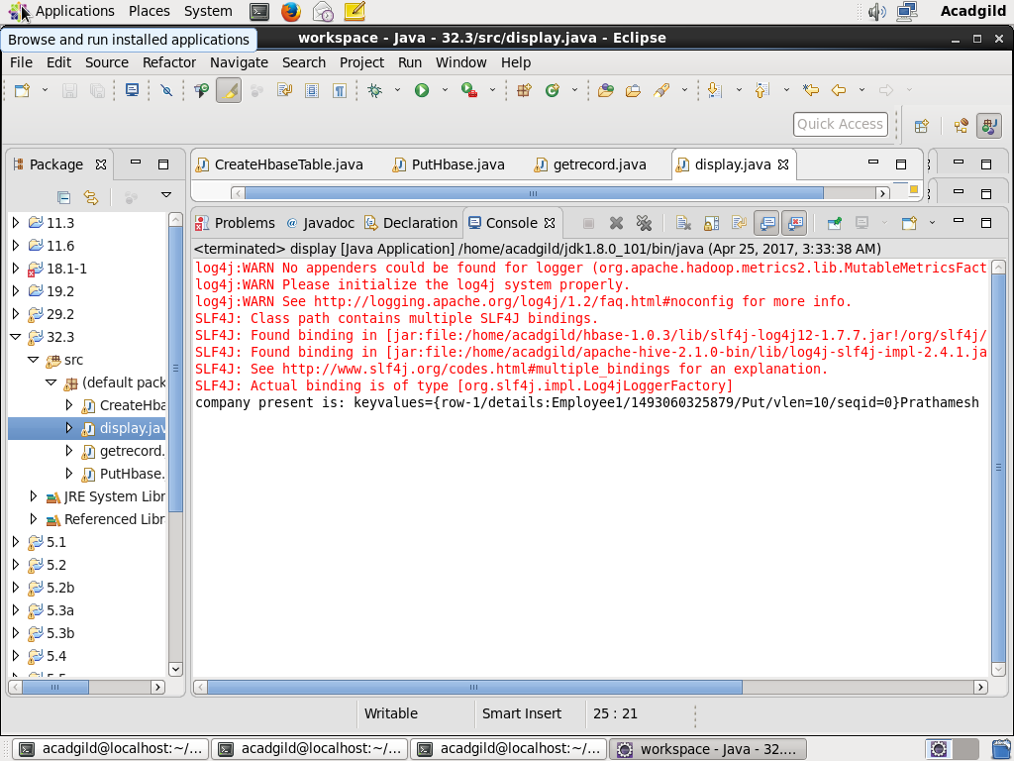

**Checking contents of company table using get command:**

