Integrate Hbase with Hive

**Solution:**

**Create hbase table:**

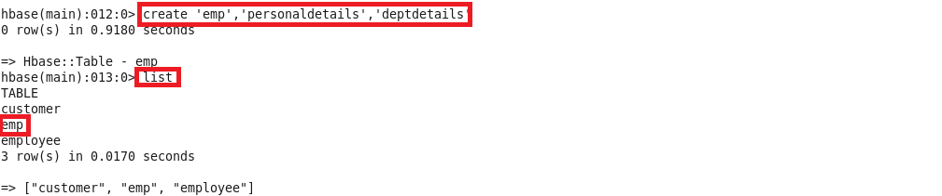

**Insert the data into HBase table:**

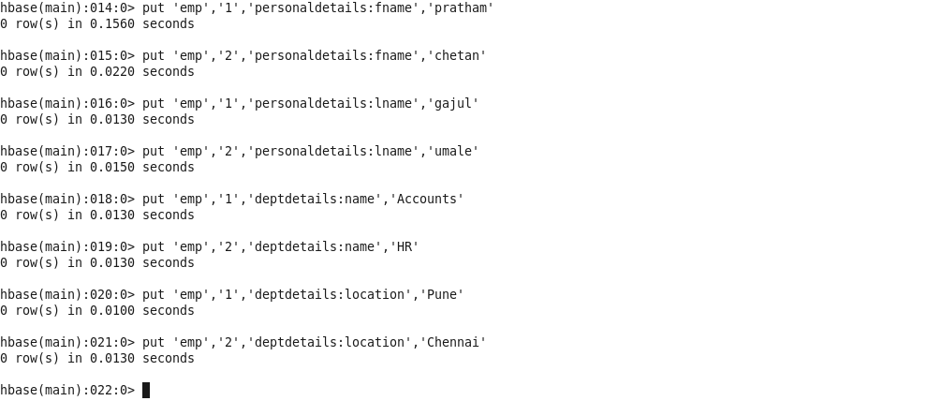

**Create the Hive table for each column family pointing to HBase table and displaying the contents of the hive table:**

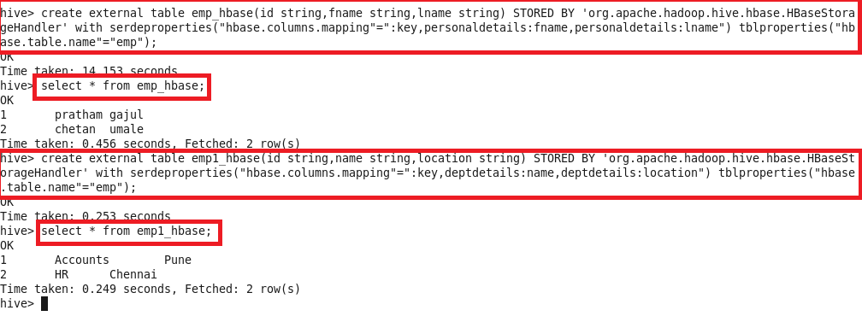

**Load Data (Bulk Load) from Hive table to Hbase Table**

**Solution:**

**Creating hbase table and scan the table(no data is loaded):**

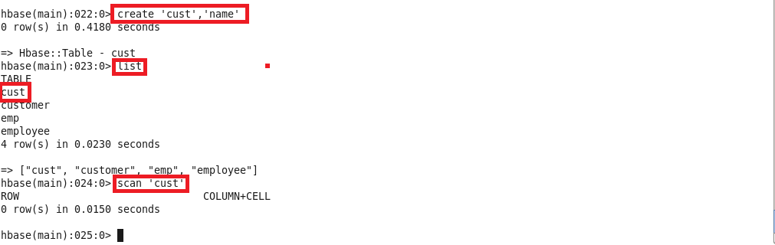

**Create table in hive and load the data and display the contents of the table:**

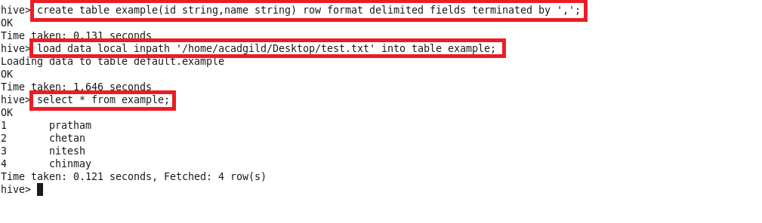

**Create external table and the loading the data from the above table:**

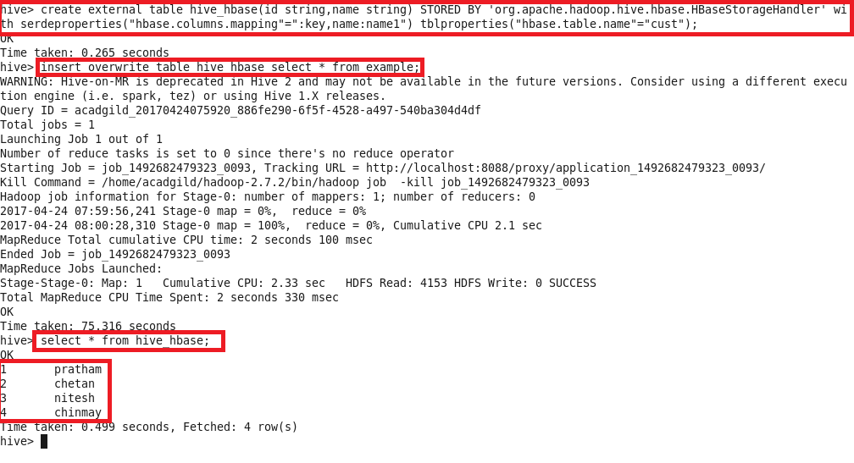

**Now scan the hbase table(data is loaded):**

