* Explain and perform Importing table contents from Mysql to Hive using Sqoop.

**Solution:**

**Creating table,inserting data,displaying the data**

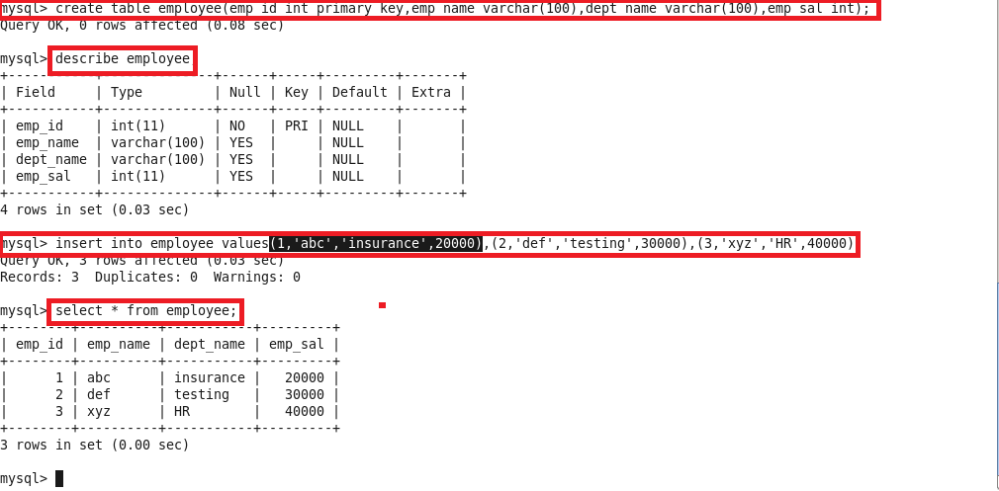

**Sqoop import command:**

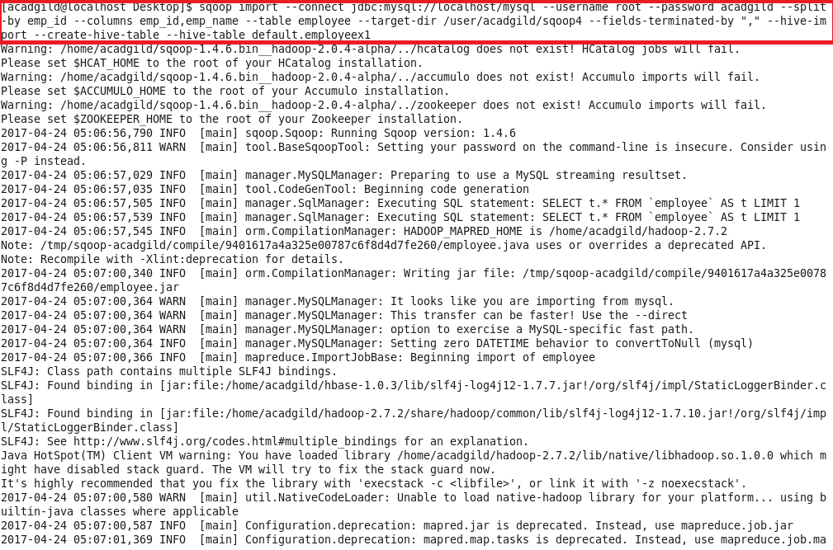

**Displaying the data of the table in hive**

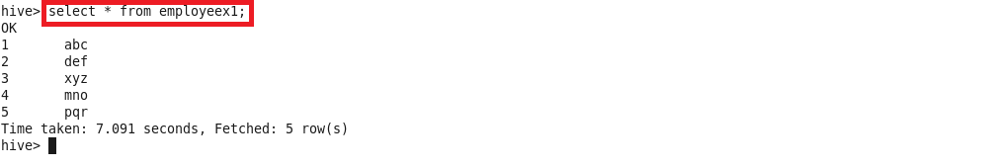

* Explain and perform Importing table contents from Mysql to HBase using Sqoop

**Solution:**

**Creating table,inserting data,displaying the data**



**Creating table in hbase:**

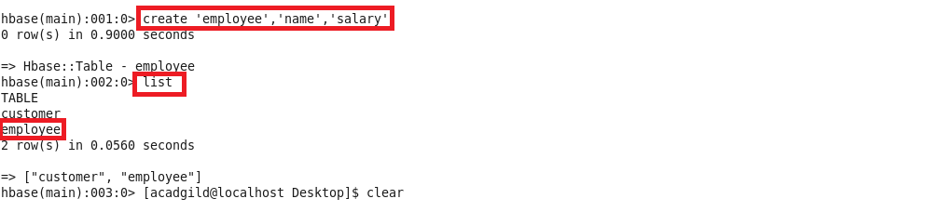

**Scoop import command for column name:**

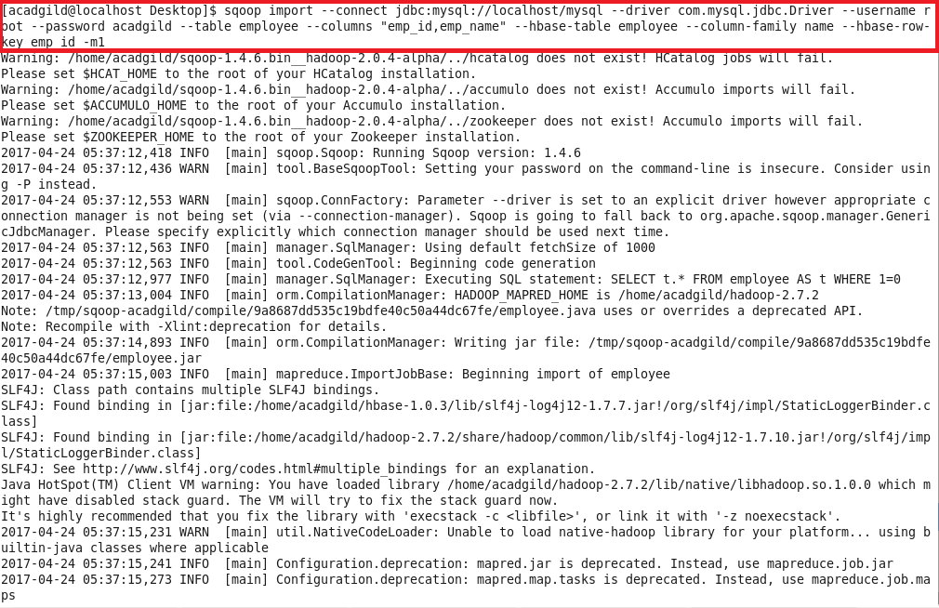

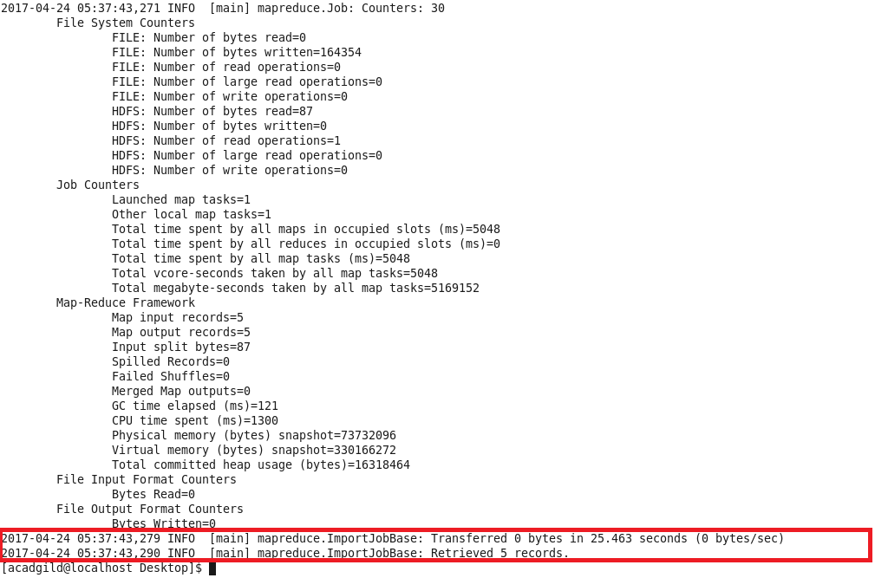

**Scoop import command for column salary:**

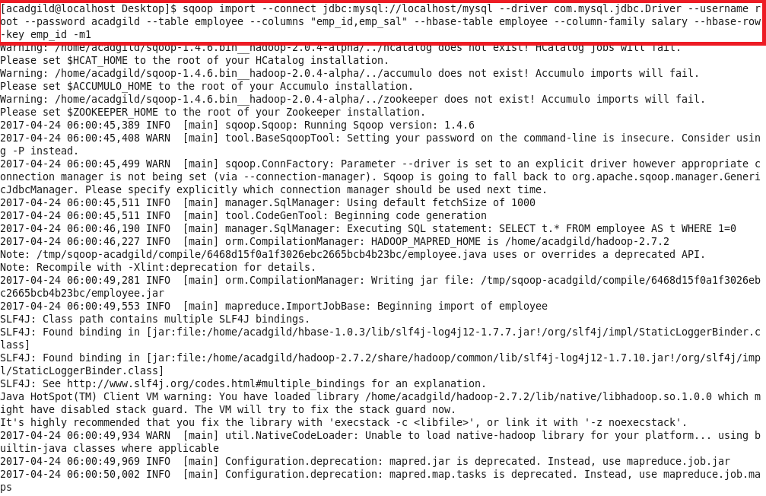

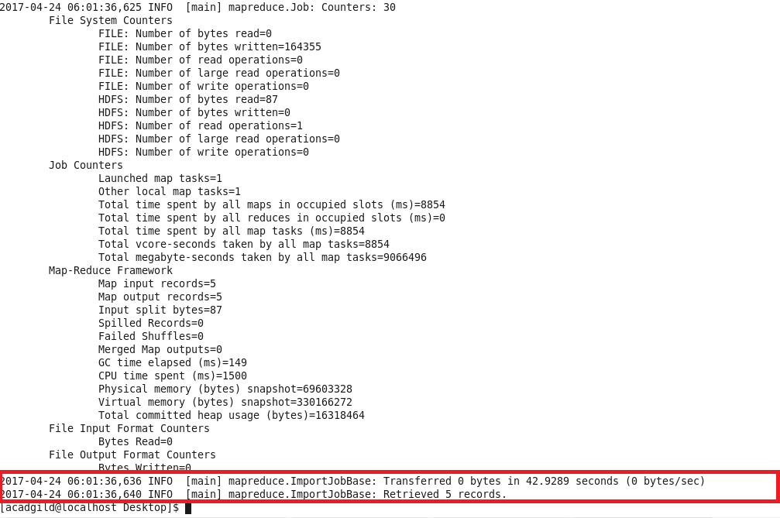

**Displaying the contents of the table in hbase:**

