Titanic Data Analysis

Write a mapreduce program to find out number of males and females survived in the titanic tragedy.

Download the Titanic data set from the below link Titanic_Dataset

DATA SET DESCRIPTION

Column 1 : PassengerId

Column 2 : Survived (survived=0 & died=1)

Column 3 : Pclass

Column 4 : Name

Column 5 : Sex

Column 6 : Age

Column 7 : SibSp

Column 8 : Parch

Column 9 : Ticket

Column 10 : Fare

Column 11 : Cabin

Column 12 : Embarked

Program:

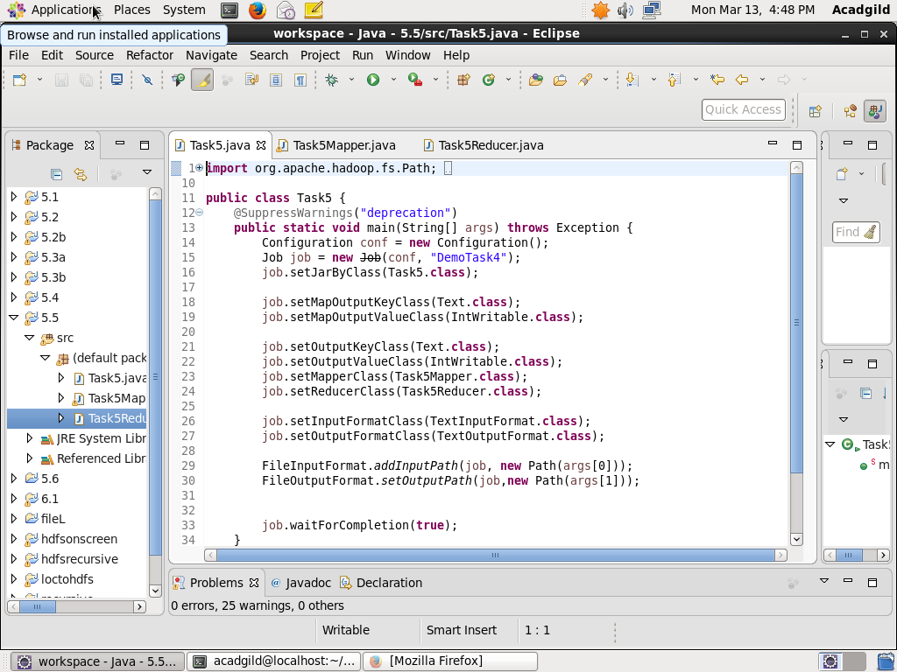

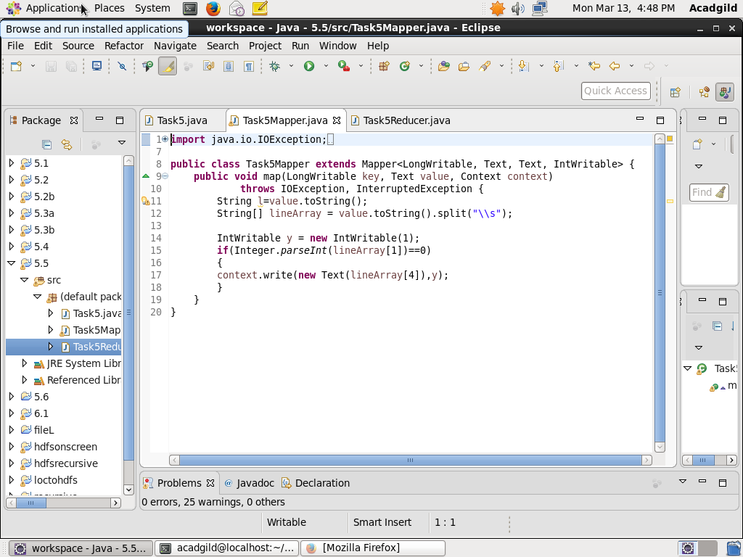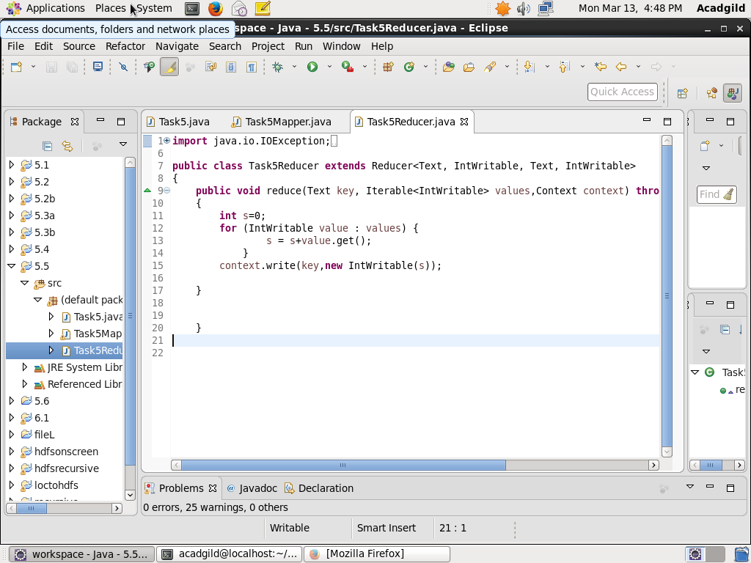

Output:

