Titanic Data Analysis

Write a mapreduce program to find out number of males and females died in the titanic tragedy and save the output in KeyValue Output format.

Download the Titanic data set from the below link Titanic_Dataset

DATA SET DESCRIPTION

Column 1 : PassengerId

Column 2 : Survived (survived=0 & died=1)

Column 3 : Pclass

Column 4 : Name

Column 5 : Sex

Column 6 : Age

Column 7 : SibSp

Column 8 : Parch

Column 9 : Ticket

Column 10 : Fare

Column 11 : Cabin

Column 12 : Embarked

Program:

Driver Class:

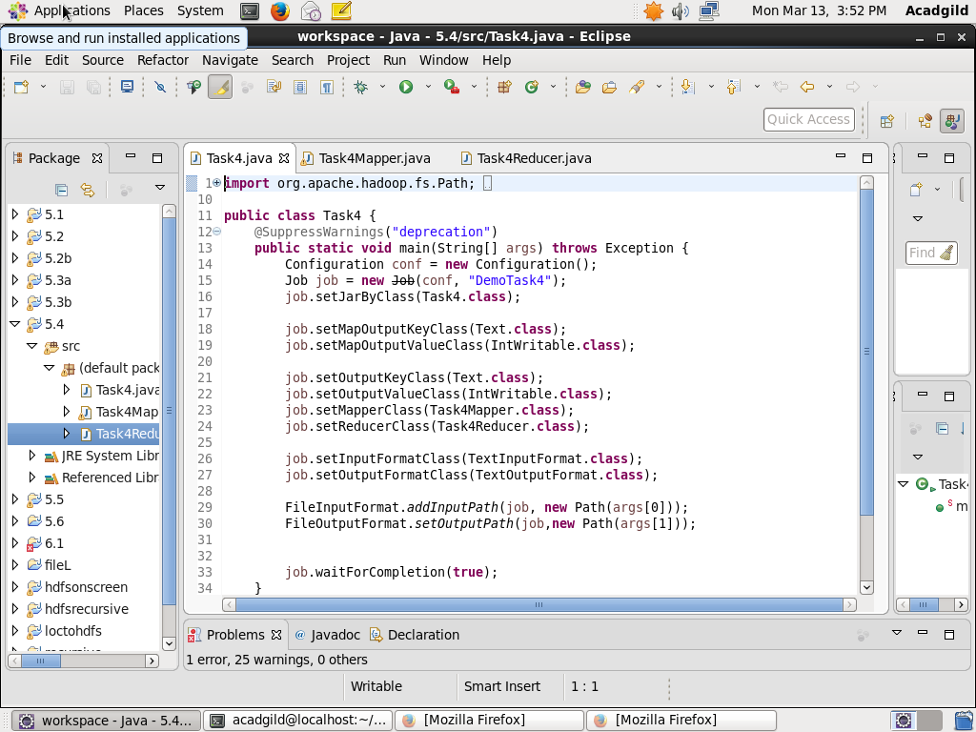

Mapper class:

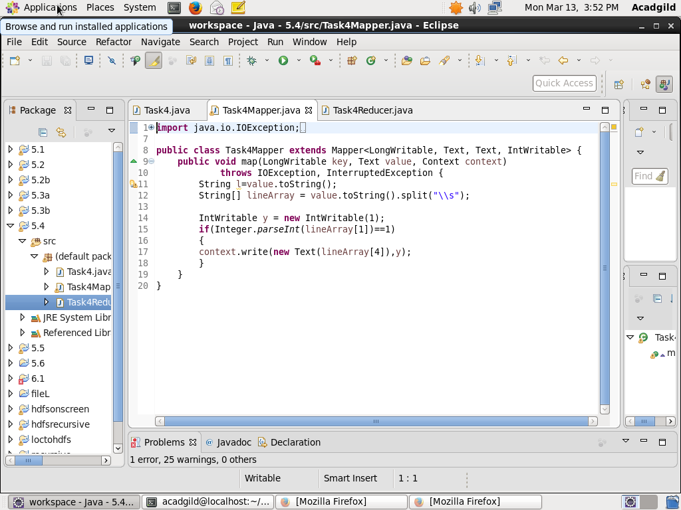

Reducer class:

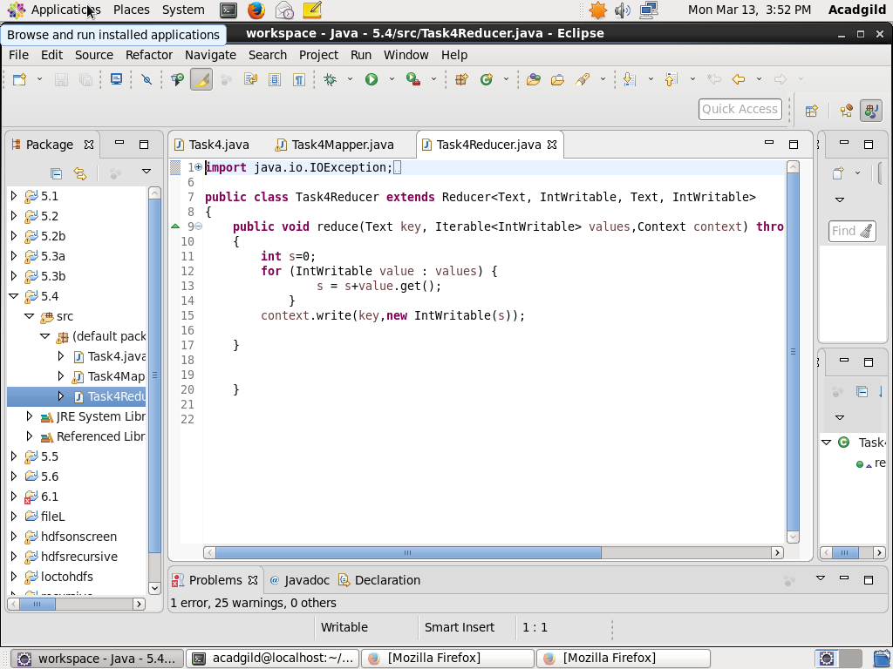

Output:

