Explain the working of below pig script commands with an example.

1. LOAD

A LOAD statement reads data from the file system

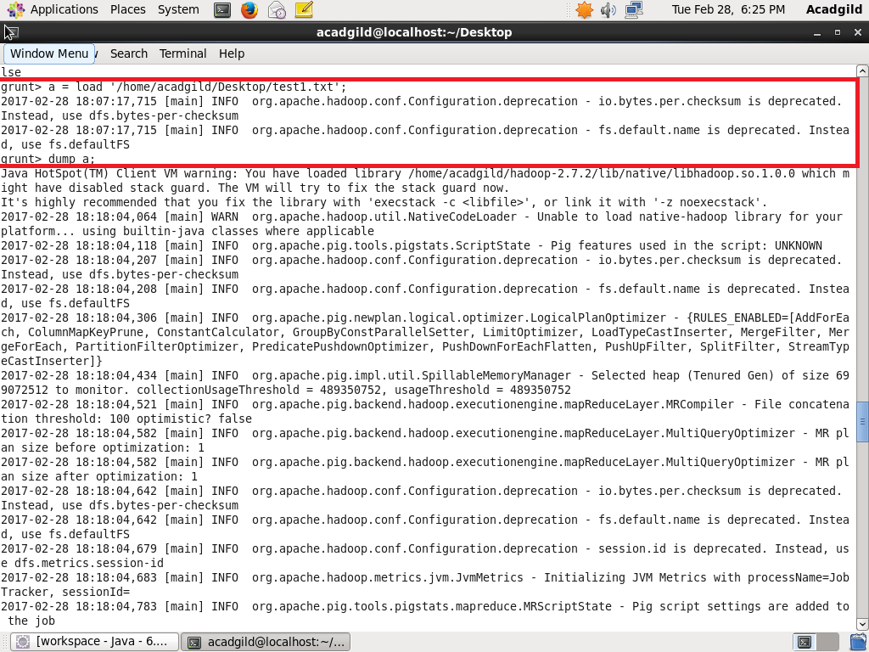

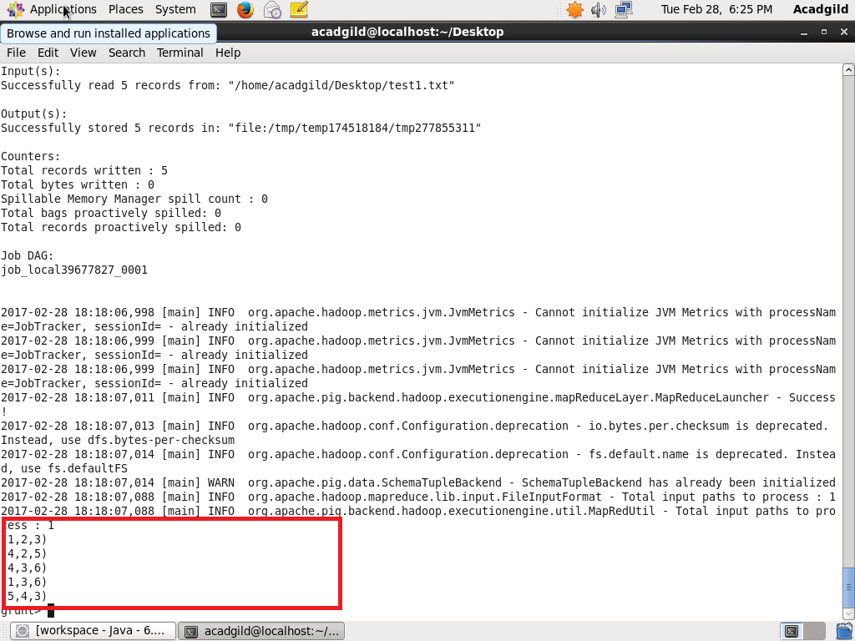

1. STORE

A STORE statement writes output to the file system.

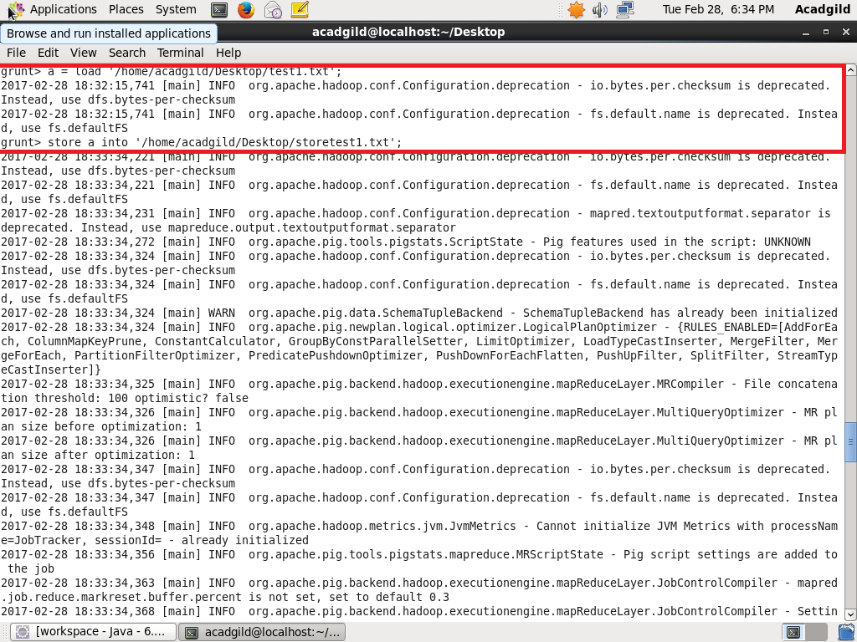

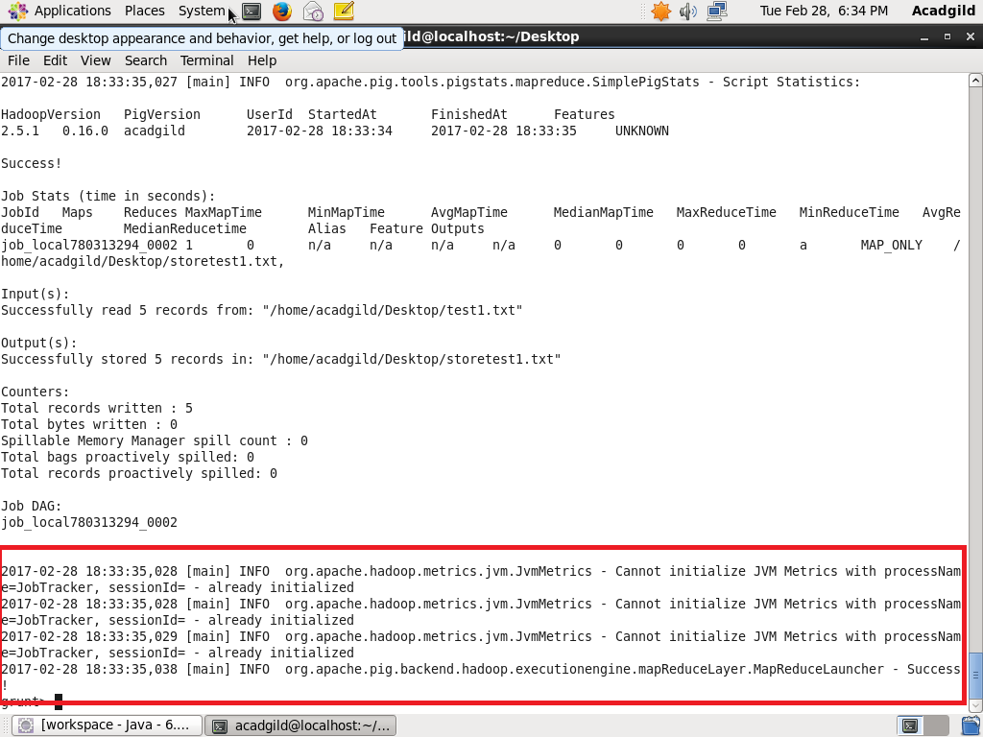

1. DUMP

A DUMP statement displays output to the screen.

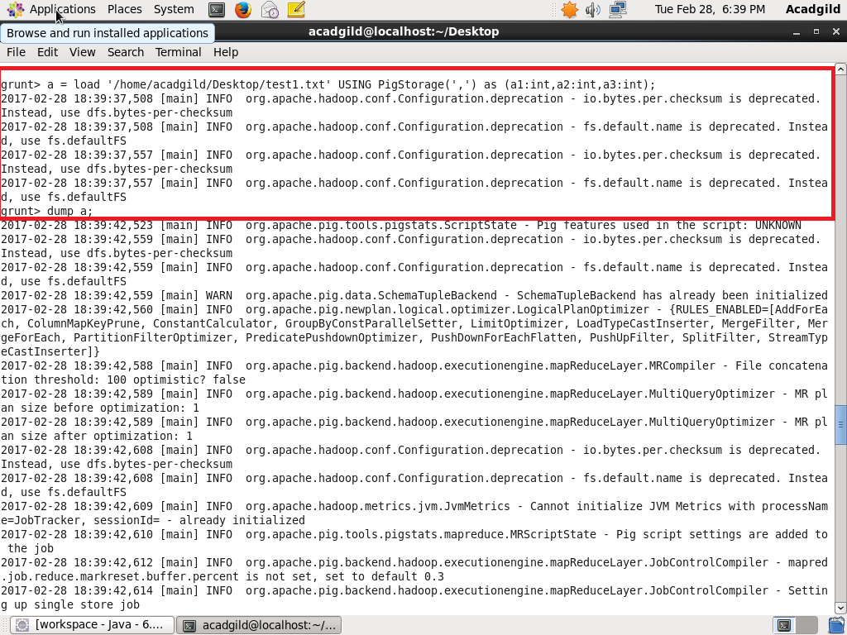

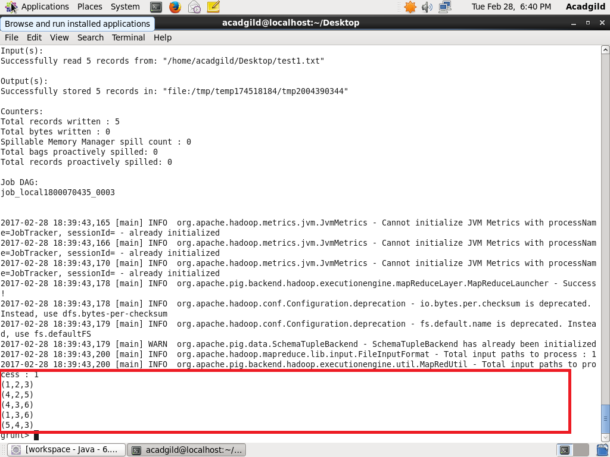

1. FOREACH

 The FOREACH operator is used to work with columns of data.

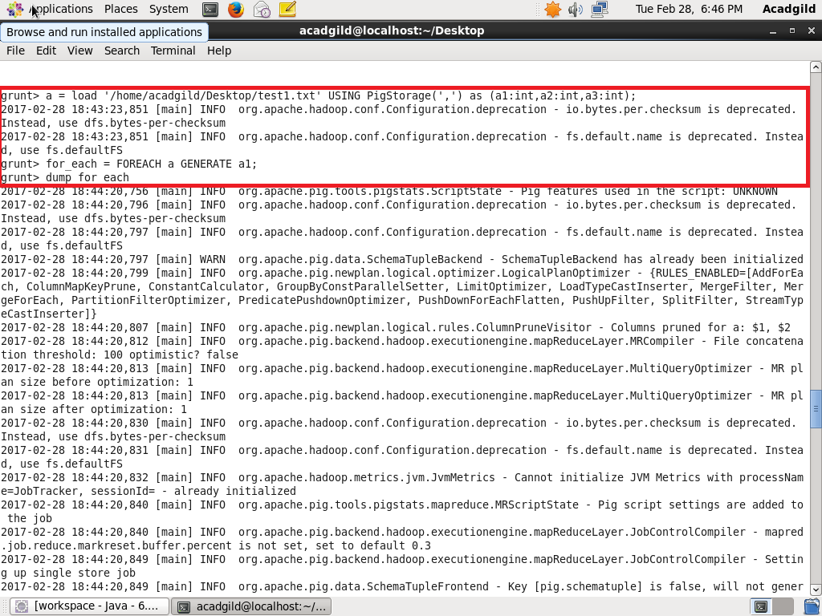

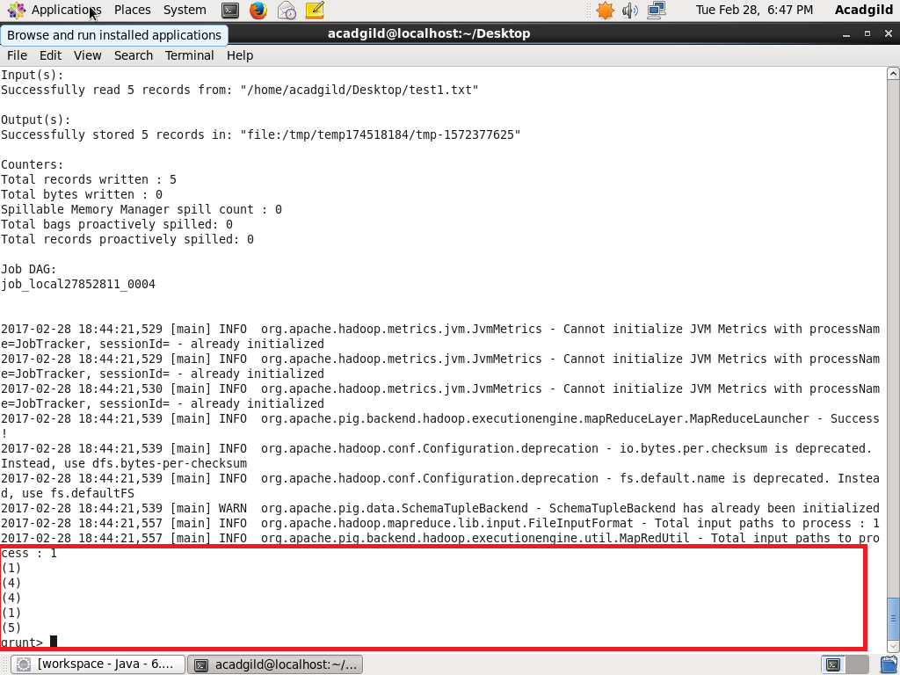

1. FILTER

The FILTER operator is used to work with tuples or rows of data.

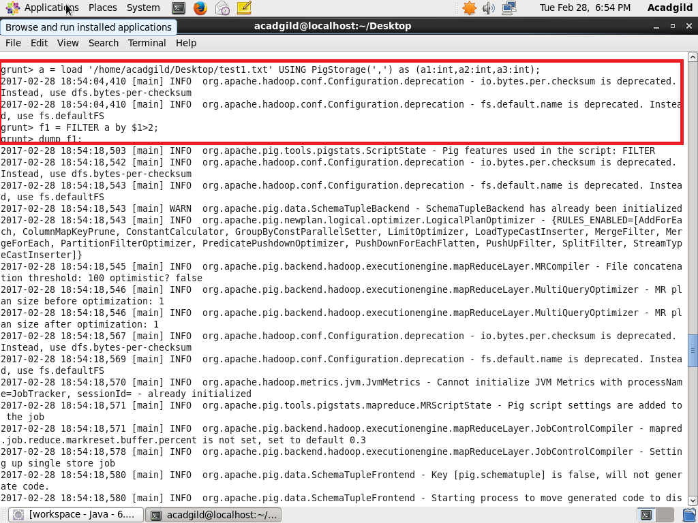

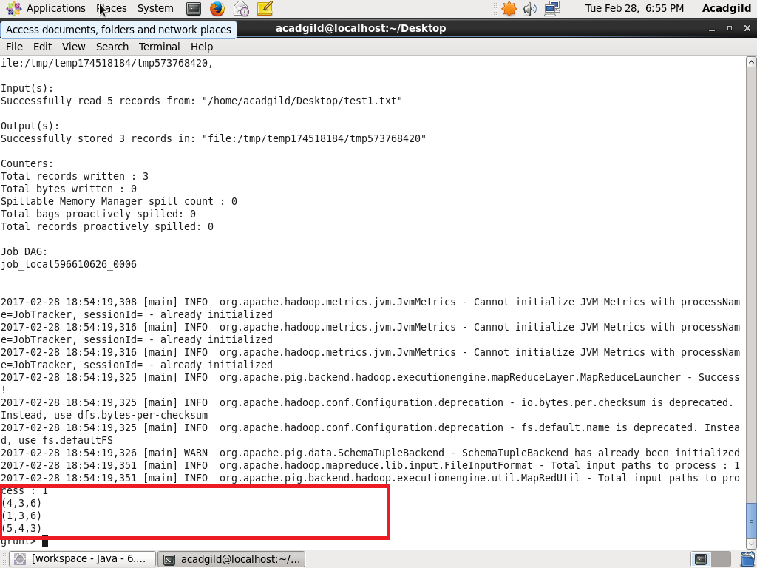

1. GROUPBY

The GROUPBY operator is used to group data in a single relation.

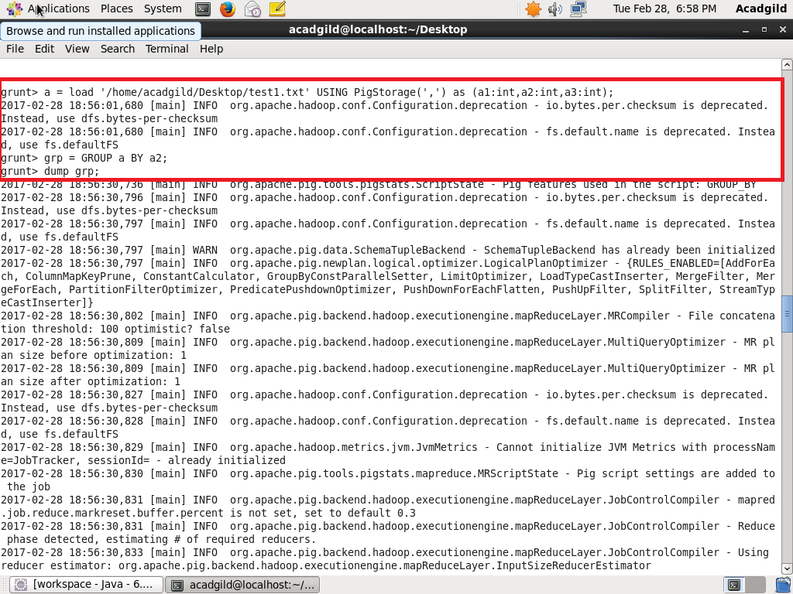

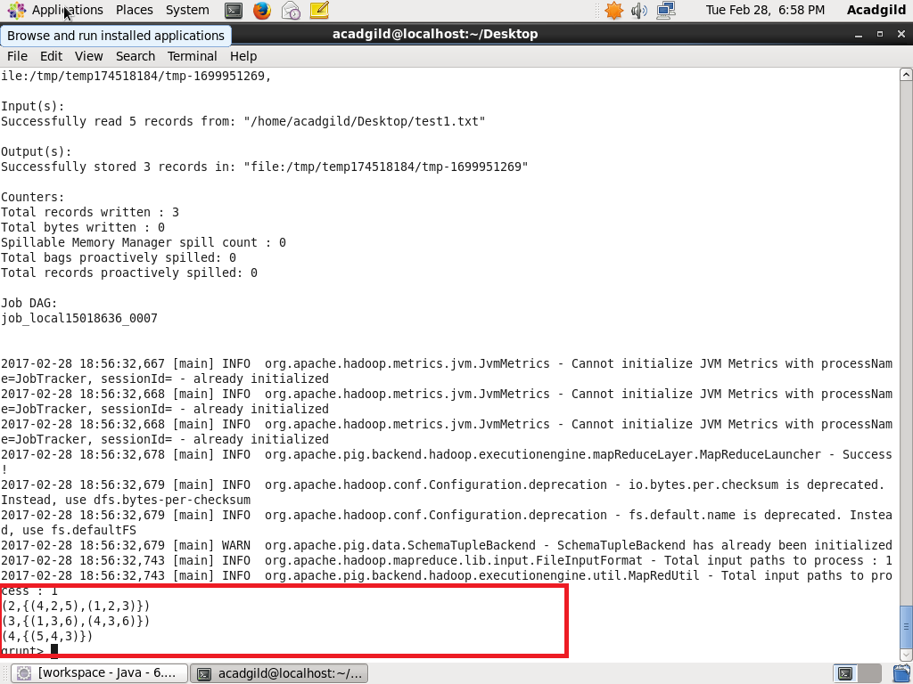

1. ORDERBY

The ORDERBY operator is used to order the data in a single relation.

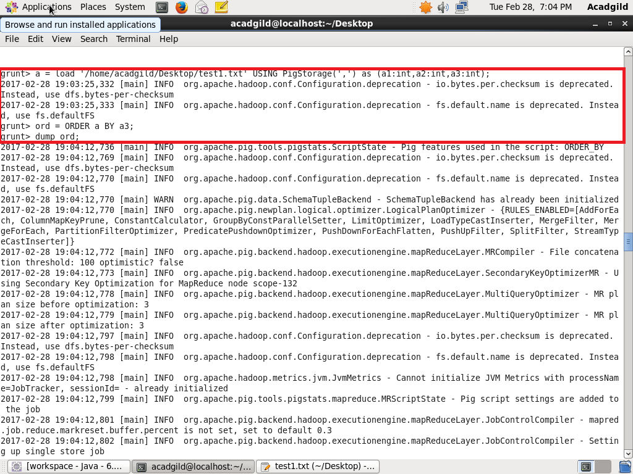

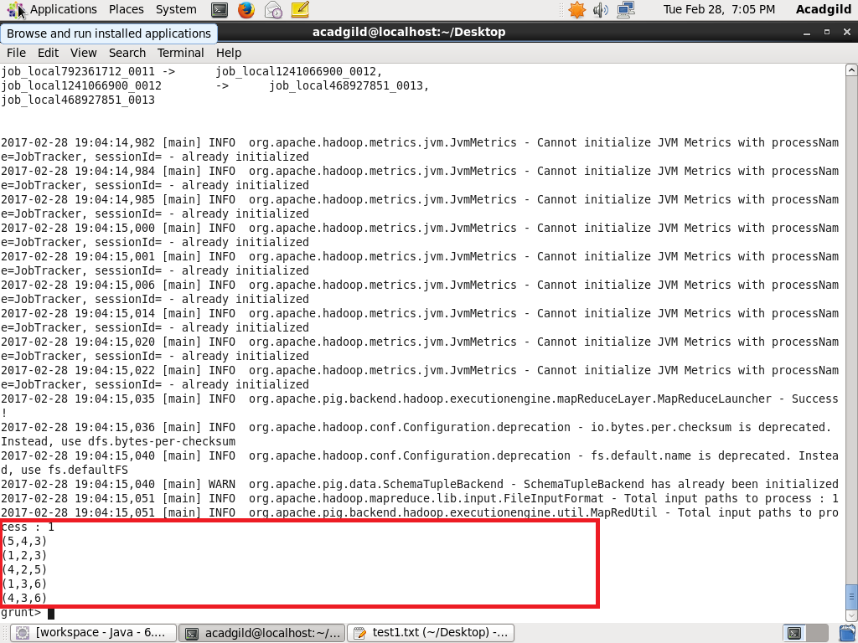

1. DESCRIBE

The describe operator is used to view the schema of a relation.

