**Problem Statement:**

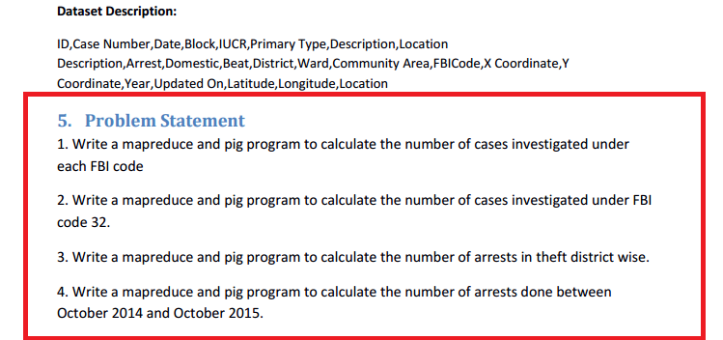

1. Write a mapreduce and pig program to calculate the number of cases investigated under each FBI code

**Solution:**

**-Map Reduce:-**

**Program:**

**Driver Class:**

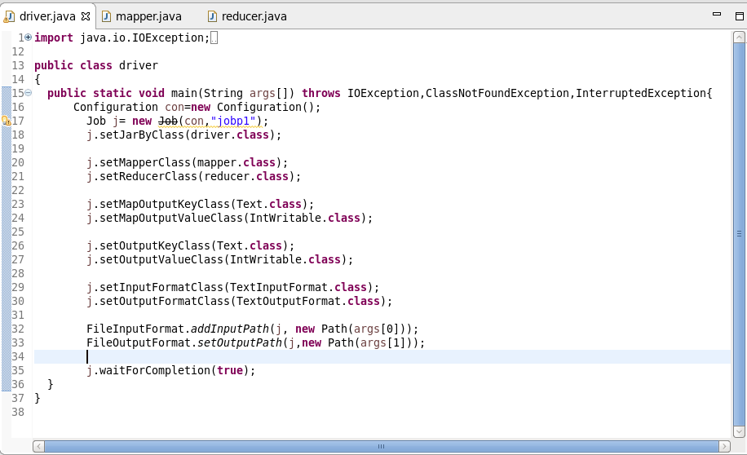

**Mapper Class:**

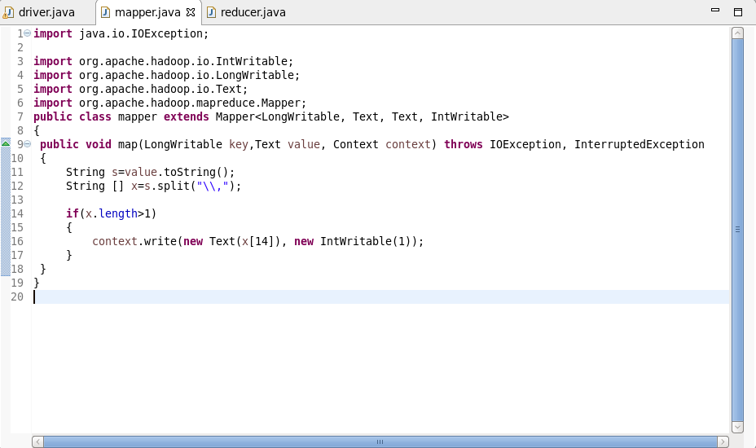

**Reducer Class:**

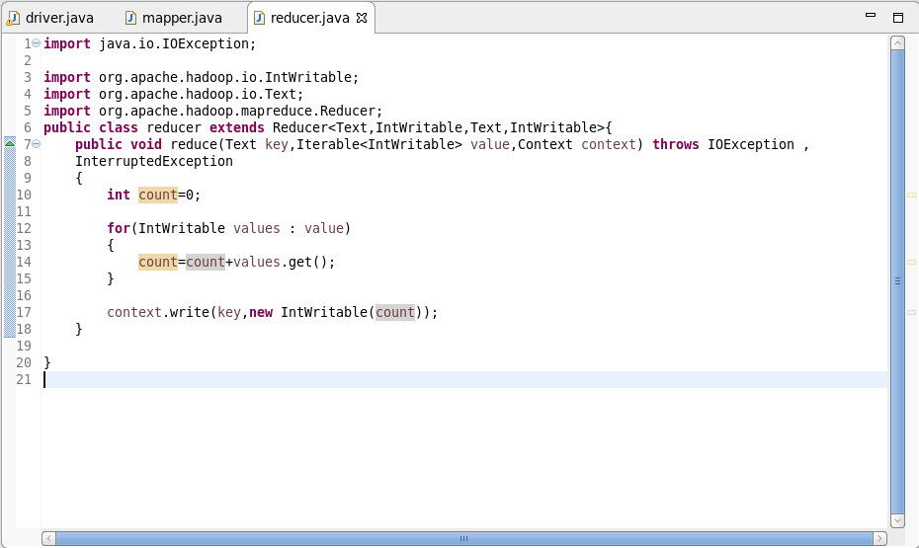

**Execution Command:**

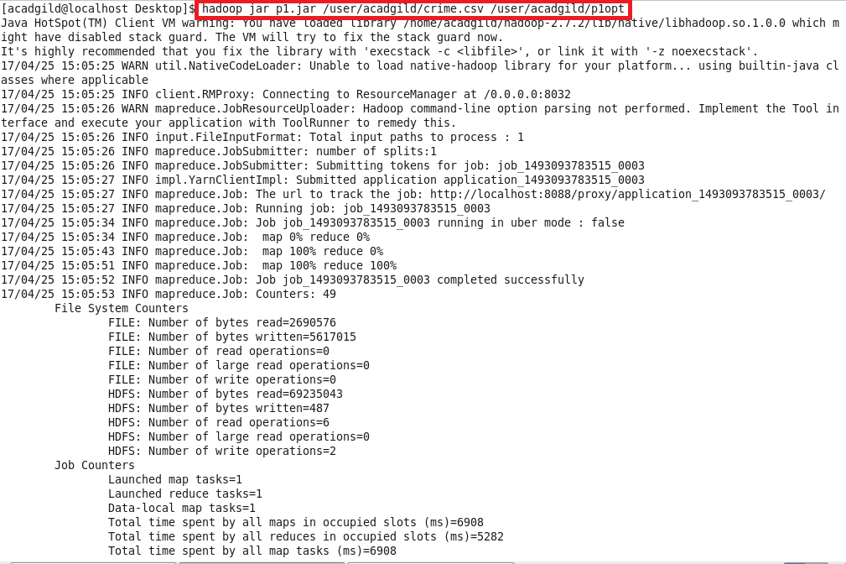

**Output:**

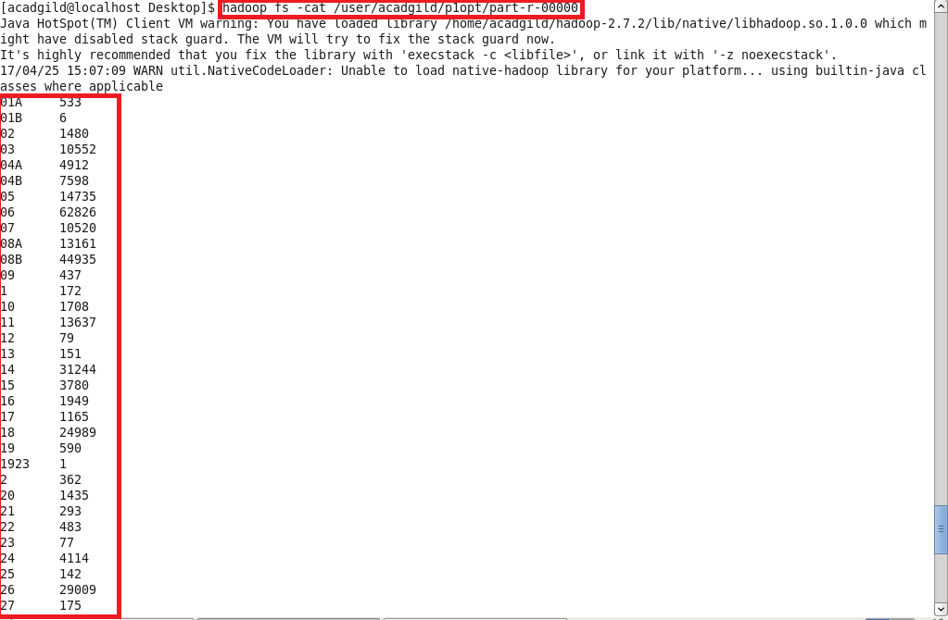



**-Pig :-**

**Program:**

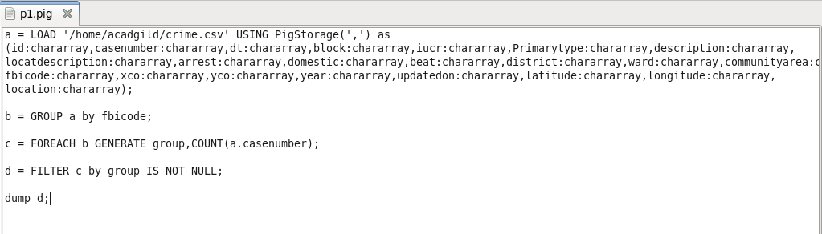

**Output:**

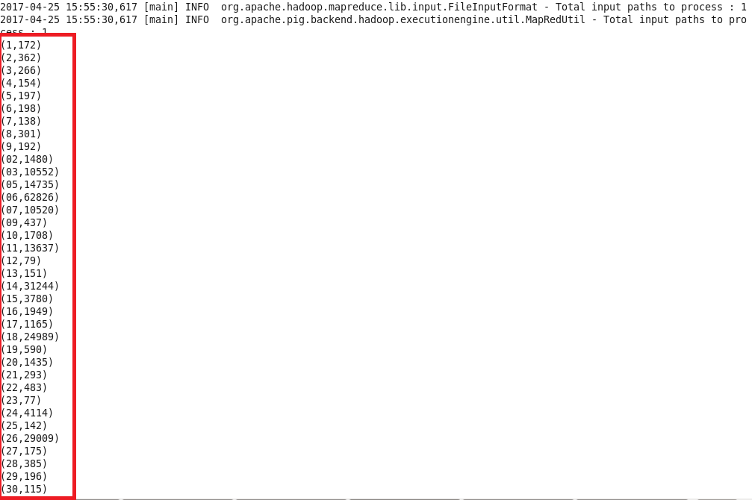

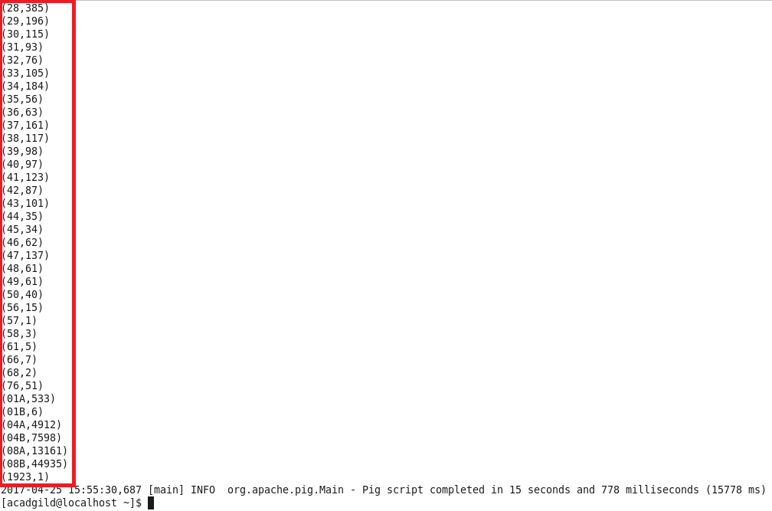

1. Write a mapreduce and pig program to calculate the number of cases investigated under FBI code 32.

**Solution:**

**-Map Reduce:-**

**Program:**

**Driver Class:**

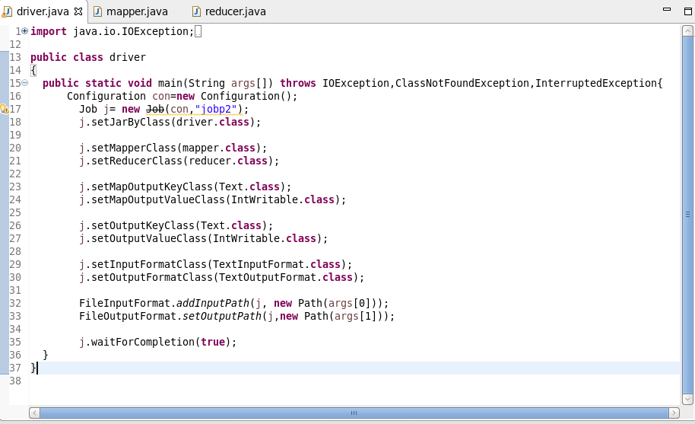

**Mapper Class:**

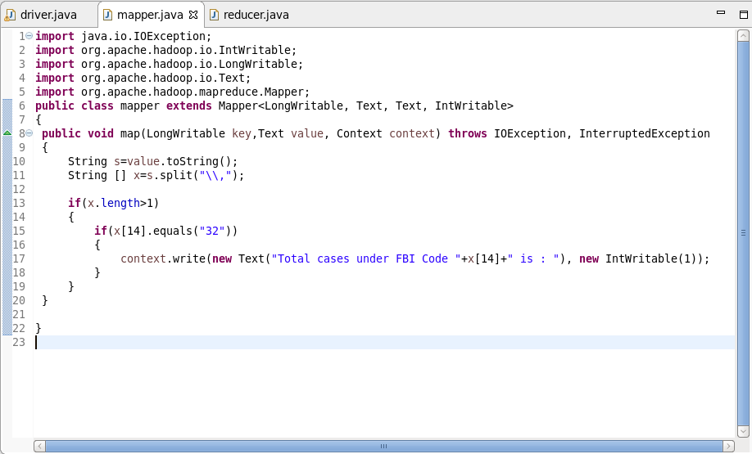

**Reducer Class:**

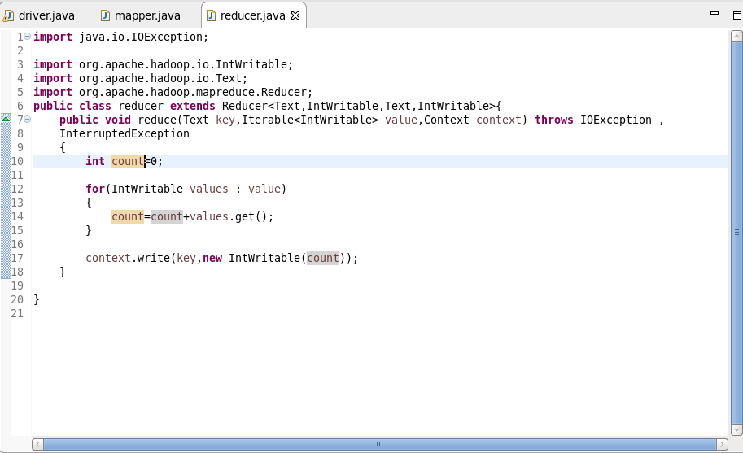

**Execution Command:**

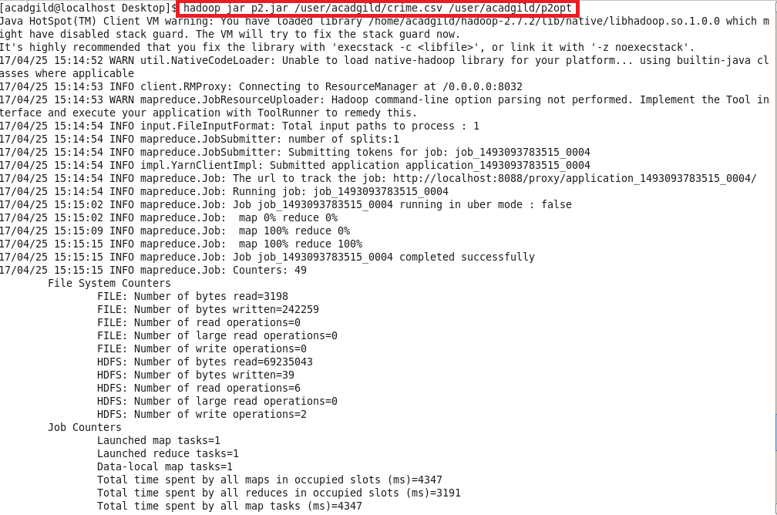

**Output:**

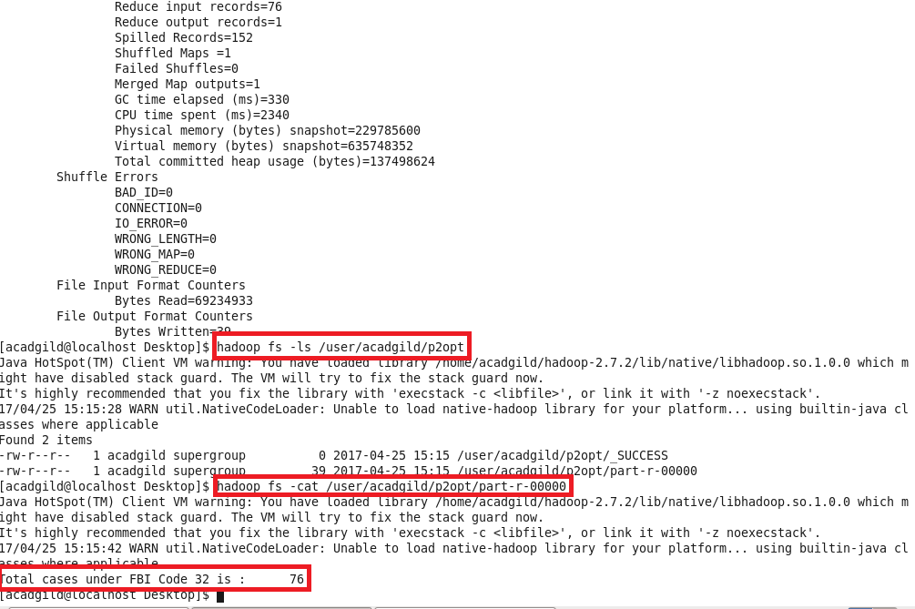

**-Pig:-**

**Program:**

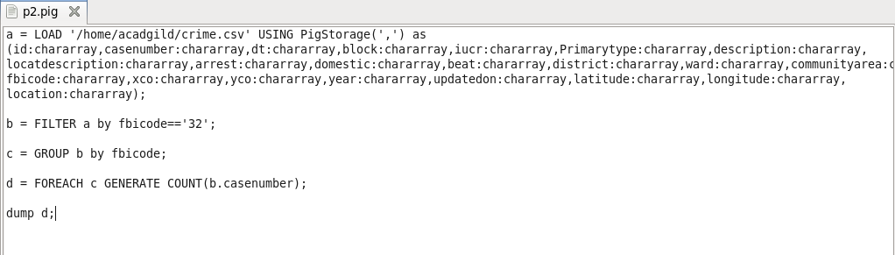

**Output:**

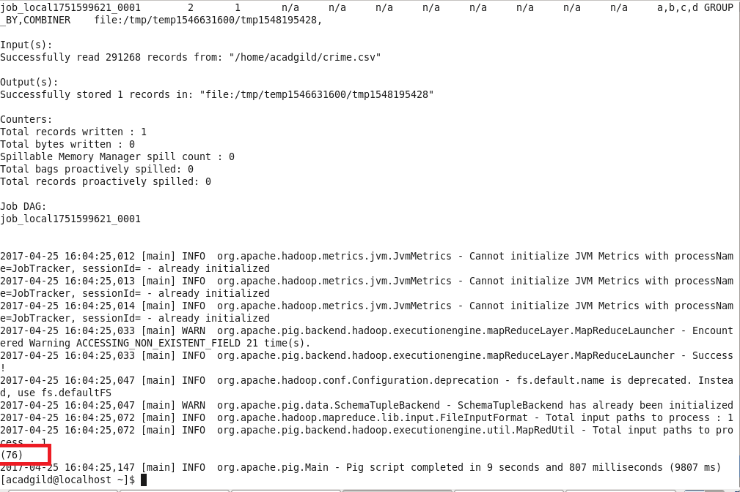

1. Write a mapreduce and pig program to calculate the number of arrests in theft district wise.

**Solution:**

**Program:**

**-Map Reduce:-**

**Driver Class:**

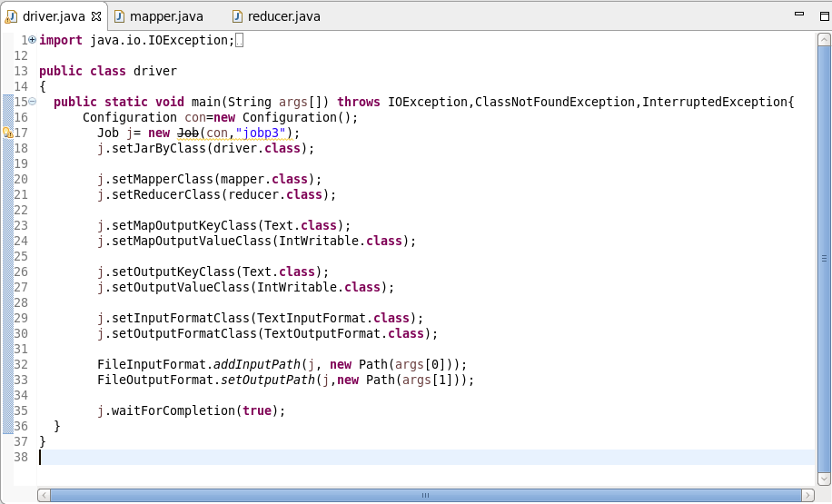

**Mapper Class:**

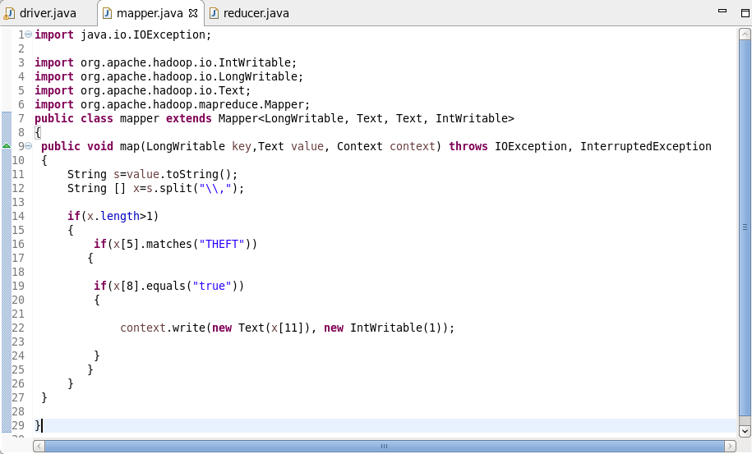

**Reducer Class:**

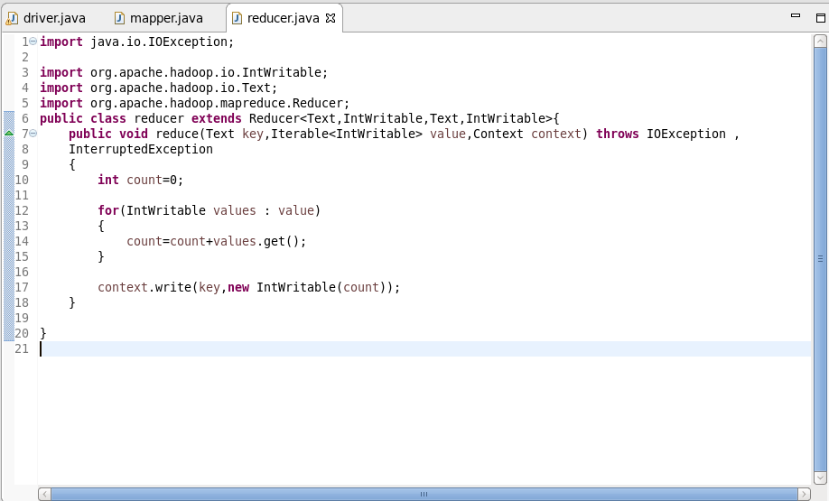

**Execution Command:**

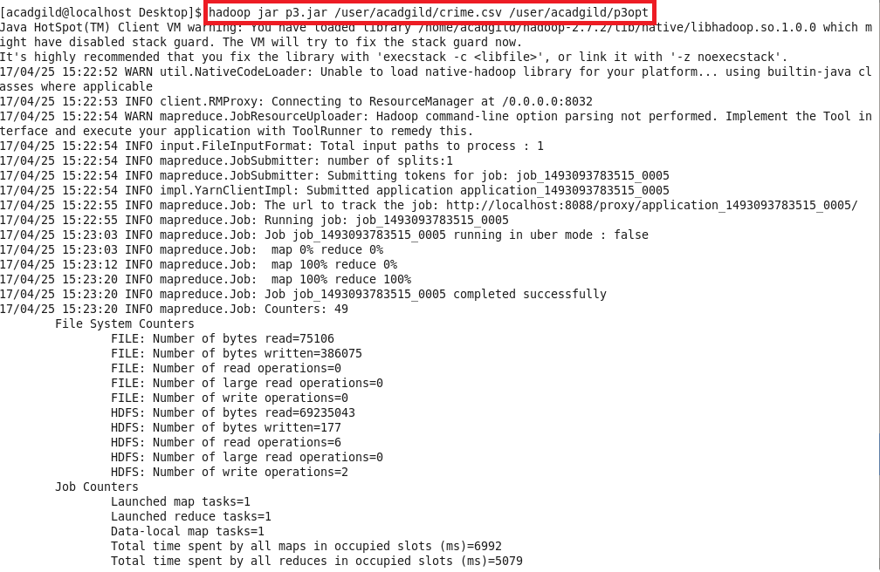

**Output:**

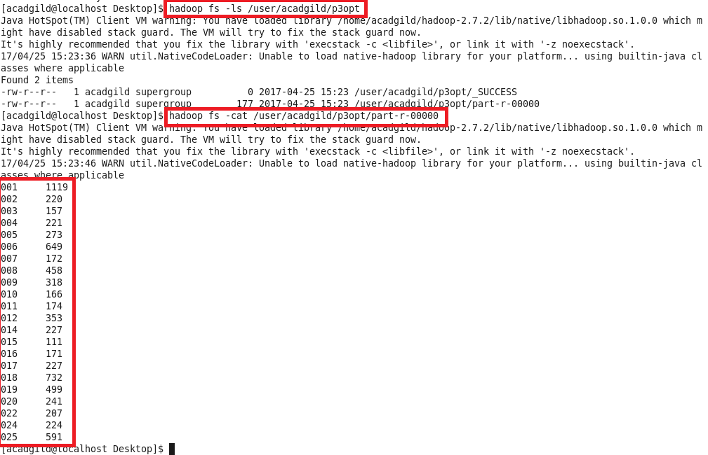

**-Pig:-**

**Program:**

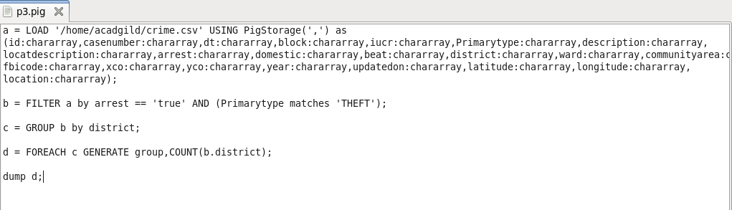

**Output:**

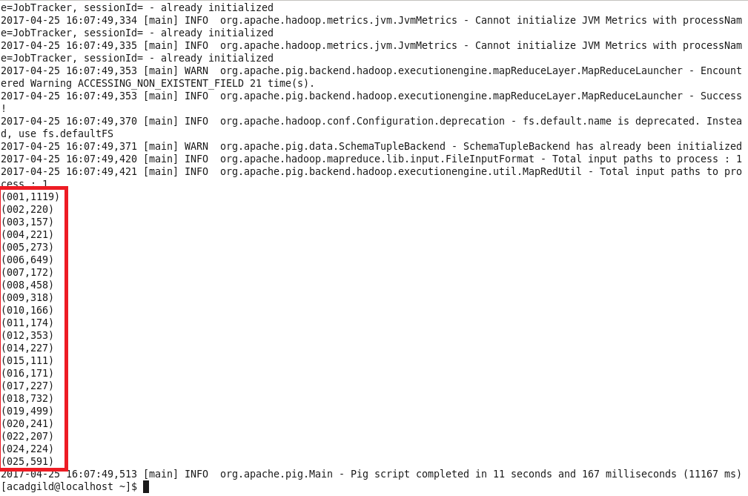

1. Write a mapreduce and pig program to calculate the number of arrests done between October 2014 and October 2015.

**Solution:**

**-Map Reduce:**

**Program:**

**Driver Class:**

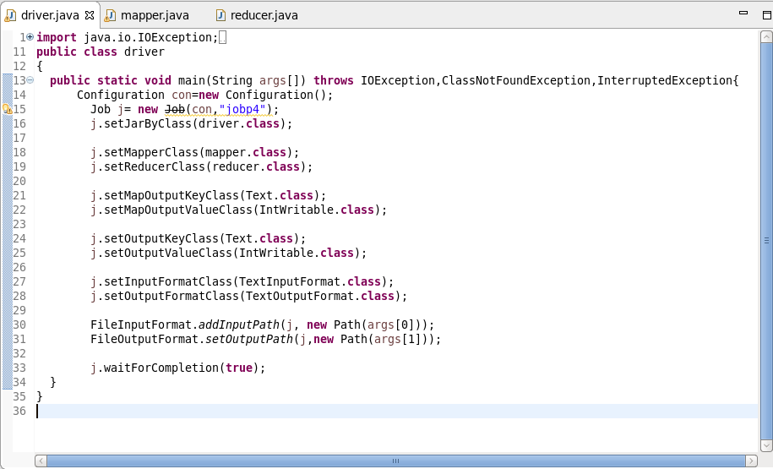

**Mapper Class:**

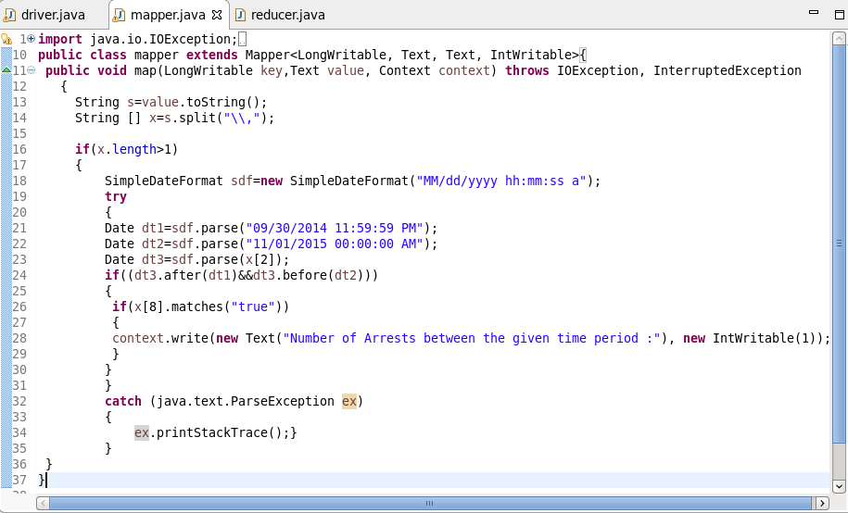

**Reducer Class:**

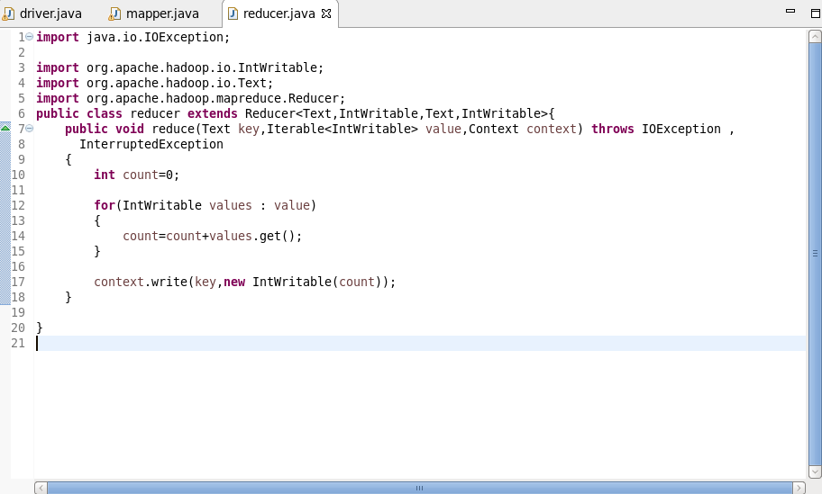

**Execution Command:**

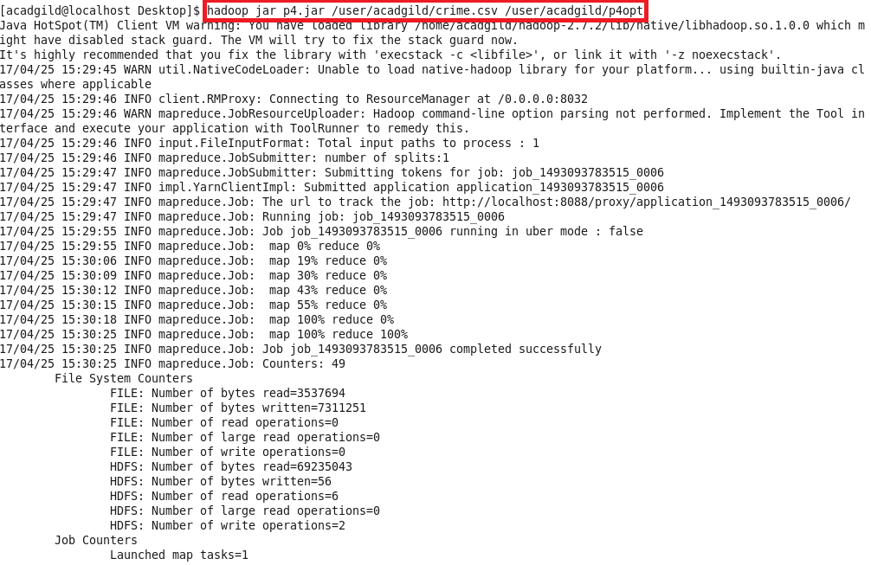

**Output:**

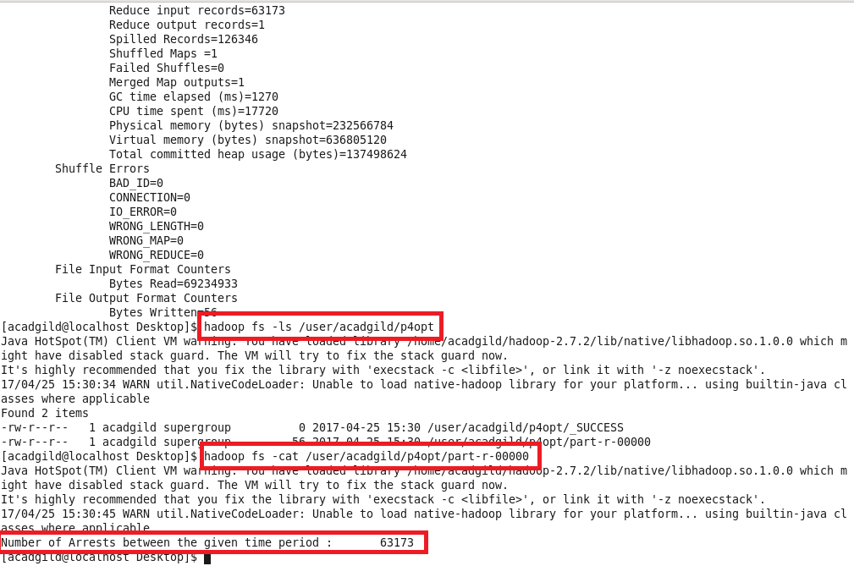

**-Pig:-**

**Program:**

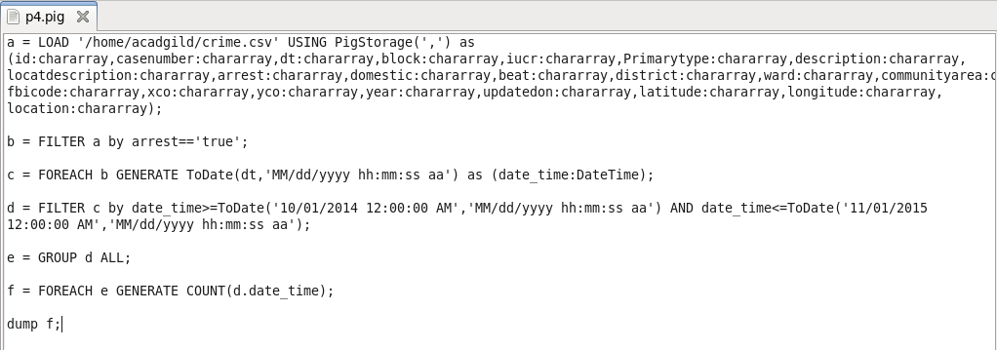

**Output:**

