**Problem Statement:**

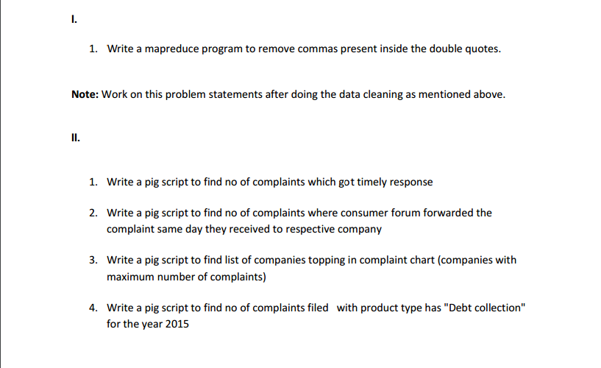

**Section-1:**

1 .Write a mapreduce program to remove commas present inside the double quotes.

**Solution:-**

**Program:**

**Driver Class:**

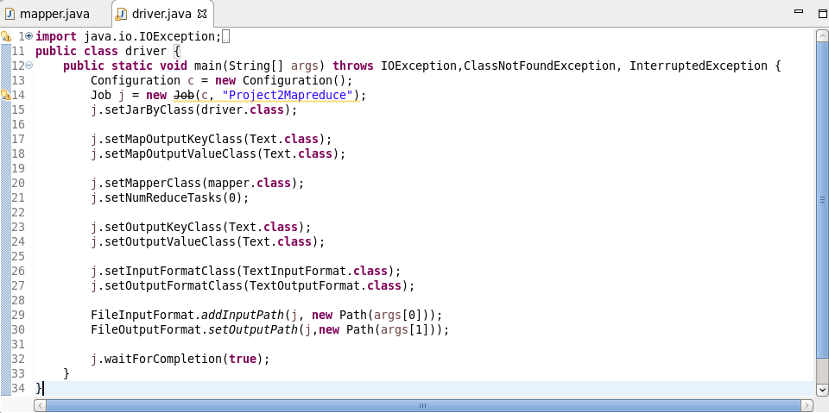

**Mapper Class:**

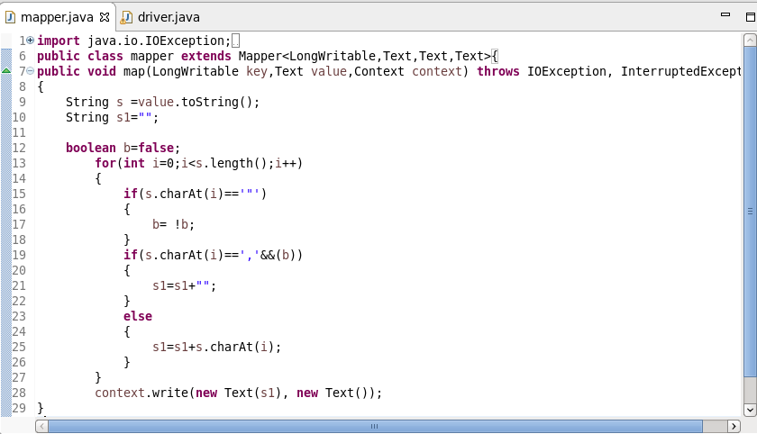

**Execution Command:**

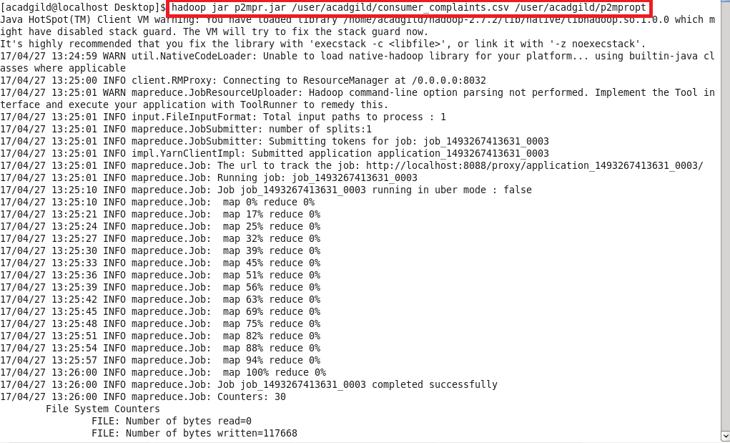

**Consumer_complaints.csv input file:**

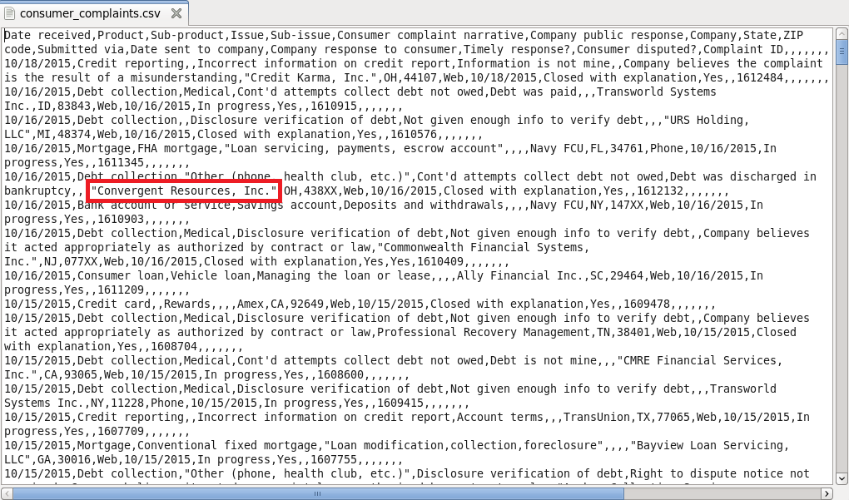

**Output:**

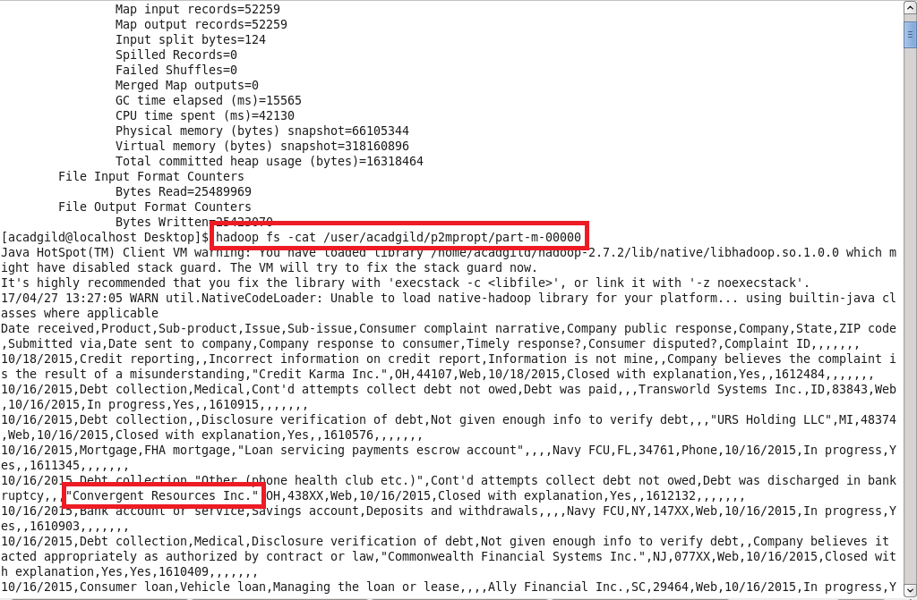

The commas within the double quotes are eliminated as shown in the output screenshot.

**Section-2:**

1. Write a pig script to find no of complaints which got timely response

**Program:**

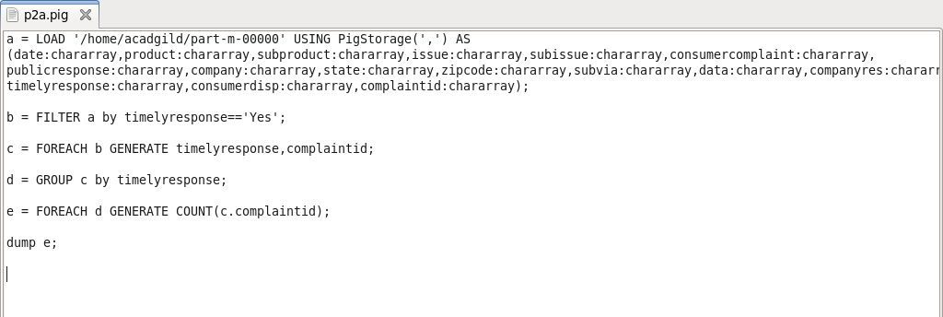

**Execution Command:**

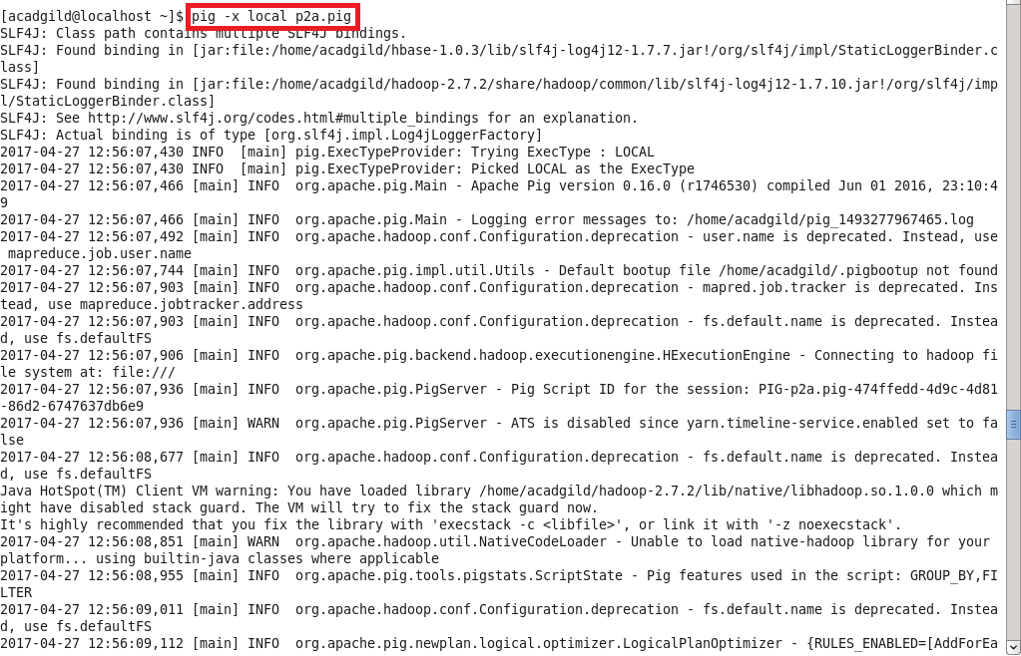

**Output:**

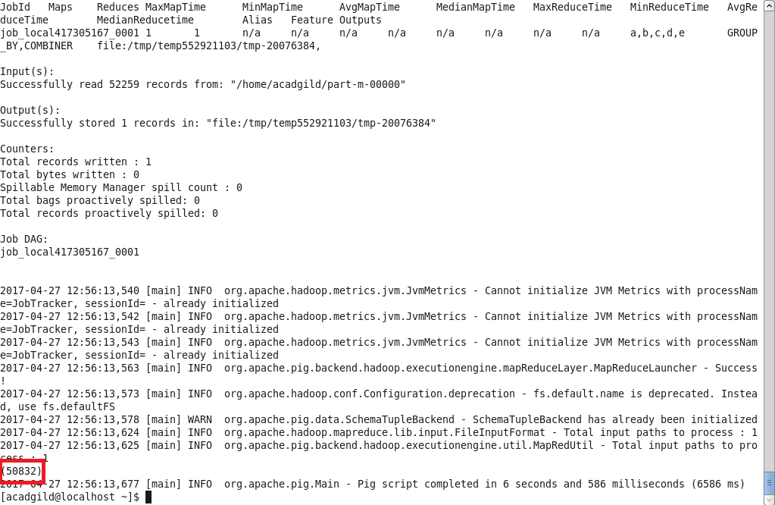

1. Write a pig script to find no of complaints where consumer forum forwarded the complaint same day they received to respective company

**Program:**

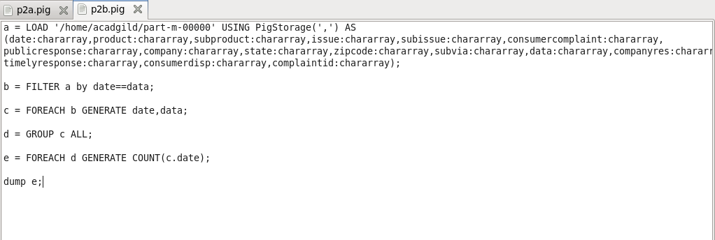

**Execution Command:**

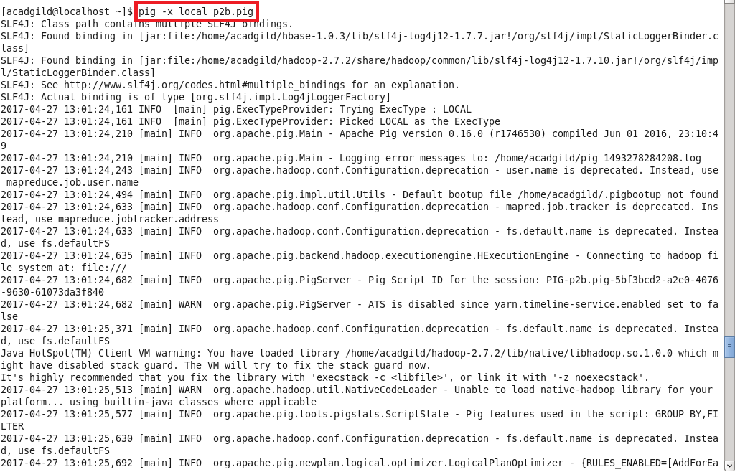

**Output:**

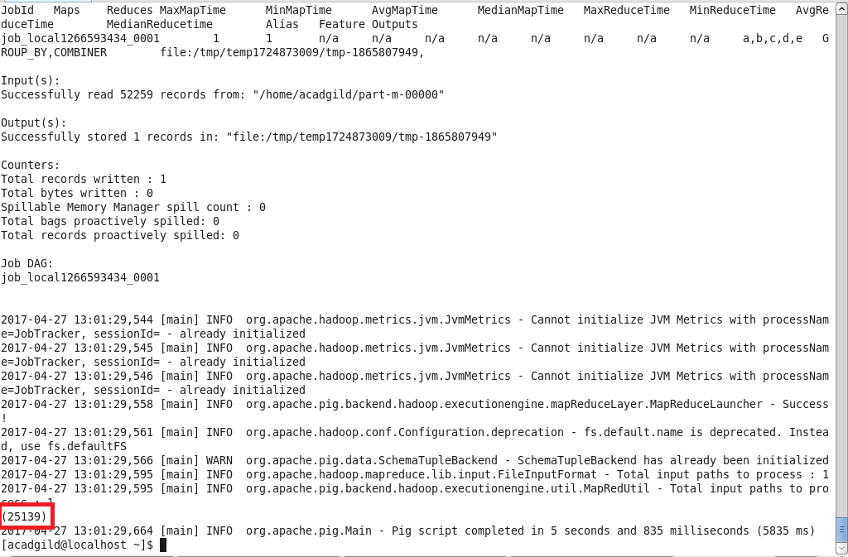

1. Write a pig script to find list of companies topping in complaint chart (companies with maximum number of complaints)

**Program:**

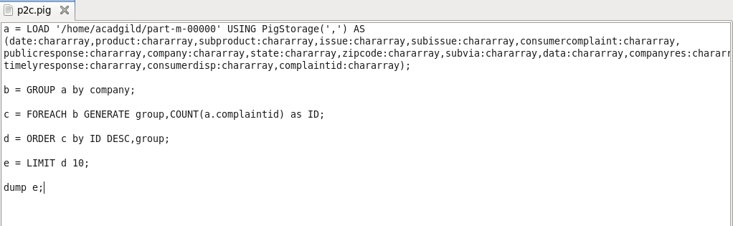

**Execution Command:**

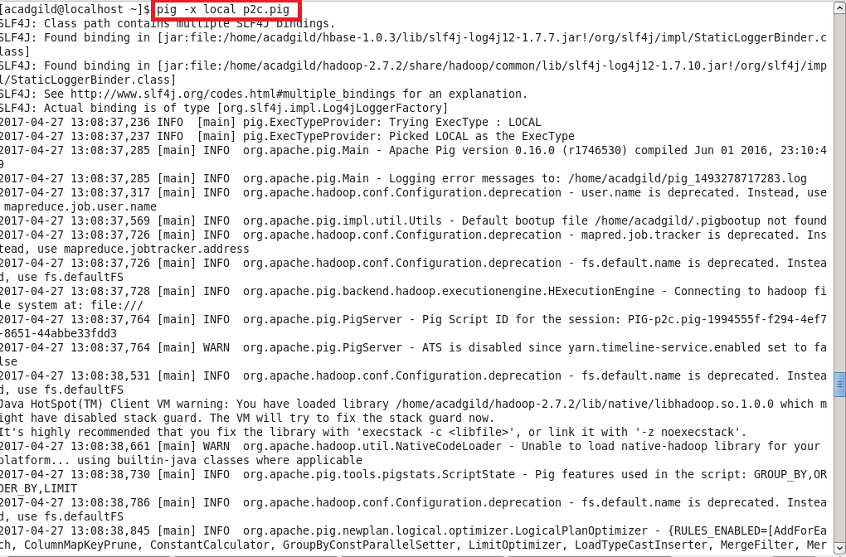

**Output:**

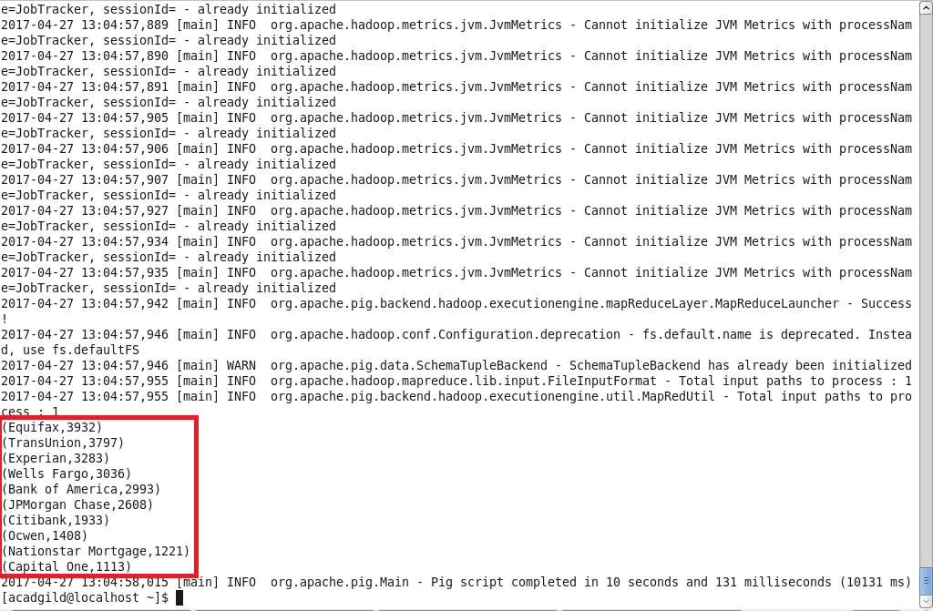

1. Write a pig script to find no of complaints filed with product type has "Debt collection" for the year 2015

**Program:**

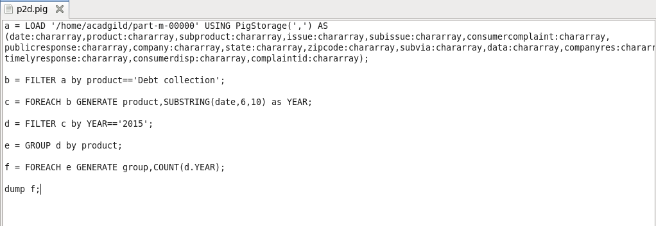

**Execution Command:**

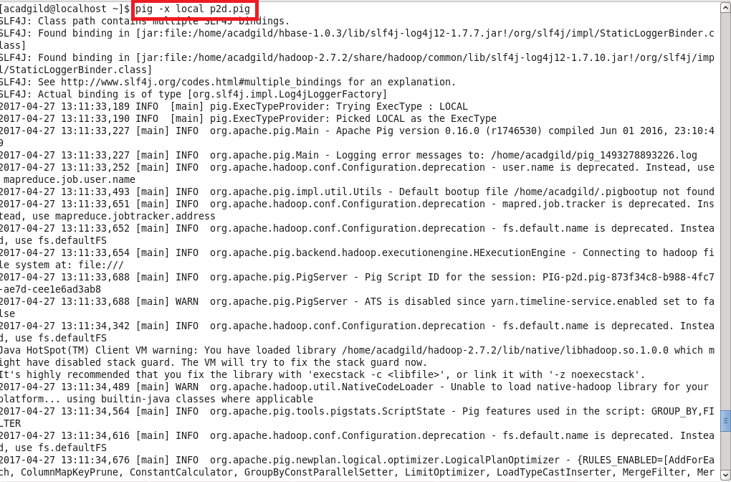

**Output:**

