SALES DATA ANALYSIS AND BUSINESS INSIGHTS
Prathamesh Jadhav

Abstract
This report looks at retail order data and uses Python to make the numbers easier to understand. The analysis covers sales, profit, profit margin, order volume, product categories, regions, monthly changes, and discount levels. Tables and charts were created from the data provided for this project. The dataset is for learning purposes, so the results should not be treated as the performance of a real company.

1. Introduction
Sales figures tell part of the story, but they do not always show whether a business is doing well. A product may sell a lot and still earn little profit. Looking at sales and profit together gives a clearer picture of which products and regions are performing well. This project uses the order data to build that picture through tables and charts.

2. Problem Statement
A large spreadsheet can be difficult to understand by looking at rows one by one. The project therefore checks the data, calculates a small set of key measures, compares different product groups and regions, and presents the results visually. This makes the main patterns easier to spot.

3. Objectives
- Inspect and prepare the supplied retail dataset.
- Check duplicate records, missing values, dates, and numeric fields.
- Calculate total sales, profit, profit margin, order count, quantity, and average sales per order.
- Compare sales and profit by category, region, and sub-category.
- Analyse monthly sales and profit trends.
- Compare profitability across discount bands.
- Create charts, export summary tables, and make evidence-based recommendations.

4. Dataset Description
The dataset contains order-level details such as order dates, shipping dates, customer segments, regions, product categories, sales, quantity, discount, and profit. These fields make it possible to compare different parts of the business and follow changes over time. The data is a fictional sample commonly used for practice and learning.

5. Tools and Technologies
- Python — analysis workflow and calculations.
- pandas — loading, cleaning, grouping, and exporting data.
- NumPy — numeric calculations and safe ratios.
- Matplotlib — visualisations.
- python-docx — generation of this report.

6. Methodology
- Loaded the CSV file and inspected its shape and column names.
- Converted sales, profit, quantity, and discount fields to numeric values where available.
- Parsed order and ship dates using date conversion with invalid values coerced to missing.
- Removed 0 exact duplicate rows, leaving 10,194 records for analysis.
- Calculated KPIs from the cleaned data and grouped records by category, region, sub-category, month, and discount band.
- Generated PNG charts and CSV summary tables for reproducibility.
- Interpreted observed patterns descriptively; no causal relationship is claimed.

7. Key Performance Indicators (KPIs)
Metric | Calculated result
Rows in original file | 10,194
Columns in original file | 21
Exact duplicate rows removed | 0
Rows after duplicate removal | 10,194
Unique orders | 5,111
Total sales | $2,326,534.35
Total profit | $292,296.81
Overall profit margin | 12.56%
Total quantity | 38,654
Average sales per order | $455.20
Average profit per order | $57.19
Missing cells after duplicate removal | 0

Formula notes: Total Sales = sum of Sales; Total Profit = sum of Profit; Profit Margin = Total Profit ÷ Total Sales; Average Sales per Order = Total Sales ÷ number of distinct Order IDs. Ratios are undefined if their denominator is zero.

8. Category Performance
Category | Sales | Profit | Profit margin
Technology | $839,893.28 | $146,543.38 | 17.45%
Furniture | $754,747.76 | $19,730.00 | 2.61%
Office Supplies | $731,893.31 | $126,023.44 | 17.22%

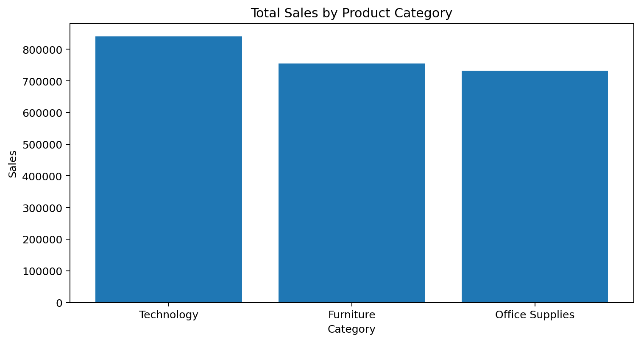
Figure 1. Total sales by product category.
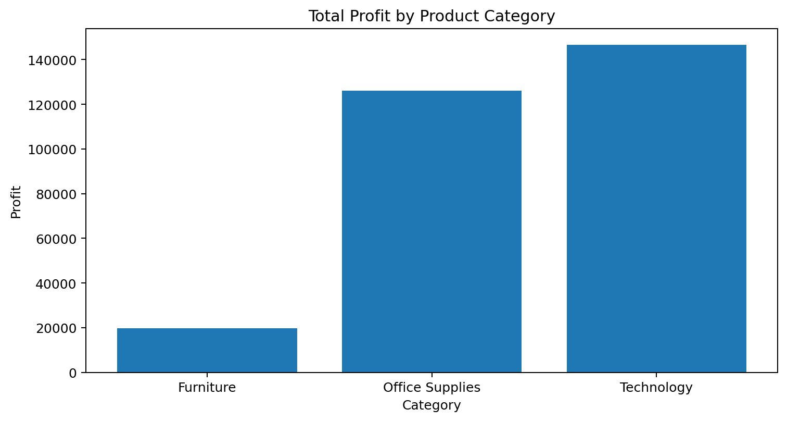
Figure 2. Total profit by product category.
The highest-sales category is Technology with $839,893.28 in sales. The highest-profit category is Technology with $146,543.38 in profit. The lowest-profit category is Furniture with $19,730.00 in profit.

9. Regional Performance
Region | Sales | Profit | Profit margin
West | $739,813.61 | $110,798.82 | 14.98%
East | $691,828.17 | $94,883.26 | 13.71%
Central | $503,170.67 | $39,865.31 | 7.92%
South | $391,721.90 | $46,749.43 | 11.93%

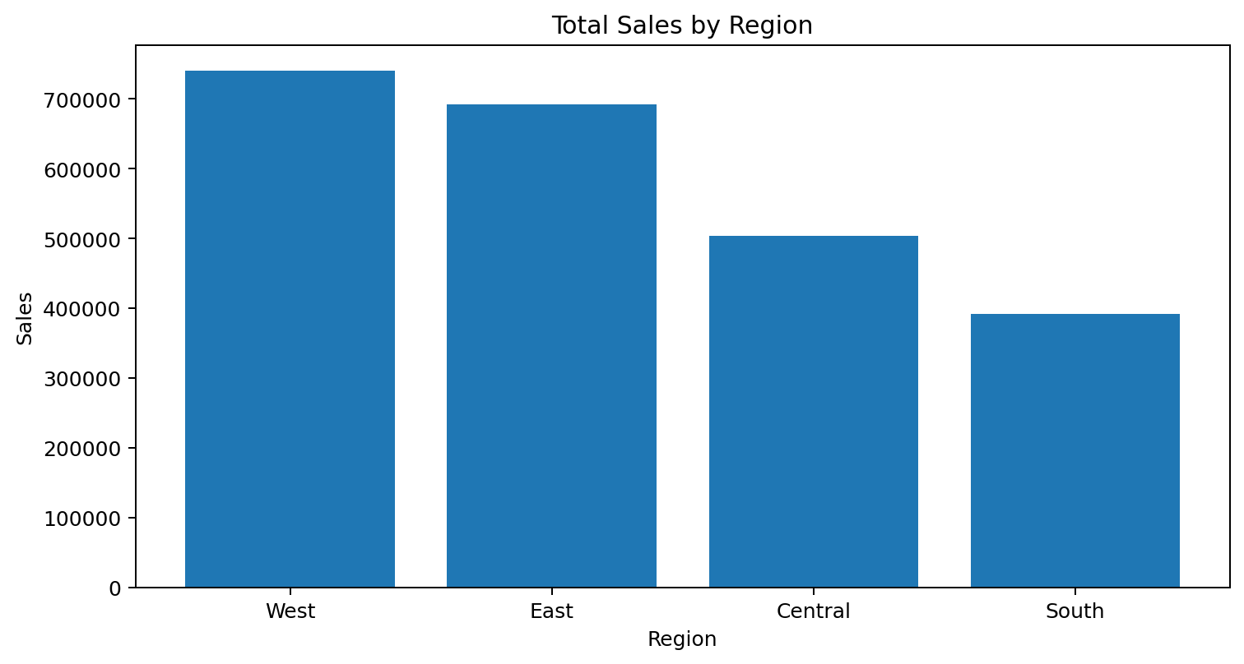
Figure 3. Total sales by region.
The region with the highest sales is West ($739,813.61). The region with the highest total profit is West ($110,798.82). Regional differences should be reviewed alongside product mix, customer segment, discounting, and operating costs.

10. Sub-Category Profitability
Lowest-profit sub-categories | Sales | Profit | Profit margin
Tables | $208,020.18 | $-17,753.21 | -8.53%
Bookcases | $115,361.20 | $-3,632.07 | -3.15%
Supplies | $46,725.50 | $-1,171.39 | -2.51%
Fasteners | $8,532.24 | $2,428.64 | 28.46%
Machines | $189,925.03 | $3,461.98 | 1.82%
Labels | $12,695.04 | $5,572.78 | 43.90%
Art | $27,659.01 | $6,653.20 | 24.05%
Envelopes | $16,528.36 | $6,988.02 | 42.28%

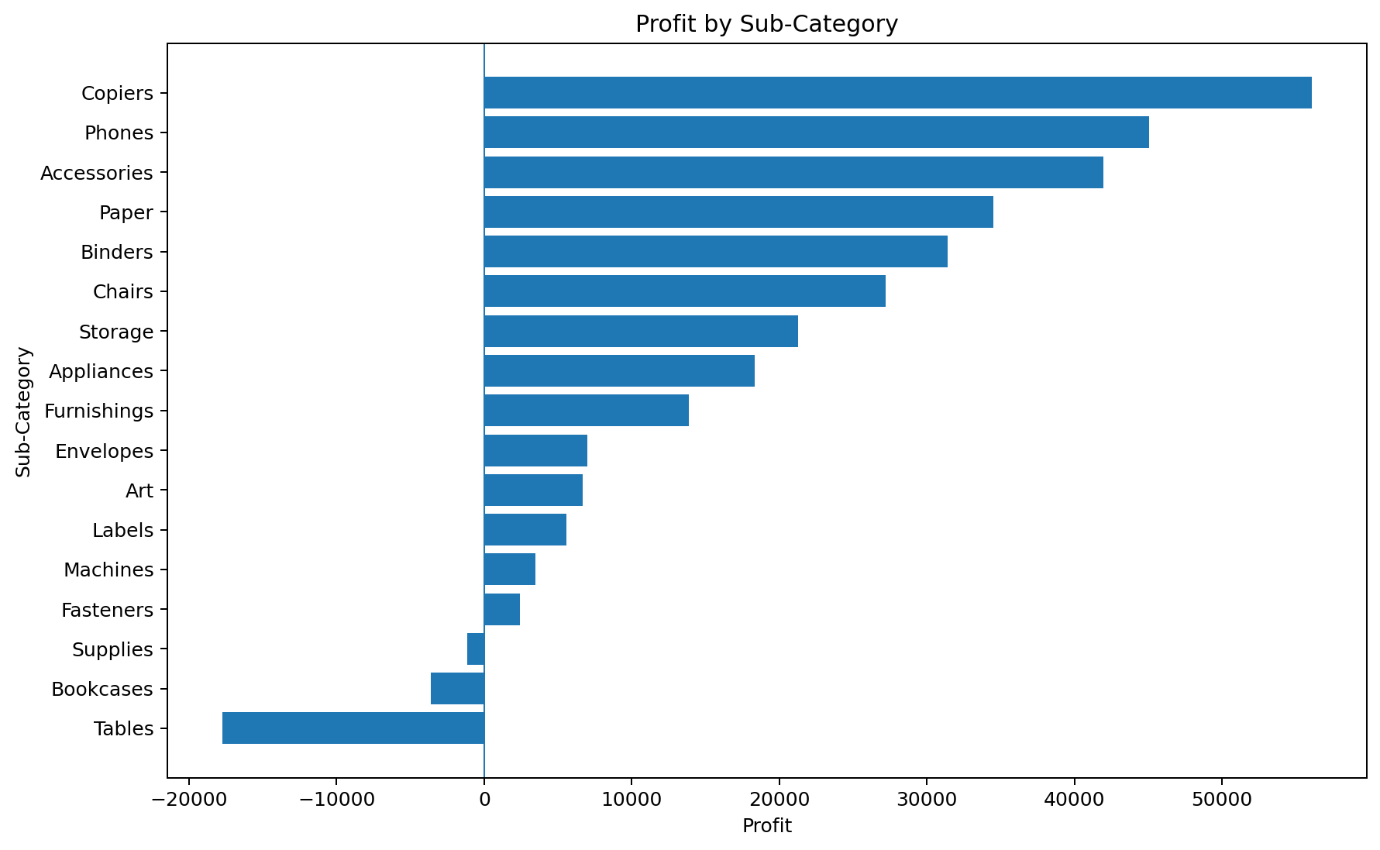
Figure 4. Profit by sub-category, sorted from lowest to highest.
3 sub-categories have negative total profit in this dataset: Tables, Bookcases, Supplies.
The lowest-profit sub-category is Tables ($-17,753.21); the highest-profit sub-category is Copiers ($56,093.94).

11. Monthly Sales and Profit Trend
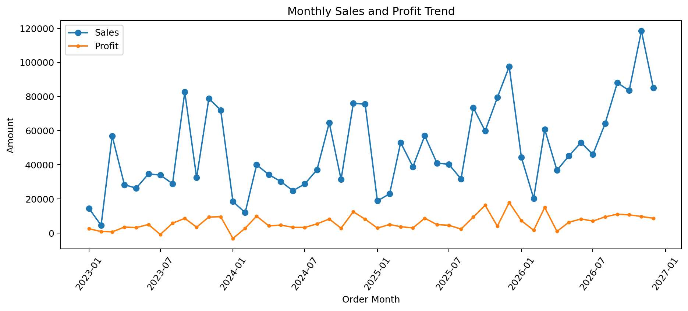
Figure 5. Monthly sales and profit totals based on order date.
The highest-sales month in the analysed period is November 2026 ($118,454.51); the lowest-sales month is February 2023 ($4,519.89). Monthly totals can vary due to seasonality, order mix, and the number of selling days. The chart is descriptive and does not by itself establish why a change occurred.

12. Discount-Band Analysis
Discount band | Rows | Sales | Profit | Profit margin
0% | 4,925 | $1,105,323.79 | $326,718.59 | 29.56%
>0–10% | 96 | $54,952.50 | $9,099.97 | 16.56%
>10–20% | 3,758 | $801,497.92 | $92,498.94 | 11.54%
>20–30% | 230 | $104,474.07 | $-10,513.45 | -10.06%
>30–50% | 311 | $195,394.73 | $-48,477.05 | -24.81%
>50% | 874 | $64,891.35 | $-77,030.19 | -118.71%

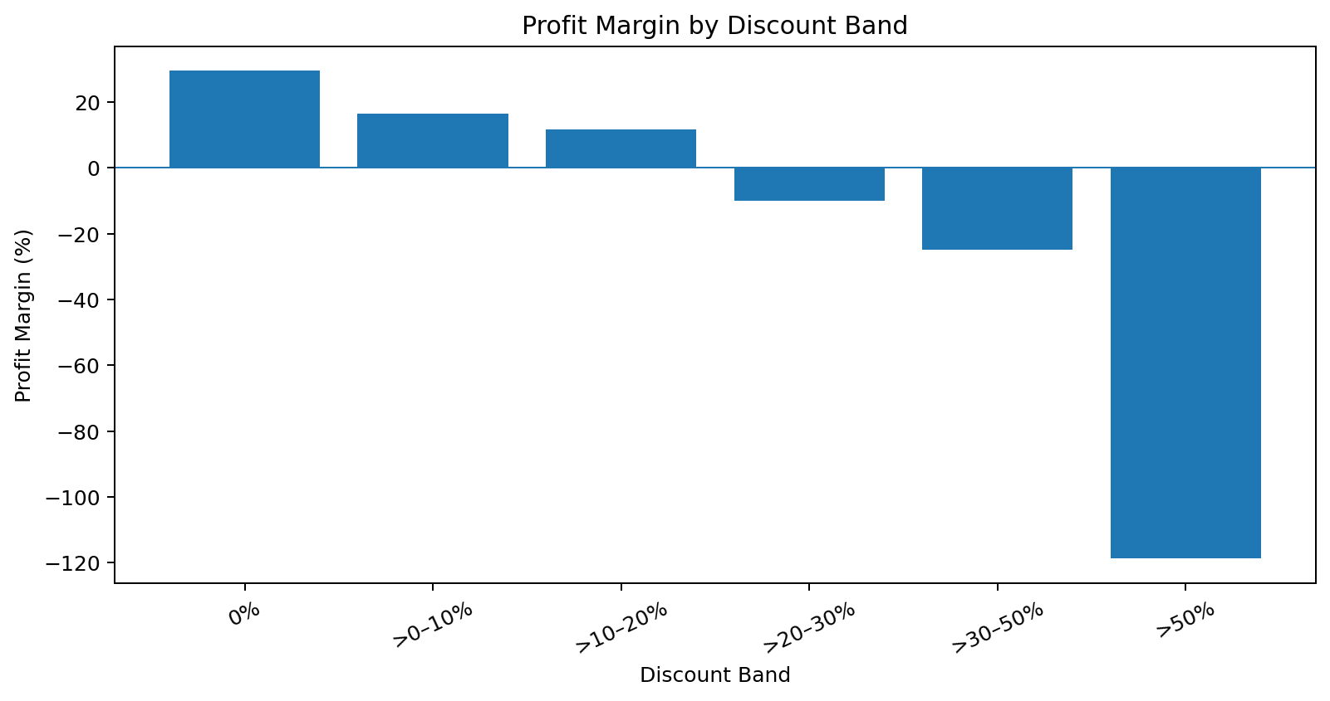
Figure 6. Profit margin by discount band.
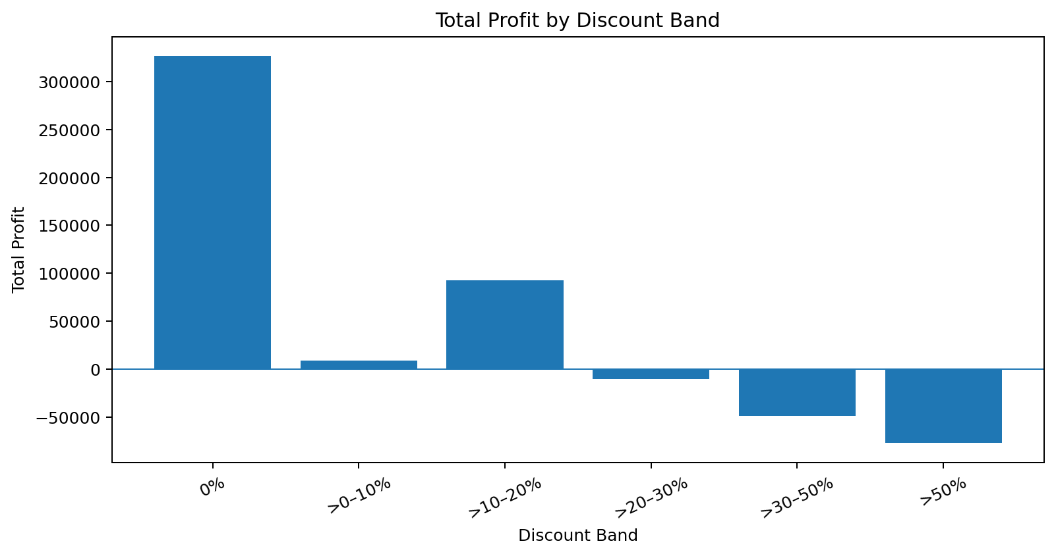
Figure 7. Total profit by discount band.
The discount band with the highest total profit is 0% ($326,718.59); the lowest is >50% ($-77,030.19). Discount bands can differ in sales volume and product mix. This comparison shows association only and does not prove that discounting caused a profit change.

13. Findings and Business Insights
- Overall sales are $2,326,534.35 and total profit is $292,296.81, giving an overall profit margin of 12.56%.
- Technology is the largest category by sales in the supplied dataset.
- West is the largest region by sales in the supplied dataset.
- Tables has the lowest total profit among sub-categories.
- November 2026 is the peak sales month in the analysed period.
- The 0% discount band has the highest total profit among the bands shown.

14. Recommendations
- Review both revenue and profit before prioritising a category or region; high sales alone may hide weak profitability.
- Investigate loss-making sub-categories by checking pricing, discount levels, product costs, shipping costs, and product mix.
- Use the monthly trend to support inventory and staffing planning, while checking seasonality and external context before acting.
- Set discount guardrails using contribution and margin analysis rather than assuming a larger discount always increases sales or profit.
- Create a recurring dashboard from the exported CSV summaries so stakeholders can track KPIs consistently.
- Validate findings on newer or real business data before using them for operational decisions.

15. Limitations
- The dataset is fictional/educational and may not represent a real organisation.
- Dataset copies can differ; all numerical results in this report correspond only to the uploaded CSV.
- Missing cells and invalid date values can affect analyses that depend on those fields.
- Group-level comparisons are descriptive and do not establish causality.
- No machine-learning model was trained for this report; the work is exploratory data analytics.

16. Conclusion
The analysis transformed 10,194 retained transaction rows into KPI summaries, segment comparisons, and seven visualisations. The dataset records $2,326,534.35 in total sales and $292,296.81 in total profit, with an overall profit margin of 12.56%. Category, region, sub-category, monthly, and discount analyses provide a structured way to identify where further business investigation may be useful. Recommendations should be validated against business context and real operational data before implementation.

17. Reproducibility and Deliverables
The accompanying results package includes this report, chart PNG files, and CSV summaries. To reproduce the analysis, load Sample - Superstore.csv, clean and parse the required fields, calculate the KPIs, and regenerate the group summaries and charts using pandas and Matplotlib.

References
- Tableau, “Sample Data,” https://public.tableau.com/app/learn/sample-data
- Kaggle, “Superstore Dataset,” https://www.kaggle.com/datasets/vivek468/superstore-dataset-final
- pandas documentation, https://pandas.pydata.org/docs/
- NumPy documentation, https://numpy.org/doc/
- Matplotlib documentation, https://matplotlib.org/stable/

