**EX NO. : 1**

**Introduction to Cloud Computing.**

**Objectives:**

1. To learn About basics Of Cloud Computing.
2. To know the Various Cloud Technologies available.
3. To Create Dashboard in one Cloud computing Platform.

**Cloud Computing:**

Cloud computing is the on-demand access of computing resources—physical servers or virtual servers, data storage, networking capabilities, application development tools, software, AI-powered analytic tools and more—over the internet with pay-per-use pricing.

**To know the Various Cloud Technologies available**

1. AWS

2. Microsoft Azure

3. Google Cloud

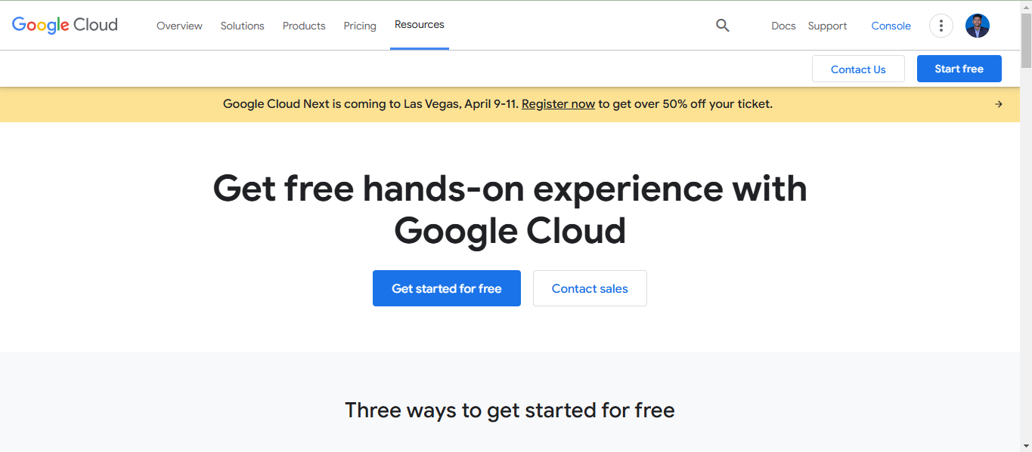

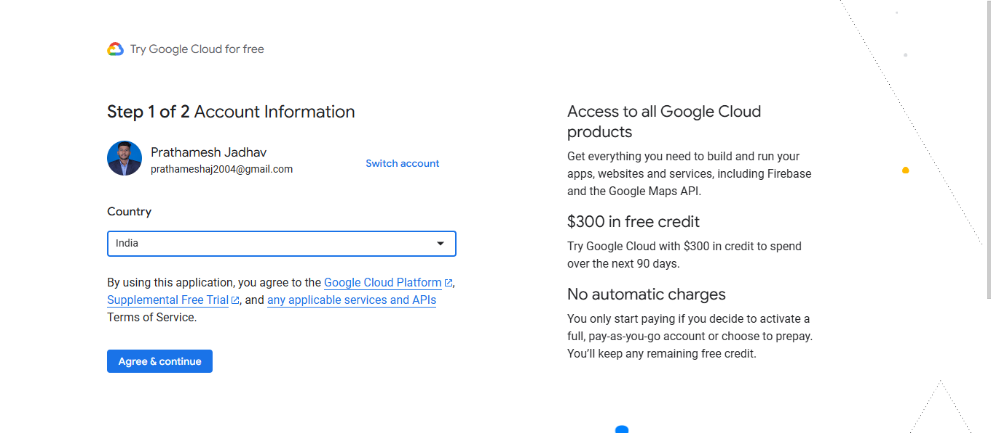

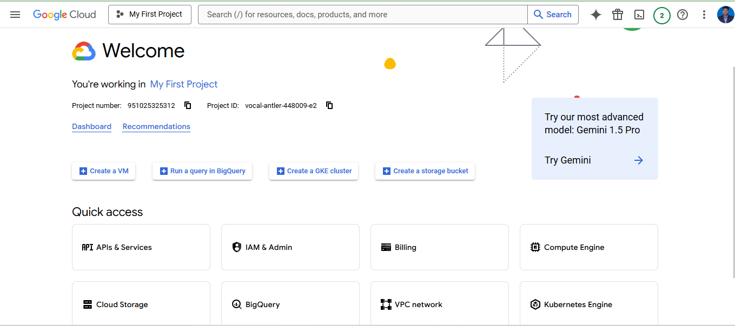

**Characteristics of Cloud Computing**

**Scalability:** With Cloud hosting, it is easy to grow and shrink the

number and size of servers based on the need. This is done by either

increasing or decreasing the resources in the cloud. This ability to alter plans

due to fluctuations in business size and needs is a superb benefit of cloud

computing, especially when experiencing a sudden growth in demand.

**Save Money:** An advantage of cloud computing is the reduction in

hardware costs. Instead of purchasing in-house equipment, hardware needs are

left to the vendor. For companies that are growing rapidly, new hardware can

be large, expensive, and inconvenient. Cloud computing alleviates these issues

because resources can be acquired quickly and easily. Even better, the cost of

repairing or replacing equipment is passed to the vendors. Along with

purchase costs, off-site hardware cuts internal power costs and saves space.

Large data centers can take up precious office space and produce a large

amount of heat. Moving to cloud applications or storage can help maximize

space and significantly cut energy expenditures.

**Reliability:** Rather than being hosted on one single instance of a

physical server, hosting is delivered on a virtual partition that draws its

resource, such as disk space, from an extensive network of underlying

physical servers. If one server goes offline it will have no effect on

availability, as the virtual servers will continue to pull resources from the

remaining network of servers.

**Physical Security:** The underlying physical servers are still housed

within data centers and so benefit from the security measures that those facilities implement to prevent people from accessing or disrupting them on-

site.

**Outsource Management:** When you are managing the business,

someone else manages your computing infrastructure. You do not need to

worry about management as well as degradation.

**Difference Between the Cloud Services:**

Amazon Web Services (AWS) dominates infrastructure, including scalable storage, networking, server, mobile development, and cybersecurity solutions. Microsoft Azure, its chief rival, provides some of the most scalable and efficient software solutions. Google Cloud Platform GCP offers high-end big data analytics solutions and allows easy interaction with other vendor products.Many people in India believe that cloud computing will play an essential role today and in the future. Microsoft India’s president, Anant Maheshwari, noted the critical role cloud computing plays in reimagining and enabling inclusion, business, and governance throughout the country. Experts additionally believe that the country’s adoption of cloud computing services will help position India amongst the leaders on the global stage, necessitating a skilled workforce. Indeed, certified cloud computing specialists are in demand, outperforming the disruptive move away from in-house servers and computing capacity toward the flexibility and scalability of cloud-based systems. Explore below how the three can shape your IT career path.

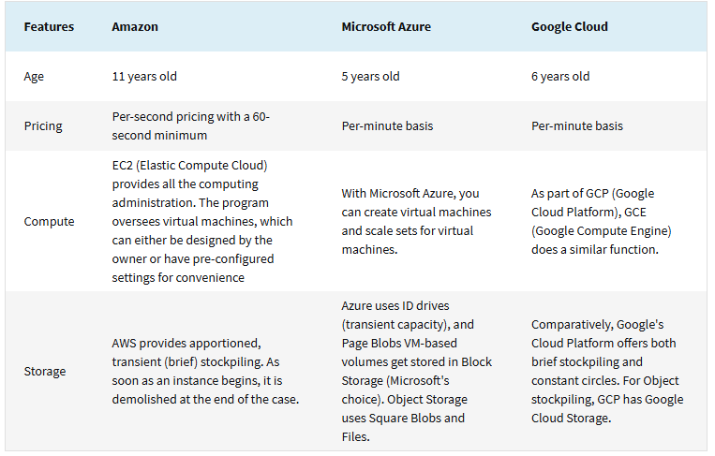

**Programming Skills Required for Cloud Services And Justify:**

Yes, Programming skills are crucial for cloud computing as they enable automation, customization, and efficient use of resources. They allow users to interact with cloud APIs, automate tasks, deploy infrastructure as code, build cloud-native applications, and manage DevOps workflows. Without programming, leveraging the full power of cloud platforms—like scalability, cost optimization, and AI/ML integration—becomes challenging. It ensures flexibility and scalability, making programming an indispensable skill for cloud professionals.

**Additional Learning:**

1. Creation of dashboard and login Credential Through Google Cloud.
2. Differences Between The Cloud Services.
3. Coding Skills Require For Cloud Computing.

**Outcomes:**

1. I Have Come to an Understanding Basics Of Cloud Computing.
2. I Came to Know About Various Platforms like AWS, Azure, Google Cloud.
3. I Have Created Dashboard in the Google Cloud.