**EXP : 2**

**Objective:**

1. To Learn And Understand About Virtualization.
2. To Understand How Virtualization Used In Local System.
3. To Install Virtual Box Or Virtual Workstation.
4. Using Vmware Install One Service(Paas).

**Virtualization:**

Virtualization Is A Process That Allows For More Efficient Use Of Physical Computer Hardware And Is The Foundation Of Cloud Computing.

**Virtualization**Is Used To Create A Virtual Version Of An Underlying Service With The Help Of Virtualization, Multiple Operating Systems And Applications Can Run On The Same Machine And Its Same Hardware At The Same Time, Increasing The Utilization And Flexibility Of Hardware. It Was Initially Developed During The Mainframe Era.

It Is One Of The Main Cost-Effective, Hardware-Reducing, And Energy-Saving Techniques Used By Cloud Providers. Virtualization Allows Sharing Of A Single Physical Instance Of A Resource Or An Application Among Multiple Customers And Organizations At One Time. It Does This By Assigning A Logical Name To Physical Storage And Providing A Pointer To That Physical Resource On Demand.

**How Virtualization Used In Local System :**

**Software Like Vmware, Virtualbox, Or Hyper-V** Allows You To Create Virtual Machines. Each VM Behaves Like A Separate Physical Computer, Running Its Own Operating System (OS) And Applications.

**Install Virtual Box Or Virtual Workstation:**

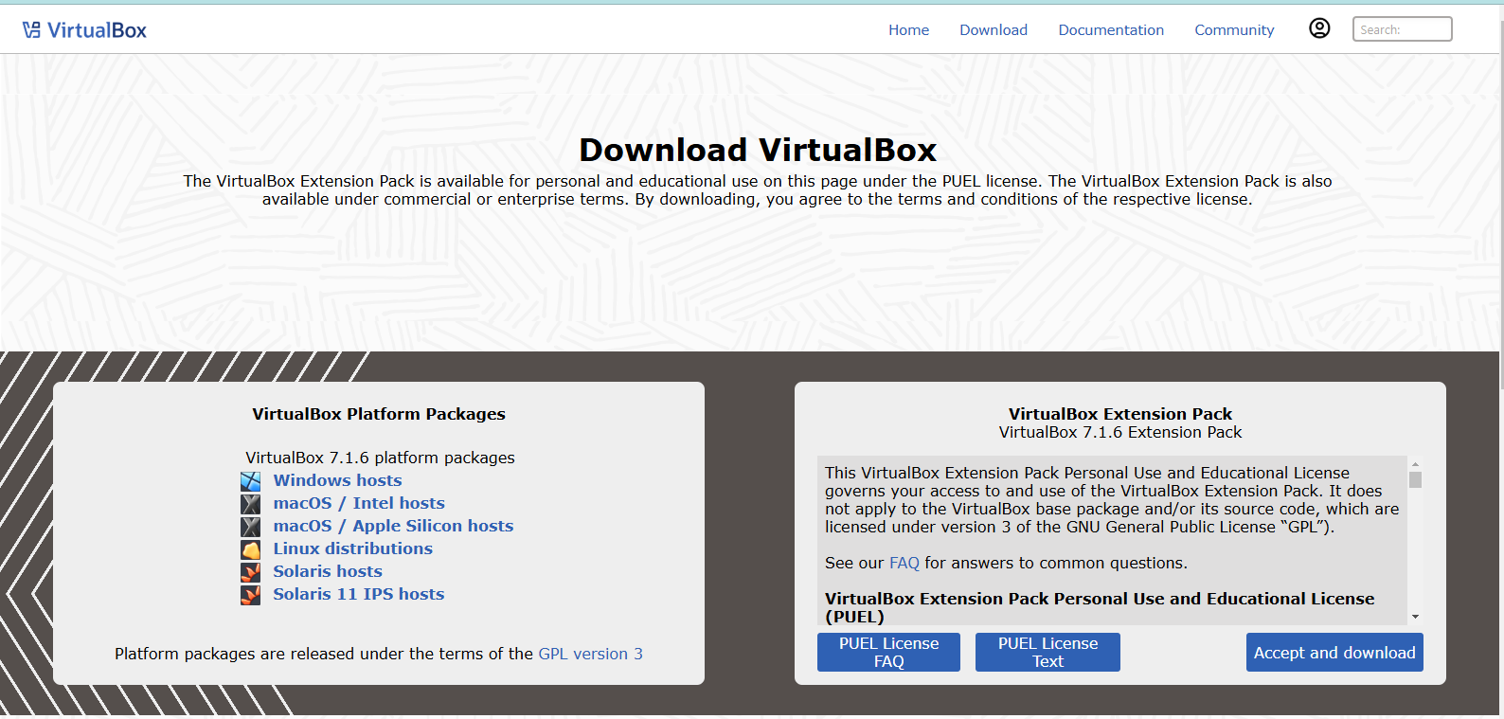

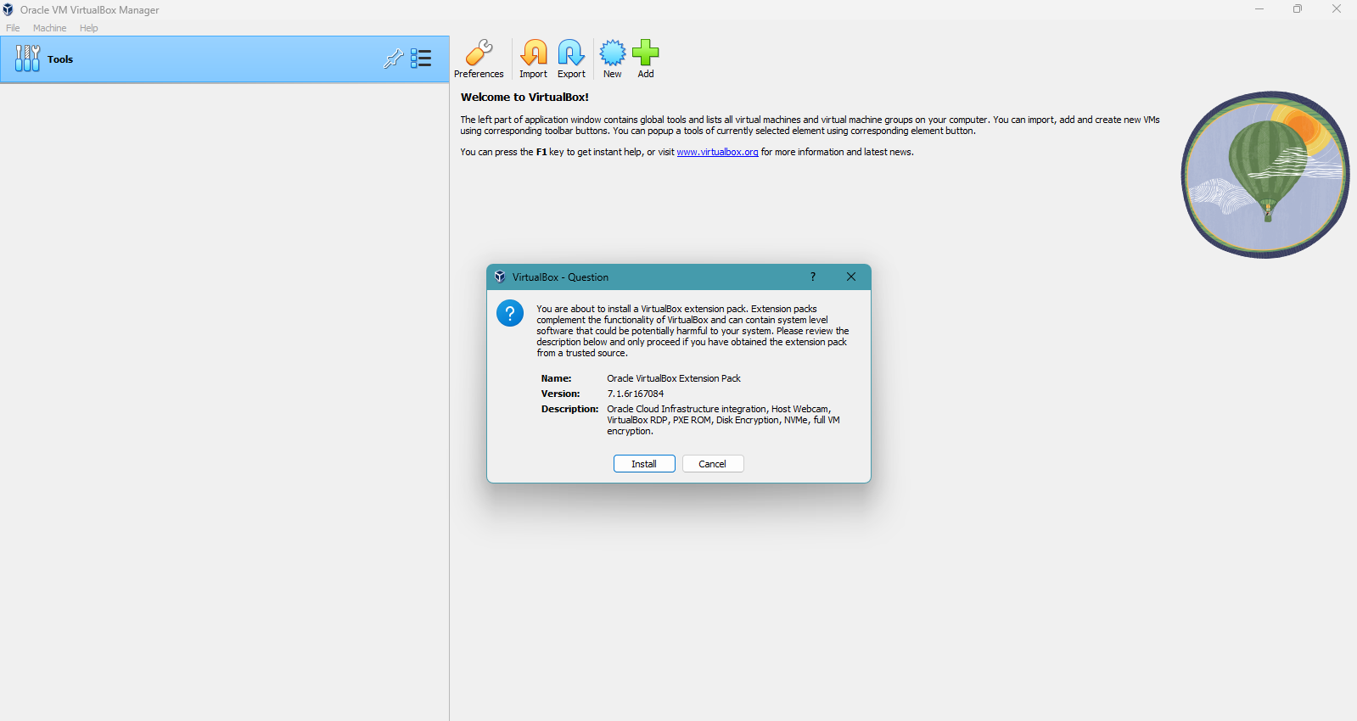

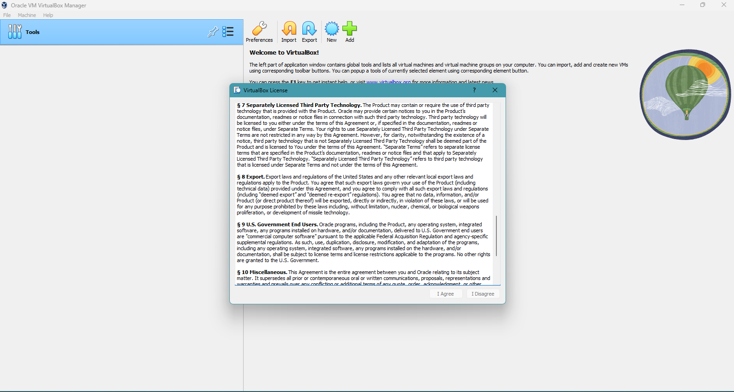

**Using Vmware Install One Service(Paas):**

**1.Requirements:**

* Installation of VMware
* Image file of Platform/Operating System

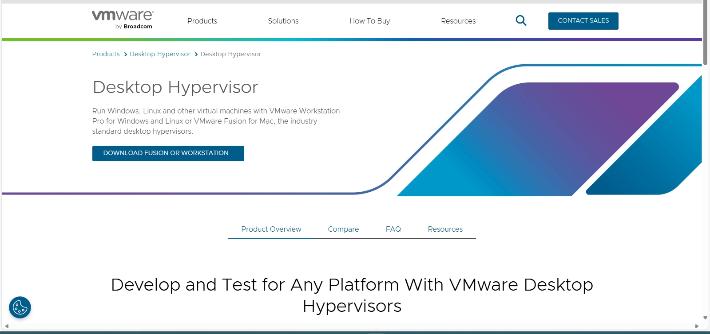

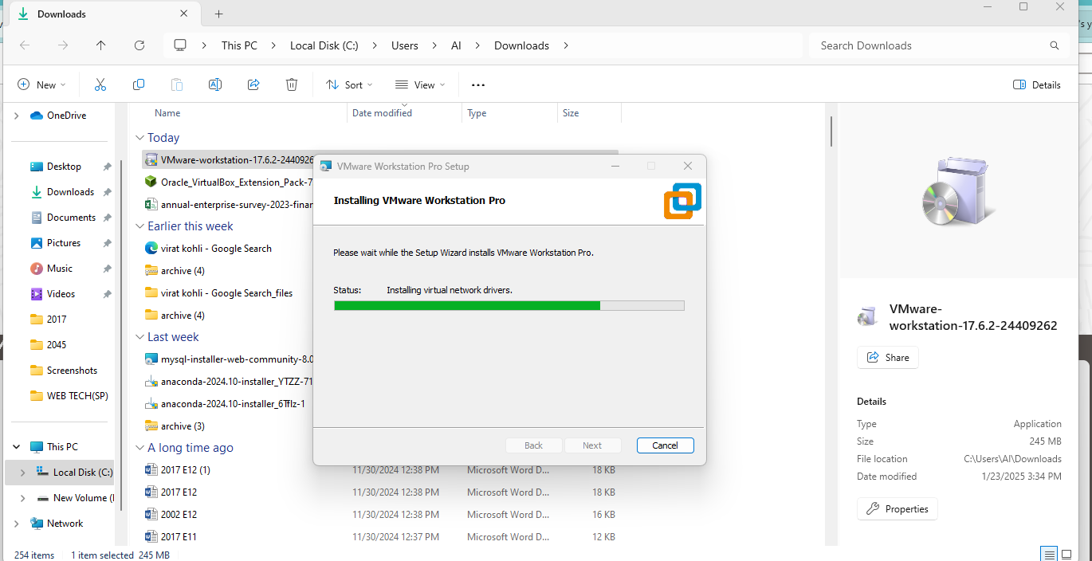

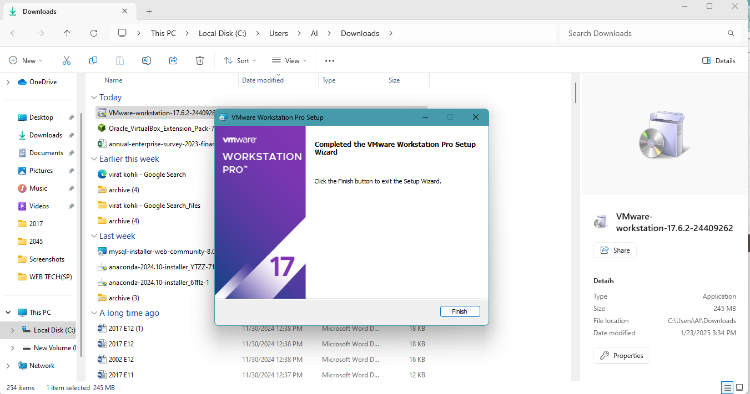

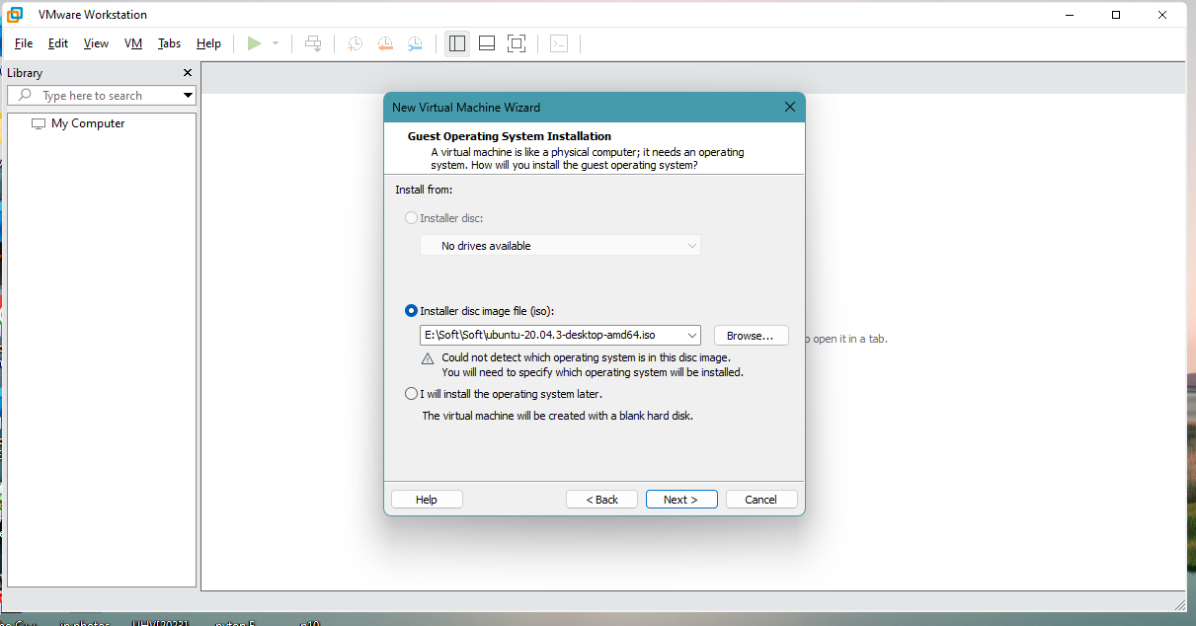

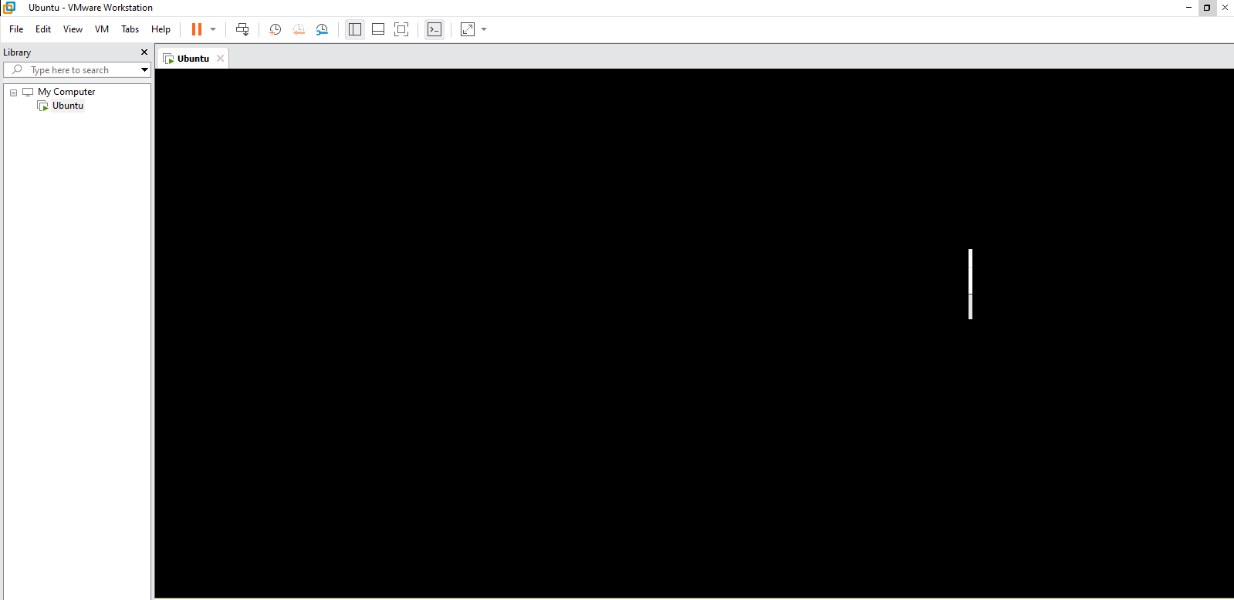

**Additional Learning:**

**1.What are the tools available for virtualization?**

• **VMware Workstation**: A powerful tool for creating and managing virtual machines on Windows and Linux.

• **Oracle VirtualBox**: A free, open-source virtualization platform for running multiple OSes on a single machine.

• **Microsoft Hyper-V**: A hypervisor-based virtualization tool for Windows, enabling VM creation and management.

• **Parallels Desktop**: A virtualization tool mainly for macOS users, allowing them to run Windows and other OSes.

• **KVM (Kernel-based Virtual Machine)**: A Linux-based virtualization tool that turns the kernel into a hypervisor.

**2.What is use of disk image?**

A **disk image** is a file that contains an exact copy or snapshot of an entire storage device, such as a hard drive or USB drive. It includes the operating system, applications, files, and all data stored on the disk. Here are its primary uses:

1. **System Backup**: A disk image acts as a full backup of a system, allowing you to restore everything to its original state if something goes wrong.
2. **Cloning**: Disk images can be used to replicate a system or disk, making it easier to set up multiple machines with the same configuration.
3. **Disk Recovery**: If a hard drive fails or data is lost, the disk image can be used to restore the system and files.
4. **Virtualization**: Disk images can be used in virtual machines to simulate the same environment as the original physical disk.
5. **Software Distribution**: Disk images can be used to distribute software, especially operating systems or large applications, as a single file for easier installation.

**3.Microsoft Office comes in which category?**

Microsoft Office falls under the category of **Productivity Software**. It includes applications like Word, Excel, PowerPoint, and Outlook, which are designed to help users perform various tasks related to document creation, data analysis, presentations, communication, and scheduling. These tools are commonly used in business, education, and personal productivity scenarios.

**Outcome:**

1.Understand the Virtualization Concept.

2.Install the Virtual Machine.

3.Create service Paas in VMware.