**EXP-3**

* **Title:-** Install a C compiler in the virtual machine created using virtual box and execute simple program.
* **Objective:**

1. To learn and understand about virtual Machine
2. To Learn And Understand about Creating Services in a virtual Machine.
3. Understanding about

1. Infrastructure (HardWare)

2. Platform (operating Systems)

3. Installing Applications and Programmming Languages

1. To install C Compiler in Virtual Linux
2. Run a Simple Arithmatic Calculator and Generate Output using Virtual C Compiler.

**To learn and understand about virtual Machine**

A virtual machine (VM) is essentially a software-based representation of a physical computer, allowing you to run an operating system and applications on a virtual environment, separate from the host machine's hardware, effectively creating a "computer within a computer" where you can run different operating systems or isolated environments on a single physical machine; this is achieved through a technology called virtualization, which allocates dedicated portions of the host computer's resources (like CPU, memory, storage) to each virtual machine, making them function independently while sharing the same physical hardware.

**Understand about Creating Services in a virtual Machine**

"Creating services in a virtual machine" means setting up and running applications or functionalities within a virtualized environment, essentially treating the virtual machine like a dedicated computer where you can install and configure software to provide a specific service, such as a web server, database, or email server, all while utilizing the resources of a physical host machine.”

**Understanding about Infrastructure (HardWare), Platform(operating Systems), Installing Applications and Programming Languages**

In computing, "infrastructure" refers to the physical hardware components like servers, computers, and network devices, while "platform" represents the software foundation, primarily the operating system, that allows applications to run on that hardware; installing applications means placing software programs onto the system, and programming languages are the tools used to write instructions for creating those applications, all working together to enable functionality on the hardware through the operating system.

**A virtual Machine Can Occure Basic Three Services:**

1. Infrastructure (CPU)

2. Platform (Operating Systems Such As Windows, Linux, Mac, Android)

3. Applications (Various Applications Such as Microsoft Office, Games, 3D Designing) and Also Compatible To programming Languages C, C++, Java, Python , Php and More.

**To install C Compiler in Virtual Linux**

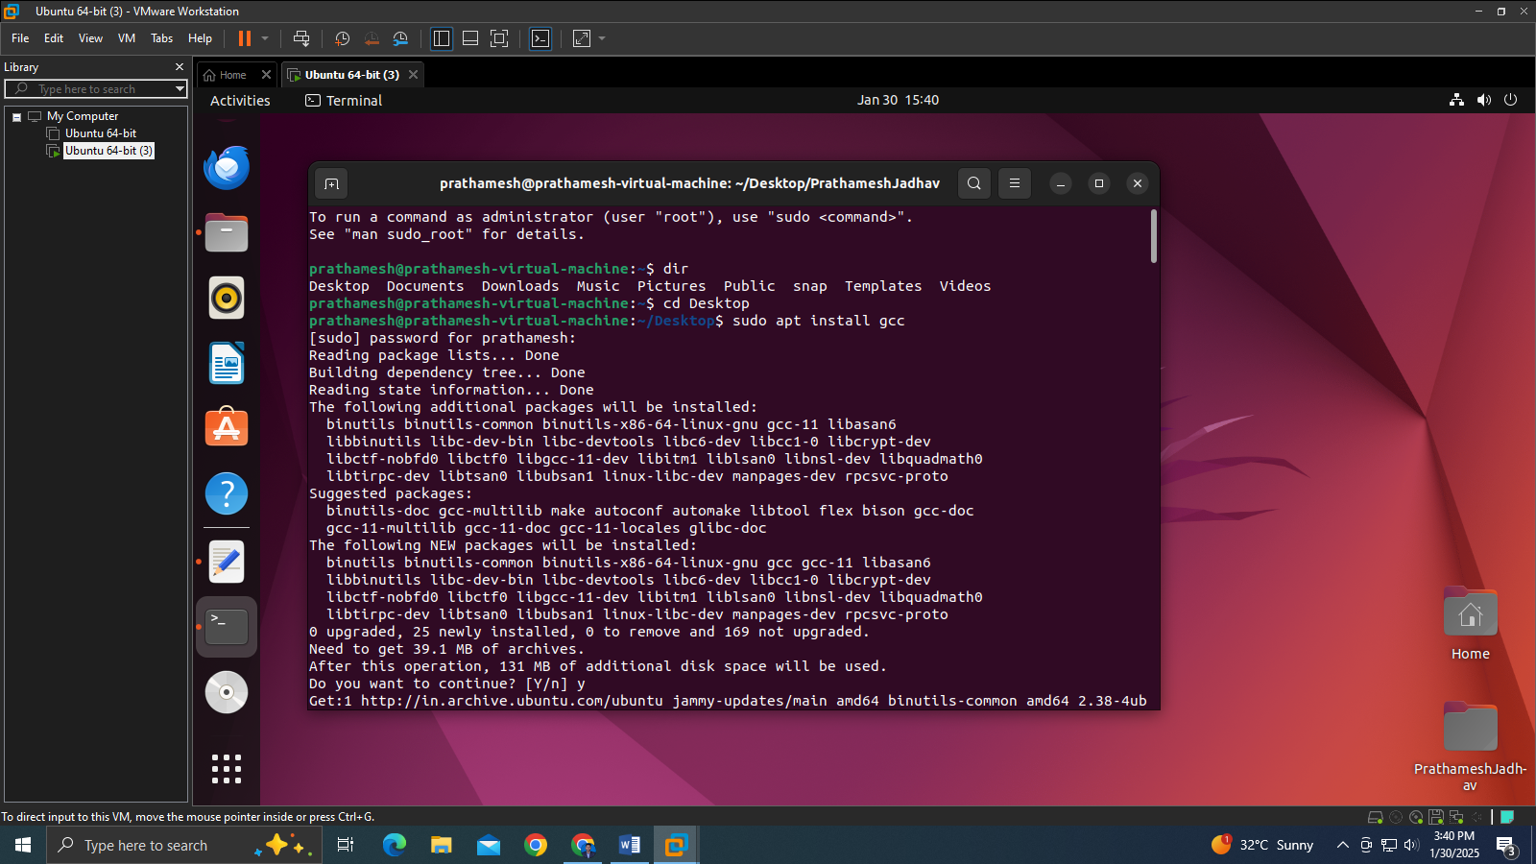

**Run a Simple Arithmatic Calculator and Generate Output using Virtual C Compiler**

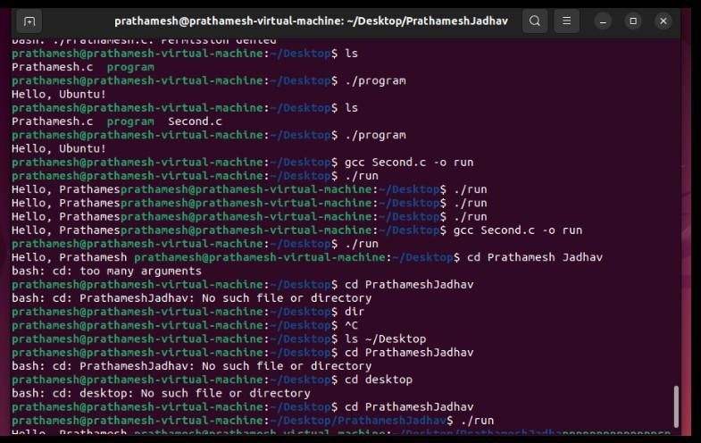

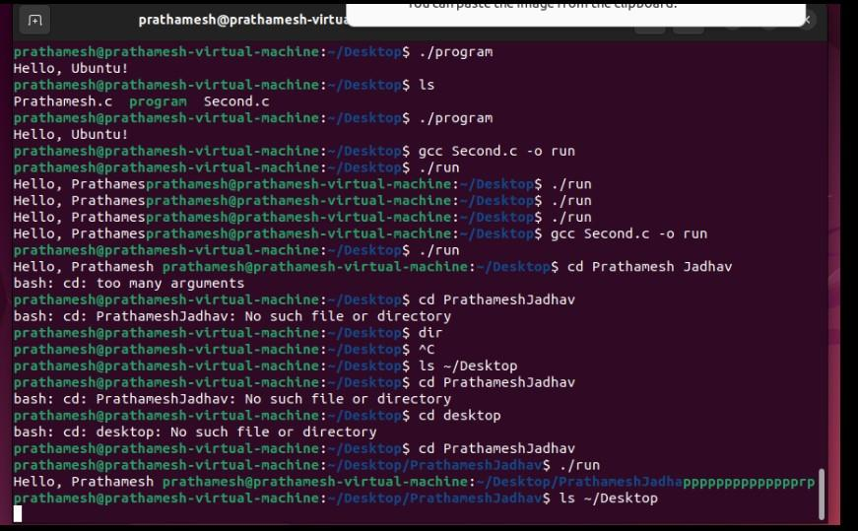

* **Addition Learning:**

1. Basic Commands In Linux

a. Sudo apt Install

b. ls

c. man

d.Operations of File: Creation, Updation, Editing, Append, Delete.

e.Directory Operations- Create, Rename, add Sub-Folders, Delete.

* **Outcomes:**

1. Gain a solid understanding of what a Virtual Machine (VM) is and how it works.
2. Learn the process of creating and configuring services within a virtual machine.
3. Understand the physical components required to support virtual machines, such as CPU, RAM, storage, and network interfaces.
4. Learn the process of installing software applications and configuring programming languages within a virtual machine environment.
5. Gain practical experience in installing and configuring the GCC (GNU Compiler Collection) C compiler on a virtual Linux machine.

* **Results:**

Successfully gained a conceptual understanding of virtual machines and their purpose in modern computing.

* **Possible Viva Questions:**

**What is a virtual machine (VM)?**

* **Answer**: A virtual machine (VM) is a software-based emulation of a physical computer, allowing you to run multiple operating systems on a single physical machine. VMs use virtualization technology to share hardware resources like CPU, RAM, and storage.

**How do you ensure a service starts automatically on boot in Linux?**

* **Answer**: You can enable a service to start on boot by using sudo systemctl enable <service-name>, such as sudo systemctl enable apache2.

**What is the difference between a host OS and a guest OS in a virtual machine?**

* **Answer**: The host OS is the operating system installed on the physical machine, while the guest OS is the operating system installed within a virtual machine, running under the hypervisor.

**What are the steps to install a programming language like Python or C in a VM?**

* **Answer**: You can install a programming language by using the package manager. For Python: sudo apt install python3, and for C (GCC compiler): sudo apt install build-essential.

**How do you install the GCC compiler in Ubuntu?**

* **Answer**: Use the command sudo apt install build-essential to install GCC and other necessary development tools on Ubuntu.

**How do you execute a C program after compiling it?**

* **Answer**: Once compiled, you can run the C program with object.