**Experiment No.4**

* **Title:-** Install Google App Engine. Create hello world app and other simple web applications using Python/java.
* **Aim:-** To Install Google App Engine. Create hello world app and other simple web applications using python/java.
* **Objective:-**

1. To know understand about the google cloud
2. To create a google cloud dashboard(upi or debit card free and no auto deduction mood)
3. To learn and understand google cloud services.
4. Installation of google app engine.
5. To run program and application using google cloud engine.

* **Theory:-**

1. **What is google cloud:-**

Google Cloud Platform (GCP) is a suite of cloud computing services provided by Google. It is a public cloud computing platform consisting of a variety of services like compute, storage, networking, application development, Big Data, and more, which run on the same cloud infrastructure that Google uses internally for its end-user products, such as Google Search, Photos, Gmail and YouTube, etc.The services of GCP can be accessed by software developers, cloud administrators and IT professionals over the Internet or through a dedicated network connection.

* **Steps:-**

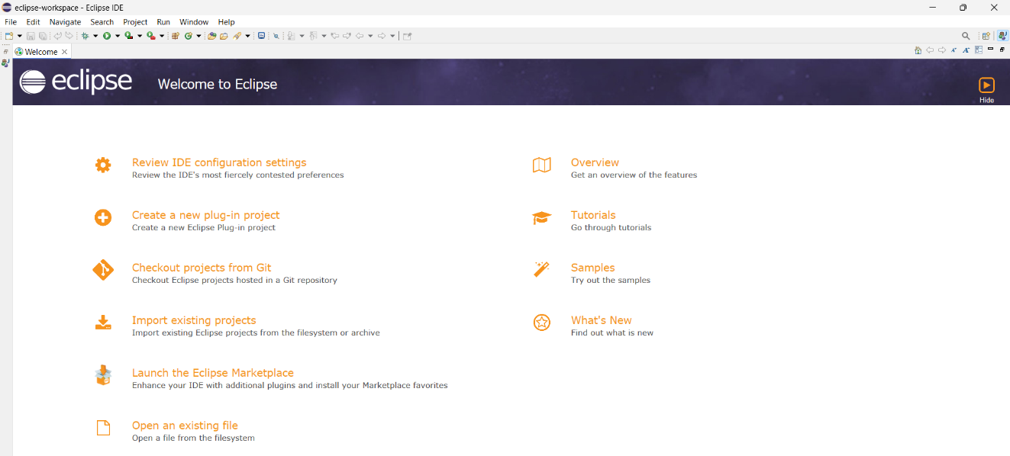

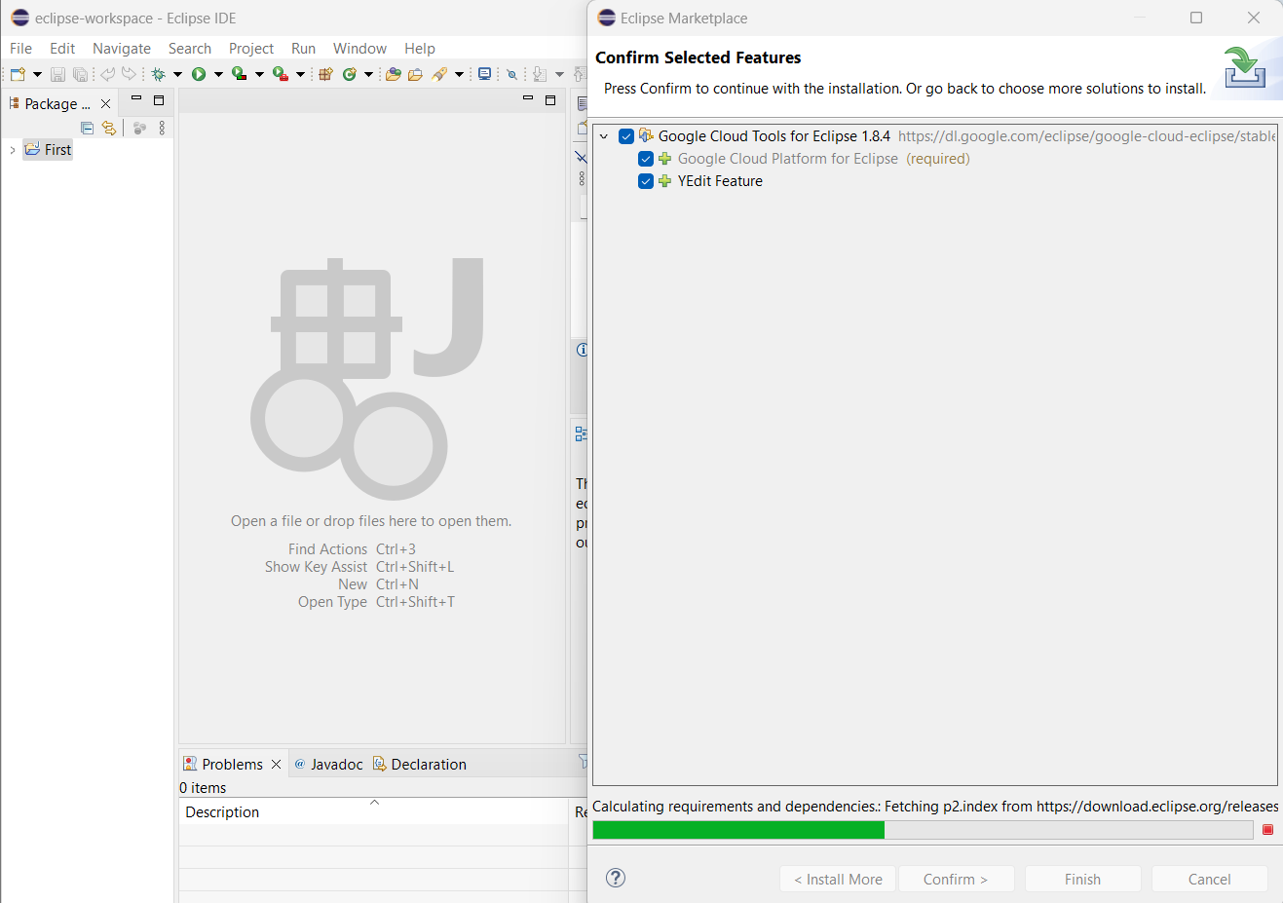

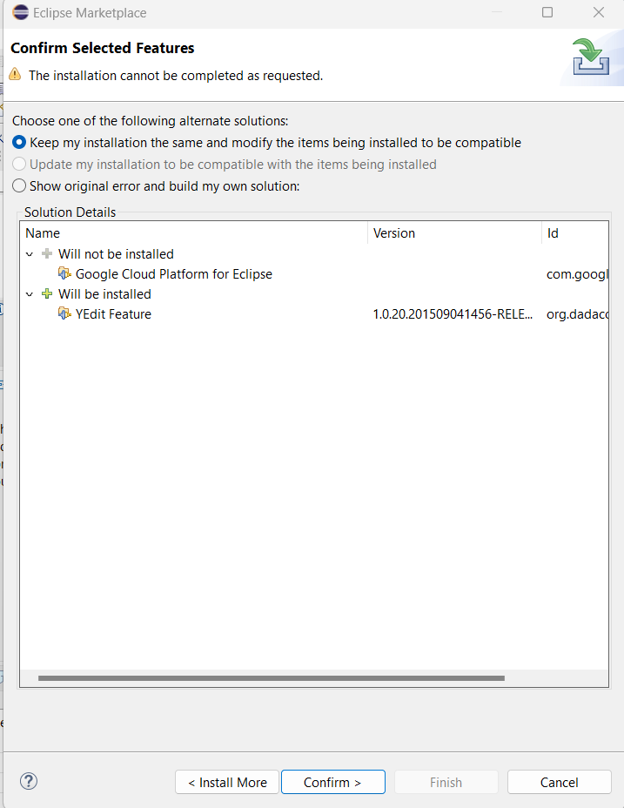

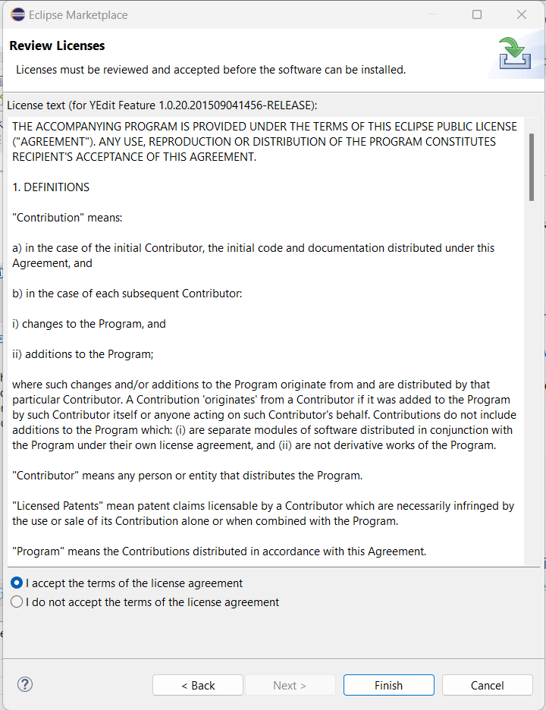

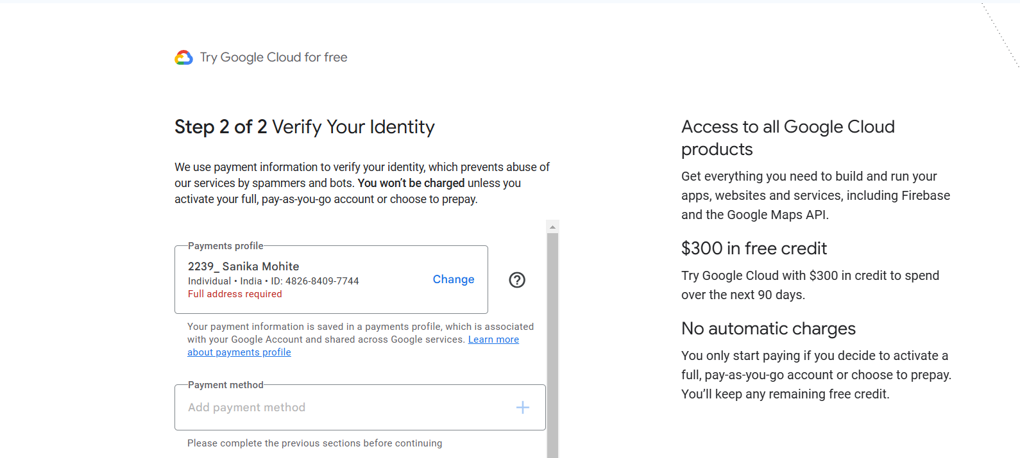

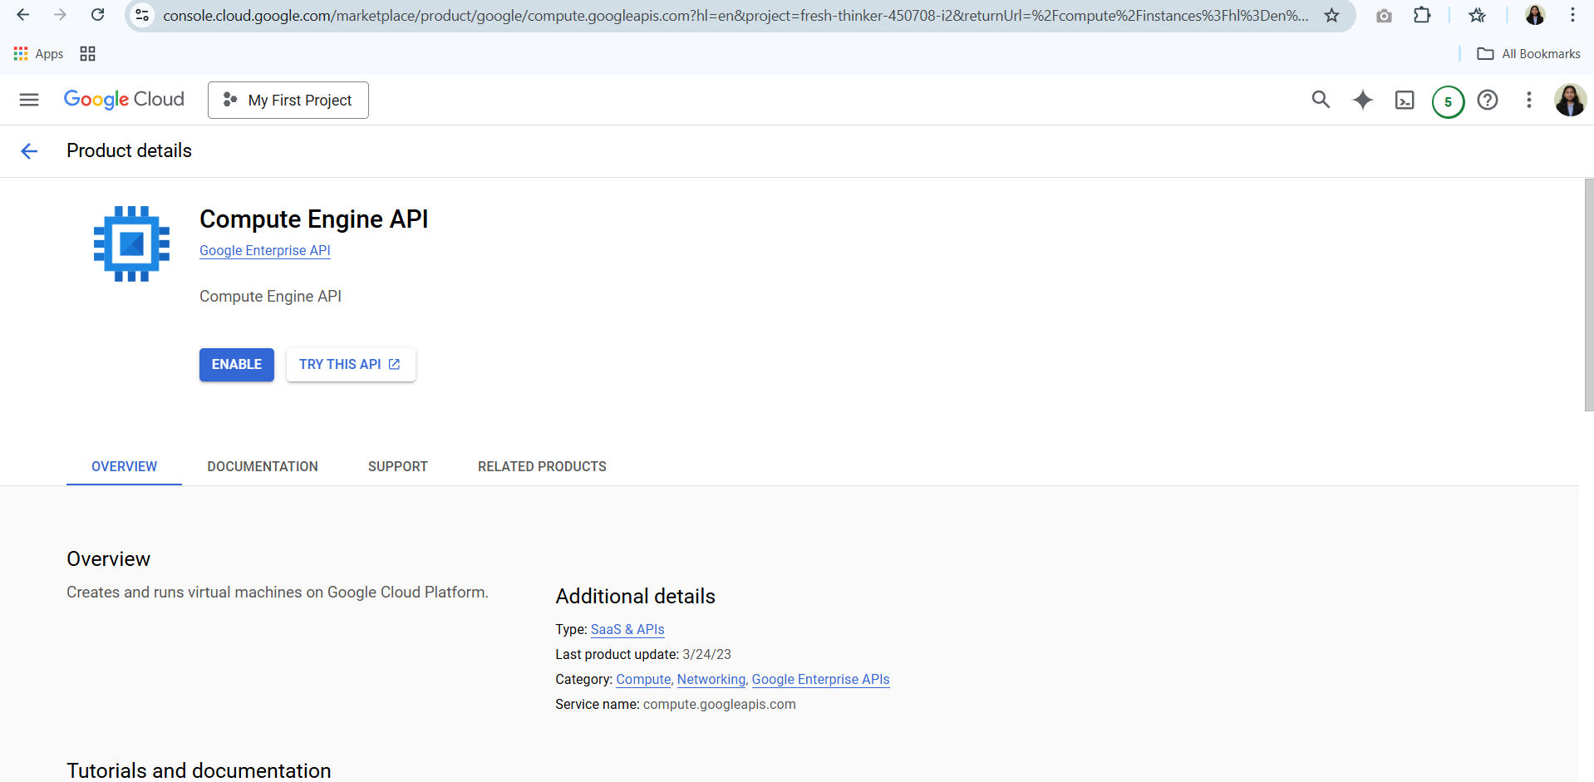

* **RESULT**:

To install **Google App Engine** (GAE), first install the **Google Cloud SDK** and set up your project in the Google Cloud Console. Then, deploy a simple "Hello World" app by creating a **Python** or **Java** web application, configuring it, and deploying it using the gcloud app deploy command.