**Experiment No.5**

* **Title:-** Simulate a cloud scenario using CloudSim and run a scheduling algorithm that is not present in CloudSim.
* **Aim:-** To simulate a cloud scenario using CloudSim and run a scheduling algorithm that is not present in CloudSim.
* **Objective:-**

1. To learn and understand about the simulation environments.

2. To know the differences between simulation ,emulations ,virtualization.

3. To download and install a cloud simulator(Windows Or Linux).

4. Creating an application or program using simulation.

5. Result generation for the simulation environment.

* **Refer this website**
* Refer geeks for geeks website
* Cloudsimtutorials.online.
* **Prerequisite:-**

1. Availability of virtual machine.

2. Any IDE’s – Eclipse /WebSphere/NetBeans

3. Java Latest Edition With JRE And JVM.

4. Python Latest Edition.

* **Theory:-**

**1. What is simulation and simulation environment?**

* **Simulation:-** is a process of developing an ideal model of a system with a view to analyzing its behavior when exposed to certain conditions. This includes employing formulas as well as algorithms in recreating the system in a simulation model.Its main aim is to replicate experience of using original hardware and software.It is simply used to imitate behavior of another program or device, running OS in hardware platform, etc.
* **Simulation environment :**A simulation environment is a virtual space that mimics a real-world system or process. It's created using a computer program and can be used to analyze, design, and optimize systems.

**2. Difference Between simulation and emulation?**

|  |  |  |
| --- | --- | --- |
| Simulation | Emulation | Virtualization |
| 1. It is a process of enabling one computer system to have like another computer system. | 1. It is a process of simulating abstract model of particular computer system. | 1. It is a process of creating virtual version of something such as OS, server, storage device, etc. |
| 2. It generally allows to model older hardware and software and then re-create them using current or new technology. | 2. It generally allows experimentation on valid digital representation of system. | 2. It generally increases IT agility, increase scalability, improve flexibility, saves costs, etc. |
| 3. Its main aim is to replicate experience of using original hardware and software. | 3. Its main aim is to establish virtual and safe environment in which each of these attributes can be tested and refined over full range of production levels. | 3. It simply allows and help us to use full capacity of physical machines by distributing its capabilities among different environments or users. |
| 4. It is simply used to imitate behavior of another program or device, running OS in hardware platform, etc. | 4. It is simply used to predict and forecast future behavior of system, study dynamic behavior of objects or systems, simulation of technology for testing, training, etc. | 4. Its main aim is to centralize administrative tasks that in turn improves scalability and workloads. |
| 5. Its advantages include better graphic quality, save space, emulation in video games, add post-processing effects, etc. | 5. Its advantages include increase safety and efficiency, avoid danger and loss of life, slowed down to study behavior more closely, etc. | 5. It runs code directly with different set of domains in use language. |

**3. To learn about download and install cloud simulator (windows, Linux).**

* **Step1:-**

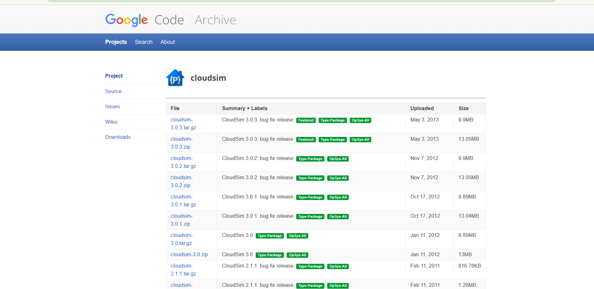

* **Step 2:-**

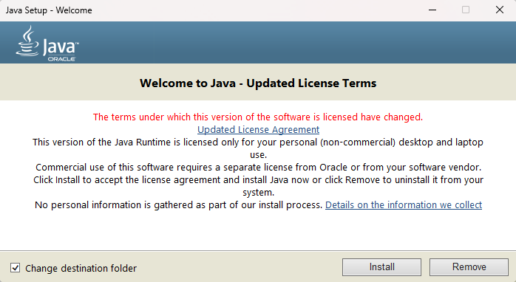

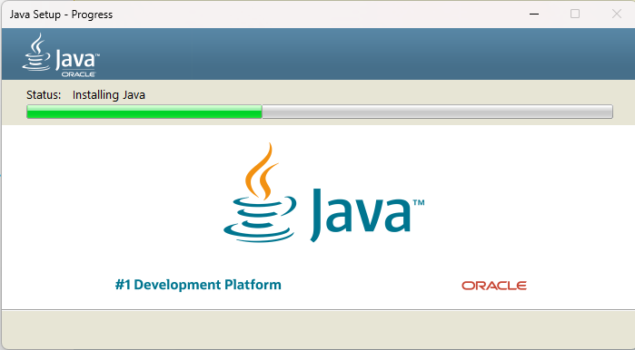

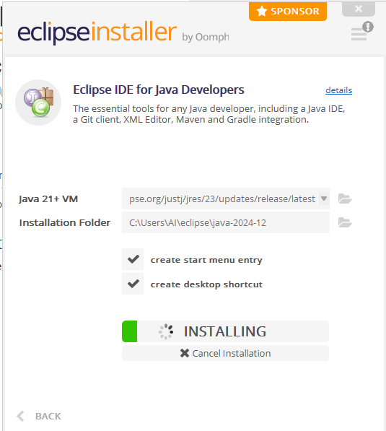

**4. Creating an application or program in the simulated environment.**

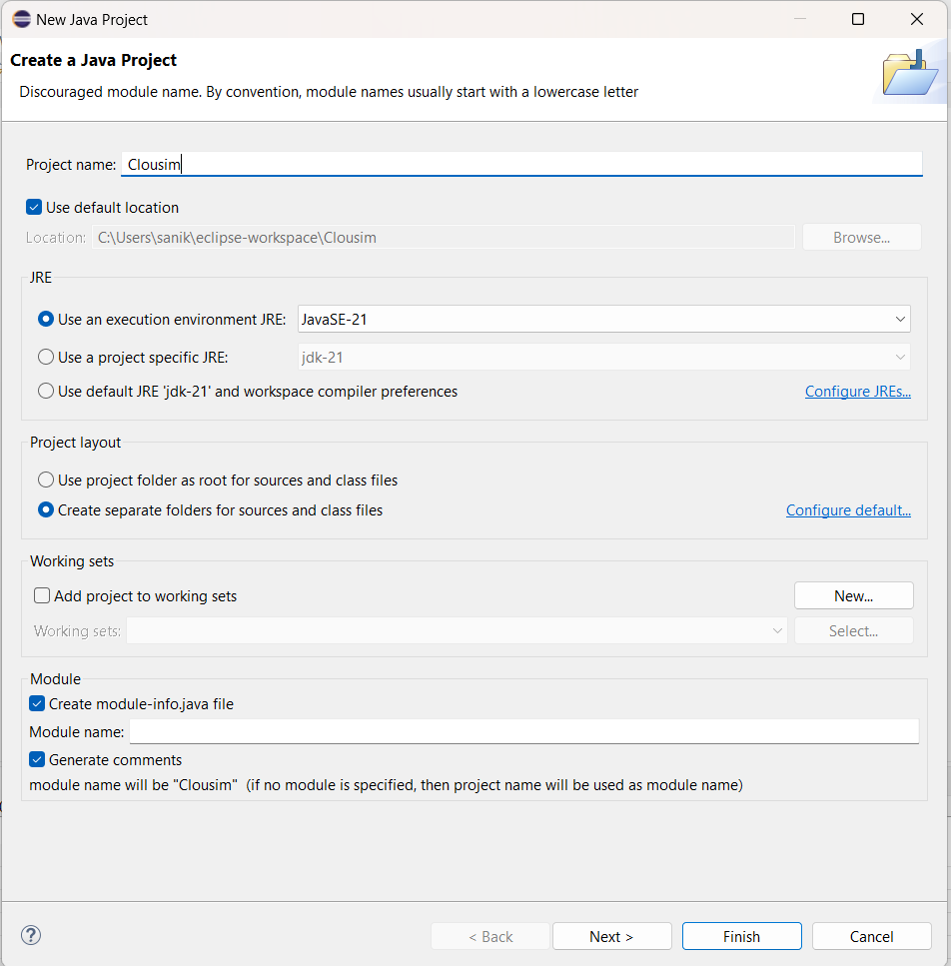

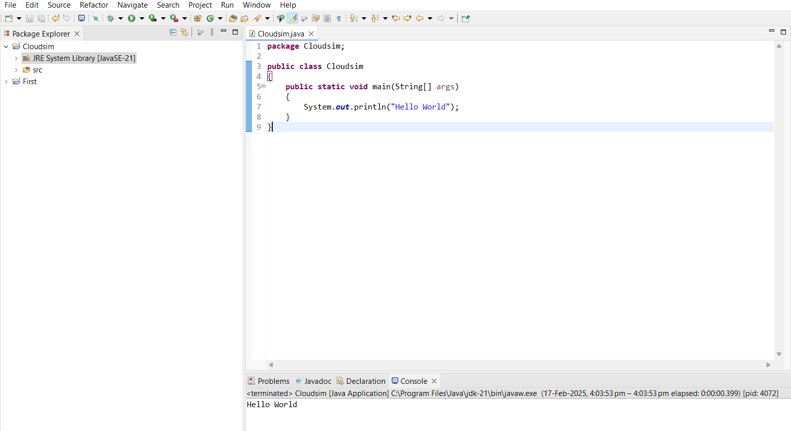

* **Outcome:-**

Successfully learn the Simulate a cloud scenario using CloudSim and run a scheduling algorithm that is not present in CloudSim.

* **Conclusion:-**

Thus, we completed the experiment onSimulate a cloud scenario using CloudSim and run a scheduling algorithm that is not present in CloudSim