**Experiment No:-6**

* **Title** : Find a procedure to transfer the files from one virtual machine to another virtual machine.
* **Aim** : To find a procedure to transfer the files from one virtual machine to another virtual machine.
* **Objectives** :

1. To open the virtual machine in a network using VirtualBox.
2. To Assign The IP Address For Virtual Machine.
3. Create a shared folder in virtual machine / host machine.
4. Test the connectivity by ping command.
5. Copy the files vm to vm to host.

* **Theory**:

1. **Virtual Machine:-**

A **Virtual Machine (VM)** is a software-based emulation of a physical computer. It runs an operating system and applications just like a physical computer, but it's hosted on a **real physical machine** called the **host**. The VM itself is called the **guest**.

1. **Ping Command:-**

The **ping command** is a network utility used to **test connectivity** between your computer and another device (like a website or server) over a network.

When you run ping, your computer sends **ICMP (Internet Control Message Protocol)** echo request packets to the target IP address or hostname.  
If the target is reachable, it replies with **echo reply** packets.

* **Syntax:-**

ping [destination]

* **PROCEDURE:**
* **Steps:**

1. Open Browser, type localhost:9869
2. Login using username: oneadmin, password: opennebula
3. Then follow the steps to migrate VMs

**Click on infrastructure**

1. Select clusters and enter the cluster name
2. Then select the host tab, and select all host
3. Then select Vnets tab, and select all vnet
4. Then select datastores tab, and select all datastores
5. And then choose host under infrastructure tab
6. Click on + symbol to add new host, name the host then click on create.
7. on instances, select VMs to migrate then follow the stpes
8. Click on 8th icon ,the drop down list display
9. Select migrate on that ,the popup window display

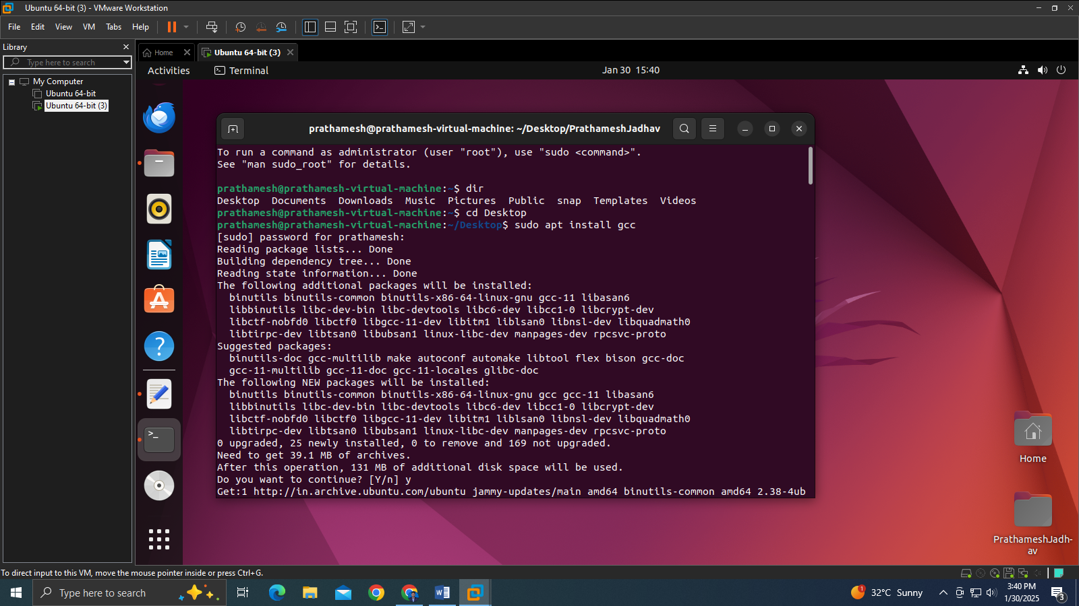

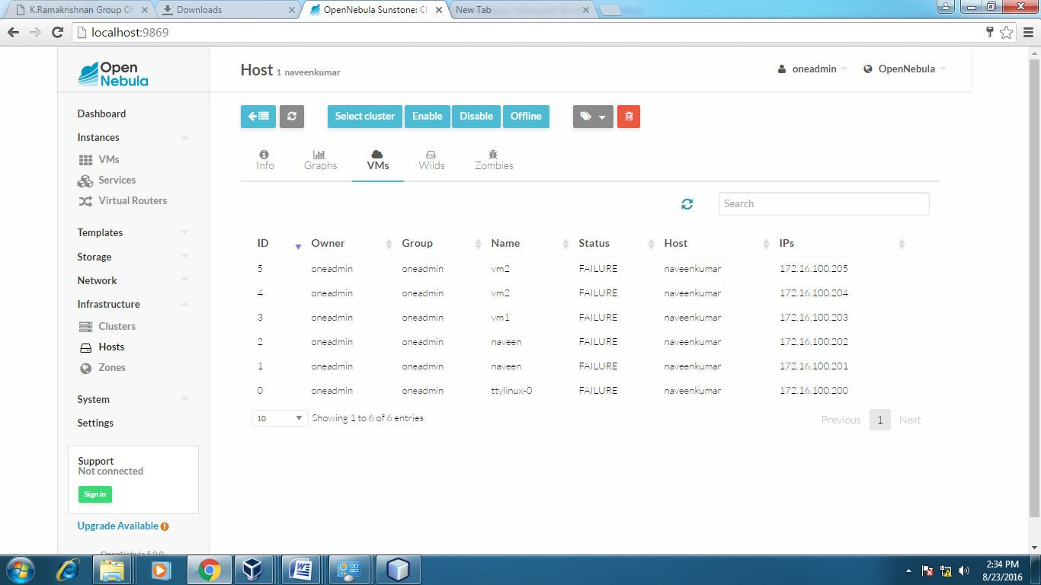**Before migration Host:SACET**

**Host:one-sandbox**

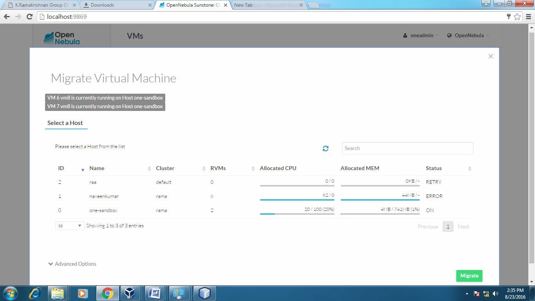

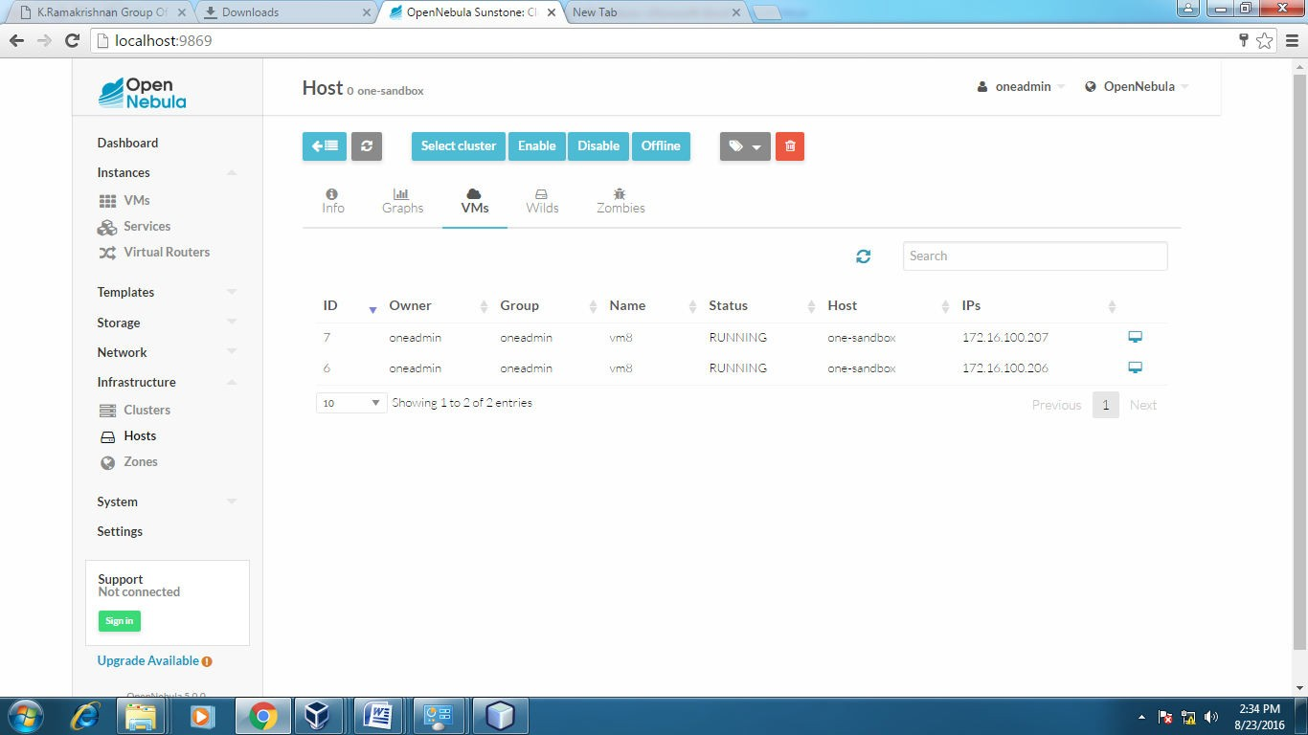

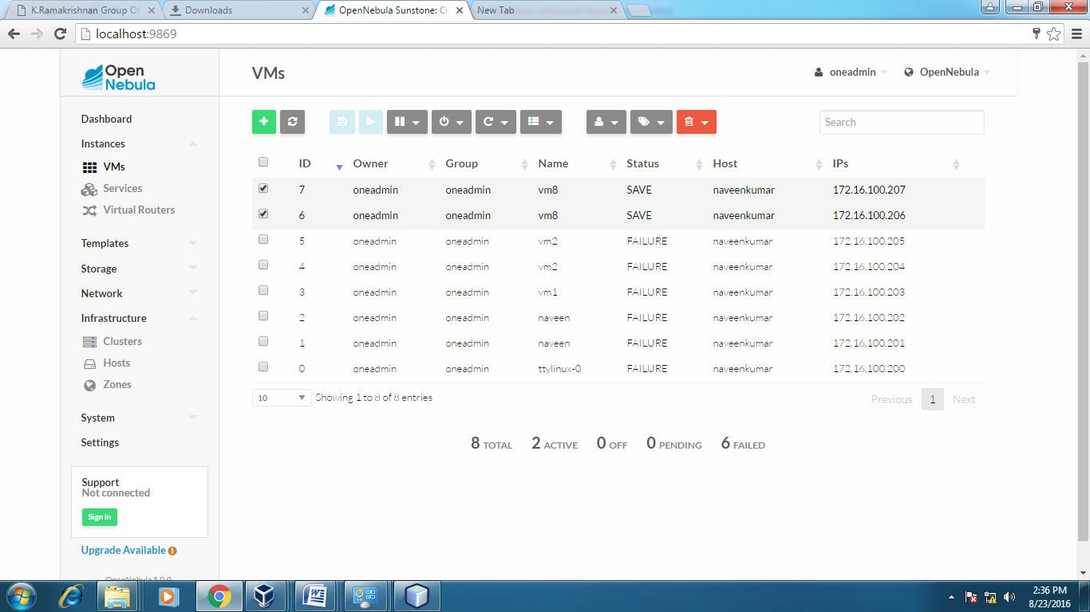

**After Migration:**

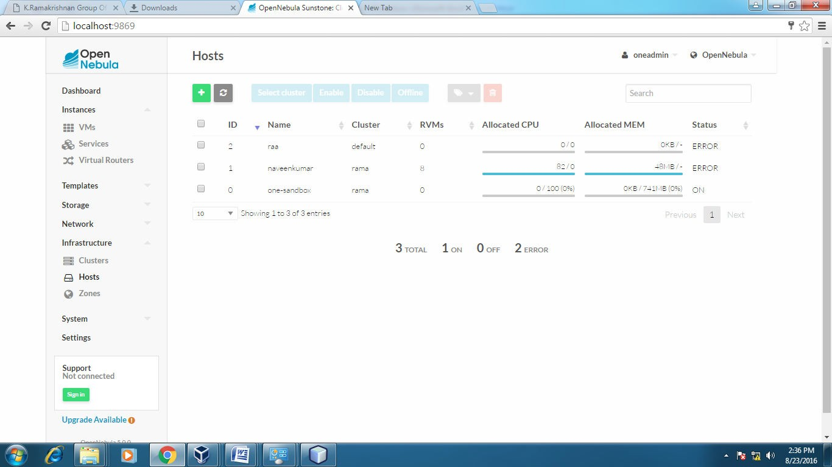

**Host:one-sandbox**

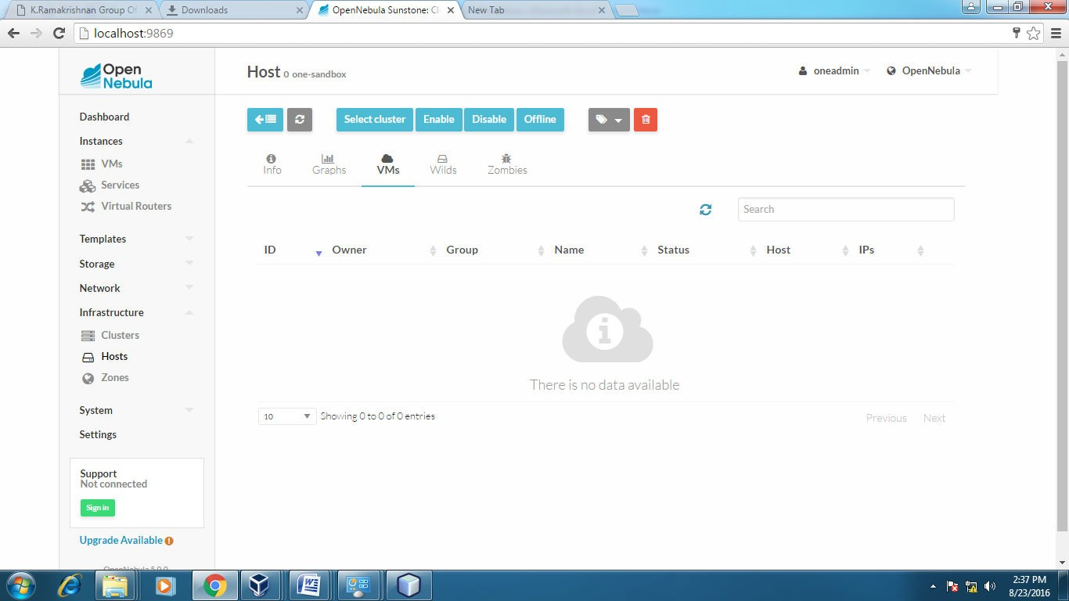

**Host: SACET**

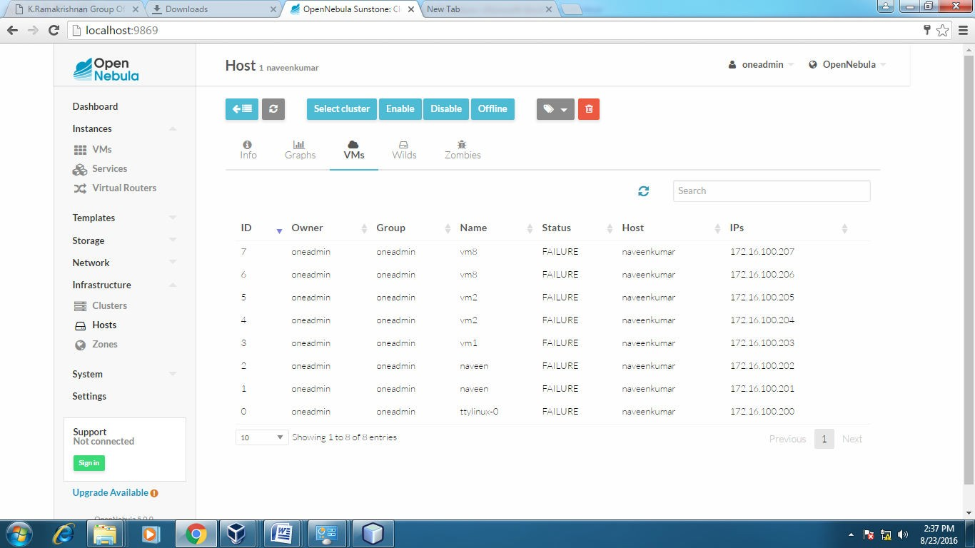

* **Applications:**

Easily migrate your virtual machine from one pc to another.

* **Outcome:-**

Successfully learn to find a procedure to transfer the files from one virtual machine to another virtual machine.

* **Result:-**

Thus, we completed the experiment onfind a procedure to transfer the files from one virtual machine to another virtual machine.