**Experiment No - 09**

* **Title** **-** Perform Case study on Platform as a service for Google app engine/ Facebook .
* **Objectives** **-**

1. To learn and understand the different models of cloud computing Iaas, Pass, Saas.
2. To know in detail about platform as a service.
3. To learn and understand the basics of Google App Engine (GAE).
4. To learn and understand the Overview of Facebook
5. To implement or deploy or test any one platform as a service.

* **Different modules of cloud computing -**

1. **Infrastructure as a Service (IaaS) :** [IaaS](https://cloud.google.com/learn/what-is-iaas) delivers on-demand infrastructure resources, such as compute, storage, networking, and virtualization. With IaaS, the service provider owns and operates the infrastructure, but customers will need to purchase and manage software, such as operating systems, middleware, data, and applications.
2. **Platform as a Service (PaaS) :** [PaaS](https://cloud.google.com/learn/what-is-paas) delivers and manages hardware and software resources for developing, testing, delivering, and managing cloud applications. Providers typically offer middleware, development tools, and [cloud databases](https://cloud.google.com/learn/what-is-a-cloud-database) within their PaaS offerings.
3. **Software as a Service (SaaS) :** SaaS provides a full application stack as a service that customers can access and use. SaaS solutions often come as ready-to-use applications, which are managed and maintained by the cloud service provider.

* **Platform as a Service (PaaS) -**

Platform as a Service, also known as PaaS, is a [type of cloud computing service model](https://cloud.google.com/discover/types-of-cloud-computing) that offers a flexible, scalable cloud platform to develop, deploy, run, and manage apps. PaaS provides everything developers need for application development without the headaches of updating the operating system and development tools or maintaining hardware. Instead, the entire PaaS environment—or platform—is delivered by a third-party service provider via the cloud.

PaaS helps businesses avoid the hassle and cost of installing hardware or software to develop or host new custom applications. Development teams simply purchase pay-as-you-go access to everything they need to build custom apps, including infrastructure, development tools, operating systems, and more.

**Advantages -**

1. Faster time to market
2. Low maintenance
3. Cost-effective pricing
4. Flexible access
5. Shared security

* **Google App Engine (GAE) -**

A scalable runtime environment, Google App Engine is mostly used to run Web applications. These dynamic scales as demand change over time because of Google’s vast computing infrastructure. Because it offers a secure execution environment in addition to a number of services, App Engine makes it easier to develop scalable and high-performance Web apps. Google’s applications will scale up and down in response to shifting demand. Croon tasks, communications, scalable data stores, work queues, and in-memory caching are some of these services.

The App Engine SDK facilitates the testing and professionalization of applications by emulating the production runtime environment and allowing developers to design and test applications on their own PCs. When an application is finished being produced, developers can quickly migrate it to App Engine, put in place quotas to control the cost that is generated, and make the programmer available to everyone. Python, Java, and Go are among the languages that are currently supported.

* **Overview of Facebook –**

Facebook is a social networking website that was founded in February 2004 by Harvard University students Chris Hughes, Andrew McCollum, Dustin Moskovitz, Eduardo Saverin and Mark Zuckerberg. The idea behind Facebook was to provide an online book of faces for university students to connect and share information. It was initially a social network for Harvard and expanded in the following years to any university. It eventually became a social network for anyone, anywhere in the world. Users post information, status updates and pictures of themselves on social networks. These items are shared with friends, family and communities of interest.

* **Implement any one Platform as a Service -**

**Google App Engine (GAE) -**

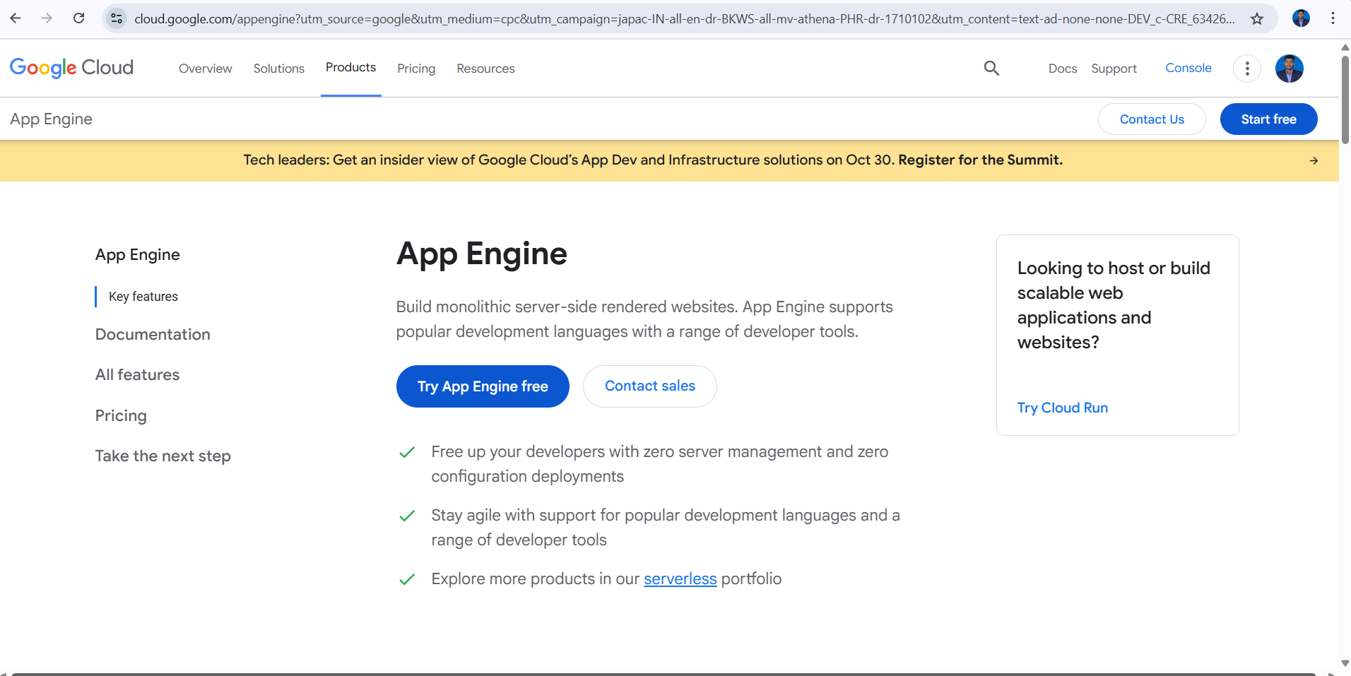

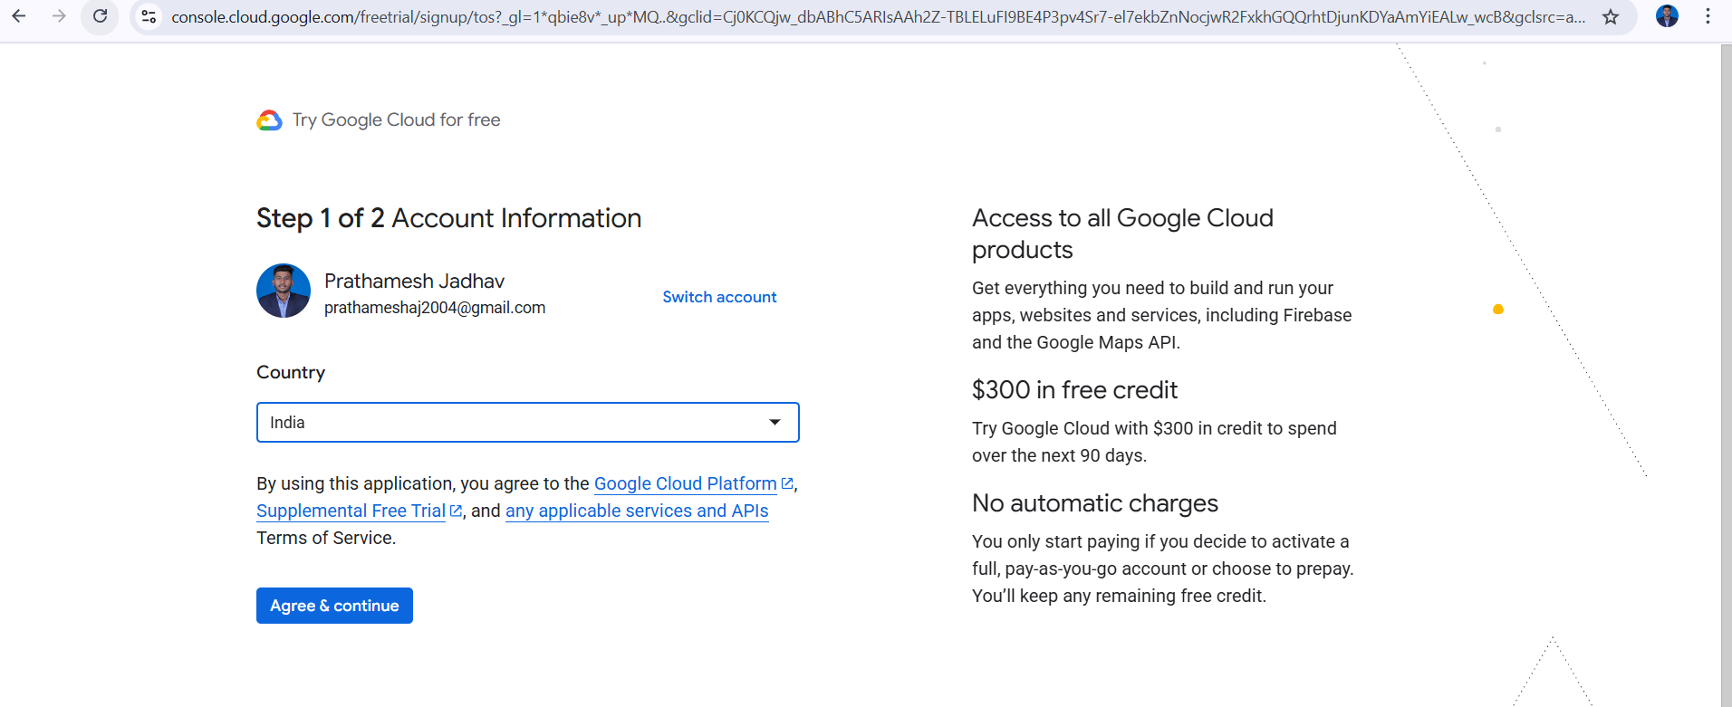

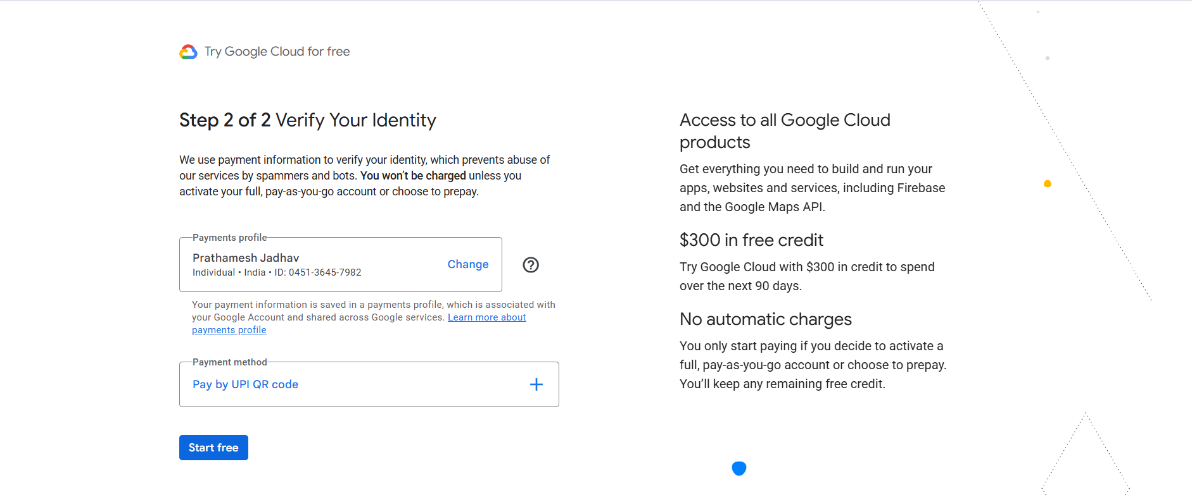

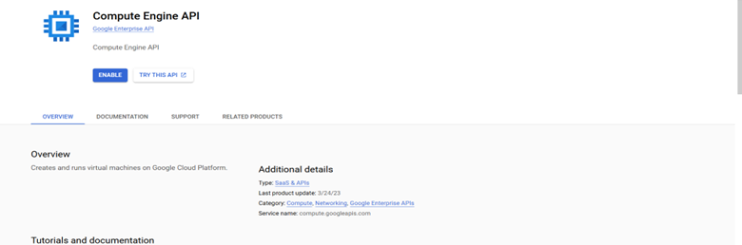

* **Outcome:-**

Successfully learn how to Perform Case study on Platform as a service for Google app engine/ Facebook .

* **Result:-**

Thus, we completed the experiment onPerform Case study on Platform as a service for Google app engine/ Facebook .