**Experiment No 10**

* **Title –** Case study on public, private cloud.
* **Aim –** To case study on public, private cloud.
* **Objectives –**

1. To learn and understand about cloud deployment models (PPH).
2. To learn and understand about public cloud environments.
3. To test / create/ login dashboard in a private cloud.
4. To learn and understand about hybrid computing model.
5. Using various metrics identify best suitable cloud environment (public / private).
6. To test the private cloud in any of this platforms(AWS/ Goggle/ Alibaba/ Azure).

* **Cloud deployment models (PPH) -**

A cloud deployment model fundamentally determines where the infrastructure for your deployment exists and who owns and controls that infrastructure. It also figures out the nature and intention of the cloud. The initial stop for any business seeking to embrace cloud services is to be familiar with the deployment models that are available. When these are familiar, an improved choice can be made as to which avenues the company should pursue. Every model will provide its strengths and weaknesses in governance, scalability, security, flexibility, cost, and management.

1. **Public Cloud :** The public cloud makes it possible for anybody to access systems and services. The public cloud may be less secure as it is open to everyone. The public cloud is one in which cloud infrastructure services are provided over the internet to the general people or major industry groups. The infrastructure in this cloud model is owned by the entity that delivers the cloud services, not by the consumer. It is a type of cloud hosting that allows customers and users to easily access systems and services.
2. **Private Cloud :** The private cloud deployment model is the exact opposite of the public cloud deployment model. It’s a one-on-one environment for a single user (customer). There is no need to share your hardware with anyone else. The distinction between private and public clouds is in how you handle all of the hardware. It is also called the “internal cloud” & it refers to the ability to access systems and services within a given border or organization.
3. **Hybrid Cloud** **:** By bridging the public and private worlds with a layer of proprietary software, hybrid cloud computing gives the best of both worlds. With a hybrid solution, you may host the app in a safe environment while taking advantage of the public cloud’s cost savings. Organizations can move data and applications between different clouds using a combination of two or more cloud deployment methods, depending on their needs.

* **Public cloud environments –**

A public cloud is an IT model where public cloud service providers make computing services including compute and storage, develop-and-deploy environments, and applications available on-demand to organizations and individuals over the public internet. Public cloud is a type of computing where resources are offered by a third-party provider via the internet and shared by organizations and individuals who want to use or purchase them. Some public cloud computing resources are available for free, while customers may pay for other resources through subscription or pay-per-usage pricing models.

Public clouds contrast with private cloud models, where the resources are available only to a single organization and the data center is managed either on-premises or off-site by a vendor. For organizations looking for an alternative to traditional on-premises IT architectures or other types of [cloud computing](https://cloud.google.com/learn/what-is-cloud-computing), the public cloud offers nearly infinite scalability and self-service provisioning to meet workload and user demands.

* **Advantages of Public Cloud**

1. Public cloud allows high scalability as the computing resources are available virtually unlimited.
2. As the data centers are located across various regions and geographies public cloud provides high availability and fault tolerance to users.
3. Public cloud allows use of resources on pay as you go model which provides cost efficiency.

* **Disadvantages of Public Cloud**

1. Public cloud is less secure and private as compared to other deployment models as the infrastructure is managed and owned by third party.
2. It provides limited control over infrastructure as compared to private cloud deployments.
3. Vendor lock in can happen because of using services from single cloud service provider.

* **Hybrid computing model –**

A hybrid cloud combines public and private cloud services, giving businesses the best of both worlds scalability from public clouds and security from private clouds. This setup allows companies to store sensitive data privately while using cost-effective public cloud resources for non-sensitive workloads. For example, in software development, teams often use a public cloud to host projects and a private cloud for secure testing. This approach offers flexibility, cost savings, and better control over data and applications.

* **Advantages of Hybrid Cloud :**

1. **Flexibility :** It provides flexibility to use both cloud environments, such as public and private cloud.
2. **Security :** It provides a private cloud to secure sensitive data or information.
3. **Cost effective :** Hybrid cloud costs are less than those of private cloud. It helps the business or organization save money, which is useful for both application support and infrastructure.

* **Disadvantages of Hybrid Cloud :**

1. **Slow Internet connection :** The internet is complex because of public and private clouds. There is too much load on the server.
2. **Visibility :** There is a visibility issue because of the complications of cloud environments. It breaks the environment into multiple clouds, making it tough to view.
3. **Implementation :** In hybrid clouds, the implementation is difficult because storage and servers are required. That's why the implementation takes a lot of time because of the private and public clouds.

* **Referances:-**

1. Difference between public ,private and hybrid cloud gfg.
2. Public and private services and matrix from google cloud.
3. Public,private and hybrid cloud frn alibaba cloud community.
4. Creating alibaba free private cloud.

Steps:-

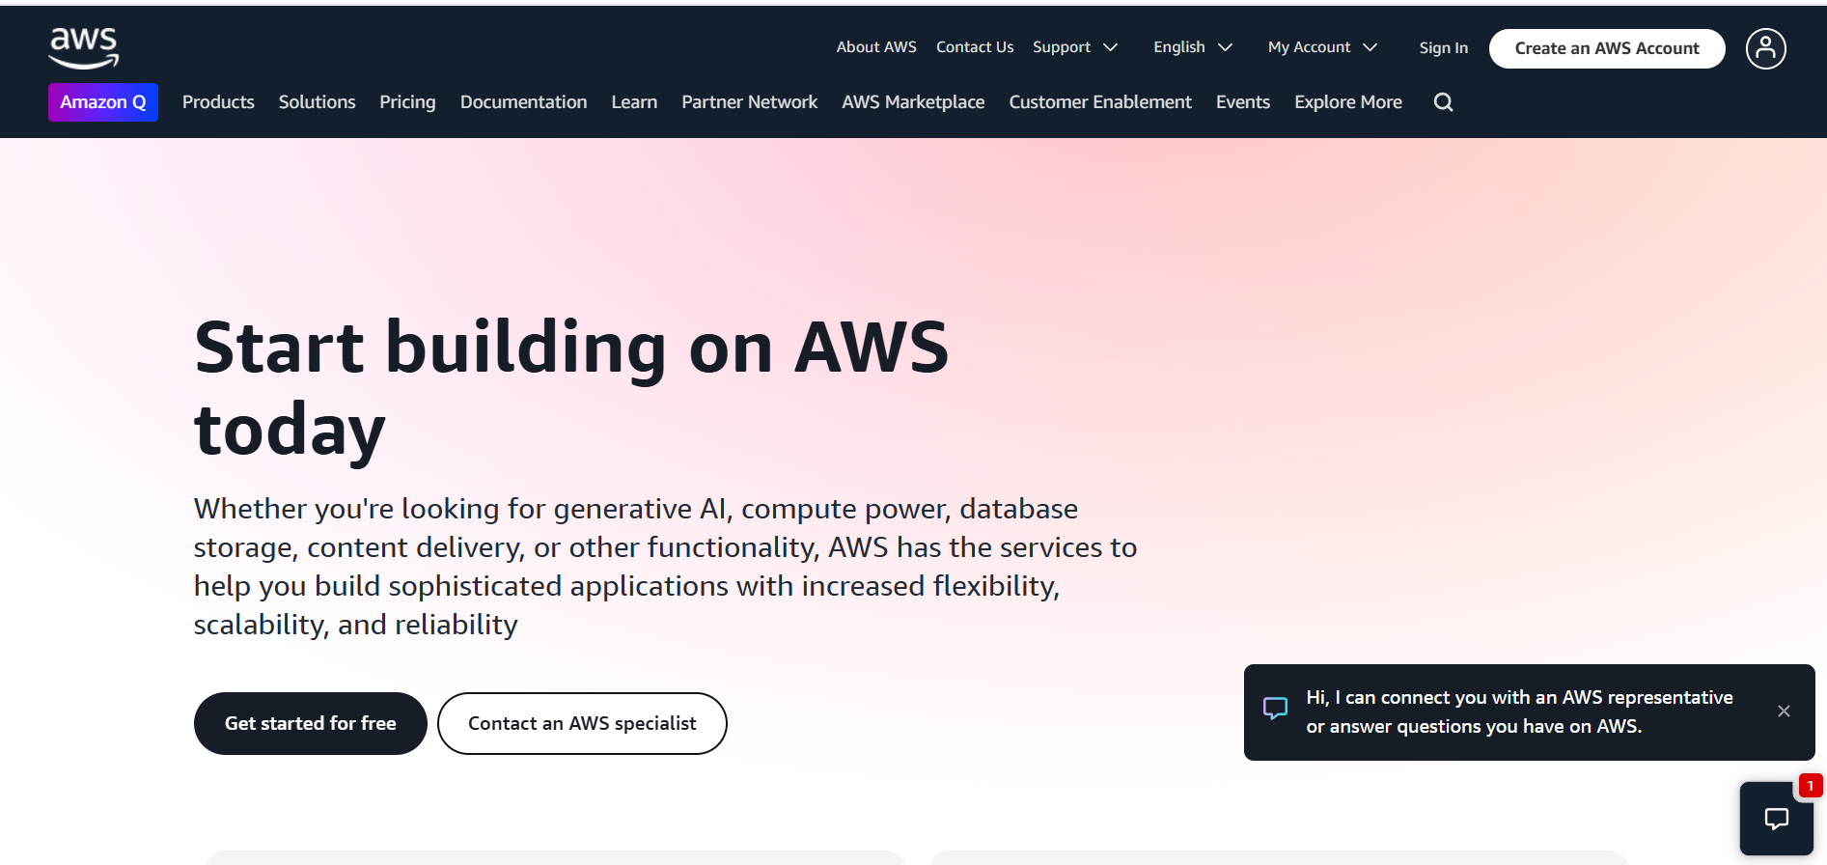

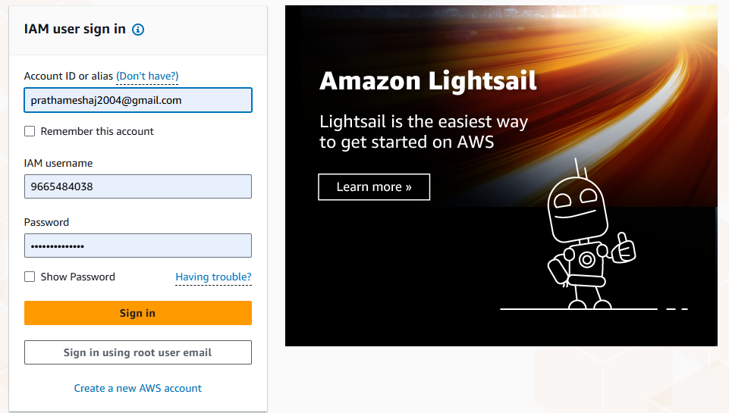

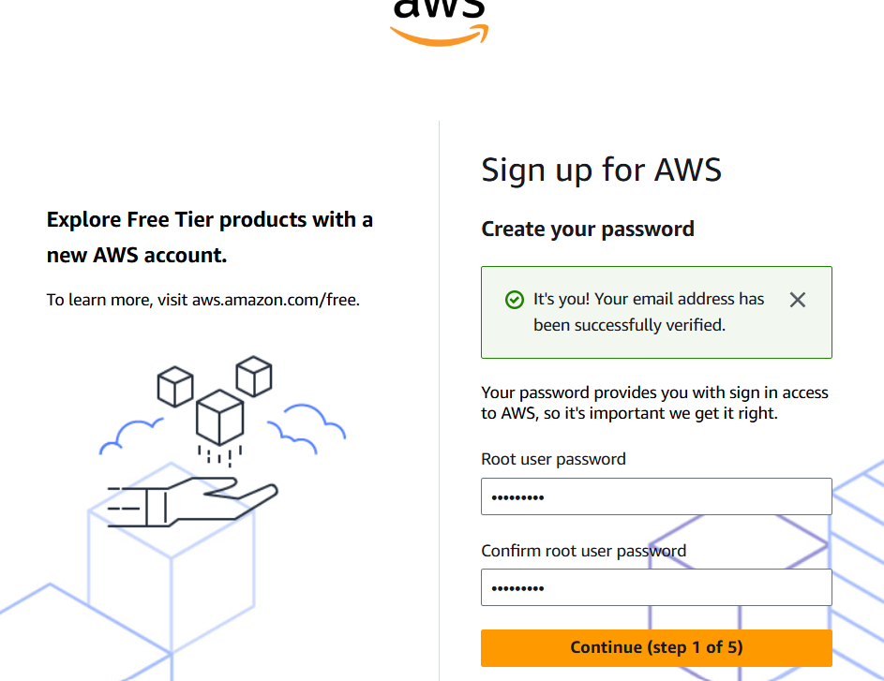

* **Outcome:-**

Successfully learn how to Perform Case study on Platform as a service for Google app engine/ Facebook .

* **Result:-**

Thus, we completed the experiment onPerform Case study on Platform as a service for Google app engine/ Facebook .