**ANNASAHEB DANGE COLLEGE**

**OF ENGINEERING AND TECHNOLOGY**

(An Autonomous Institute) Ashta, Maharashtra –416301)



# **DEPARTMENT OF**

**ARTIFICIAL INTELLIGENCE AND DATA SCIENCE**

**Report On Web Services (ISE- Activity-I)**

**Under The Subject**

**“Cloud Computing (1ADVS313)”**

**Submitted By**

|  |  |  |  |
| --- | --- | --- | --- |
| **Sr.no** | **Roll No** | **Name** | **URN** |
| **1** | **3014** | **Prathamesh Arvind Jadhav** | **1022091028** |

**Under The Guidance Of**

**Prof. Krishnakumar . L**

**Academic Year – 2025-26**

|  |  |  |
| --- | --- | --- |
| **Sr.No** | **Content** | **Page No** |
| **1.** | **Objective** | **3** |
| **2.** | **Introduction** | **3** |
| **3.** | **Web Services** | **4** |
| **4.** | **Working Principles** | **4** |
| **5.** | **Characteristics** | **5** |
| **6.** | **Components Of Web Services** | **6** |
| **7.** | **Web Server Architecture** | **7 - 8** |
| **8.** | **Communication Protocol** | **9 -10** |
| **9.** | **Cloud Based Web Service** | **10** |
| **10.** | **Security In Web Services** | **11** |
| **11.** | **Deployment Models** | **12** |
| **12.** | **Use Cases Of Services Of Cloud Computing** | **12** |
| **13.** | **Objective Questions** | **13 - 16** |
| **14.** | **Subjective Questions** | **17 -21** |
| **15.** | **Conclusion** | **22** |
| **16.** | **Outcome** | **22** |

1. **Objectives:-**

a) Understand Web Services Concepts.

b) Identify Different Types of Web Services

c) Analyse Web Services Advantages & Challenges

d) Compare Cloud Storage Deployment Models.

e) Examine Security & Compliance in Web Services.

f) Evaluate Factors for Choosing a Web Service Provider.

**2. Introduction:-**

Web services in cloud computing are standardized methods that enable applications to communicate and exchange data over the internet. They allow different systems, regardless of their underlying platforms or programming languages, to interact seamlessly. Web services use protocols such as **SOAP (Simple Object Access Protocol)** and **REST (Representational State Transfer)** to facilitate this communication.

In cloud computing, web services play a crucial role in providing on-demand access to resources, enabling businesses to integrate applications, automate workflows, and build scalable, distributed systems. Cloud providers like **Amazon Web Services (AWS), Microsoft Azure, and Google Cloud** offer various web services to support application development, API management, and microservices-based architectures.

**3. Web Service:-**

Web Service is the set of rules or guidelines which enable communication among different applications via the World wide web (.i.e. the internet). Before web service, there were other technologies but some of them have dependencies such as EJB (enterprise java bean) which allows applications to communicate only if the applications are working on Java, these dependencies make communication difficult. These dependencies are removed by web services.

In the present world, applications are developed on a variety of programming languages such as Java, Python, PHP, etc. These heterogeneous applications need communication to happen between them. Since they are developed in different programming languages it becomes difficult to ensure efficient communication between them. Here is where web services come into the picture, web services provide a language-independent way of communication that means the applications working on Java can communicate with other applications working on Python. Therefore, web service helps us to invoke the functionality of other programs in the existing program.

**4. Working Principals:-**

Web services use the request-response method to communicate among applications. For any communication, we need a medium and a common format that can be understood by everyone, in the case of web services medium is the internet and the common format is the XML (Extensible Markup Language) format as every programming language can understand the XML markup language.

A client is the one that requests some service from the server that is known as the service provider. The request is sent through a message which is in common XML format and in response to that request, the service provider will respond with a message in a common format (.i.e. XML).

**5. Characteristics of web services:-**

1. Web services are XML-based as they use XML as a standard language for data exchange as XML allows flexible coding and decoding of data with every programming language and operating system.
2. Web services are coarse-grained. It means they have broader functionality and scope of operations. It is cheaper and provides more fine-grained services in one coarse-grained service.
3. Web Services supports RPCs (Remote Procedure Calls). Web services that use the RPCs style are synchronous, which means the client has to wait for the response after the request. RPCs allows a program to invoke procedure and functions on remote objects.
4. Web services allow loose coupling with the systems that means systems are weekly associated with each other. Web service does not concern with the state of the system involved in the process of communication.
5. Web Services are Synchronous and Asynchronous. In synchronous web services, the client will wait for the response until the server sends the response. Synchronous web service is provided through RPC communication. In Asynchronous web services, the client will not wait for the response and in the meantime, it can continue with other operations processing.

**6. Components Of Web Services:-**

**a) SOAP web services:-**

SOAP stands for Simple Object Access Protocol. These protocols are based on XML which is a lightweight data exchange language. These protocols are independent of language and can be run on any platform.

SOAP supports both stateful and stateless operations. Stateful means that the server keeps track of the information received from the client on each request. While Stateless means that each request contains enough information about the state of the client and thus server does not need to bother about saving the state of the client thus increasing the speed of communication.

Many companies such as IBM, Microsoft are producing an implementation of SOAP into their systems.

**b) RESTful web services:-**

It stands for Representational State Transfer. They are also language and platform-independent and are faster in comparison to SOAP. Nowadays RESTful web services are more used than SOAP. They treat the data as resources. RESTful web services return data in JSON format or XML  format. These web services create the object and send the state of the object in response to the client’s requests, that’s why known as Representational State Transfer.

**7.**  **Web Service Architecture:-**

**a) Client-Server Architecture:-**

Client-server architecture is a cornerstone of modern system design, where the network infrastructure is structured to include multiple clients and a central server. In this model, clients are devices or programs that make requests for services or resources, while the server is a powerful machine or software that fulfills these requests. Communication between clients and the server follows a request-response protocol, such as HTTP/HTTPS for web services or SQL for database queries.

* This architecture allows for efficient data management and resource allocation by centralizing critical functions on the server, which can handle complex processing and large-scale data storage.
* Clients manage user interactions and send specific requests to the server, which processes these requests and sends back appropriate responses.
* The client-server architecture is highly scalable, as it can accommodate more clients by scaling the server's capabilities or adding additional servers.
* This design is prevalent in various applications, including web services, database management, and email systems, providing a robust framework for developing and managing complex, distributed systems efficiently.

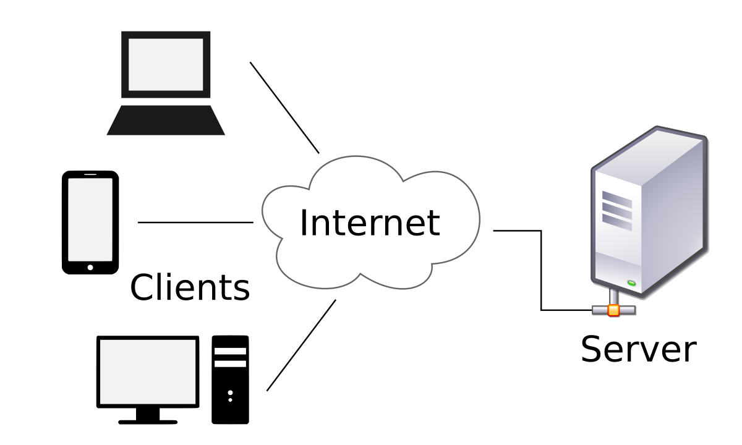

**b) Service-Oriented Architecture (SOA):-**

Service-Oriented Architecture (SOA) is a stage in the evolution of application development and/or integration. It defines a way to make software components reusable using the interfaces.

Formally, SOA is an architectural approach in which applications make use of services available in the network. In this architecture, services are provided to form applications, through a network call over the internet. It uses common communication standards to speed up and streamline the service integrations in applications. Each service in SOA is a complete business function in itself. The services are published in such a way that it makes it easy for the developers to assemble their apps using those services. Note that SOA is different from microservice architecture.

* SOA allows users to combine a large number of facilities from existing services to form applications.
* SOA encompasses a set of design principles that structure system development and provide means for integrating components into a coherent and decentralized system.
* SOA-based computing packages functionalities into a set of interoperable services, which can be integrated into different software systems belonging to separate business domains.

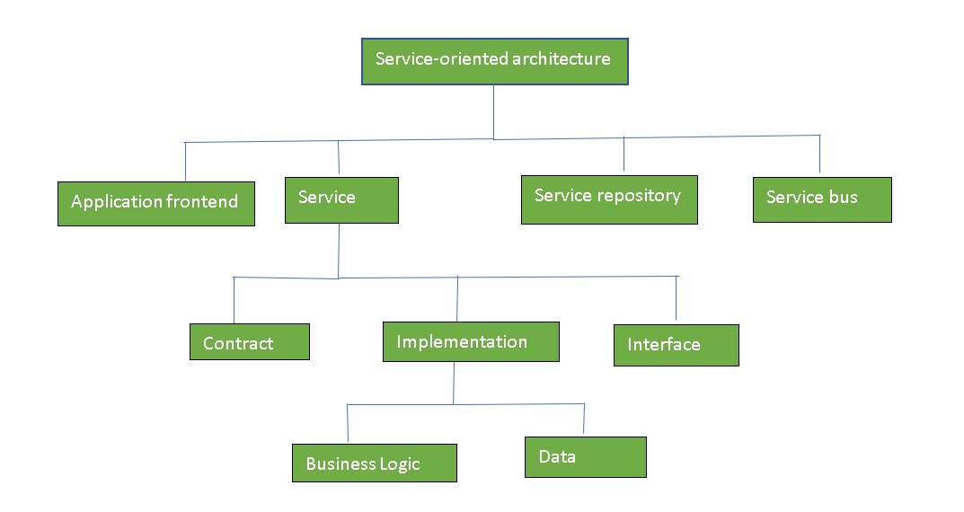

**8. Communication Protocols:-**

**1. HTTP/HTTPS (HyperText Transfer Protocol / Secure):-**

* **HTTP (HyperText Transfer Protocol)** is the foundation of web communication, used to transfer data between clients and servers.
* **HTTPS (HTTP Secure)** is an encrypted version of HTTP, using **SSL/TLS** to ensure secure communication.
* **Key Features:**  
   1. Widely used for RESTful web services.  
   2. Supports multiple request methods (**GET, POST, PUT, DELETE**).  
   3. HTTPS ensures **data encryption and security**.
* **Example:** A REST API for a weather service where a client sends an HTTP **GET request** to retrieve temperature data.

**2. XML-RPC (XML Remote Procedure Call):-**

* XML-RPC is a **lightweight protocol** that enables communication between applications using **XML-formatted requests** over HTTP.
* It allows remote execution of procedures (functions) on a server.
* **Key Features:**  
  1. Uses XML for structured data exchange.  
  2. Supports remote method invocation (**function calls between systems**).  
  3. Simpler than SOAP but less flexible than REST.
* **Example:** A **blogging platform** where a desktop application remotely publishes a blog post using XML-RPC.

**3. JSON-RPC (JavaScript Object Notation Remote Procedure Call):-**

* JSON-RPC is a **lightweight, stateless protocol** similar to XML-RPC but uses **JSON format** instead of XML for data exchange.
* It enables **remote method invocation** between distributed systems.
* **Key Features:**  
  1. Uses **JSON**, making it faster and more compact than XML-RPC.  
  2. Supports **batch processing** (multiple requests in a single call).  
  3. Commonly used in modern web applications and APIs.
* **Example:** A **cryptocurrency wallet** interacting with a blockchain node using JSON-RPC to fetch transaction details.

**9. Cloud Based Web Services:-**

**1. AWS Web Services (Amazon Web Services):-**

AWS provides a vast range of cloud services, including computing, storage, and API management.

🔹 **Key Services:**

* **API Gateway** – Manages and secures APIs at scale.
* **Lambda** – Serverless computing for running code without managing servers.
* **EC2 (Elastic Compute Cloud)** – Scalable virtual machines for hosting applications.
* **S3 (Simple Storage Service)** – Object storage for data backup and content distribution.

🔹 **Use Case:** A mobile app using **AWS Lambda** and **API Gateway** to process user requests dynamically.

**2. Google Cloud Web Services:-**

Azure provides cloud-based solutions with strong enterprise integration and hybrid cloud support.

🔹 **Key Services:**

* **Azure Functions** – Serverless event-driven execution for microservices.
* **API Management** – Securely exposes and manages APIs for internal and external use.

🔹 **Use Case:** A **corporate HR system** using **Azure API Management** to integrate third-party services securely.

**10. Security In Web Services:-**

**a) Authentication (OAuth, JWT, API Keys)**

Authentication ensures that only authorized users or systems can access web services.

* **Key Methods:**
* **OAuth (Open Authorization):** A token-based authentication framework used for delegated access (e.g., logging into apps via Google/Facebook).
* **JWT (JSON Web Token):** A compact, encrypted token used for secure authentication and authorization.
* **API Keys:** Unique identifiers passed in requests to verify and authenticate API consumers.
* **Example:** A mobile app using **OAuth 2.0** to authenticate users via Google login.

**b) Encryption (SSL/TLS):-**

Encryption protects data during transmission between clients and servers.

* **Key Methods:**
* **SSL (Secure Sockets Layer) / TLS (Transport Layer Security):** Encrypts HTTP traffic to create **HTTPS** connections.
* **End-to-End Encryption:** Ensures that only the sender and recipient can access the data.
* **Example:** A banking website using **HTTPS (TLS encryption)** to secure customer transactions.

**c) Data Integrity and Compliance:-**

Ensuring data is **accurate, unaltered, and compliant** with security regulations.

* **Key Aspects:**
* **Hashing & Digital Signatures:** Verify that data is not tampered with during transmission.
* **Compliance Standards:** GDPR (EU data protection), HIPAA (healthcare security), and PCI-DSS (payment security).
* **Example:** An e-commerce platform ensuring **PCI-DSS compliance** to securely process credit card payments.

**11. Deployment Models:-**

**a)** **Public Cloud Web Services –** Hosted by third-party cloud providers like AWS, Google Cloud, and Microsoft Azure, public cloud web services are cost-effective, scalable, and accessible over the internet. They are ideal for startups, SaaS applications, and enterprises looking for on-demand resources without managing infrastructure.

**b)** **Private Cloud Web Services –** Designed for a single organization, private clouds provide greater security, control, and customization. These services are hosted either on-premises or by a dedicated cloud provider. Private clouds are widely used in industries like finance, healthcare, and government, where strict security and compliance are required.

**c) Hybrid Cloud Web Services –** A combination of public and private clouds, hybrid cloud web services balance security with scalability. Organizations can store sensitive data in a private cloud while using public cloud resources for less critical workloads. This model is ideal for businesses requiring flexibility, disaster recovery, and optimized resource utilization.

**12. Use Cases Of Services Of Cloud Computing:-**

**a) Cloud-Based API Integrations** :-

Web services facilitate **API-driven integrations** between different applications, platforms, and services. Businesses use APIs to connect CRM systems, payment gateways, and third-party tools without complex infrastructure management.  
**Example:** An **e-commerce website** integrating with a third-party **payment API** (PayPal, Stripe) to process transactions securely.

**b)** **SaaS Applications**:-

Software-as-a-Service (SaaS) applications rely on cloud-based web services to deliver **on-demand software** without installation or maintenance. Web services handle **user authentication, data processing, and real-time updates** across multiple devices.  
**Example:** **Google Drive and Microsoft 365** use web services to provide cloud-based file storage, editing, and collaboration.

**c)** **IoT Communication**:-

Web services enable **Internet of Things (IoT) devices** to send and receive data in real time via the cloud. This ensures remote monitoring, automation, and analytics for smart devices.  
**Example:** **Smart home systems** (like Alexa, Google Nest) use cloud web services to process voice commands and control IoT devices.

**13. Objective Questions:-**

**1. What is the primary function of web services?**

a) To store large amounts of data  
b) To enable communication between different applications over the internet  
c) To create physical networks  
d) To replace all desktop applications

**Answer:** **b) To enable communication between different applications over the internet**  
**Explanation:-** Web services act as a bridge between applications running on different platforms by using standard protocols like **SOAP, REST, and GraphQL** to exchange data over the internet.

**2. Which of the following is NOT a web service communication protocol?**

a) SOAP  
b) REST  
c) JSON  
d) XML-RPC

**Answer:** **c) JSON**  
**Explanation:** **JSON (JavaScript Object Notation)** is a lightweight data exchange format, but it is not a communication protocol. **SOAP, REST, and XML-RPC** are protocols used for communication in web services.

**3. What does REST stand for in web services?**

a) Representational State Transfer  
b) Remote Execution of Services and Transactions  
c) Reliable System Transfer  
d) Random Event Session Tracking

**Answer:** **a) Representational State Transfer**  
**Explanation:** **REST** is an architectural style for web services that uses HTTP methods (**GET, POST, PUT, DELETE**) to interact with resources, making it lightweight and scalable.

**4. Which security mechanism is commonly used in web services?**

a) API Keys  
b) OAuth  
c) JWT (JSON Web Token)  
d) All of the above

**Answer:** **d) All of the above**  
**Explanation:** Web services use multiple authentication and security mechanisms:

* **API Keys**: Simple and widely used for API authentication.
* **OAuth**: A token-based authentication framework used for secure authorization.
* **JWT**: A compact, encrypted format for securely transmitting authentication data between parties.

**5. Which cloud computing model provides web services over the internet to multiple users?**

a) Private Cloud  
b) Public Cloud  
c) Hybrid Cloud  
d) Local Cloud

**Answer:** **b) Public Cloud**  
**Explanation:** In a **Public Cloud**, third-party providers like **AWS, Google Cloud, and Azure** host and manage web services, making them accessible over the internet to multiple users.

**6. Which AWS service is used to manage APIs in cloud-based web services?**

a) AWS Lambda  
b) Amazon S3  
c) AWS API Gateway  
d) Amazon EC2

**Answer:** **c) AWS API Gateway**  
**Explanation:** **AWS API Gateway** enables developers to create, deploy, and manage APIs that allow communication between cloud applications and services.

**7. What is the main advantage of using Microservices Architecture in web services?**

a) Monolithic structure  
b) Scalability and independent deployment  
c) Single large application deployment  
d) Less security

**Answer:** **b) Scalability and independent deployment**  
**Explanation:** **Microservices** architecture allows applications to be broken into smaller, independent services that can be deployed, managed, and scaled separately, improving flexibility and performance.

**8. What is the purpose of XML-RPC in web services?**

a) To define how APIs are documented  
b) To send remote procedure calls using XML over HTTP  
c) To encrypt data before transmission  
d) To replace JSON

**Answer:** **b) To send remote procedure calls using XML over HTTP**  
**Explanation:** **XML-RPC** is a protocol that uses **XML format** to encode remote procedure calls (RPCs) and transmits them over **HTTP**, allowing communication between different applications.

**9. Which layer in web services ensures secure data transmission using encryption?**

a) Application Layer  
b) Transport Layer  
c) Data Link Layer  
d) Network Layer

**Answer:** **b) Transport Layer**  
**Explanation:** The **Transport Layer** ensures secure communication in web services by using **SSL/TLS encryption** for data transmission over HTTPS.

**10. What is the difference between SOAP and REST web services?**

a) SOAP is protocol-based, REST is architecture-based  
b) SOAP uses JSON, REST uses XML  
c) REST is only used for mobile applications  
d) SOAP does not support security features

**Answer:** **a) SOAP is protocol-based, REST is architecture-based**  
**Explanation:** **SOAP (Simple Object Access Protocol)** is a **strict protocol** that defines rules for messaging, while **REST (Representational State Transfer)** is a **flexible architectural style** that allows APIs to be built using standard web protocols like HTTP.

**14. Subjective Questions:-**

**1. What are web services in cloud computing? Explain their importance in modern applications.**

**Answer:**  
Web services are **standardized methods of communication** between different software applications over the internet. They allow applications to **exchange data and functionality** using web protocols like **HTTP, SOAP, and REST**.

* **Importance in Modern Applications:**
* Enables **interoperability** between different platforms (e.g., Java, .NET, Python).
* Facilitates **scalability** and **cloud-based API integrations**.
* Supports **SaaS, IoT, and mobile applications**.
* Allows **real-time data exchange** in distributed systems.
* **Example:** Google Drive provides web services that allow third-party apps to access and modify stored files.

**2. Compare SOAP and REST web services with their advantages and limitations.**

**Answer:**

| **Feature** | **SOAP (Simple Object Access Protocol)** | **REST (Representational State Transfer)** |
| --- | --- | --- |
| **Architecture** | Protocol-based | Architectural style |
| **Data Format** | XML | JSON, XML, YAML, etc. |
| **Security** | Built-in security (WS-Security) | Requires additional security mechanisms (OAuth, JWT) |
| **Performance** | Slower due to heavy XML processing | Faster due to lightweight JSON format |
| **Flexibility** | Strict standards, less flexible | More flexible and widely used in modern APIs |
| **Use Case** | Banking and enterprise applications requiring strict security | Web, mobile, and cloud applications |

**3. Explain the role of HTTP/HTTPS, XML-RPC, and JSON-RPC in web services.**

**Answer:**  
**1. HTTP/HTTPS** – The most common **protocol for web communication**. HTTPS provides **encrypted and secure data transfer** using **SSL/TLS**.  
**Example:** RESTful APIs in cloud services (AWS, Google Cloud).

2. **XML-RPC** – Uses **XML format** for **remote procedure calls (RPC)** over HTTP.  
**Example:** Used in **WordPress API** for content management.

3. **JSON-RPC** – A **lightweight alternative** to XML-RPC, using **JSON format** for communication.  
**Example:** Used in **cryptocurrency APIs** (e.g., Bitcoin API).

**4. How do OAuth, JWT, and API Keys help in securing web services?**

**Answer:**  
1. **OAuth (Open Authorization)** – A token-based authentication method allowing third-party apps to access user data without sharing passwords.  
**Example:** **Google Sign-in** for third-party apps.

2. **JWT (JSON Web Token)** – A compact and secure token format used for **authentication and authorization** in APIs.  
**Example:** Used in **stateless authentication** for microservices.

3. **API Keys** – Unique identifiers used to **authenticate API requests**.  
**Example:** Used in **Google Maps API** for access control.

**5. Compare Public Cloud, Private Cloud, and Hybrid Cloud web services.**

**Answer:**

| **Deployment Model** | **Description** | **Example Use Case** |
| --- | --- | --- |
| **Public Cloud** | Services are hosted by **third-party providers** and shared among multiple users. | SaaS applications like Gmail, Dropbox |
| **Private Cloud** | Dedicated infrastructure for **a single organization**. | Banking & healthcare data storage (e.g., IBM Cloud) |
| **Hybrid Cloud** | Combination of **public & private cloud** for flexibility. | Large enterprises storing sensitive data privately while using public cloud for scalability |

**6. How are web services used in SaaS applications? Provide examples.**

**Answer:**  
🔹**SaaS (Software as a Service)** relies on web services to provide **on-demand access** to applications via the cloud.  
🔹 Web services handle **authentication, data exchange, and API integrations** for SaaS platforms.

**Examples:**

* **Google Drive** – Uses web services to allow users to upload, edit, and share files.
* **Salesforce CRM** – Uses web services to integrate with third-party marketing tools.

**7. What is Microservices Architecture in web services? How does it differ from Monolithic Architecture?**

**Answer:**  
🔹 **Microservices Architecture** – A design pattern where applications are divided into **small, independent services** that communicate via APIs.

| **Feature** | **Monolithic Architecture** | **Microservices Architecture** |
| --- | --- | --- |
| **Scalability** | Limited | Highly scalable |
| **Deployment** | Single unit | Independent services |
| **Fault Tolerance** | Failure affects entire system | Failure affects only one service |
| **Technology** | Single technology stack | Can use different technologies per service |

**8. Explain how web services enable IoT communication.**

**Answer:**  
🔹 Web services allow **IoT devices** to communicate over the internet using RESTful APIs and MQTT protocols.  
🔹 Cloud platforms process and store IoT data for **analytics and automation**.

**Example:**

* **Smart Home Systems (Google Nest, Alexa)** – Uses web services to connect IoT devices (lights, thermostats, cameras).
* **Healthcare Monitoring** – IoT sensors send patient data to cloud-based web services for real-time tracking.

**9. What are the challenges of using web services in cloud computing?**

**Answer:**  
🔹 **Security Risks** – APIs can be vulnerable to attacks (DDoS, injection attacks).  
🔹 **Performance Issues** – High latency in web service communication.  
🔹 **Data Compliance** – GDPR, HIPAA regulations require strict data handling.  
🔹 **Complexity** – Managing multiple microservices and APIs increases system complexity.

**Example:** A **financial service provider** using cloud-based web services must ensure compliance with **PCI-DSS security standards**.

**10. What are the future trends in web services and cloud computing?**

**Answer:**  
🔹 **Serverless Computing** – Web services like AWS Lambda run without managing servers.  
🔹 **AI & Machine Learning APIs** – Cloud providers offer AI-powered web services for automation.  
🔹 **Edge Computing** – IoT and web services processing data closer to devices (e.g., 5G-powered applications).  
🔹 **Blockchain & Web Services** – Secure and decentralized web service authentication.

**15. Conclusion:-**

Web services play a crucial role in modern cloud computing by enabling seamless communication between applications across different platforms. They provide a standardized way for software components to interact over the internet using protocols like **SOAP, REST, XML-RPC, and JSON-RPC**. Cloud-based web services offered by **AWS, Google Cloud, and Microsoft Azure** enhance scalability, flexibility, and automation for businesses. However, security measures such as **OAuth, JWT, API keys, and SSL/TLS encryption** are essential to ensure data protection and compliance. With the rise of **microservices, serverless computing, and IoT integrations**, web services continue to evolve, shaping the future of cloud-based applications and digital transformation.

**16. Outcome:-**

1. Learn **web services** and explain their role in **cloud computing**.

2. Learn Difference between **SOAP, REST, and GraphQL** web services.

3. Learn **benefits of web services**, such as **scalability, flexibility, and interoperability**.

4. Describe **Public, Private, and Hybrid Cloud** storage models.

5. Learn **authentication mechanisms** like **OAuth, JWT, and API keys**.

6. Compare top cloud providers like **AWS, Google Cloud, and Microsoft Azure** based on their web service offerings.