**GitHub**

1. **App Summary**

GitHub is a cloud-based platform designed for developers to collaborate, manage, and maintain software projects using Git, a distributed version control system. It provides tools for source code management, project tracking, and workflow automation, making it an essential platform for open-source and enterprise-level development.GitHub is widely used due to its ease of use, integration with DevOps pipelines, and large developer community. It supports multiple programming languages and frameworks, making it an essential tool for individuals and businesses working on software development projects.

1. **Service Provided**

In the case of **GitHub**, the **entire platform is accessed via a browser** or Git tools. Users don’t have to worry about server setup, version control infrastructure, or deployment pipelines — everything is hosted and managed in the cloud by GitHub.

1. **Free Services Available**

| **Feature** | **Description** |
| --- | --- |
| **Unlimited Public Repos** | Anyone can create and contribute to public repositories. |
| **Private Repos** | Free users can create private repositories with up to 3 collaborators. |
| **GitHub Actions (CI/CD)** | 2,000 free CI/CD minutes/month for public & private repos. |
| **GitHub Packages** | Store and manage container images or packages with limited storage quota. |
| **Issues & Projects** | Track bugs, enhancements, and assign tasks using Kanban boards. |
| **Codespaces (Free Tier)** | Up to 60 hours/month of cloud-hosted dev environments (currently free). |
| **GitHub Pages** | Host static websites directly from your GitHub repo — great for portfolios. |
| **Basic Security Tools** | Dependency scanning, Dependabot alerts, and basic vulnerability detection. |

1. **Other Similar Services**

| **S.No** | **Platform Name** |
| --- | --- |

|  |  |
| --- | --- |
| 1 | GitLab |

|  |  |
| --- | --- |
| 2 | Bitbucket |

|  |  |
| --- | --- |
| 3 | SourceForge |

|  |  |
| --- | --- |
| 4 | Azure Repos |

|  |  |
| --- | --- |
| 5 | Gitea |

**5. Applications**

**1. Version Control :-**

🔹 **Tracking Code Changes** – Every modification in the code is recorded as a commit, allowing developers to review history and revert if necessary.  
🔹 **Branching & Merging** – Developers can work on different branches without affecting the main code, merging changes once they are ready.

**2. Collaboration:-**

🔹 **Pull Requests & Code Reviews** – Developers can submit pull requests for new features, allowing team members to review and suggest changes before merging into the main branch.  
🔹 **Issue Tracking** – Teams can report bugs, assign tasks, and track project progress using GitHub Issues.

**3. Code Hosting:-**

🔹 **Public & Private Repositories** – Developers can host open-source projects publicly or keep repositories private for confidential work.  
🔹 **GitHub Packages** – Stores and manages software packages for reuse.

**4. Automation (CI/CD Workflows) ⚙️**

🔹 **Continuous Integration (CI)** – Automatically tests code changes before merging to ensure quality.  
🔹 **Continuous Deployment (CD)** – Deploys applications automatically after passing tests.

**6. Merits And Demerits**

* **Merits:-**

**1. Easy Collaboration & Project Management:-**

GitHub makes it easy for multiple developers to work on the same project without conflicts.

**2. Open-Source Community Support:-**

GitHub is home to millions of **open-source projects**, providing a vast knowledge base and developer support.

**3. Integrated CI/CD & Automation Tools:-**

GitHub provides built-in **Continuous Integration (CI) and Continuous Deployment (CD)** tools to automate development workflows.

**4. Secure Code Hosting & Access Control:-**

GitHub ensures **data security, access control, and compliance** for software development teams.

* **Demerits:-**

1. Private repositories require a paid plan.  
2. Learning curve for Git and advanced features.  
3. Can be affected by outages.

**7. Uses**

* Software development and open-source projects.
* Version control and history tracking.
* DevOps and CI/CD pipeline integration.
* Documentation and project management.

**8.** **Uniqueness of GitHub**

* World's **largest developer platform** with massive open-source contributions
* **GitHub Copilot** – AI pair programmer (unique to GitHub)
* **GitHub Pages** for free static site hosting from repos
* **Native GitHub Actions** CI/CD integrated directly into platform

**9. Privacy Policy of the App**

* Collects personal data like email, IP address, and usage behavior.
* Uses cookies for analytics and personalization.
* Allows third-party integrations with permissions.
* Provides control over data sharing and account deletion.

**10. Screenshot**



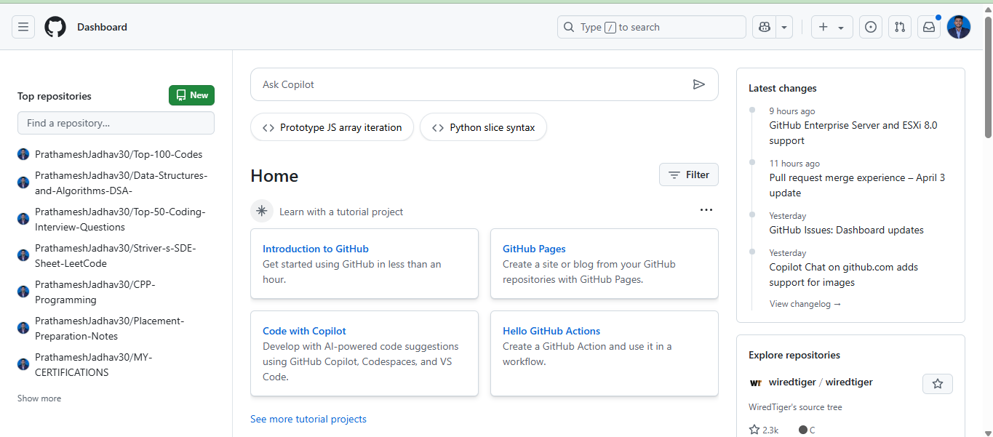





**11. Conclusion**

GitHub is a cloud-based platform that revolutionized software development by enabling seamless collaboration, version control, and automation. It is widely used for open-source projects, enterprise software development, and DevOps integration. With built-in CI/CD workflows, secure code hosting, and project management tools, GitHub enhances productivity and streamlines development processes. While it has a learning curve and some features require a paid plan, its vast developer community and extensive functionality make it an essential tool for modern software development.