

**E&TC Engineering Department**

**Shivnagar Vidhya Prasarak Mandal’s Malegaon BK**

**Third Year of E&TC Engineering 2024-25**

**Semester II**

**Internship Report**

* **Student Name: Khatal Omkar Mohan**
* **Student Roll Number:** 350
* **Name of Company:** PRODIGY INFOTECH
* **Name of Industry Mentor:** Om Sonawane
* **Place of Work:** Online
* **Faculty Mentor:** Prof S.D.KALE
* **Internship Duration:** 1 MONTH (15th January 2025 – 15th February 2025)

**CERTIFICATE**

This is to certify that,

**Khatal Omkar Mohan (350)**

Of class T.E E&TC Engineering have successfully completed their internship on “**Web Development**” at PRODIGY INFOTECH, in the partial fulfilment of the Bachelor’s Degree Course in T.E (E&TC Engineering) 2019 Course, in the academic year 2024-2025 Semester-II as prescribed by the Savitribai Phule Pune University.

Prof. S.D.Kale Prof. R.K.Patil.

**Guide Name** **Head of the Department**

**Date:**

**Place:** Malegaon

**INTERNSHIP PERMISSION LETTER**

**Omkar Mohan Khatal**

khatalomkar2004@gmail.com

To,

The Internship Supervisor,

Dept. of E&TC Engineering

SVPM’S COE Malegaon,

Baramati. 413115

**Subject:** Application to grant the permission to attend the Internship at PRODIGY INFOTECH.

Respected Sir,

I the undersigned **Mr KHATAL OMKAR** studying in T.E. E&TC Engineering Department, SVPM’S COE Malegaon having roll number 350 According to academic’s curriculum, I want to do an internship for this year.

I recently got selected for **PRODIGY INFOTECH to Organize CODELEVATE-INTERNSHIP Web Development Program 2025** per the schedule, the internship will run for 1 Months (Jan to Feb ).

This internship program is an integral part of my education. I also believe it will also help us to learn new technologies of full stack web development like Angular, Spring boot, Hibernate and Server side etc. Therefore, I would appreciate it if you grant me permission to attend.

So, please grant me for the same.

Sincerely,

Omkar Mohan Khatal.

**Prof. S.D.Kale Prof. R.K.Patil**

Internship Supervisor HOD E&TC Department

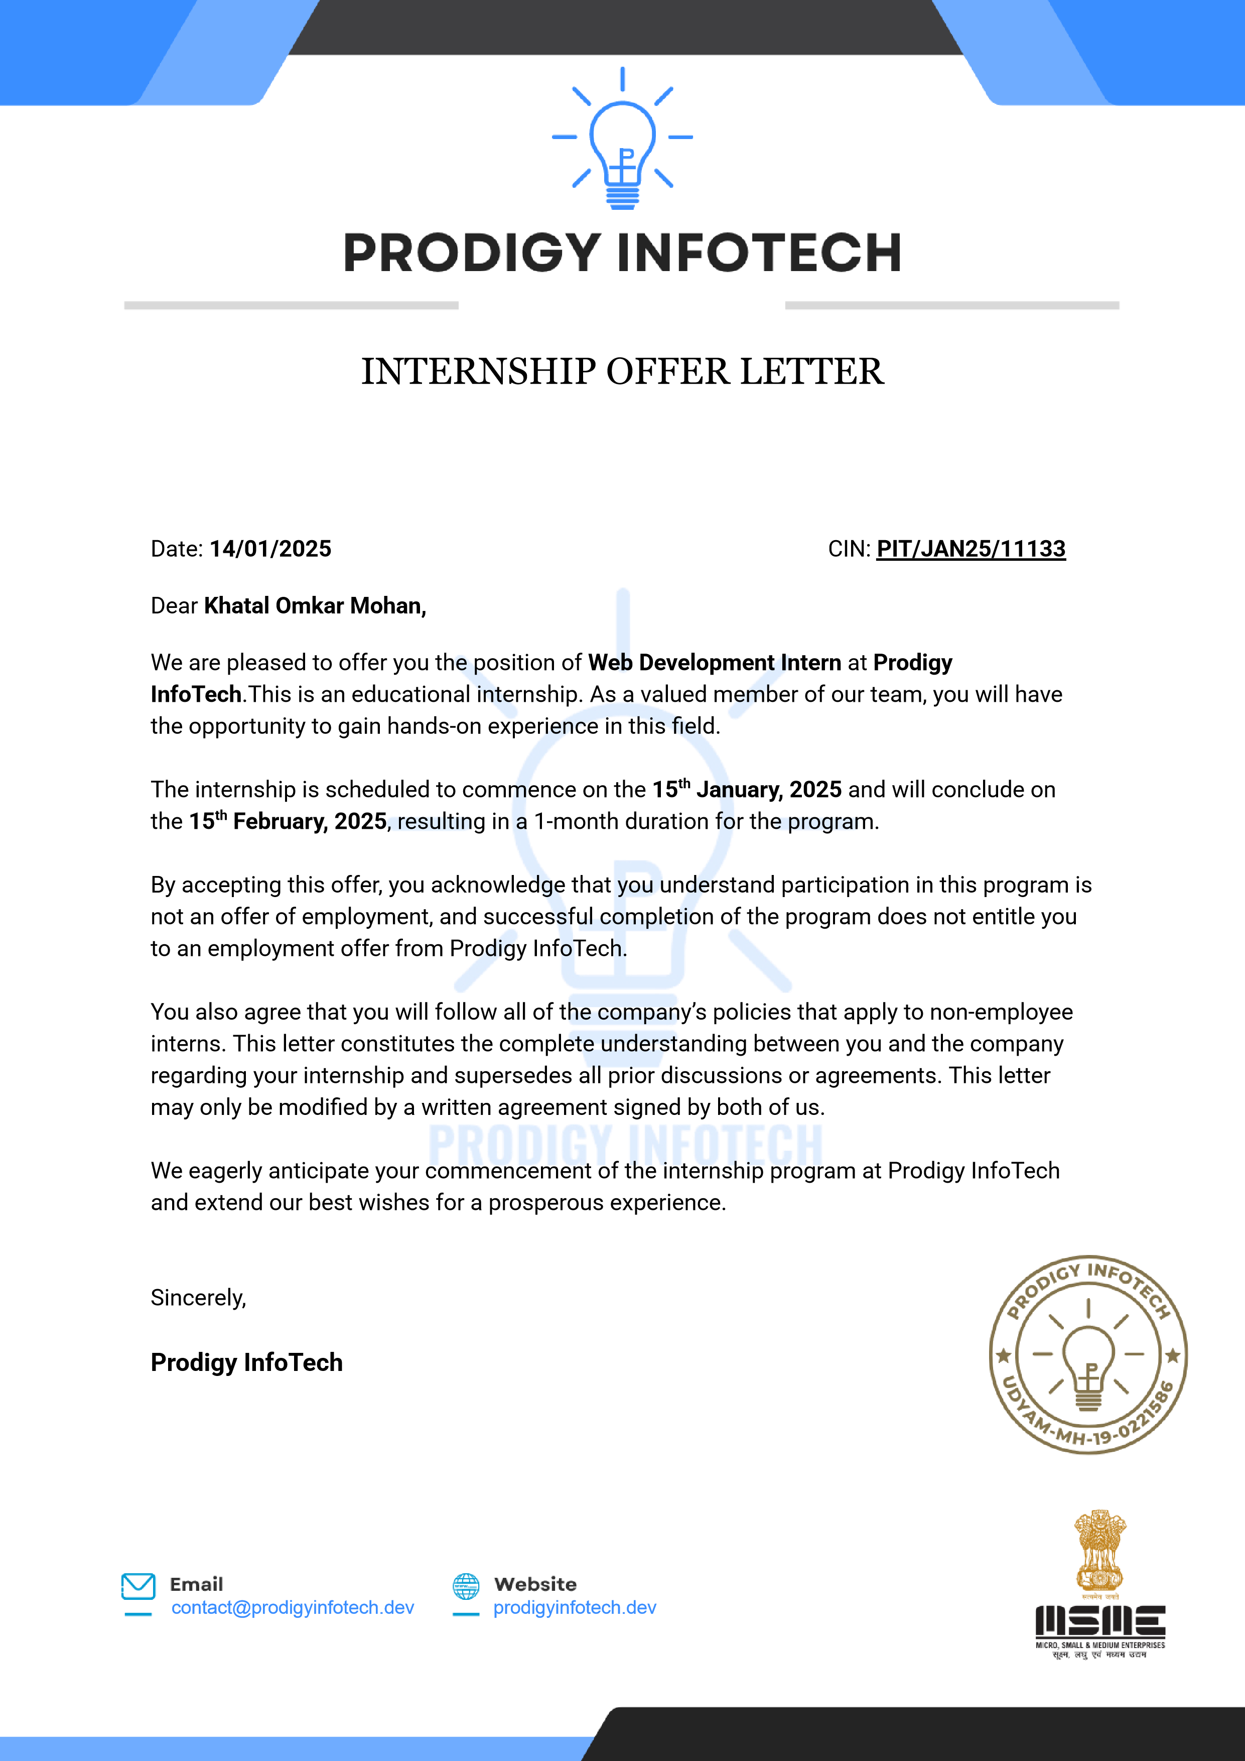**OFFER LETTER BY COMPANY**

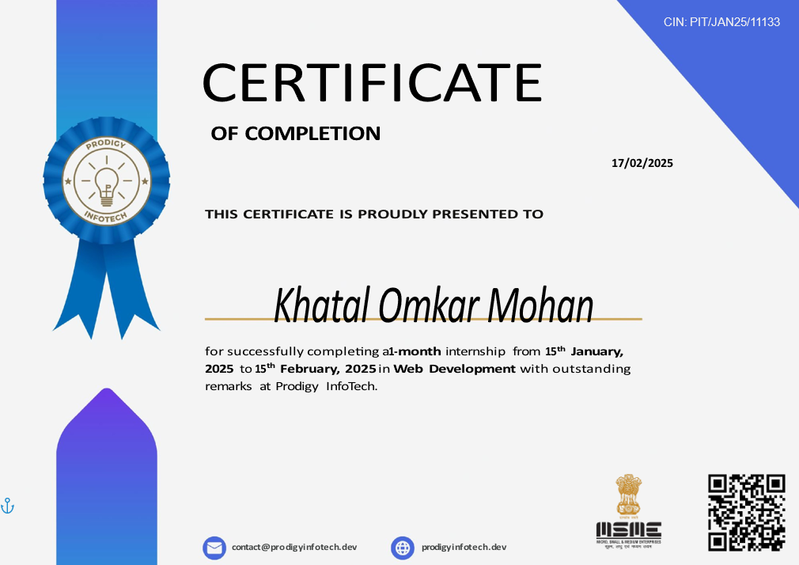

**ACKNOWLEDGEMENT**

I would like to thank everyone who supported and encouraged me during my **Web Development internship at Prodigy Infotech.**, as a part of the **Codelevate Program 2025**. This internship gave me a great opportunity to learn new skills and apply my knowledge through real-world projects.

I am especially thankful to my mentor, **Prof. S.D.Kale**, for always guiding me, answering my questions, and motivating me throughout the internship. His help made it easier for me to understand technical concepts and complete my work confidently.

I would also like to thank **Prof. R.K.Patil**, Head of the E&TC Engineering Department, for providing full support and encouraging me to take part in this internship program.

A big thanks to the team at **PRODIGY INFOTECH.** and the mentors from the **Codelevate Program**, who provided useful feedback, proper training, and a friendly learning environment. Working on projects like the Landing Page, Stopwatch App, Tic-Tac-Toe Game, Portfolio Website, and Organic Food Website helped me grow as a developer and understand how real-world websites are made.

Lastly, I want to thank my **family and friends** for always being there for me, motivating me, and believing in me throughout this journey.

**Khatal Omkar Mohan**

**INDEX**

1. Organization Profile
2. Name of the mentor and contact details from organization
3. Information about work assigned
4. Flow Of Project Execution
5. Week-wise course summary
6. Skills gained
7. Challenges faced & faced
8. Conclusion
9. References

**1. ORGANIZATION PROFILE**

* **Company Name:** Prodigy Infotech
* **Background of the Company:**Prodigy Infotech is a company that focuses on providing digital solutions and skill development opportunities to students and young professionals across India. Their goal is to empower local businesses and the youth by offering practical training in web development, app development, and real-world project work. One of their major initiatives is the **CODELEVATE Internship Program**, which helps students gain hands-on experience in the field of technology. The company encourages learning by doing, and provides internships that involve real tasks like building websites, web apps, and interactive features. Based in Worli Mumbai, Prodigy infotech operates both online and offline, allowing interns from all locations to participate and learn. Their program is recognized under the Ministry of Micro, Small & Medium Enterprises (MSME), and they aim to bridge the gap between college education and industry needs through guided mentorship and practical exposure.

**Key Services & Offerings:**1. Web & App Development  
 – They create websites and mobile apps for small businesses and startups.

2. Internship & Training Programs  
 – They offer hands-on internships like Codelevate, where students learn web development by doing real projects.

3. Student Skill Building  
 – They help students improve their practical skills in HTML, CSS, JavaScript, Bootstrap, and other web tools.

4. Project-Based Learning  
 – Interns work on real websites like landing pages, games, and portfolio sites, which helps them build strong portfolios.

* **Achievements & Impact:**• Guided 5000+ students globally through industry-relevant internships.  
  • Partnered with universities and tech communities for collaborative learning.  
  • Offers well-structured task-based learning with flexible timelines.
* **Address:**

PRODIGY INFOTECH   
Gandhi Nagar, Upper Worli,

Worli, Mumbai - 400018

* **Contact:  
  • Email:** prodigyinfotech@gmail.com **• Website:** https://prodigyinfotech.dev/

**2. MENTOR DETAILS**

* **Name:** Mr. Om Sonwane
* **Designation:** Web Development Mentor
* **Contact:**

**Website:** **https://prodigyinfotech.dev/**

**Role Offered:** Web Developer Intern  
As a Web Developer Intern, I was responsible for creating and deploying responsive web pages.  
I designed multiple UI layouts using HTML and CSS.  
Implemented interactivity through JavaScript and ensured mobile responsiveness using Bootstrap.  
I also tested projects across devices and hosted them using Netlify App.

**3. INFORMATION ABOUT WORK ASSIGNED**

* **Problem Statement**

In today’s digital world, it’s very important for businesses, individuals, and professionals to have an online presence. But many people still struggle to create websites that are attractive, responsive, and easy to use. At the same time, many students like me, who are learning web development, don’t get enough real-world practice to apply what we’ve studied in college.

The main problem I faced before this internship was a **lack of practical experience**. I knew the basics of HTML, CSS, and JavaScript, but I had never built full websites or web apps on my own. I also didn’t know how to design responsive layouts or make interactive features work properly across devices.

This internship at **PRODIGY INFOTECH** , through the **Codelevate Program 2025**, helped me solve that problem. Instead of working on just one project, I got to build **five different mini-projects** — each one teaching me a new skill or concept:

* A **Landing Page** to learn layout and UI design
* A **Stopwatch App** to understand real-time JavaScript functions
* A **Tic-Tac-Toe Game** to work on logic and interactivity
* A **Portfolio Website** to present myself professionally online
* An **Organic Food Website** to apply everything together in a real-world themed site

These tasks helped me turn theory into practice and gave me confidence to build full websites from scratch.

* **Project Titles:**  
  **1. Landing Page**  
   A visually attractive and responsive homepage for a product/service.

**2. Stopwatch Web Application**  
 A functional stopwatch with Start, Stop, Reset, and Lap features using JavaScript.

**3. Tic-Tac-Toe Game**  
 A 2-player interactive web-based game with win/draw logic and reset option.

**4. Personal Portfolio Website**  
 A professional portfolio website showcasing profile, skills, and contact form.

**5. Organic Food Website**  
 A promotional website for organic food products with product cards and contact form.

* **Applications:**

1. **Landing Page:** Brand promotion, product launch intro, or event registration.
2. **Stopwatch App:** Time tracking for fitness routines or academic tasks.
3. **Tic-Tac-Toe:** Educational mini-game, showcases logic and design ability.
4. **Portfolio Website:** Job-seeking, showcasing personal branding.
5. **Organic Food Website:** E-commerce or awareness platform for health-conscious users.

* **Tools & Technologies Used:**

|  |  |  |
| --- | --- | --- |
| **Category** | **Tools / Technologies** | **Purpose / Description** |
| **Languages** | HTML5, CSS3, JavaScript | For structure, styling, and interactivity of websites |
| **Framework** | Bootstrap | For responsive design, grid system, and UI components |
| **Code Editor** | Visual Studio Code (VS Code) | Writing and organizing project code |
| **Version Control** | Git, GitHub | Source code management and collaboration |
| **Deployment** | Netlify | Hosting and deploying live web projects |
| **Design Tools** | Figma (optional/planning), Browser Dev Tools | For planning UI and debugging |
| **Testing Tools** | Chrome Developer Tools | To test responsiveness and fix errors |

* **Objective**

The internship was undertaken with the goal of developing a strong foundation in frontend web development through real-time project implementations. Specific objectives included:

* Understanding the structure and working of modern websites.
* Applying HTML for semantic layout, CSS for styling, Bootstrap for responsiveness, and JavaScript for interactivity.
* Gaining the ability to design UI/UX focused components.
* Learning how to create and host fully functional and responsive websites.
* Developing confidence in deploying projects to production platforms
* **Deliverables:**

During the internship at PRODIGY INFOTECH , I was responsible for building, testing, and deploying a set of diverse web-based projects. Each project focused on a particular skill area such as UI design, interactivity, responsive layout, or personal branding. Below are the key deliverables from the internship:

1. Landing Page
   * Developed a modern and responsive homepage for a sample product/service.
   * Included: navigation bar, hero section with CTA, and responsive layout using Bootstrap.
2. Stopwatch Web App
   * Created a working stopwatch that supports start, stop, reset, and lap functionalities.
   * Implemented time logic using JavaScript event listeners and DOM manipulation.
3. Tic-Tac-Toe Game
   * Designed a two-player web game with real-time interactivity.
   * Delivered win/draw condition checking, grid layout, and reset functionality.
4. Portfolio Website
   * Built a complete personal portfolio to showcase projects and contact info.
   * Sections included About, Projects, and Contact with a functional contact form.
5. Organic Food Website
   * Created a green-themed website to promote organic food and healthy living.
   * Featured responsive product cards, brand messaging, and user-friendly contact form.
   * Project Link: <https://organic-foods12.netlify.app>
6. Code Repository and Hosting
   * All projects were version-controlled using Git and uploaded to GitHub repositories.
   * Live deployment was done using Netlify, ensuring public accessibility and real-time preview.
7. Internship Presentation
   * A formal presentation file was prepared summarizing the entire internship experience, tech stack, project outcomes, and key takeaways.
8. Comprehensive Internship Report
   * A detailed report (this document) covering project insights, learning outcomes, challenges, and technical documentation.

**4. FLOW OF PROJECT EXECUTION**

Step-by-step Process Followed for Each Project:

1. Requirement Gathering and Wireframing
   * Analysed objectives for each task.
   * Sketched layout ideas and structure.
2. Design Phase
   * Selected appropriate colour schemes and UI components.
   * Planned responsive behaviour using Bootstrap Grid System.
3. Development Phase
   * Implemented structure with HTML5.
   * Styled elements using CSS and Bootstrap classes.
   * Wrote JavaScript logic for functional components.
4. Testing and Debugging
   * Cross-browser and cross-device testing.
   * Identified UI glitches, script errors, and fixed them.
5. Hosting and Review
   * Used Netlify for deployment.
   * Peer review and mentor feedback received.

**5. WEEK WISE COURSE SUMMARY**

**Week 1 – Orientation & Basic Design**

* Introduction to internship structure and technologies.
* Overview of HTML, CSS, JavaScript, and Bootstrap.
* Learning about project planning and wireframing.
* Task Assigned: Landing Page
  + Basic layout design using HTML/CSS
  + Bootstrap integration for responsiveness
* **Outcome**: Completed a simple responsive landing page.
* 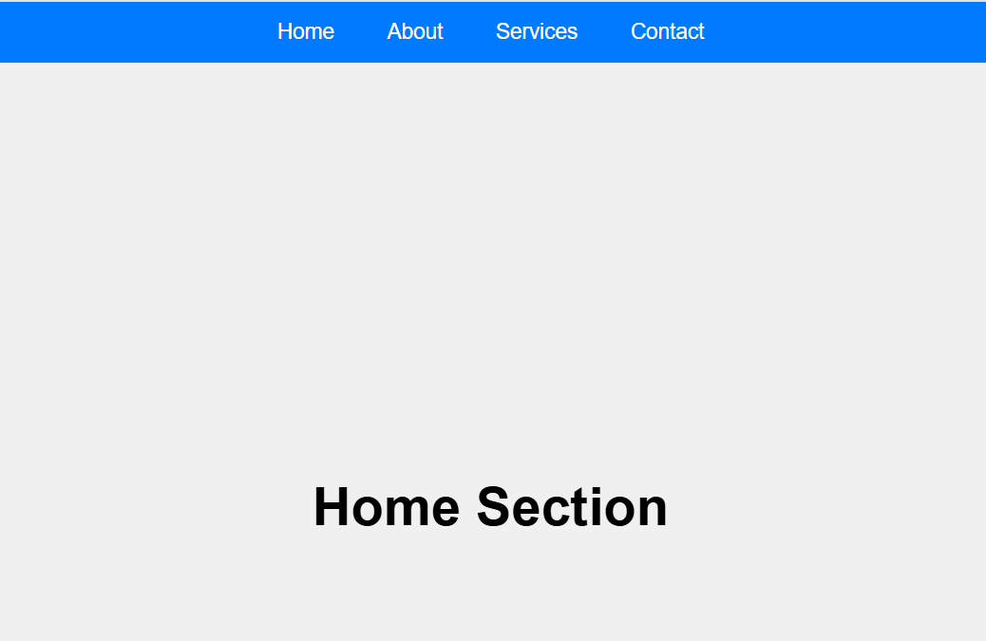**Screen-Shot:**

**Week 2 – JavaScript Programming & Interactivity**

* Introduction to JavaScript syntax, events, and DOM manipulation.
* Logic building for utility-based applications.
* Task Assigned: Stopwatch App
  + Start/Stop/Reset/Lap functionality
  + Precise time tracking and lap counter logic
* **Outcome**: Delivered a working stopwatch with all functions.
* **Screen-Shot:**

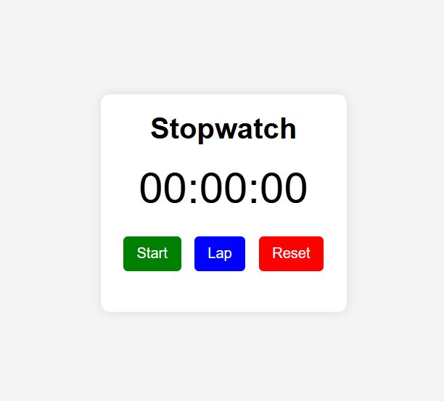

**Week 3 – Logical Projects & Game Development**

* Building interactive applications with more complex logic.
* Game state tracking and event-based UI response.
* Task Assigned: Tic-Tac-Toe Game
  + 2-player logic, win/draw detection
  + Reset functionality and UI enhancement
* **Outcome**: Completed a bug-free browser-based game.
* 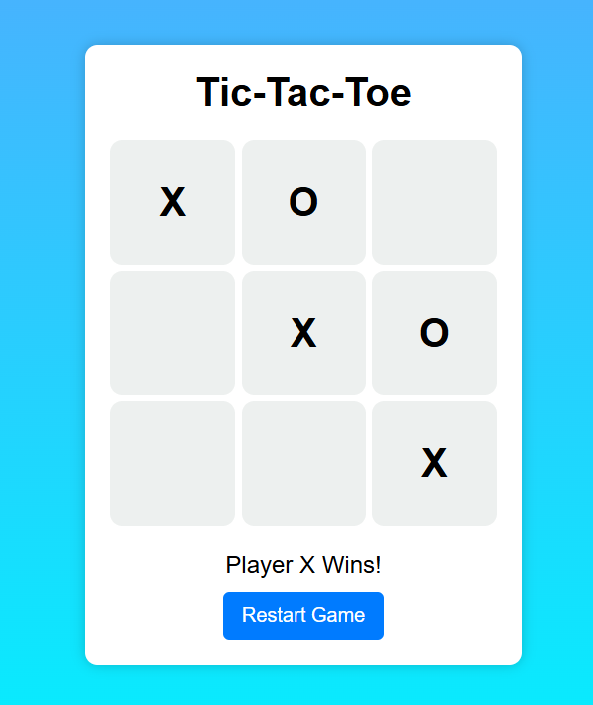**Screen-Shot**:

**Week 4 – Professional Portfolio & Organic Website**

* Design thinking, content structuring, and branding.
* Portfolio creation for showcasing personal work.
* Task Assigned:
  + Portfolio Website: About, Projects, Contact sections
  + Organic Food Website: Product cards, green theme, contact form
* **Outcome**:
  + Hosted two live websites using Netlify.
  + Learned how to present self and ideas professionally online.
* **Screen-Shot:**

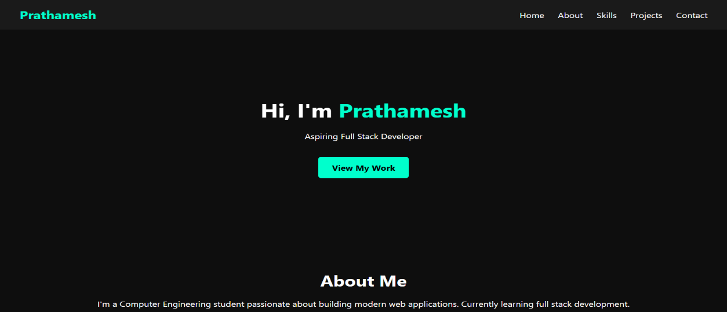

**5. Organic Food Website – (Main Project)**

This was my main and final project during the internship. I created a complete website to promote organic food and a healthy lifestyle. The website had a nature-friendly look with green colours and simple design.

Key Features:

* Clean, green-themed UI representing freshness and nature.
* Product display cards with image, title, and pricing layout (static for demo).
* Contact form for customers to reach out or send inquiries.
* About Us section describing the vision of promoting an organic lifestyle.
* Mobile-responsive layout designed using Bootstrap grid system.

Technical Highlights:

* Built using HTML5 for structure and CSS3 for custom styling.
* Bootstrap was used extensively for responsiveness and layout components.
* JavaScript enabled form validation and basic UI interactions.
* Hosted live using Netlify for public access and demo.

Project Goals:

* Promote awareness about organic food and sustainability.
* Provide a sample site that small organic brands can use or adapt.
* Demonstrate proficiency in layout design, responsiveness, and thematic aesthetics.

**Outcome**:

* Fully functional and visually appealing site completed within the final week of internship.
* Successfully hosted and reviewed by mentor.
* Received appreciation and selected as the highlight project of the internship.

🌐 Project Link: <https://organic-foods12.netlify.app>

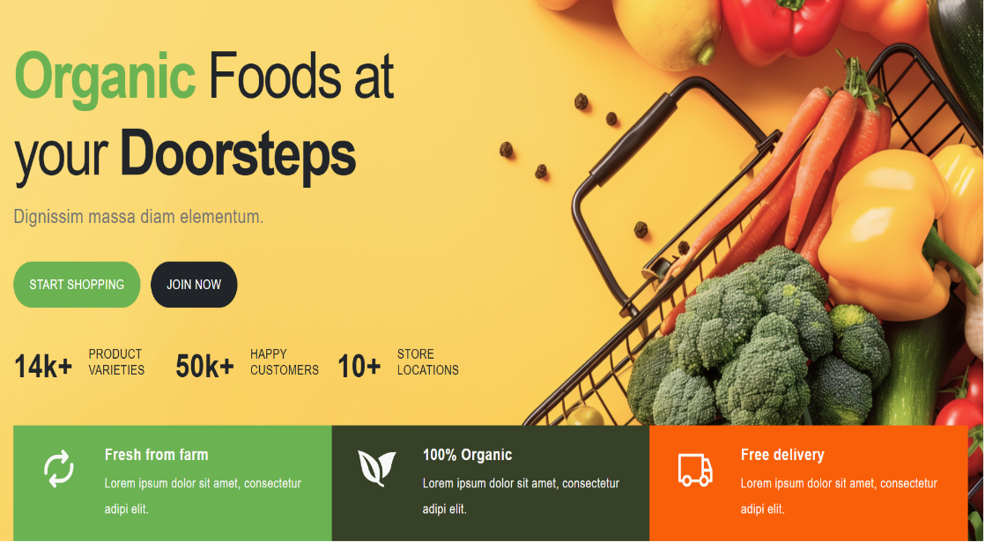**Screen-Shots:**

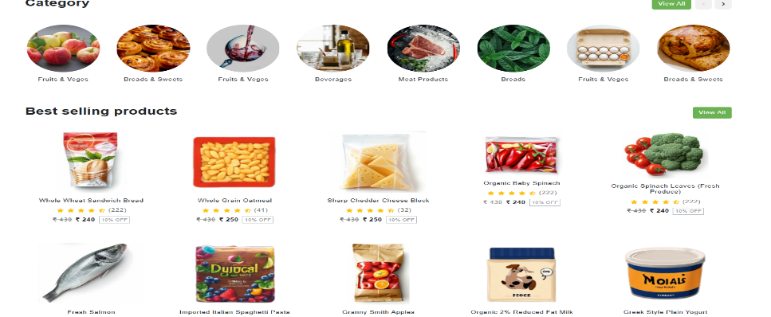

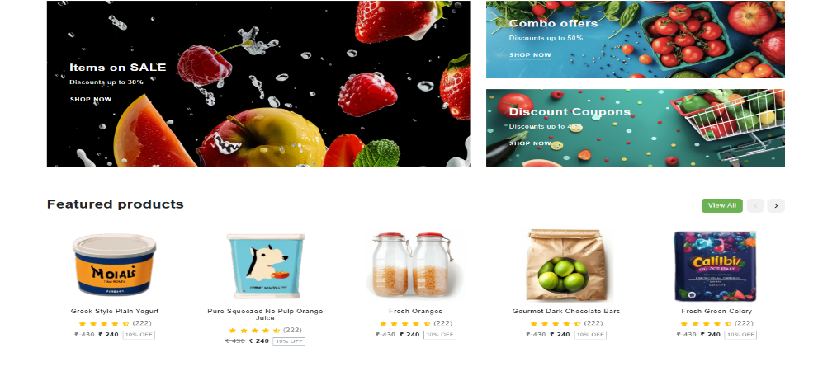

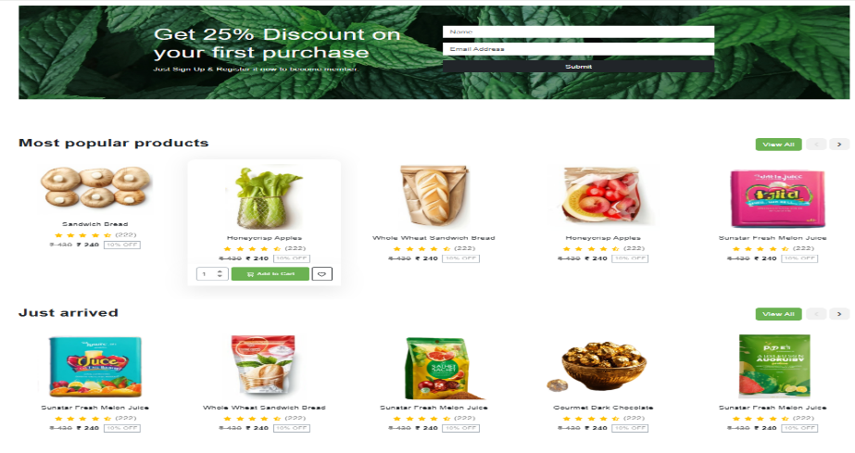

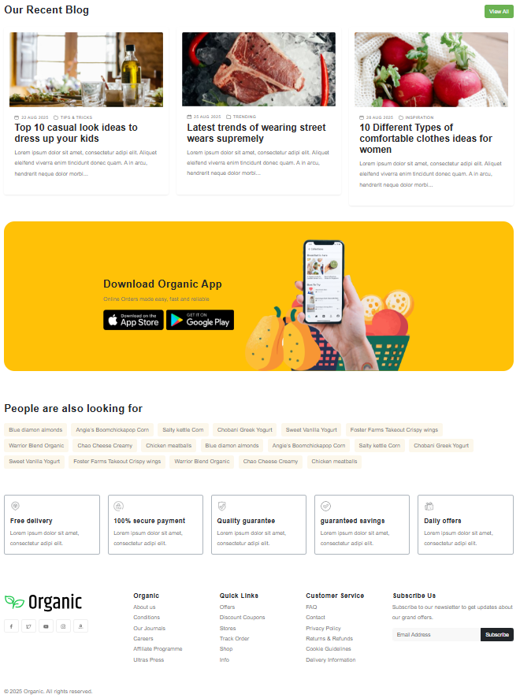

**6. SKILLS GAINED**

During this internship, I developed various technical and soft skills that helped me grow as a beginner web developer. Here are the major skills I learned in detail:

**1. HTML & CSS Skills**

* Learned how to create a structured webpage layout using HTML5.
* Gained confidence in using semantic tags like header, footer, section, and article.
* Understood how to style content with CSS3 including colors, spacing, fonts, margins, padding, and borders.

**2. Responsive Web Design**

* Used Bootstrap’s grid system to make webpages mobile-friendly.
* Practiced creating layouts that adjust according to screen size.
* Used media queries and responsive containers for better viewing experience.

**3. JavaScript Fundamentals**

* Gained knowledge of basic JS syntax, variables, functions, and conditions.
* Used JavaScript to build interactive apps like Stopwatch and Tic-Tac-Toe.
* Practiced DOM manipulation and event handling.

**4. UI/UX Design Basics**

* Designed clean and user-friendly interfaces.
* Understood importance of color schemes, spacing, and simplicity in web design.
* Used hover effects, icons, and fonts for better visual impact.

**5. Project Hosting and Deployment**

* Learned how to host websites online using Netlify.
* Understood the process of uploading files, linking domains, and making sites live.

**6. Git & GitHub (Basics)**

* Learned how to use Git for version control.
* Practiced pushing projects to GitHub and managing code online.

**7. Time Management & Problem Solving**

* Completed multiple projects within the given timeline.
* Debugged code errors independently.
* Improved logical thinking while building games and interactive features.

**7. CHALLENGES FACED**

While working on multiple projects during the internship, I came across a few challenges. Each one helped me improve my skills and find better solutions. Here are the key challenges I faced and how I overcame them:

**1. Making Websites Fully Responsive**

* Challenge: Initially, the layouts were not adjusting properly on mobile screens.
* Solution: I used Bootstrap’s grid system and media queries to fix responsiveness issues. Also tested on different devices using browser developer tools.

**2. JavaScript Logic for Stopwatch & Game**

* Challenge: Writing correct logic for stopwatch timer and Tic-Tac-Toe win detection was confusing.
* Solution: Practiced basic JavaScript syntax and broke down problems into small steps. Used console.log () to test values during debugging.

**3. Time Management While Handling Multiple Projects**

* Challenge: Completing 5 projects within a short time was difficult.
* Solution: Followed a structured weekly plan, worked consistently every day, and prioritized tasks based on complexity.

**4. Designing Clean UI Without Templates**

* Challenge: Making a good-looking layout from scratch without using design templates.
* Solution: Learned UI basics like alignment, spacing, colour combinations, and used online references (e.g., Dribble, Figma samples) for inspiration.

**5. Hosting & Deployment Issues**

* Challenge: First time using Netlify, faced small issues with file paths and site updates.
* Solution: Read Netlify documentation and fixed path issues by restructuring folders and using relative paths.

**6. Debugging Errors in Code**

* Challenge: Small syntax mistakes or misplaced tags would break the whole layout or logic.
* Solution: Used browser inspect tools and console log to trace bugs. Referred to MDN and W3Schools frequently.

**7. Writing Clear and Clean Code**

* Challenge: At first, the code was messy and hard to read.
* Solution: Learned to use proper indentation, comments, and code structuring for better readability.

**8. CONCLUSION**

This internship at PRODIGY INFOTECH has been a transformative experience. From building basic structures to deploying complete responsive projects, each task taught me valuable lessons in real-world web development. The mentorship, structure, and challenging tasks helped enhance not only my technical skills but also my time management and creative thinking.

I now feel more confident in my frontend development skills and look forward to exploring full-stack development, keeping user-centric design at the heart of my work.

**9. REFERENCES**

1. [HTML – MDN Documentation](https://developer.mozilla.org/en-US/docs/Web/HTML)
2. [CSS – MDN Documentation](https://developer.mozilla.org/en-US/docs/Web/CSS)
3. [JavaScript – MDN Documentation](https://developer.mozilla.org/en-US/docs/Web/JavaScript)
4. [Bootstrap Official Docs](https://getbootstrap.com/)
5. [W3Schools – Web Tutorials](https://www.w3schools.com/)
6. [Netlify – Hosting Platform](https://www.netlify.com/)
7. [Prodigy Infotech Internship Tasks]