# INDEX

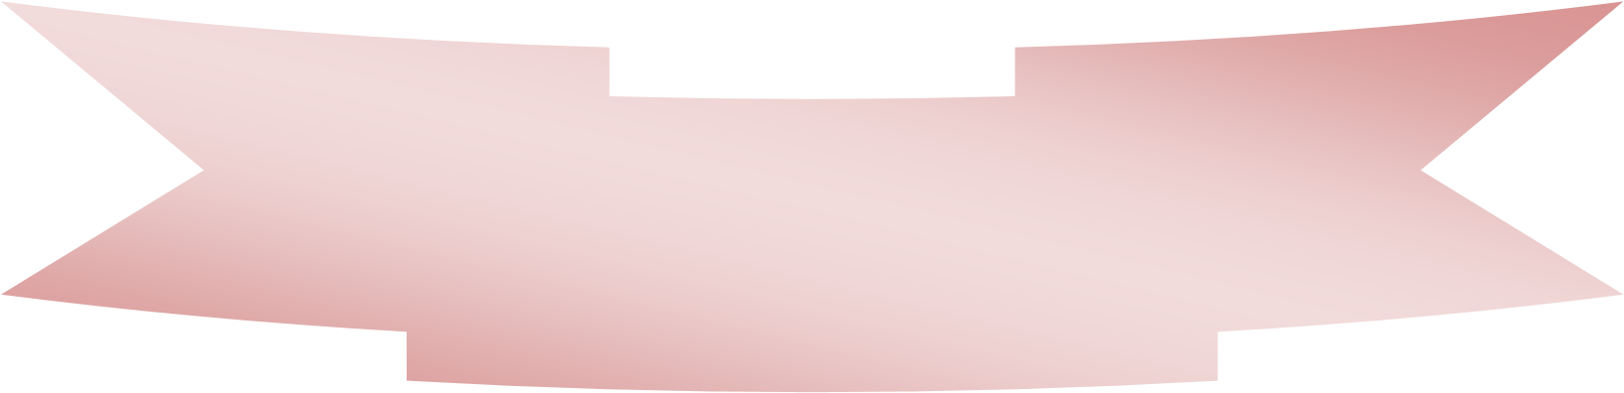

|  |  |  |
| --- | --- | --- |
| Index | Topic | Page No |
| **1.** | System Concept | 2 |
| **2.** | System Analysis | 3 |
| **3.** | Hardware Requirements | 4 |
| **4.** | Software Requirements | 4 |
| **5.** | Code Of Project | 5-20 |
| **7.** | Future Enhancement | 21 |
| **8.** | Conclusion | 22 |

# 

# System Concept

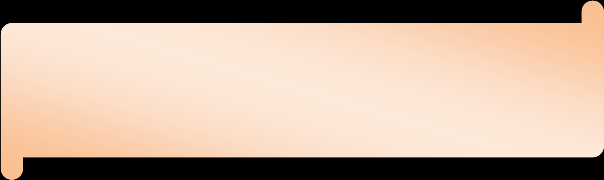

**System Concept:**

The music player allows a user to play various media file formats. It can be used to play audio as well as video files. The music player is a software project supporting all known media files and has the ability to play them with ease.

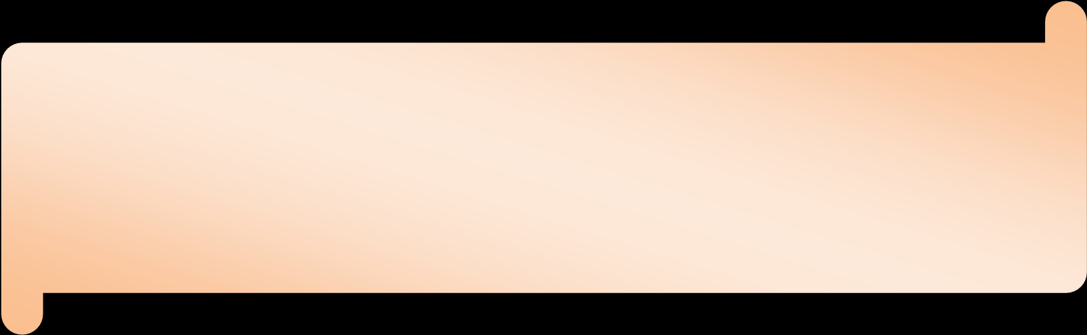

# System Analysis

1. The desktop music player is a software application designed to play audio files on a computer.

2. It provides a user-friendly interface to manage and organize music collections.

## Hardware Requirements :-

1. Intel processor core 2 Duo(2.53 GHz).
2. 1 GB RAM.
3. All types of monitors are used.
4. Keyboard
5. Mouse.

## Software Requirements :-

1. windows XP or 7 Operating System
2. Notepad
3. Chrome Browser

## Code For Application :-

Projecto-Audio-Player.html :-

<!DOCTYPE html>

<html lang="en">

<head>

<meta name="viewport" content="width=device-width, initial-scale=1.0">

<meta charset="UTF-8">

<title>Audio Player</title>

<link href="https://fonts.googleapis.com/css?family=Darker+Grotesque|Poiret+One&display=swap" rel="stylesheet">

<link rel="stylesheet" type="text/css" href="https://stackpath.bootstrapcdn.com/font-awesome/4.7.0/css/font-awesome.min.css">

<link rel="stylesheet" type="text/css" href="src/app.css">

</head>

<body>

<div class="audio-player" id="skin">

<div class="holder">

<div class="cover">

<img src="assets/cover.png">

</div>

<div class="audio-wrapper" id="player-container" href="javascript:;">

<audio id="player" preload="metadata" onloadedmetadata="mDur()" ontimeupdate="initProgressBar()">

<source src="" type="audio/mp3">

</audio>

</div>

<div class="player-controls scrubber">

<div>

<div>

<p class="title"></p>

</div>

<div class="range">

<input id="dur" type="range" class="range" name="rng" min="0" max="1" step="0.00000001" value="0" onchange="mSet()" style="width: 100%">

</div>

<br>

<span class="time start-time"></span>

<span class="time end-time"></span>

<br>

<div class="ctrl">

<div>

<a href="#prev" class="ctrl_btn " id="prev"><i class="fa fa-arrow-left" ></i></a>

<span id="play-btn" class="fa fa-play "></span>

<a href="#next" class="ctrl_btn " id="next"><i class="fa fa-arrow-right" ></i></a>

</div>

<div class="volumeControl">

<div class="wrapper">

<i class="fa fa-volume-up"></i>

<span class="outer">

<span class="inner"></span>

</span>

</div>

</div>

</div>

</div>

<div>

</div>

</div>

</div>

</div>

<script type="text/javascript" src="assets/jquery/jquery.min.js"></script>

<script type="text/javascript" src="src/app.js"></script>

</body>

</html>

# App.cs –

* {

transition: 0.8s ease !important;

}

html {

height: 100%;

display: table;

margin: auto;

}

body {

height: 100%;

display: table-cell;

vertical-align: middle;

background: #e3b3b3;

font-family: 'Poiret One', cursive;

}

a {

color: #fff;

text-decoration: none;

}

.holder {

margin: 0.23rem 0 0.23rem 0;

display: flex;

align-items: center;

}

.shadow {

box-shadow: 0 1px 30px rgba(0, 0, 0, 0.22);

}

/* Important stuff */

.set {

position: absolute;

right: 1em;

top: 0;

z-index: 999;

}

.dropdown-toggle {

display: block;

width: 50%;

margin: 0 auto;

}

.dropdown-toggle i {

padding: 0.5em 0.55em;

background: #fff;

border-radius: 4px;

color: #555;

}

#skin.dark {

background: #334d50;

/* fallback for old browsers */

background: -webkit-linear-gradient(to right, #cbcaa5, #334d50);

/* Chrome 10-25, Safari 5.1-6 */

background: linear-gradient(to right, #cbcaa5, #334d50);

/* W3C, IE 10+/ Edge, Firefox 16+, Chrome 26+, Opera 12+, Safari 7+ */

color: #fff!important;

border-color: #fff!important;

}

#skin.white {

background: white;

}

#skin.blue {

background: linear-gradient(126deg, rgba(43, 57, 144, 1), rgba(102, 45, 145, 0.9));

}

ul.dropdown {

display: none;

position: absolute;

left: 25%;

width: 50%;

margin-top: 0.5em;

margin: 0.5em auto;

background: #777;

min-width: 12em;

padding: 0;

border-radius: 0 0 0.2em 0.2em;

}

ul.dropdown li {

list-style-type: none;

}

ul.dropdown li a {

text-decoration: none;

padding: 0.5em 1em;

display: block;

}

.audio-player {

position: relative;

border: 1px solid #dfdfdf;

width: 50vw;

margin: 1rem auto;

box-shadow: 0 10px 30px rgba(0, 0, 0, 0.32);

background: #fff;

padding: 1rem;

height: auto;

}

.audio-player .user_avatar {

width: 100%;

justify-content: space-around;

margin: 0 auto;

position: relative;

}

.audio-player .user_avatar .live,

.audio-player .user_avatar .listeners {

background: #fff;

padding: 8px 10px 0 10px;

font-size: 15px;

font-weight: 700;

color: #555 !important;

border-radius: 4px;

margin: 3px;

text-align: center;

}

.live i {

-moz-animation-duration: 1s;

-moz-animation-name: blink;

-moz-animation-iteration-count: infinite;

-moz-animation-direction: alternate;

-webkit-animation-duration: 1s;

-webkit-animation-name: blink;

-webkit-animation-iteration-count: infinite;

-webkit-animation-direction: alternate;

animation-duration: 1s;

animation-name: blink;

animation-iteration-count: infinite;

animation-direction: alternate;

color: red;

}

@-moz-keyframes blink {

from {

opacity: 1;

}

to {

opacity: 0;

}

}

@-webkit-keyframes blink {

from {

opacity: 1;

}

to {

opacity: 0;

}

}

@keyframes blink {

from {

opacity: 1;

}

to {

opacity: 0;

}

}

.audio-player .user_avatar img {

display: block;

margin: 0 auto;

height: 100px;

width: 100px;

padding: 0.65em;

object-fit: cover;

border-radius: 50%;

border: 2px solid #dfdfdf;

background: #fff;

margin-top: -4em;

}

#dur:hover {

cursor: pointer;

}

.audio-player .cover img {

height: 200px;

width: 200px;

object-fit: cover;

border-radius: 30px;

padding: 10px;

box-shadow: 0 10px 30px rgba(0, 0, 0, 0.12);

}

.audio-player .title {

padding: 0;

margin-top: 2.5rem;

font-weight: 800;

font-size: 28px;

}

.audio-player .like {

padding: 6px 17px;

background: #fff;

font-size: 16px;

color: #555;

margin: 1rem 0;

font-weight: 900;

text-decoration: none;

position: relative;

}

.audio-player .player-controls {

align-items: center;

justify-content: center;

flex: 4;

position: relative;

padding: 0 1rem;

margin: 0 auto;

}

.audio-player .player-controls p {

color: #000;

}

.progress_bar {

border: 2px solid #ccc;

width: 100%;

min-height: 15px;

display: flex;

padding: 0.45em 0;

align-items: center;

}

.range {

position: relative;

}

.range input[type=range] {

appearance: none;

padding: 0;

width: 100%;

height: 22px;

cursor: pointer;

display: block;

}

.range input[type=range]:focus {

outline: none;

}

.range input[type=range][disabled] {

opacity: 0.3;

cursor: default;

background: transparent;

}

.range .rangeslider {

position: relative;

height: 22px;

cursor: pointer;

user-select: none;

}

.range .rangeslider:before {

box-sizing: border-box;

width: 100%;

height: 4px;

background: #e6e6e6;

border-radius: 100px;

content: "";

position: absolute;

top: 50%;

transform: translateY(-50%);

}

.range input::-webkit-slider-runnable-track {

box-sizing: border-box;

width: 100%;

height: 4px;

background: #e6e6e6;

border-radius: 100px;

margin: 11px 0;

}

.range input::-moz-range-track {

box-sizing: border-box;

width: 100%;

height: 4px;

background: #e6e6e6;

border-radius: 100px;

margin: 11px 0;

}

.range input::-ms-track {

box-sizing: border-box;

width: 100%;

height: 4px;

background: #e6e6e6;

border-radius: 100px;

color: transparent;

padding: 11px 0;

background: transparent;

border-color: transparent;

}

.range input::-ms-fill-lower,

.range input::-ms-fill-upper {

box-sizing: border-box;

width: 100%;

height: 4px;

background: #e6e6e6;

border-radius: 100px;

}

.range input::-ms-fill-lower {

background: #60cd18;

}

.range .rangeslider-fill-lower {

background-color: #60cd18;

border-radius: 100px;

position: absolute;

top: 50%;

transform: translateY(-50%);

height: 4px;

will-change: width;

}

.range input::-webkit-slider-thumb {

box-sizing: border-box;

box-shadow: 0px 4px 25px rgba(0, 0, 0, .5);

border: 6px solid #fff;

height: 24px;

width: 24px;

border-radius: 100px;

background: #333940;

cursor: pointer;

appearance: none;

transform: translateY(-50%);

margin-top: 2px;

}

.range input::-moz-range-thumb {

box-sizing: border-box;

box-shadow: 0px 4px 25px rgba(0, 0, 0, .5);

border: 6px solid #fff;

height: 24px;

width: 24px;

border-radius: 100px;

background: #333940;

cursor: pointer;

}

.range input::-ms-thumb {

box-sizing: border-box;

box-shadow: 0px 4px 25px rgba(0, 0, 0, .5);

border: 6px solid #fff;

height: 24px;

width: 24px;

border-radius: 100px;

background: #333940;

cursor: pointer;

}

.range .rangeslider-thumb {

box-sizing: border-box;

box-shadow: 0px 4px 25px rgba(0, 0, 0, .5);

border: 6px solid #fff;

height: 24px;

width: 24px;

border-radius: 50%;

background: #333940;

cursor: pointer;

position: absolute;

touch-action: pan-x;

top: 50%;

transform: translateY(-50%);

will-change: left;

}

.audio-player #play-btn,

.ctrl_btn {

margin: 0 1rem 2rem 0;

color: #363732;

}

.audio-player #play-btn {

padding: 1rem 1.2rem;

font-size: 24px;

}

.audio-player .ctrl_btn {

font-size: 22px;

}

.audio-player #play-btn:hover {

cursor: pointer;

}

.audio-player .volumeControl {

display: flex;

flex-basis: 20%;

justify-content: center;

align-items: center;

padding-bottom: 1rem;

}

.audio-player .volumeControl .wrapper {

display: flex;

flex-basis: 100%;

align-items: center;

color: #363732;

}

.audio-player .volumeControl .wrapper:hover i.fa {

color: #363732;

}

.audio-player .volumeControl .outer {

border-radius: 2px;

box-shadow: -2px 3px 4px rgba(0, 0, 0, 0.23);

overflow: hidden;

height: 0.3rem;

flex-basis: 80%;

margin-left: 0.4rem;

display: flex;

justify-content: flex-start;

align-items: center;

}

.audio-player .volumeControl .outer .inner {

background-color: #363732;

width: 100%;

display: inline-block;

height: 100%;

}

.audio-player .volumeControl .outer:hover {

cursor: pointer;

}

.start-time,

.end-time {

font-size: 14px;

font-weight: 800;

font-family: 'Darker Grotesque', sans-serif;

transition: 1s ease-in-out;

line-height: 0;

}

.start-time {

float: left;

position: relative;

left: 0;

}

.end-time {

float: right;

position: relative;

right: 0;

}

.ctrl {

display: flex;

justify-content: space-between;

}

.action {

margin: 1rem auto;

text-align: left;

}

.action span {

font-size: 14px;

font-family: 'Darker Grotesque', sans-serif;

}

@media screen and (max-width: 950px) {

ul.dropdown {

right: 20%;

left: unset;

}

.holder {

display: block;

justify-content: all;

align-items: all;

}

.audio-player {

width: 80%;

padding: 1rem 1rem;

}

.audio-player .cover img {

height: 100%;

width: 80%;

object-fit: cover;

display: block;

margin: 0 auto;

}

.audio-player .player-controls {

position: relative;

padding: 0 0;

margin: 0 auto;

}

.audio-player #play-btn,

.ctrl_btn {

margin: 15px 6px;

}

.audio-player .volumeControl,

.audio-player .volumeControl .wrapper {

display: block;

}

.audio-player .volumeControl .wrapper .fa-volume-up {

margin: 10px;

opacity: 0.6;

}

.audio-player .title {

text-align: center;

}

.start-time {

left: 0.85em;

}

.end-time {

right: 1em;

}

.ctrl,

.action {

display: block;

text-align: center;

}

.action a {

display: block;

}

.set {

position: relative;

}

.audio-player .user_avatar {

margin: 0 0 1em 0;

display: flex;

justify-content: space-around;

}

.audio-player .user_avatar img {

display: none;

}

}

# App.js –

let playlist = [ {

'title': 'Lahenga | Projecto.in',

'audio': "assets/sample2.mp3",

}, {

'title': 'Agar Tum Saath Ho | Projecto.in',

'audio': "assets/sample.weba",

} ];

i = 0;

n = playlist.length;

let player = document.getElementById( 'player' );

let dur = document.getElementById( 'dur' );

playlist.forEach( function( i ) {

console.log( i.audio )

player.src = i.audio;

$( '.title' ).html( i.title );

}, );

function calculateTotalValue( length ) {

let minutes = Math.floor( length / 60 ),

seconds_int = length - minutes * 60,

seconds_str = seconds_int.toString( ),

seconds = seconds_str.substr( 0, 2 ),

time = minutes + ':' + seconds

return time;

}

function calculateCurrentValue( currentTime ) {

let current_hour = parseInt( currentTime / 3600 ) % 24,

current_minute = parseInt( currentTime / 60 ) % 60,

current_seconds_long = currentTime % 60,

current_seconds = current_seconds_long.toFixed( ),

current_time = ( current_minute < 10 ? "0" + current_minute : current_minute ) + ":" + ( current_seconds < 10 ? "0" + current_seconds : current_seconds );

return current_time;

}

function initProgressBar( ) {

let length = player.duration;

let current_time = player.currentTime;

let totalLength = calculateTotalValue( length )

jQuery( ".end-time" ).html( totalLength );

let currentTime = calculateCurrentValue( current_time );

jQuery( ".start-time" ).html( currentTime );

dur.value = player.currentTime;

if ( player.currentTime == player.duration ) {

$( "#play-btn" ).fadeIn( "slow", function( ) {

$( this ).removeClass( "fa-pause" );

$( this ).addClass( "fa-play" );

dur.value = 0;

} );

}

};

function mSet( ) {

player.currentTime = dur.value;

}

function mDur( ) {

let length = player.duration;

dur.max = length;

}

function initPlayers( num ) {

for ( let i = 0; i < num; i++ ) {

( function( ) {

let playerContainer = document.getElementById( 'player-container' ),

player = document.getElementById( 'player' ),

isPlaying = false,

playBtn = document.getElementById( 'play-btn' );

if ( playBtn != null ) {

playBtn.addEventListener( 'click', function( ) {

togglePlay( )

} );

}

function togglePlay( ) {

if ( player.paused === false ) {

player.pause( );

isPlaying = false;

$( "#play-btn" ).fadeIn( "slow", function( ) {

$( this ).removeClass( "fa-pause" );

$( this ).addClass( "fa-play" );

} );

}

else {

player.play( );

$( "#play-btn" ).fadeIn( "slow", function( ) {

$( this ).removeClass( "fa-play" );

$( this ).addClass( "fa-pause" );

} );

isPlaying = true;

}

}

}( ) );

}

}

$( "#next" ).data( 'dir', 1 );

$( "#prev" ).data( 'dir', -1 );

$( '#next, #prev' ).on( 'click', function( ) {

i = ( i + $( this ).data( 'dir' ) + n ) % n;

console.log( i );

player.src = playlist[ i ].audio;

$( '.title' ).html( playlist[ i ].title );

$( '#play-btn' ).removeClass( "fa-play" );

$( '#play-btn' ).addClass( "fa-pause" );

player.play( );

} );

$( ".audio-player" )

.toArray( )

.forEach( function( player ) {

let audio = $( player ).find( "audio" )[ 0 ];

let volumeControl = $( player ).find( ".volumeControl .wrapper" );

volumeControl.find( ".outer" ).on( "click", function( e ) {

let volumePosition = e.pageX - $( this ).offset( ).left;

let audioVolume = volumePosition / $( this ).width( );

if ( audioVolume >= 0 && audioVolume <= 1 ) {

audio.volume = audioVolume;

$( this )

.find( ".inner" )

.css( "width", audioVolume * 100 + "%" );

}

} );

} );

$( function( ) {

// Dropdown toggle

$( '.dropdown-toggle' ).click( function( ) {

$( this ).next( '.dropdown' ).slideToggle( "fast" );

} );

$( document ).click( function( e ) {

var target = e.target;

if ( !$( target ).is( '.dropdown-toggle' ) && !$( target ).parents( ).is( '.dropdown-toggle' ) ) {

$( '.dropdown' ).hide( );

}

} );

} );

$( '#darkButton' ).click( switchDark );

$( '#whiteButton' ).click( switchWhite );

$( '#blueButton' ).click( switchBlue );

function switchDark( ) {

$( '#skin' ).attr( 'class', 'dark audio-player' );

$( '.inner' ).css( 'background', '#fff' );

$( '.title' ).css( 'color', '#fff' );

$( '.time' ).css( 'color', '#fff' );

$( '.fa-volume-up' ).css( {

'color': '#fff'

} );

$( '.audio-player #play-btn' ).css( {

'color': '#fff',

'border-color': '#fff'

} );

$( '.ctrl_btn' ).css( {

'color': '#fff',

'border-color': '#fff'

} );

}

function switchWhite( ) {

$( '#skin' ).attr( 'class', 'white audio-player' );

$( '.inner' ).css( 'background', '#555' );

$( '.title' ).css( 'color', '#555' );

$( '.time' ).css( 'color', '#555' );

$( '.fa-volume-up' ).css( {

'color': '#555'

} );

$( '.audio-player #play-btn' ).css( {

'color': '#555',

'border-color': '#555'

} );

$( '.ctrl_btn' ).css( {

'color': '#555',

'border-color': '#555'

} );

}

function switchBlue( ) {

$( '#skin' ).attr( 'class', 'blue audio-player' );

$( '.inner' ).css( 'background', '#fff' );

$( '.title' ).css( 'color', '#fff' );

$( '.time' ).css( 'color', '#fff' );

$( '.fa-volume-up' ).css( {

'color': '#fff'

} );

$( '.audio-player #play-btn' ).css( {

'color': '#fff',

'border-color': '#fff'

} );

$( '.ctrl_btn' ).css( {

'color': '#fff',

'border-color': '#fff'

} );

}

initPlayers( jQuery( '#player-container' ).length );

# Future Enhancement -

1. Implementation of advance Graphics.
2. Implementation of validation is possible.

# Conclusion

*This system is desktop application To start the software following steps should be takes place.*

1. First start the machine.
2. You will see various icons.
3. Open Files.
4. You will see opening Screen.
5. After opening of system, just double tap On Project-audio-player.html
6. Now You will be On Music Player.
7. Just play songs and Feel Happy.
8. This desktop application is user friendly.