**Hospitality Revenue Explorer: A Comprehensive Insights Dashboard**

Step 1: Problem Statement:

Domain: Hospitality

Function: Revenue

GDS Grands owns multiple five-star hotels across India. They have been in the hospitality industry for the past 20 years. Due to strategic moves from other competitors and ineffective decision-making in management, GDS Grands is losing its market share and revenue in the luxury/business hotels category. As a strategic move, the managing director of GDS Grands wanted to incorporate “Business and Data Intelligence” to regain their market share and revenue. However, they do not have an in-house data analytics team to provide them with these insights.

Their revenue management team had decided to hire a 3rd party service provider to provide them with insights from their historical data.

Task:

You are a data analyst who has been provided with sample data and some relevant metrics to work on the following task. You can download all relevant documents from the download section.

* Create the metrics according to the metric list.
* Add relevant metrics that are not provided in the metric list.
* Create a dashboard to keep regular track of all metrics.
* Mention relevance and importance of all metrics.
* Draw insights from the data and suggest action plan(s).

Step 2: Data Pre-processing

The datasets are obtained from google drive link. The data folder consists of 5 CSV files, i.e.

1. dim_date.csv
2. dim_hotels.csv
3. dim_rooms.csv
4. **fact_aggregated_bookings.csv**
5. **fact_bookings.csv**

With the given files, their Column distributions as well as data types were also provided. After manually checking the files and checking all features provided, the file is later imported to Power BI desktop.

After importing into Power BI all files are individually transformed and wherever it is necessary to perform transformations, it was done. But most of the data was genuine and ready to use.

Step 3: Data-Relationships

After successfully importing and performing pre-processing of data, the next step was to link all dataset to make sure all data is linked and ready to use.

While performing the above step, concepts of Primary key, Foreign key, Relationships and Schemas were used.

Step 4: Creating Measures of Key Metrics

After successful completion of the above step then we move towards the important part of problem statement which was defining Key Metrics. Some of the Key Metrics were already provided which was very helpful but after researching I also found some other important key metrics which are as important, so I tried to make them use the given features. The following are the Key Metrics that I have used in my Dashboard.

* Total Revenue – Aggregation of Revenue Realized generated.
* Total Bookings – Count of Booking IDs.
* Average Customer Satisfaction Ratings – Average ratings provided by Customer.
* Total Successful Bookings – Aggregation of Successful Bookings.
* Occupancy % - Indicates the percentage of rooms that are occupied.
* Total Cancelled Booking – Aggregation of Bookings that were cancelled.
* Cancellation Rate – Rate at which the Cancellation of booking happens over Total Bookings.
* Average Daily Rate (ADR) - Represents the average price paid per room per day.
* Revenue per Available Room (RevPAR) - Combines both occupancy rate and ADR to measure the overall effectiveness of room revenue generation.
* Total Checked Out – Aggregation of Bookings where Status was Checked Out.
* Total No Show - Aggregation of Bookings where Status was No Show.
* Website Conversion Rate – Rate where customers were bookings. It is acknowledged that there are various online partners available in the database so other categories were built using Measure for Online Conversion Rate and Offline Conversion Rate.
* Turn Over Rate – Successful Rate occupied by Eliminating Cancellation Rate and No-Show Rate from Total Booking Rate.
* Average Daily Bookings – So Count of Bookings were divided by Total Number of Days in the database, resulting in Average Daily Bookings.

So above were the Key Metrics that were used to build the dashboard.

Step 4: Building the Dashboard

The dashboard consists of Two Pages, one mainly exploring the total Key Metrics and Other mapping the Metrics with different features for checking Trends that can be useful solve the Problem Statement.

Here are some snapshots of the dashboard:

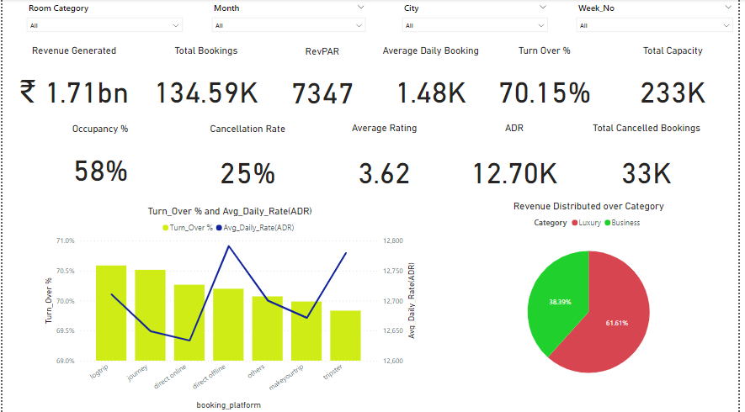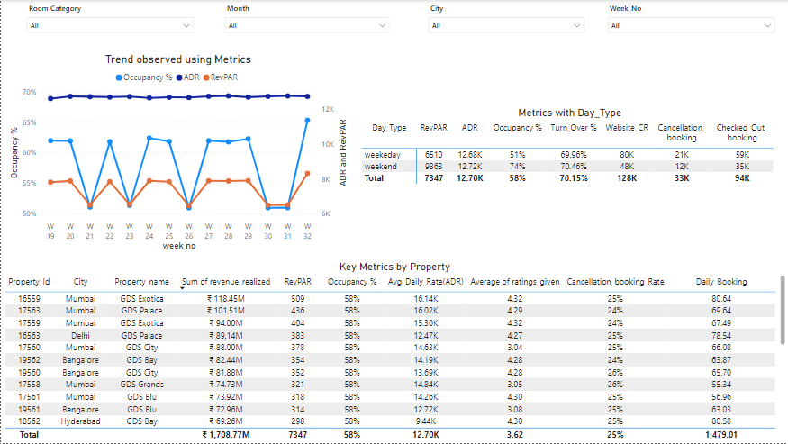

The above dashboard is created having the following key metrics:

* Overview of all Key Metrics mentioned above.
* Key Metrics by Day Types.
* Trend of Turn-Over & ADR by different booking platforms.
* Revenue by category.
* Key Metrics by Weekly Trend.
* Key Metrics by Property.

Insights from analysis:

1. Poor Customer Services and Online Reputation:
   1. In the luxury segment, exceptional customer service is a key differentiator. If a hotel fails to meet or exceed guest expectations in terms of service, it can lead to negative reviews, decreased customer loyalty, and ultimately lower revenue.
   2. Currently Average Ratings given by Customer is around 3.6 * which is very Average compared to other hotels which present in same segments.
   3. Also, there are some Hotels with ratings below 3* which are GDS Season, GDS Exotica, GDS Grands and GDS Bay. So, they need to focus on this hotel and their ambience and try to improve services of these Hotels.
2. Inadequate Pricing Strategy:
   1. From Visual Key Metric by Weekly Trend, we can see that Average daily rate the difference between both Day type is very Marginal, but if we see bookings factor there is increase in Bookings at Weekend compared to Weekdays but why the ADR is minimal in this case. Seems that they are following the same rate over all days, which is not an optimal and efficient solution for the hotel segment. Looking over this issue can help to increase the profitability of GDS Hotels.
3. Lacking in Marketing Strategies:
   1. After looking at the Occupancy rate of the overall timespan it is observed that 58% can led to decrease in Potential revenue.
   2. After looking in deep with Occupancy rate compared with weeks, it comes into observation that in weekdays occupancy rate is around ~50% which is very low, so marketing team can look towards this issue and come up with different strategies or collaborations with different businesses to cover up the Occupancies may be providing some corporate discounts can one of the solutions to overcome this factor.
4. Other Factors impacting Business can be:
   1. Cancellation Rate: It is one factor that is very important, currently it is at 25% which is moderately high, maybe trying to overcome and if marketing team or members can investigate the reasons of cancellation and try to come up with different solution and creates a target to reduce the number to around 5-7% till upcoming fiscal year this can also help to boost the numbers.
   2. Targeting More Metropolitical cities: Currently hotels are located at 4 big cities which has more setup-costs and other factors but if try to setup other hotels in Metro cities it can help to improve business and franchise money can also be one of the factors contributing to profitability.

The Above are some Points which in future can be improved or looked after and will help to increase Revenue.