Experiment No: 6
Course Name: | Web Programming Laboratory (216U01L405) | Semester: | IV
Date of Performance: | 30/03/2026 | DIV/ Batch No: | B2
Student Name: | Prathamesh Jadhav | Roll No: | 16010124109

Title: Develop a PHP application that performs CRUD (Create, Read, Update, Delete) operations.

Aim of the Experiment:
To design and develop a dynamic web application using PHP and MySQL that performs CRUD (Create, Read, Update, Delete) operations on a database.

Objectives for the Experiment:
- Understand and explain the architecture of a PHP–MySQL web application and the role of CRUD operations in database-driven systems.
- Implement Create, Read, Update, and Delete functionalities using PHP and MySQL with proper form handling and database connectivity.
- Analyze and validate user inputs and database transactions to ensure data integrity and error handling (if possible secure from SQL injection).
- Design and develop a functional and user-friendly CRUD-based web application following best practices in modular coding and structured programming.

COs to be achieved:
- Design dynamic web pages using various HTML tags.
- Use CSS to prepare the layout of web pages.
- Apply JavaScript for validation in client-side programming.
- Integrate server-side pages using PHP.
- Apply database operations by integrating SQL queries and session variables.

Books/ Journals/ Websites references:
- Students should write

Software / Tools Required
- XAMPP / WAMP / MAMP
- PHP
- MySQL
- phpMyAdmin
- Code Editor (VS Code / Sublime / Notepad++/ any other)
- Web Browser

Methodology:
- Start XAMPP server.
- Create database and table in phpMyAdmin.
- Establish PHP-MySQL connection.
- Create HTML form for data input.
- Write PHP code for:
  - Insert
  - Fetch
  - Update
  - Delete
- Execute queries.
- Display results.
- Close database connection.

Theory:

Problem statement:
Design and implement an application to demonstrate HTML form integration with PHP for data collection and processing and perform the CRUD operations.

Note: Mini Project should start with CRUD operations too.
Note: Ensure all mini project code / work is regularly pushed to Github

Code:
Database:
-- Step 1: Create the database
CREATE DATABASE IF NOT EXISTS wpl_lab;

-- Step 2: Use the database
USE wpl_lab;

-- Step 3: Create the table
CREATE TABLE IF NOT EXISTS students (
id INT AUTO_INCREMENT PRIMARY KEY,
name VARCHAR(100) NOT NULL,
email VARCHAR(100) NOT NULL UNIQUE,
branch VARCHAR(50) NOT NULL
);

-- Optional: Insert dummy data
INSERT INTO students (name, email, branch) VALUES
('John Doe', 'john@example.com', 'Computer Engineering'),
('Jane Smith', 'jane@example.com', 'Information Technology');

Db php
<?php
// Establish PHP-MySQL connection
$host = "localhost";
$user = "root"; // Default XAMPP username
$pass = ""; // Default XAMPP password is empty
$dbname = "wpl_lab";

// Create connection
$conn = new mysqli($host, $user, $pass, $dbname);

// Check connection
if ($conn->connect_error) {
die("Connection failed: " . $conn->connect_error);
}
?>

Index php
<?php
include 'db.php'; // Include connection

// Check if there is an action (Delete operation)
if (isset($_GET['delete'])) {
$id = intval($_GET['delete']);
$delete_sql = "DELETE FROM students WHERE id = $id";
if ($conn->query($delete_sql) === TRUE) {
header("Location: index.php");
exit;
} else {
echo "Error deleting record: " . $conn->error;
}
}
?>

<!DOCTYPE html>
<html lang="en">
<head>
<meta charset="UTF-8">
<title>Student Data Management</title>
<link rel="stylesheet" href="style.css">
</head>
<body>

<div class="container">
<h2>Student Registration Form (Insert)</h2>
<form action="insert.php" method="POST">
<label>Name:</label>
<input type="text" name="sname" required>

<label>Email:</label>
<input type="email" name="semail" required>

<label>Branch:</label>
<select name="sbranch" required>
<option value="Computer Engineering">Computer Engineering</option>
<option value="Information Technology">Information Technology</option>
<option value="Mechanical Engineering">Mechanical Engineering</option>
</select>

<button type="submit" name="submit">Add Student</button>
</form>
</div>

<div class="container">
<h2>Registered Students (Fetch & Display)</h2>
<table>
<tr>
<th>ID</th>
<th>Name</th>
<th>Email</th>
<th>Branch</th>
<th>Actions</th>
</tr>
<?php
// Fetch query to display data
$sql = "SELECT id, name, email, branch FROM students";
$result = $conn->query($sql);

if ($result->num_rows > 0) {
while($row = $result->fetch_assoc()) {
echo "<tr>
<td>".$row['id']."</td>
<td>".$row['name']."</td>
<td>".$row['email']."</td>
<td>".$row['branch']."</td>
<td>
<a href='update.php?id=".$row['id']."' class='action-btn edit-btn'>Edit</a>
<a href='index.php?delete=".$row['id']."' class='action-btn delete-btn' onclick='return confirm(\"Are you sure you want to delete this record?\");'>Delete</a>
</td>
</tr>";
}
} else {
echo "<tr><td colspan='5' style='text-align:center;'>No records found in database</td></tr>";
}

// Close database connection
$conn->close();
?>
</table>
</div>

</body>
</html>

Insert php
<?php
include 'db.php'; // Include connection

if (isset($_POST['submit'])) {
// Sanitize user inputs
$name = $conn->real_escape_string($_POST['sname']);
$email = $conn->real_escape_string($_POST['semail']);
$branch = $conn->real_escape_string($_POST['sbranch']);

// Insert Query
$sql = "INSERT INTO students (name, email, branch) VALUES ('$name', '$email', '$branch')";

if ($conn->query($sql) === TRUE) {
// Redirect back to main page on success
header("Location: index.php");
exit;
} else {
echo "Error: " . $sql . "<br>" . $conn->error;
}
}

// Close connection
$conn->close();
?>

Update php
<?php
include 'db.php'; // Include connection

$id = isset($_GET['id']) ? intval($_GET['id']) : 0;

// Update Logic Process
if (isset($_POST['update'])) {
$uid = intval($_POST['id']);
$name = $conn->real_escape_string($_POST['sname']);
$email = $conn->real_escape_string($_POST['semail']);
$branch = $conn->real_escape_string($_POST['sbranch']);

$sql = "UPDATE students SET name='$name', email='$email', branch='$branch' WHERE id=$uid";

if ($conn->query($sql) === TRUE) {
header("Location: index.php");
exit;
} else {
echo "Error updating record: " . $conn->error;
}
}

// Fetch single record for pre-filling the form
$row = [];
if ($id > 0) {
$result = $conn->query("SELECT * FROM students WHERE id = $id");
if ($result->num_rows == 1) {
$row = $result->fetch_assoc();
} else {
die("Record not found!");
}
} else {
die("Invalid ID");
}
?>

<!DOCTYPE html>
<html lang="en">
<head>
<meta charset="UTF-8">
<title>Update Student Data</title>
<link rel="stylesheet" href="style.css">
</head>
<body>

<div class="container">
<h2>Update Student Record</h2>
<form action="update.php" method="POST">
<!-- Hidden input for ID -->
<input type="hidden" name="id" value="<?php echo $row['id']; ?>">

<label>Name:</label>
<input type="text" name="sname" value="<?php echo $row['name']; ?>" required>

<label>Email:</label>
<input type="email" name="semail" value="<?php echo $row['email']; ?>" required>

<label>Branch:</label>
<select name="sbranch" required>
<option value="Computer Engineering" <?php if($row['branch'] == 'Computer Engineering') echo 'selected'; ?>>Computer Engineering</option>
<option value="Information Technology" <?php if($row['branch'] == 'Information Technology') echo 'selected'; ?>>Information Technology</option>
<option value="Mechanical Engineering" <?php if($row['branch'] == 'Mechanical Engineering') echo 'selected'; ?>>Mechanical Engineering</option>
</select>

<button type="submit" name="update" style="background-color: #ff9800;">Update Student</button>
<a href="index.php" style="display:block; text-align:center; margin-top:10px; color:#1976d2; text-decoration:none;">Cancel</a>
</form>
</div>

<?php
// Close database connection
$conn->close();
?>
</body>
</html>

Style css
body {
font-family: Arial, sans-serif;
background-color: #f4f4f9;
margin: 0;
padding: 20px;
}

h2 {
color: #333;
text-align: center;
}

.container {
width: 80%;
margin: 0 auto;
background: #fff;
padding: 20px;
box-shadow: 0 0 10px rgba(0,0,0,0.1);
border-radius: 8px;
margin-bottom: 30px;
}

form {
display: flex;
flex-direction: column;
width: 50%;
margin: 0 auto;
}

form label {
margin-top: 10px;
font-weight: bold;
}

form input, form select {
padding: 10px;
margin-top: 5px;
border: 1px solid #ccc;
border-radius: 4px;
}

form button {
margin-top: 20px;
padding: 10px;
background: #4caf50;
color: #fff;
border: none;
border-radius: 4px;
cursor: pointer;
font-size: 16px;
}

form button:hover {
background: #45a049;
}

table {
width: 100%;
border-collapse: collapse;
margin-top: 20px;
}

table, th, td {
border: 1px solid #ddd;
}

th, td {
padding: 12px;
text-align: left;
}

th {
background-color: #2196f3;
color: white;
}

tr:nth-child(even) {
background-color: #f2f2f2;
}

.action-btn {
padding: 5px 10px;
color: #fff;
text-decoration: none;
border-radius: 4px;
margin-right: 5px;
}

.edit-btn { background-color: #ff9800; }
.edit-btn:hover { background-color: #e68a00; }

.delete-btn { background-color: #f44336; }
.delete-btn:hover { background-color: #da190b; }

Output / Screenshot:
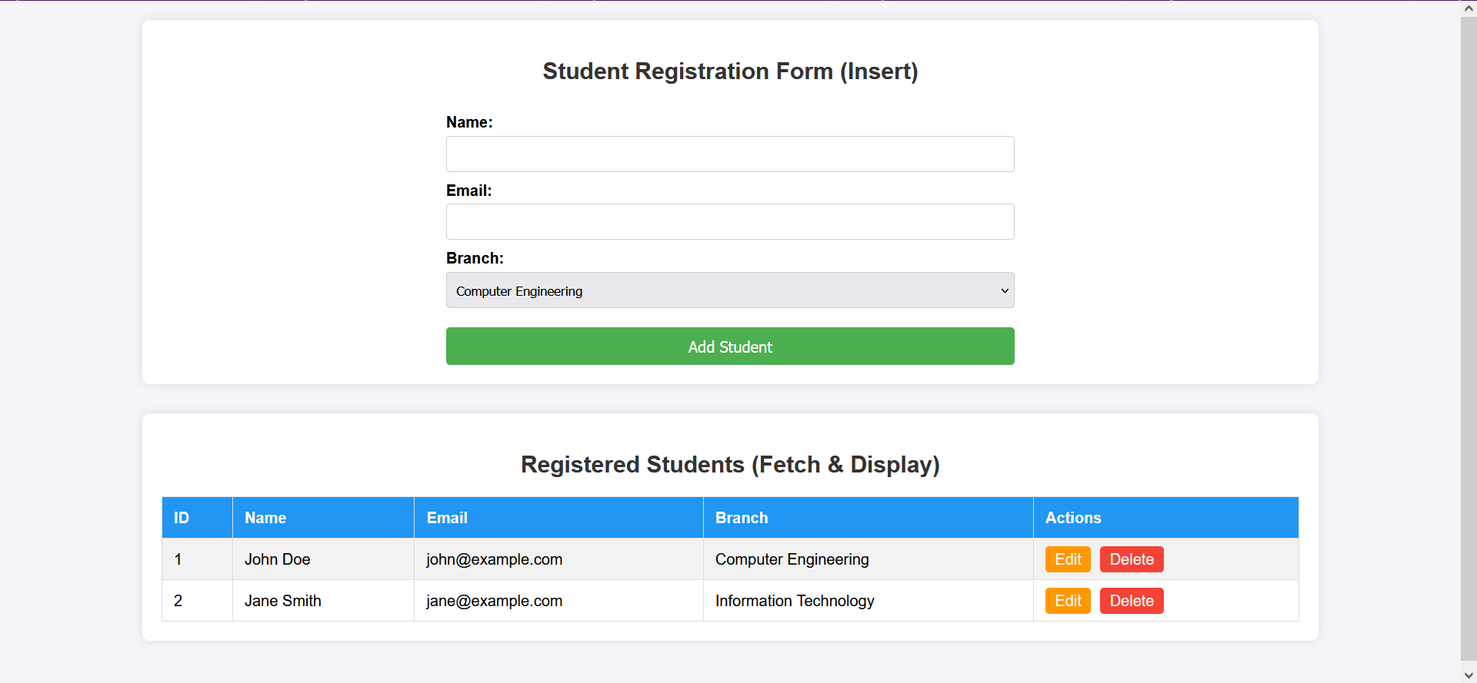
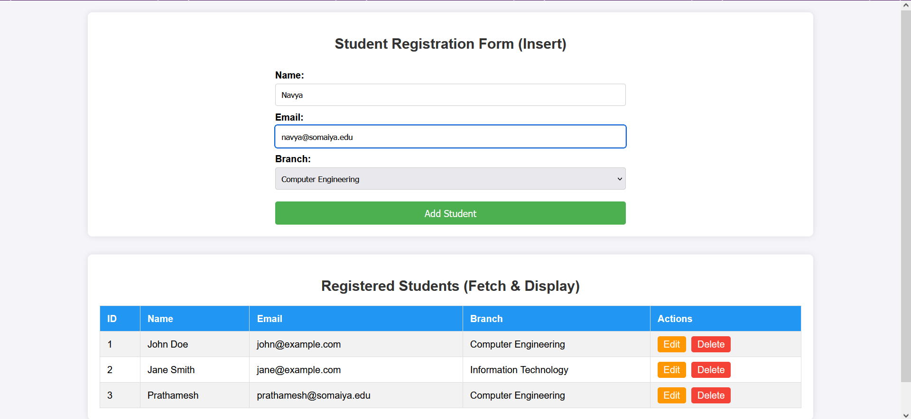
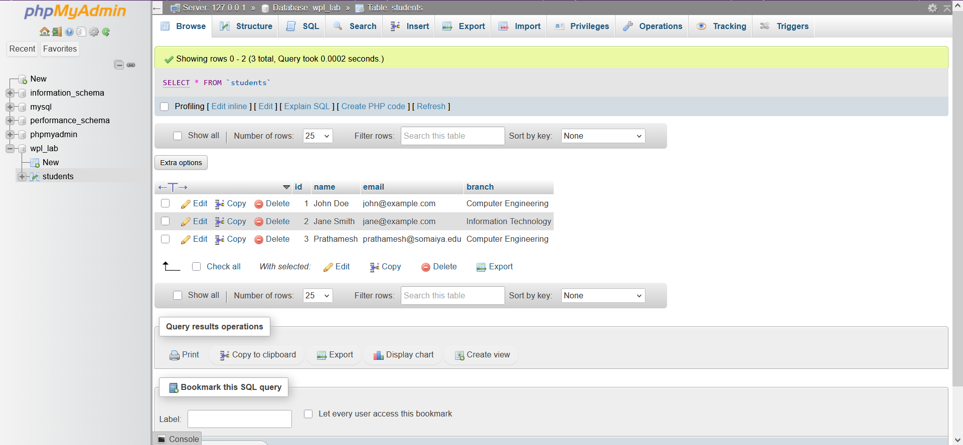
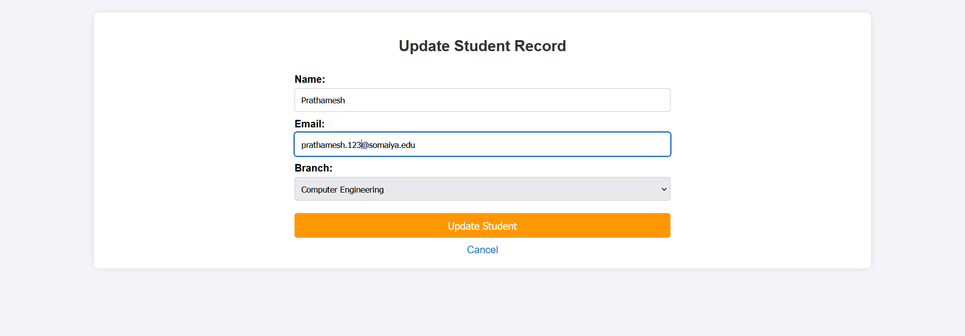
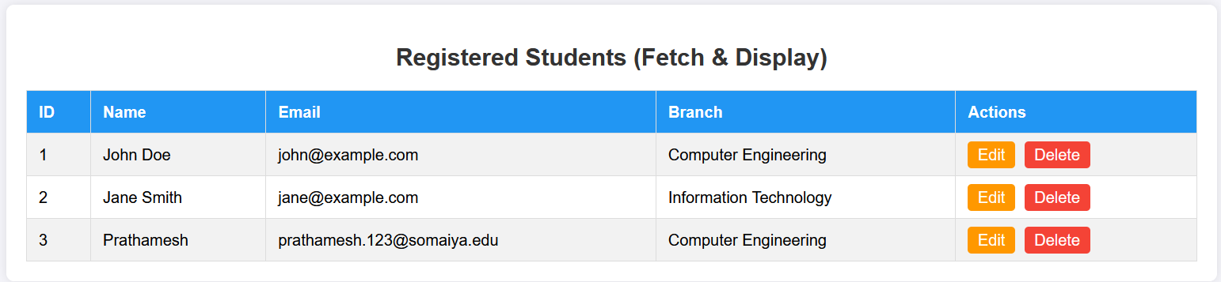

Post Lab Subjective/Objective type Questions:
- What is the role of mysqli or PDO in PHP?
mysqli and PDO are PHP extensions used to connect and interact with databases like MySQL. They allow execution of SQL queries such as INSERT, SELECT, UPDATE, and DELETE.

mysqli is specific to MySQL and provides both procedural and object-oriented approaches.
PDO (PHP Data Objects) is database-independent and supports multiple databases with a consistent interface. It also supports prepared statements, improving security against SQL injection.
- What is the difference between GET and POST methods in PHP?
• GET Method:
- Sends data through URL parameters.
- Data is visible in the browser.
- Limited data size.
- Suitable for fetching data (not secure for sensitive info).
• POST Method:
- Sends data in the request body.
- Data is not visible in the URL.
- Can send large amounts of data.
- More secure and used for form submissions like login or insert operations.
- Explain the flow of data when a user submits a form to insert a record into the database.
When a user fills out a form and clicks submit, the data is sent to the server using GET or POST method. PHP receives this data using $_GET or $_POST. The server-side script validates and sanitizes the input to ensure correctness and security. Then, a database connection is established using mysqli or PDO. An SQL INSERT query is executed to store the data in the database. After successful insertion, a response is generated, such as a success message or redirect, and the updated data can be displayed to the user.
- Write a PHP code snippet to establish a database connection using mysqli.
<?php
$servername = "localhost";
$username = "root";
$password = "";
$dbname = "test_db";

// Create connection
$conn = new mysqli($servername, $username, $password, $dbname);

// Check connection
if ($conn->connect_error) {
die("Connection failed: " . $conn->connect_error);
}
echo "Connected successfully";
?>
- Modify the Update functionality to allow partial record updates instead of updating all fields.
<?php
$id = $_POST['id'];
$name = $_POST['name'];
$email = $_POST['email'];

$updates = [];

if (!empty($name)) {
$updates[] = "name='$name'";
}
if (!empty($email)) {
$updates[] = "email='$email'";
}

$sql = "UPDATE users SET " . implode(", ", $updates) . " WHERE id=$id";

$conn->query($sql);
?>
- Propose enhancements to extend your CRUD application (e.g., authentication, pagination, search functionality, REST API integration).
The application can be improved with the following features:
- User Authentication: Login/logout system with session handling.
- Input Validation & Security: Use prepared statements to prevent SQL injection.
- Search Functionality: Allow users to search records dynamically.
- Pagination: Handle large datasets efficiently by displaying limited records per page.
- REST API Integration: Expose CRUD operations via APIs for mobile or frontend apps.
- UI Improvements: Use modern CSS frameworks like Bootstrap for better design.
- File Upload Support: Allow storing images or documents.
- Role-Based Access Control: Different permissions for admin and users.

Conclusion and Discussion:
(students should write in your words)
This experiment helped in understanding the development of a dynamic web application using PHP and MySQL.
(Also get feedback from fellow classmates (minimum 3) and faculty to add here)
Vedant: Suggested improving the UI using Bootstrap for better user experience.
Prajwal : Recommended adding search and filter features to make the application more interactive.
Mohammad : Advised implementing prepared statements to enhance security.

