Experiment No: 5
Course Name: | Web Programming Laboratory (216U01L405) | Semester: | IV
Date of Performance: | 28/03/2026 | DIV/ Batch No: | B2
Student Name: | Prathamesh Sanjeev Jadhav | Roll No: | 16010124109

Title: Design and Develop a web application that integrates PHP and HTML to display dynamic content based on user inputs and server-side data.

Aim of the Experiment:
The aim of this experiment is to design and develop a web application that utilizes PHP and HTML to create interactive, dynamic web pages. This application will allow users to input data through a form, which is then processed on the server side to display customized content based on the user's inputs.

Objectives for the Experiment:
- To Implement User Input Handling: Develop an HTML form that allows users to input data, ensuring a user-friendly interface for data collection.
- To Integrate PHP for Server-Side Processing: Utilize PHP to process the data received from the HTML form, enabling dynamic content generation based on user inputs.
- To Dynamically Display Results: Create a method to display the processed information on the web page, showcasing how server-side scripts can influence the content presented to the user.

COs to be achieved:
- Design dynamic web pages using various HTML tags.
- Use CSS to prepare the layout of web pages.
- Apply JavaScript for validation in client-side programming.
- Integrate server-side pages using PHP.

Books/ Journals/ Websites references:
- Students should write

Methodology:
Setting Up the Server Environment
- Install a local server environment (XAMPP/MAMP) to host the application.
- Start the Apache server and ensure it is running.
Creating HTML Form
- Develop an HTML form to receive user input.
Processing User Input with PHP
- Create a PHP file (process.php) to handle the form submission.
Testing the Application
- Open the HTML file in a web browser.
- Fill in the form and submit to ensure that the output displays correctly and dynamically based on user input

Theory:

Problem statement:
Design and implement an application to demonstrate HTML form integration with PHP for data collection and processing.

Utilize the registration page designed in Experiment No. 1 and create PHP scripts to handle form submission and data processing as follows:

1. Create separate PHP scripts for handling form submissions using different methods:
- post_registration.php: Processes the registration form data using the $_POST method.
- get_registration.php: Handles the form data using the $_GET method.
- request_registration.php: Retrieves the submitted data using the $_REQUEST method.
2. Each script should validate the input fields (e.g., check for valid email format and ensure mandatory fields are filled) and display the submitted registration details in a structured format.
Also,
- Define Problem statement for your Mini Project.
- Start working on Figma design of Mini Project.
- Design Frontend pages.
- Apply validation over

Code:
Register.html:
<!DOCTYPE html>
<html lang="en">

<head>
<meta charset="UTF-8">
<meta name="viewport" content="width=device-width, initial-scale=1.0">
<title>Hackathon Registration</title>
<link rel="stylesheet" href="form.css">
</head>

<body>
<h1>Register for Hackathon</h1>

<!-- Method selector -->
<div class="method-selector">
<label><strong>Choose submission method:</strong></label>
<select id="methodSelect" onchange="switchMethod()">
<option value="post">POST Method</option>
<option value="get">GET Method</option>
<option value="request">REQUEST Method</option>
</select>
</div>

<form id="registrationForm" action="post_registration.php" method="post" novalidate>
<div class="form-group">
<label for="pname">Student Name: </label>
<input type="text" id="pname" name="pname" required>
<span id="nameError" class="error-msg"></span>
</div>

<div class="form-group">
<label for="email">Student Email:</label>
<input type="email" id="email" name="email" required>
<span id="emailError" class="error-msg"></span>
</div>

<div class="form-group">
<label for="phone">Contact Number: </label>
<input type="tel" id="phone" name="phone">
<span id="phoneError" class="error-msg"></span>
</div>

<div class="form-group">
<label for="password">Password: </label>
<input type="password" id="password" name="password" required>
<span id="passwordError" class="error-msg"></span>
</div>

<div class="form-group">
<label for="confirmPassword">Confirm Password: </label>
<input type="password" id="confirmPassword" name="confirmPassword" required>
<span id="confirmPasswordError" class="error-msg"></span>
</div>

<div class="form-group">
<label for="dept">Branch: </label>
<select id="dept" name="dept">
<option value="cs">Computer Engineering</option>
<option value="it">Information Technology</option>
<option value="mech">Mechanical Engineering</option>
</select>
</div>

<div class="form-group">
<label>Gender: </label>
<input type="radio" id="male" name="gender" value="male">
<label for="male" class="inline-label">Male</label>
<input type="radio" id="female" name="gender" value="female">
<label for="female" class="inline-label">Female</label>
</div>

<div class="form-group">
<label>Tech Stack:</label>
<input type="checkbox" id="frontend" name="stack[]" value="Frontend Web">
<label for="frontend" class="inline-label">Frontend Web</label>
<input type="checkbox" id="backend" name="stack[]" value="Backend API">
<label for="backend" class="inline-label">Backend API</label>
<input type="checkbox" id="ai" name="stack[]" value="AI / ML">
<label for="ai" class="inline-label">AI / ML</label>
<input type="checkbox" id="app" name="stack[]" value="Mobile App">
<label for="app" class="inline-label">Mobile App</label>
</div>

<div class="form-actions">
<input type="submit" value="Register Now">
<input type="reset" value="Clear Form">
</div>
</form>

<script src="validation.js"></script>
<script>
function switchMethod() {
const form = document.getElementById('registrationForm');
const method = document.getElementById('methodSelect').value;
if (method === 'post') {
form.action = 'post_registration.php';
form.method = 'post';
} else if (method === 'get') {
form.action = 'get_registration.php';
form.method = 'get';
} else {
form.action = 'request_registration.php';
form.method = 'post'; // REQUEST works with both; use POST here
}
}
</script>
</body>

</html>

Get_registration.php
<!DOCTYPE html>
<html lang="en">
<head>
<meta charset="UTF-8">
<title>Registration Result (GET)</title>
<link rel="stylesheet" href="form.css">
</head>
<body>

<div class="result-container">
<h2>Submission Successful (GET Method)</h2>
<?php
if ($_SERVER["REQUEST_METHOD"] == "GET" && !empty($_GET)) {
// Sanitize and Validate Inputs
$name = htmlspecialchars(trim($_GET['pname'] ?? ''));
$email = filter_var(trim($_GET['email'] ?? ''), FILTER_SANITIZE_EMAIL);
$phone = htmlspecialchars(trim($_GET['phone'] ?? ''));
$dept = htmlspecialchars($_GET['dept'] ?? '');
$gender = htmlspecialchars($_GET['gender'] ?? 'Not Specified');
$stack = isset($_GET['stack']) ? $_GET['stack'] : [];

$errors = [];

// Server-side validation
if (empty($name)) {
$errors[] = "Name is a mandatory field.";
}
if (!filter_var($email, FILTER_VALIDATE_EMAIL)) {
$errors[] = "Invalid email format.";
}

if (count($errors) > 0) {
echo "<div style='color: red;'><h3>Validation Errors:</h3><ul>";
foreach ($errors as $err) {
echo "<li>" . htmlspecialchars($err) . "</li>";
}
echo "</ul></div>";
} else {
// Display structured data
echo "<div class='result-item'><strong>Name:</strong> " . $name . "</div>";
echo "<div class='result-item'><strong>Email:</strong> " . $email . "</div>";
echo "<div class='result-item'><strong>Phone:</strong> " . (!empty($phone) ? $phone : 'N/A') . "</div>";
echo "<div class='result-item'><strong>Branch:</strong> " . strtoupper($dept) . "</div>";
echo "<div class='result-item'><strong>Gender:</strong> " . ucfirst($gender) . "</div>";

echo "<div class='result-item'><strong>Tech Stack:</strong> ";
if (!empty($stack)) {
echo implode(", ", array_map('htmlspecialchars', $stack));
} else {
echo "None Selected";
}
echo "</div>";
}
} else {
echo "<p>No data received via GET method. Please ensure you submitted the form.</p>";
}
?>
<br>
<a href="register.html" class="back-link">Go Back</a>
</div>

</body>
</html>

Post php
<!DOCTYPE html>
<html lang="en">
<head>
<meta charset="UTF-8">
<title>Registration Result (POST)</title>
<link rel="stylesheet" href="form.css">
</head>
<body>

<div class="result-container">
<h2>Submission Successful (POST Method)</h2>
<?php
if ($_SERVER["REQUEST_METHOD"] == "POST") {
// Sanitize and Validate Inputs
$name = htmlspecialchars(trim($_POST['pname'] ?? ''));
$email = filter_var(trim($_POST['email'] ?? ''), FILTER_SANITIZE_EMAIL);
$phone = htmlspecialchars(trim($_POST['phone'] ?? ''));
$dept = htmlspecialchars($_POST['dept'] ?? '');
$gender = htmlspecialchars($_POST['gender'] ?? 'Not Specified');
$stack = isset($_POST['stack']) ? $_POST['stack'] : [];

$errors = [];

// Server-side validation
if (empty($name)) {
$errors[] = "Name is a mandatory field.";
}
if (!filter_var($email, FILTER_VALIDATE_EMAIL)) {
$errors[] = "Invalid email format.";
}

if (count($errors) > 0) {
echo "<div style='color: red;'><h3>Validation Errors:</h3><ul>";
foreach ($errors as $err) {
echo "<li>" . htmlspecialchars($err) . "</li>";
}
echo "</ul></div>";
} else {
// Display structured data
echo "<div class='result-item'><strong>Name:</strong> " . $name . "</div>";
echo "<div class='result-item'><strong>Email:</strong> " . $email . "</div>";
echo "<div class='result-item'><strong>Phone:</strong> " . (!empty($phone) ? $phone : 'N/A') . "</div>";
echo "<div class='result-item'><strong>Branch:</strong> " . strtoupper($dept) . "</div>";
echo "<div class='result-item'><strong>Gender:</strong> " . ucfirst($gender) . "</div>";

echo "<div class='result-item'><strong>Tech Stack:</strong> ";
if (!empty($stack)) {
echo implode(", ", array_map('htmlspecialchars', $stack));
} else {
echo "None Selected";
}
echo "</div>";

// Personalized greeting based on input
echo "<div class='result-item' style='margin-top: 20px; padding: 15px; background: #e3f2fd; border-radius: 4px;'>";
echo "<strong>Welcome Message:</strong> Hello, " . $name . "! We are thrilled to have a student from the " . strtoupper($dept) . " department joining our hackathon.";
if (in_array("AI / ML", $stack)) {
echo " We see you are interested in AI/ML – make sure to check out the neural network workshops!";
}
echo "</div>";
}
} else {
echo "<p>No data received via POST method.</p>";
}
?>
<br>
<a href="register.html" class="back-link">Go Back</a>
</div>

</body>
</html>

Request php
<!DOCTYPE html>
<html lang="en">
<head>
<meta charset="UTF-8">
<title>Registration Result (REQUEST)</title>
<link rel="stylesheet" href="form.css">
</head>
<body>

<div class="result-container">
<h2>Submission Successful (REQUEST Method)</h2>
<?php
if (!empty($_REQUEST['pname'])) {
// Sanitize and Validate Inputs using $_REQUEST
$name = htmlspecialchars(trim($_REQUEST['pname'] ?? ''));
$email = filter_var(trim($_REQUEST['email'] ?? ''), FILTER_SANITIZE_EMAIL);
$phone = htmlspecialchars(trim($_REQUEST['phone'] ?? ''));
$dept = htmlspecialchars($_REQUEST['dept'] ?? '');
$gender = htmlspecialchars($_REQUEST['gender'] ?? 'Not Specified');
$stack = isset($_REQUEST['stack']) ? $_REQUEST['stack'] : [];

$errors = [];

// Server-side validation
if (empty($name)) {
$errors[] = "Name is a mandatory field.";
}
if (!filter_var($email, FILTER_VALIDATE_EMAIL)) {
$errors[] = "Invalid email format.";
}

if (count($errors) > 0) {
echo "<div style='color: red;'><h3>Validation Errors:</h3><ul>";
foreach ($errors as $err) {
echo "<li>" . htmlspecialchars($err) . "</li>";
}
echo "</ul></div>";
} else {
// Display structured data cleanly
echo "<div class='result-item'><strong>Name:</strong> " . $name . "</div>";
echo "<div class='result-item'><strong>Email:</strong> " . $email . "</div>";
echo "<div class='result-item'><strong>Phone:</strong> " . (!empty($phone) ? $phone : 'N/A') . "</div>";
echo "<div class='result-item'><strong>Branch:</strong> " . strtoupper($dept) . "</div>";
echo "<div class='result-item'><strong>Gender:</strong> " . ucfirst($gender) . "</div>";

echo "<div class='result-item'><strong>Tech Stack:</strong> ";
if (!empty($stack)) {
echo implode(", ", array_map('htmlspecialchars', $stack));
} else {
echo "None Selected";
}
echo "</div>";
}
} else {
echo "<p>No data received via REQUEST method.</p>";
}
?>
<br>
<a href="register.html" class="back-link">Go Back</a>
</div>

</body>
</html>

Validation js
document.addEventListener("DOMContentLoaded", function () {
const form = document.getElementById("registrationForm");
const pname = document.getElementById("pname");
const email = document.getElementById("email");
const password = document.getElementById("password");
const confirmPassword = document.getElementById("confirmPassword");

// Validation Rules
const validateField = (field, errorId, validationFn, errorMessage) => {
const errorSpan = document.getElementById(errorId);
if (!validationFn(field.value)) {
field.classList.add("error-input");
field.classList.remove("valid-input");
errorSpan.innerText = errorMessage;
return false;
} else {
field.classList.remove("error-input");
field.classList.add("valid-input");
errorSpan.innerText = "";
return true;
}
};

const isNotEmpty = (val) => val.trim() !== "";
const isValidEmail = (val) => /^[^\s@]+@[^\s@]+\.[^\s@]+$/.test(val);
const isValidPassword = (val) => val.length >= 8;
const doPasswordsMatch = (val) => val === password.value;

// Real-time validation
pname.addEventListener("input", () => {
validateField(pname, "nameError", isNotEmpty, "Name is required.");
});

email.addEventListener("input", () => {
validateField(email, "emailError", isValidEmail, "Enter a valid email address.");
});

password.addEventListener("input", () => {
validateField(password, "passwordError", isValidPassword, "Password must be at least 8 characters.");
if (confirmPassword.value !== "") {
validateField(confirmPassword, "confirmPasswordError", doPasswordsMatch, "Passwords do not match.");
}
});

confirmPassword.addEventListener("input", () => {
validateField(confirmPassword, "confirmPasswordError", doPasswordsMatch, "Passwords do not match.");
});

// Q7: JavaScript function that checks user inputs before submission
function validateFormBeforeSubmit(e) {
let isNameValid = validateField(pname, "nameError", isNotEmpty, "Name is required.");
let isEmailValid = validateField(email, "emailError", isValidEmail, "Enter a valid email address.");
let isPasswordValid = validateField(password, "passwordError", isValidPassword, "Password must be at least 8 characters.");
let isConfirmValid = validateField(confirmPassword, "confirmPasswordError", doPasswordsMatch, "Passwords do not match.");

// Check if required fields are filled to provide specific user feedback (as requested)
if (!isNotEmpty(pname.value) || !isNotEmpty(email.value) || !isNotEmpty(password.value) || !isNotEmpty(confirmPassword.value)) {
alert("Error: Some required fields are currently empty. Please fill out all required fields.");
}

if (!(isNameValid && isEmailValid && isPasswordValid && isConfirmValid)) {
e.preventDefault(); // Stop submission
}
// If valid, allow form to naturally submit to the PHP handler
}

form.addEventListener("submit", validateFormBeforeSubmit);
});

Form css
form {
width: 60%;
margin: 20px auto;
padding: 20px;
background: #f9f9f9;
border-radius: 8px;
box-shadow: 0 0 10px rgba(0,0,0,0.1);
font-family: Arial, sans-serif;
}

h1 {
text-align: center;
color: #333;
font-family: Arial, sans-serif;
}

.method-selector {
width: 60%;
margin: 20px auto;
padding: 15px;
background: #e3f2fd;
border: 1px solid #bbdefb;
border-radius: 8px;
text-align: center;
font-family: Arial, sans-serif;
}

.method-selector select {
padding: 8px;
font-size: 16px;
margin-left: 10px;
border-radius: 4px;
border: 1px solid #1976d2;
}

.form-group {
margin-bottom: 20px;
}

label {
display: block;
font-weight: bold;
margin-bottom: 5px;
color: #444;
}

.inline-label {
display: inline;
font-weight: normal;
margin-left: 5px;
margin-right: 15px;
}

input[type="text"],
input[type="email"],
input[type="password"],
input[type="tel"],
select {
width: 100%;
padding: 10px;
border: 1px solid #ccc;
border-radius: 4px;
box-sizing: border-box;
font-size: 14px;
}

.error-input {
border: 2px solid #f44336 !important;
}

.valid-input {
border: 2px solid #4caf50 !important;
}

.error-msg {
color: #f44336;
font-size: 0.85em;
display: block;
margin-top: 5px;
min-height: 1em;
}

.form-actions {
margin-top: 30px;
text-align: center;
}

input[type="submit"] {
background-color: #4caf50;
color: white;
padding: 12px 24px;
border: none;
border-radius: 4px;
cursor: pointer;
font-weight: bold;
font-size: 16px;
}

input[type="submit"]:hover {
background-color: #45a049;
}

input[type="reset"] {
background-color: #f44336;
color: white;
padding: 12px 24px;
border: none;
border-radius: 4px;
cursor: pointer;
font-weight: bold;
font-size: 16px;
margin-left: 10px;
}

input[type="reset"]:hover {
background-color: #da190b;
}

.result-container {
width: 60%;
margin: 40px auto;
padding: 20px;
background: #fff;
border: 2px solid #4caf50;
border-radius: 8px;
font-family: Arial, sans-serif;
}
.result-container h2 {
color: #4caf50;
border-bottom: 2px solid #4caf50;
padding-bottom: 10px;
}
.result-item {
margin-bottom: 10px;
font-size: 16px;
}
.result-item strong {
color: #333;
}
.back-link {
display: inline-block;
margin-top: 20px;
padding: 10px 20px;
background: #2196f3;
color: white;
text-decoration: none;
border-radius: 4px;
}
.back-link:hover {
background: #0b7dda;
}

Output / Screenshot:
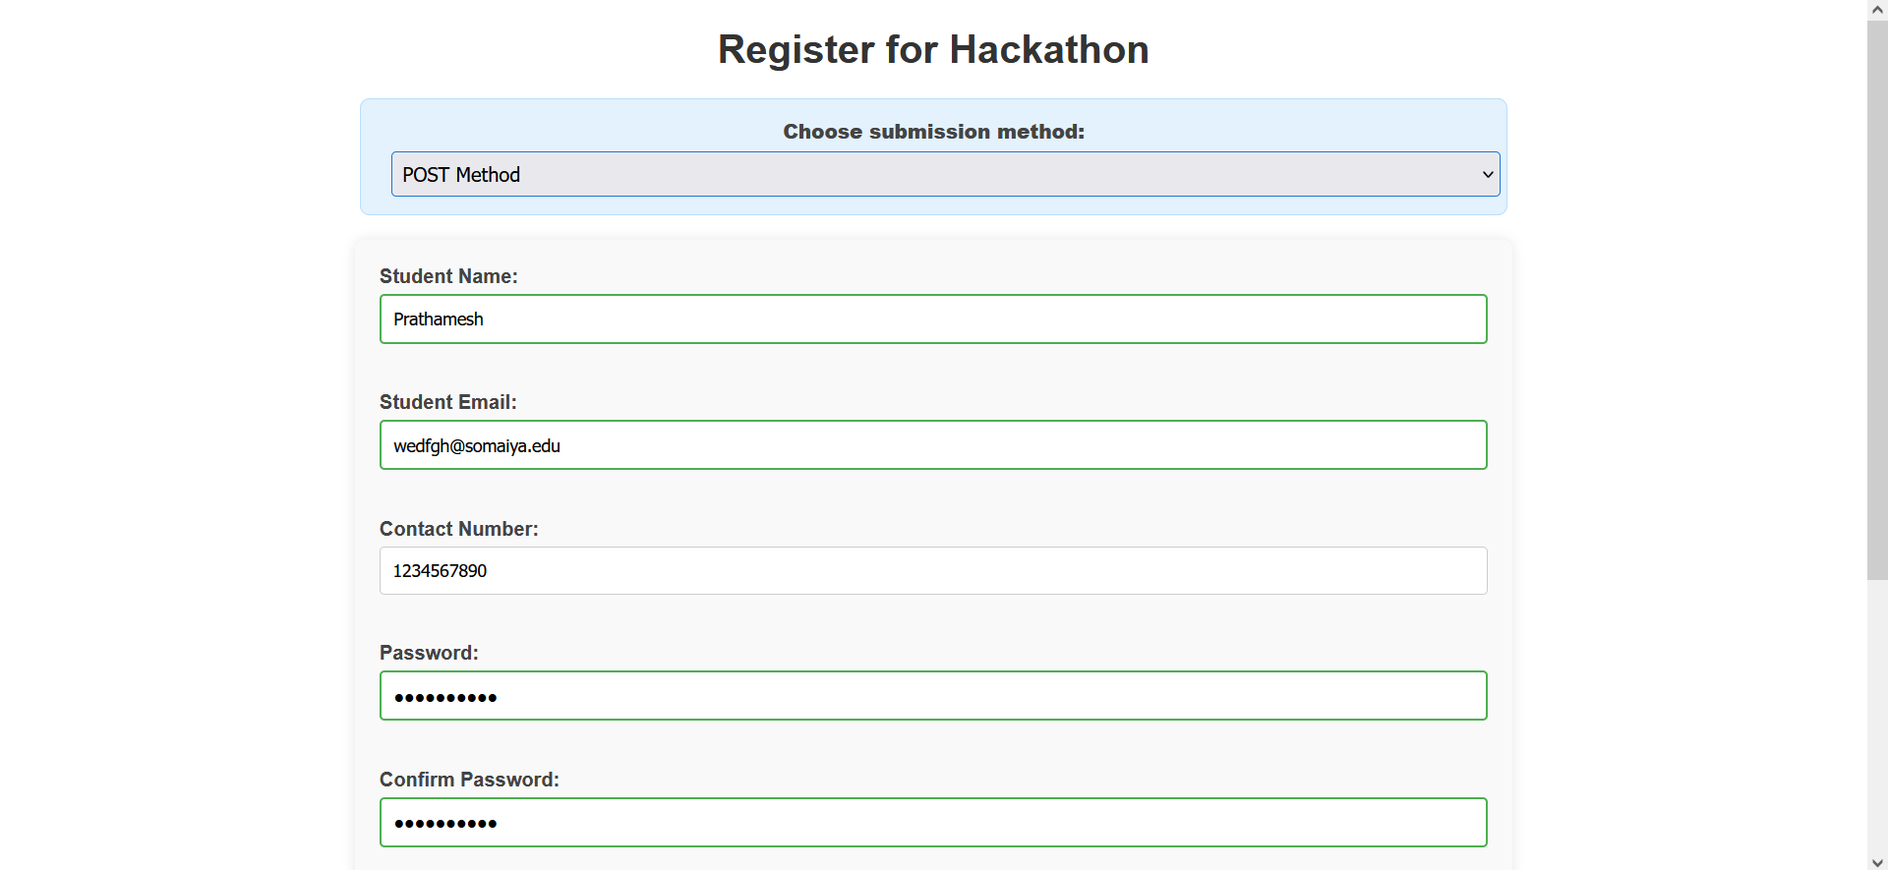
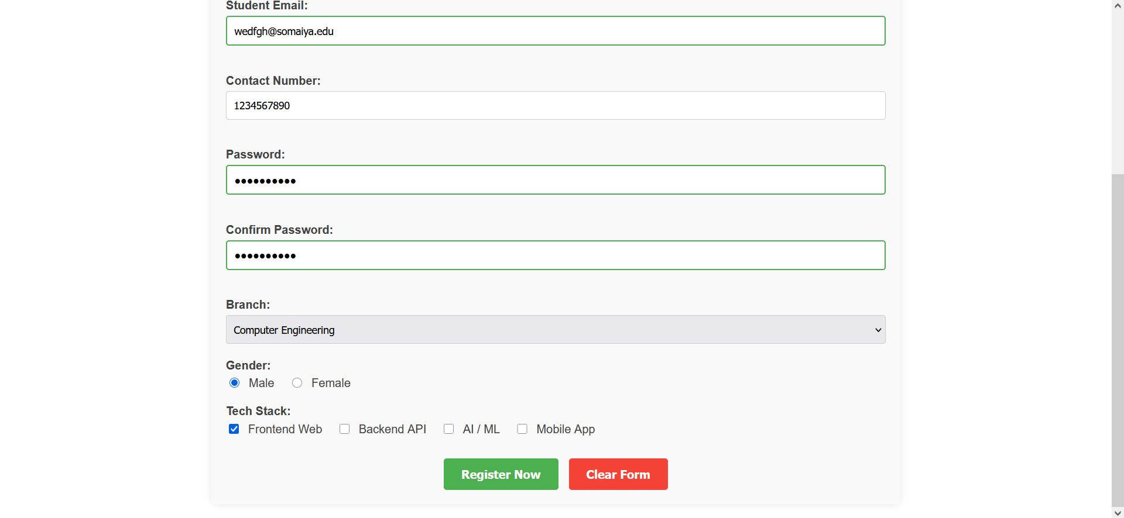
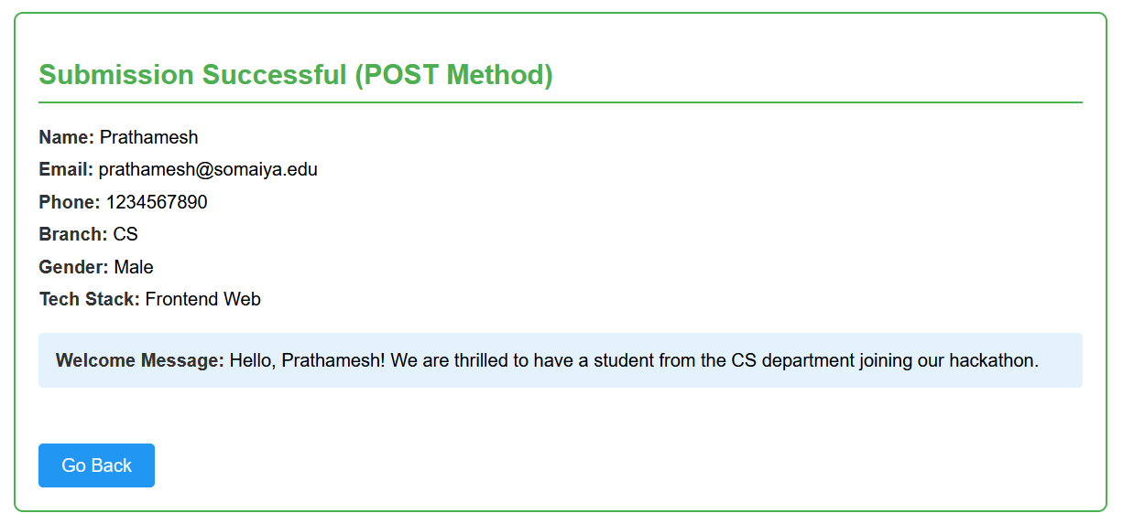
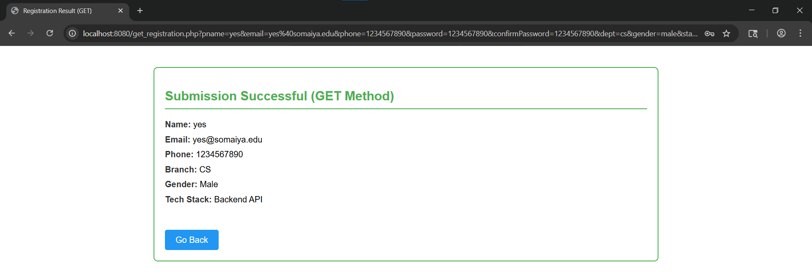
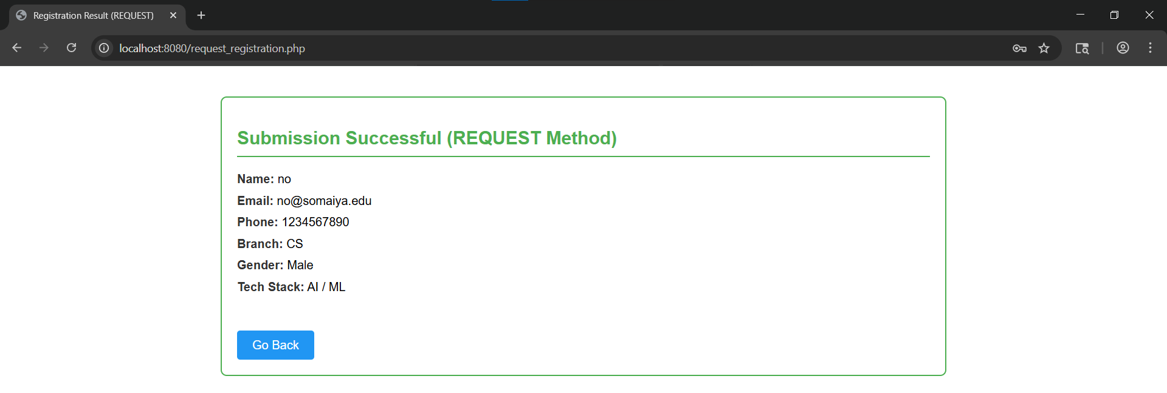

Post Lab Subjective/Objective type Questions:
- Which method ($_POST, $_GET, $_REQUEST) is the most secure, and why?
`$_POST` is the most secure method. When using `$_POST`, the form data is encapsulated within the HTTP request body rather than being appended to the URL string. This ensures that sensitive information (like passwords) is not visible in the browser's address bar, is not saved in the browser’s history, and does not appear in server access logs.

- From a developer's perspective, which method ($_POST, $_GET, $_REQUEST) is easier to use, and why?
From a sheer convenience standpoint, `$_REQUEST` is the easiest to use because it automatically absorbs data from `$_POST`, `$_GET`, and `$_COOKIE` globally. A developer doesn't have to explicitly check how the data was transmitted. However, strictly speaking, experienced developers prefer `$_POST` or `$_GET` because they clearly dictate the intention (fetching vs. mutating) and prevent cross-contamination of variables if a GET parameter and a POST parameter share the same name.
- How does the $_GET method handle data transmission, and what are its limitations?
The `$_GET` method handles data transmission by appending the form variables and values directly to the destination URL as query parameters (e.g., `process.php?name=John&age=20`).
**Limitations:**
- **Insecure:** Data is fully exposed in the URL.
- **Length Constraint:** Browsers and servers limit URL length (often around 2048 characters), meaning you cannot send large blocks of text.
- **Data Type limitation:** It cannot be used to upload binary data, such as images or documents.
- Write a PHP code snippet that sanitizes user inputs using htmlspecialchars() or similar functions to prevent XSS vulnerabilities. How would you ensure that inputs are safe to display?
```php
<?php
// Retrieve user comment
$raw_comment = $_POST['comment'] ?? '';

// Sanitize using htmlspecialchars to convert special characters to HTML entities
$safe_comment = htmlspecialchars($raw_comment, ENT_QUOTES, 'UTF-8');

// The $safe_comment is now safe to display in the browser.
echo "<div class='comment-box'>" . $safe_comment . "</div>";
?>
```
*Ensuring safety:* To ensure inputs are safe to display, developers must consistently enforce "Output Escaping" using `htmlspecialchars()` directly before rendering the data into the HTML DOM. This neutralizes any injected `<script>` tags, rendering them as raw text rather than executable browser code.
- Create a function in PHP that validates the user inputs to ensure they meet certain criteria (e.g., username must contain only letters and numbers, and the user input must not exceed 200 characters).
<?php
function validateUsername($username) {
// Check length constraint (Max 200 chars)
if (strlen($username) > 200 || strlen($username) == 0) {
return false;
}

// Check characters constraint (Only letters and numbers)
if (!preg_match("/^[a-zA-Z0-9]+$/", $username)) {
return false;
}

return true;
}
?>

- Write a PHP function that generates a personalized greeting message based on the user’s input. For example, if the input includes their favorite hobby, include that in the greeting.
<?php
function generateGreeting($name, $hobby) {
$safeName = htmlspecialchars(trim($name));
$safeHobby = htmlspecialchars(trim($hobby));

if (!empty($safeHobby)) {
return "Welcome, {$safeName}! We hope you find plenty of time to enjoy {$safeHobby}!";
} else {
return "Welcome, {$safeName}! It's great to have you with us.";
}
}

- Develop a JavaScript function that checks user inputs before submission. The function should confirm that all fields are filled and provide user feedback if any field is empty.
function validateFormBeforeSubmit(e) {
const pname = document.getElementById("pname").value.trim();
const email = document.getElementById("email").value.trim();
const password = document.getElementById("password").value;

// Check if required fields are filled to provide specific user feedback
if (!pname || !email || !password) {
alert("Error: Important fields are currently empty. Please fill out all required fields before submitting.");
e.preventDefault(); // Stop submission
return false;
}

// You can add further regex validations here
return true; // Form is valid and will now submit
}

// Attachment listener
const form = document.getElementById("registrationForm");
form.addEventListener("submit", validateFormBeforeSubmit);

Conclusion and Discussion:
(students should write in your words)
Through this experiment, the integration bridge between client-side interfaces (HTML/CSS/JS) and server-side processing (PHP) was successfully established.
(Also get feedback from fellow classmates (minimum 3) and faculty to add here)
Vedant: "The switch logic to verify POST vs GET methods provides a very robust understanding of URL boundaries versus body payloads."
Navjyot: "Client-side validation effectively prevents round-trip delays, although enforcing `htmlspecialchars` on the PHP side proved to be the ultimate layer of necessary security against script injections."
Akhil: "The styling mapping back to the PHP echoed back elements seamlessly, making the result output look highly professional instead of plain text dumps."

