Experiment No: 4
Course Name: | Web Programming Laboratory (216U01L405) | Semester: | IV
Date of Performance: | 07/03/2026 | DIV/ Batch No: | B2
Student Name: | Prathamesh Sanjeev Jadhav | Roll No: | 16010124109

Title: Develop a JavaScript program that implements client-side validation for HTML forms.

Aim of the Experiment:
- The aim of this project is to develop a JavaScript program that implements client-side validation for HTML forms, enhancing user experience by providing immediate feedback and reducing server-side processing.

Objectives for the Experiment:
- Implement Basic Validation:
  - Check for required fields and ensure they are filled before submission.
  - Validate data types (e.g., ensuring email fields contain valid email addresses).
- Enhance User Feedback:
  - Provide clear error messages that guide users on how to correct their input.
  - Highlight fields that contain errors dynamically.
- Integrate Advanced Validations:
  - Implement complex validations (e.g., password confirmation, minimum/maximum length).
  - Consider real-time validation as the user types.
- Test and Debug the Program:
  - Use various test cases to ensure that all validation scenarios are covered.
  - Fix any issues to ensure smooth user interaction.
- Document the Code:
  - Write thorough documentation explaining the code, functions, and intended behavior of the validation process.

COs to be achieved:
Design dynamic web pages using various HTML tags.
Use CSS to prepare the layout of web pages.
Apply JavaScript for validation in client-side programming.

Books/ Journals/ Websites references:
- Students should write

Theory:
Students should write about CSS3 (citation needed for content taken (IEEE or APA7 style))

Problem statement: “College Event & Student Services Web Portal” A college wants to develop a basic HTML5-based web portal to showcase events, registrations, information, and services for students. Each task contributes one page or feature of this portal. Enhanced the portal using CSS3 and Java script with validation.

Code:
Register.html
<!DOCTYPE html>
<html lang="en">

<head>
<meta charset="UTF-8">
<title>Hackathon Registration</title>
<link rel="stylesheet" href="form.css">
</head>

<body>
<h1>Register for Hackathon</h1>
<form id="registrationForm" action="submit_registration.php" method="post" novalidate>
<div class="form-group">
<label for="pname">Student Name: </label>
<input type="text" id="pname" name="pname" required>
<span id="nameError" class="error-msg"></span>
</div>

<div class="form-group">
<label for="email">Student Email:</label>
<input type="email" id="email" name="email" required>
<span id="emailError" class="error-msg"></span>
</div>

<div class="form-group">
<label for="phone">Contact Number: </label>
<input type="tel" id="phone" name="phone">
<span id="phoneError" class="error-msg"></span>
</div>

<div class="form-group">
<label for="password">Password: </label>
<input type="password" id="password" name="password" required>
<span id="passwordError" class="error-msg"></span>
</div>

<div class="form-group">
<label for="confirmPassword">Confirm Password: </label>
<input type="password" id="confirmPassword" name="confirmPassword" required>
<span id="confirmPasswordError" class="error-msg"></span>
</div>

<div class="form-group">
<label for="dept">Branch: </label>
<select id="dept" name="dept">
<option value="cs">Computer Engineering</option>
<option value="it">Information Technology</option>
<option value="mech">Mechanical Engineering</option>
</select>
</div>

<div class="form-group">
<label>Gender: </label>
<input type="radio" id="male" name="gender" value="male">
<label for="male" class="inline-label">Male</label>
<input type="radio" id="female" name="gender" value="female">
<label for="female" class="inline-label">Female</label>
</div>

<div class="form-group">
<label>Tech Stack:</label>
<input type="checkbox" id="frontend" name="stack" value="frontend">
<label for="frontend" class="inline-label">Frontend Web</label>
<input type="checkbox" id="backend" name="stack" value="backend">
<label for="backend" class="inline-label">Backend API</label>
<input type="checkbox" id="ai" name="stack" value="ai">
<label for="ai" class="inline-label">AI / ML</label>
<input type="checkbox" id="app" name="stack" value="app">
<label for="app" class="inline-label">Mobile App</label>
</div>

<div class="form-actions">
<input type="submit" value="Register Now">
<input type="reset" value="Clear Form">
</div>
</form>
<script src="validation.js"></script>
</body>

</html>

Validation.js
document.addEventListener("DOMContentLoaded", function () {
const form = document.getElementById("registrationForm");
const pname = document.getElementById("pname");
const email = document.getElementById("email");
const password = document.getElementById("password");
const confirmPassword = document.getElementById("confirmPassword");

// Validation Rules
const validateField = (field, errorId, validationFn, errorMessage) => {
const errorSpan = document.getElementById(errorId);
if (!validationFn(field.value)) {
field.classList.add("error-input");
field.classList.remove("valid-input");
errorSpan.innerText = errorMessage;
return false;
} else {
field.classList.remove("error-input");
field.classList.add("valid-input");
errorSpan.innerText = "";
return true;
}
};

const isNotEmpty = (val) => val.trim() !== "";
const isValidEmail = (val) => /^[^\s@]+@[^\s@]+\.[^\s@]+$/.test(val);
const isValidPassword = (val) => val.length >= 8;
const doPasswordsMatch = (val) => val === password.value;

// Real-time validation
pname.addEventListener("input", () => {
validateField(pname, "nameError", isNotEmpty, "Name is required.");
});

email.addEventListener("input", () => {
validateField(email, "emailError", isValidEmail, "Enter a valid email address.");
});

password.addEventListener("input", () => {
validateField(password, "passwordError", isValidPassword, "Password must be at least 8 characters.");
// Re-validate confirm password if it's already filled
if (confirmPassword.value !== "") {
validateField(confirmPassword, "confirmPasswordError", doPasswordsMatch, "Passwords do not match.");
}
});

confirmPassword.addEventListener("input", () => {
validateField(confirmPassword, "confirmPasswordError", doPasswordsMatch, "Passwords do not match.");
});

// Form Submission
form.addEventListener("submit", function (e) {
let isNameValid = validateField(pname, "nameError", isNotEmpty, "Name is required.");
let isEmailValid = validateField(email, "emailError", isValidEmail, "Enter a valid email address.");
let isPasswordValid = validateField(password, "passwordError", isValidPassword, "Password must be at least 8 characters.");
let isConfirmValid = validateField(confirmPassword, "confirmPasswordError", doPasswordsMatch, "Passwords do not match.");

if (!(isNameValid && isEmailValid && isPasswordValid && isConfirmValid)) {
e.preventDefault();
alert("Please correct the errors before submitting.");
} else {
alert("Registration successful! (Demo only)");
e.preventDefault(); // Prevent actual submission for demo purposes
}
});

console.log("Validation system initialized.");
});

Output / Screenshot:
Initial state
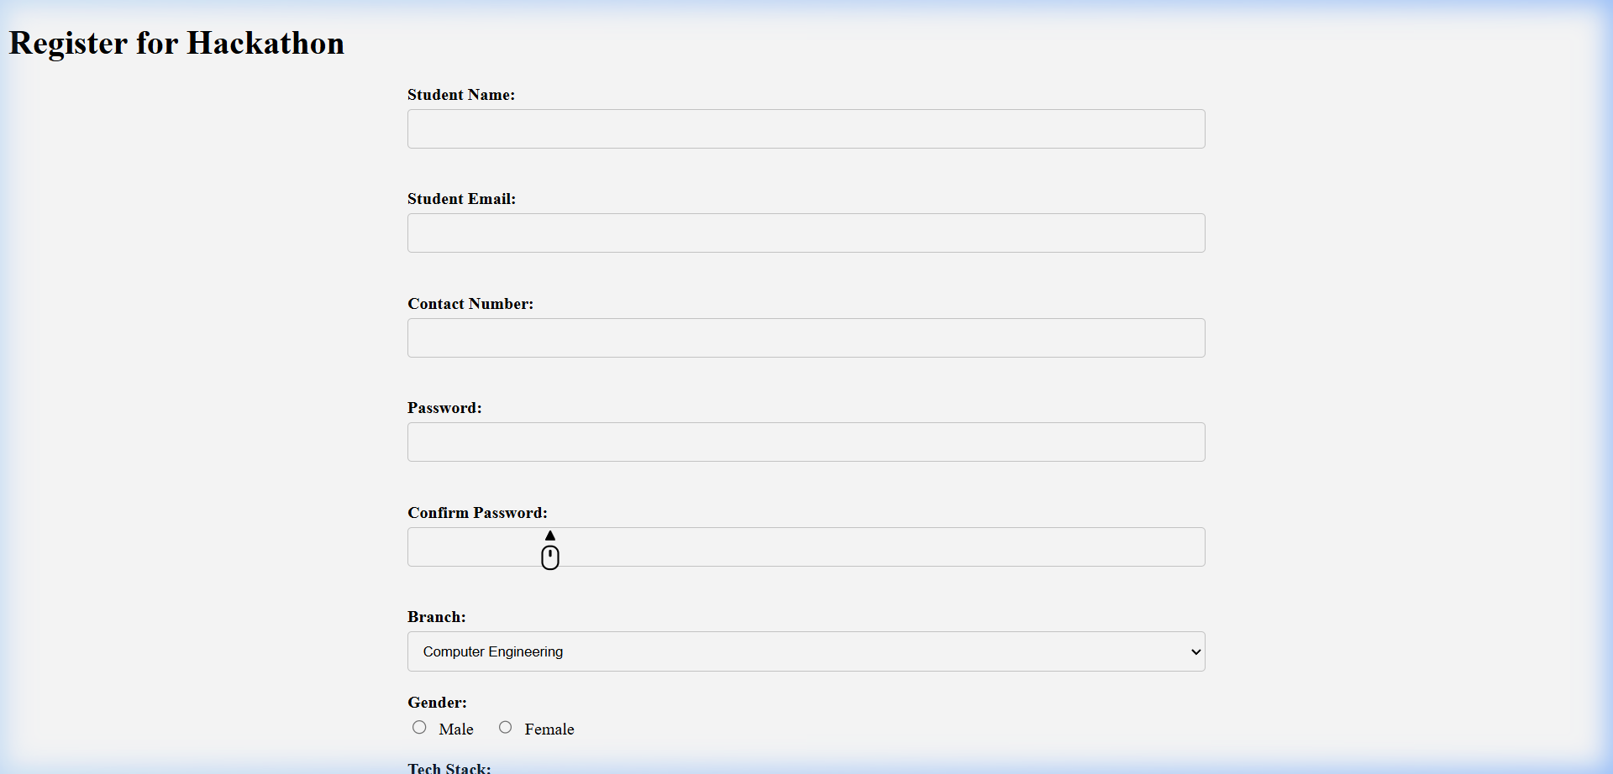
Required errors
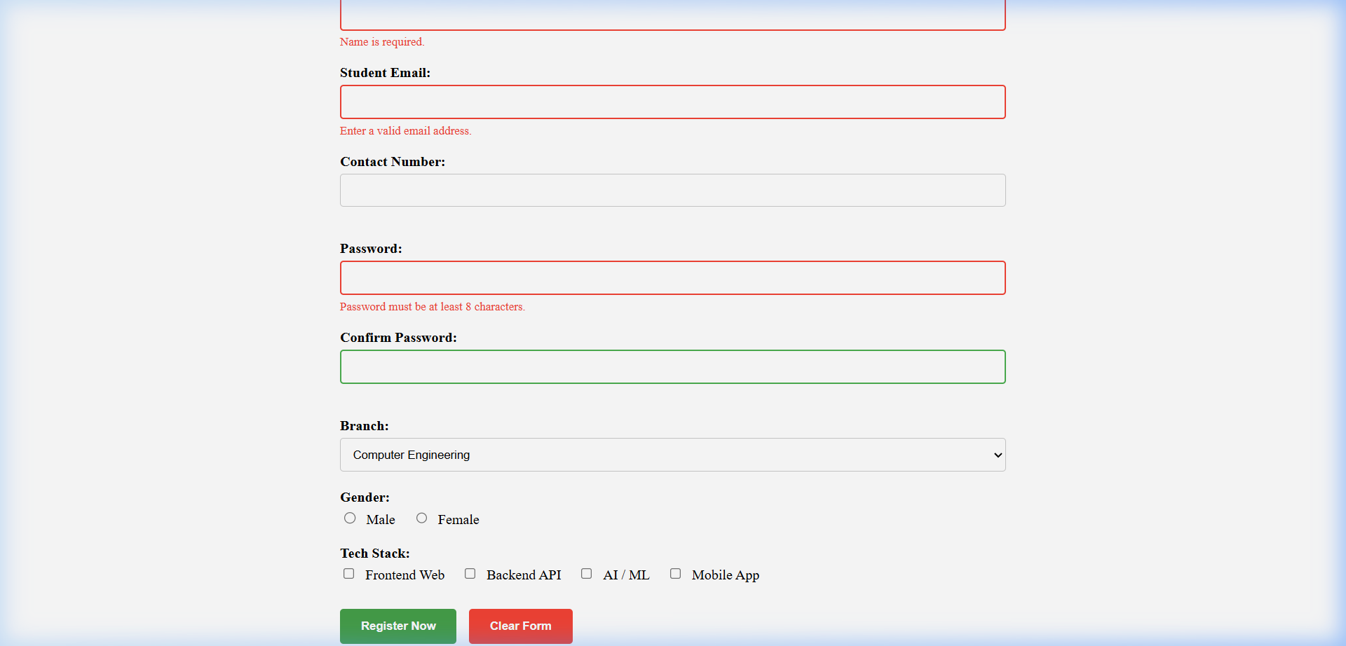
Invalid errors
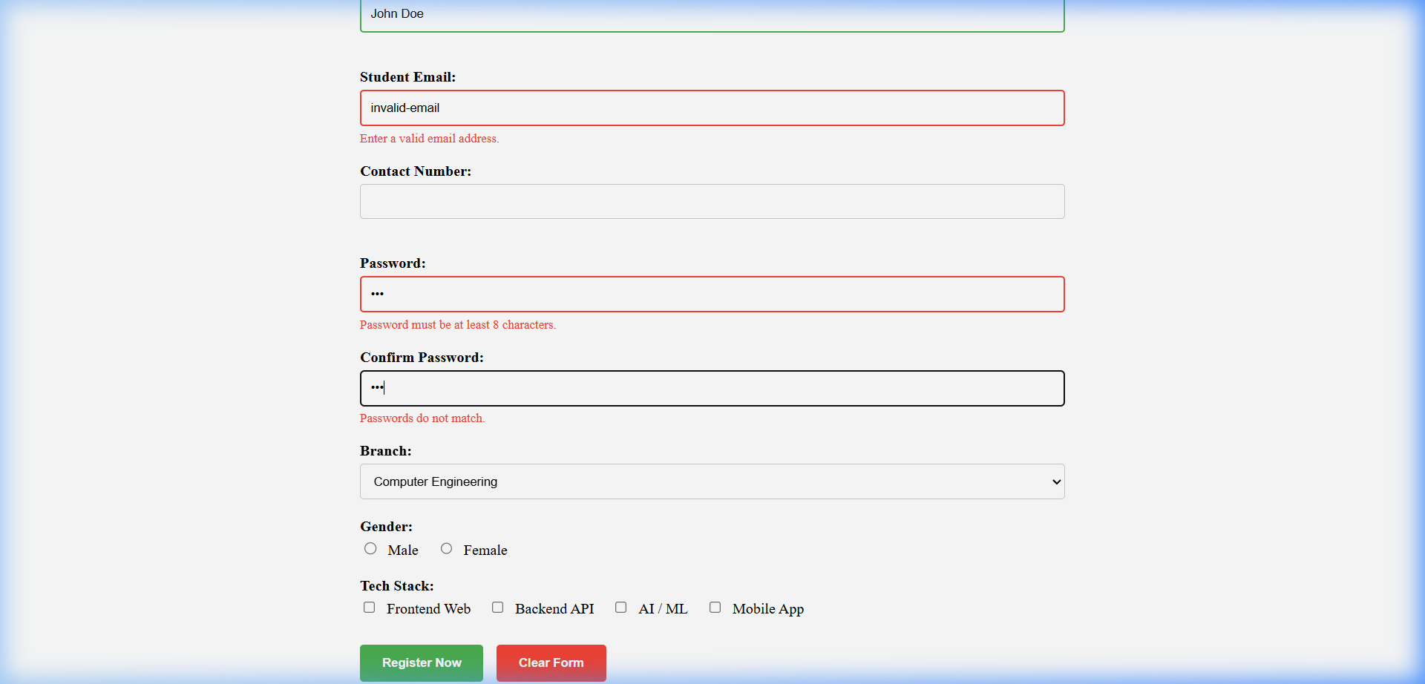
Valid inputs
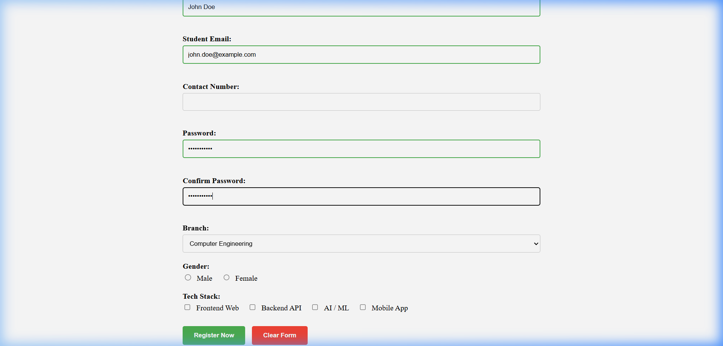
Final state
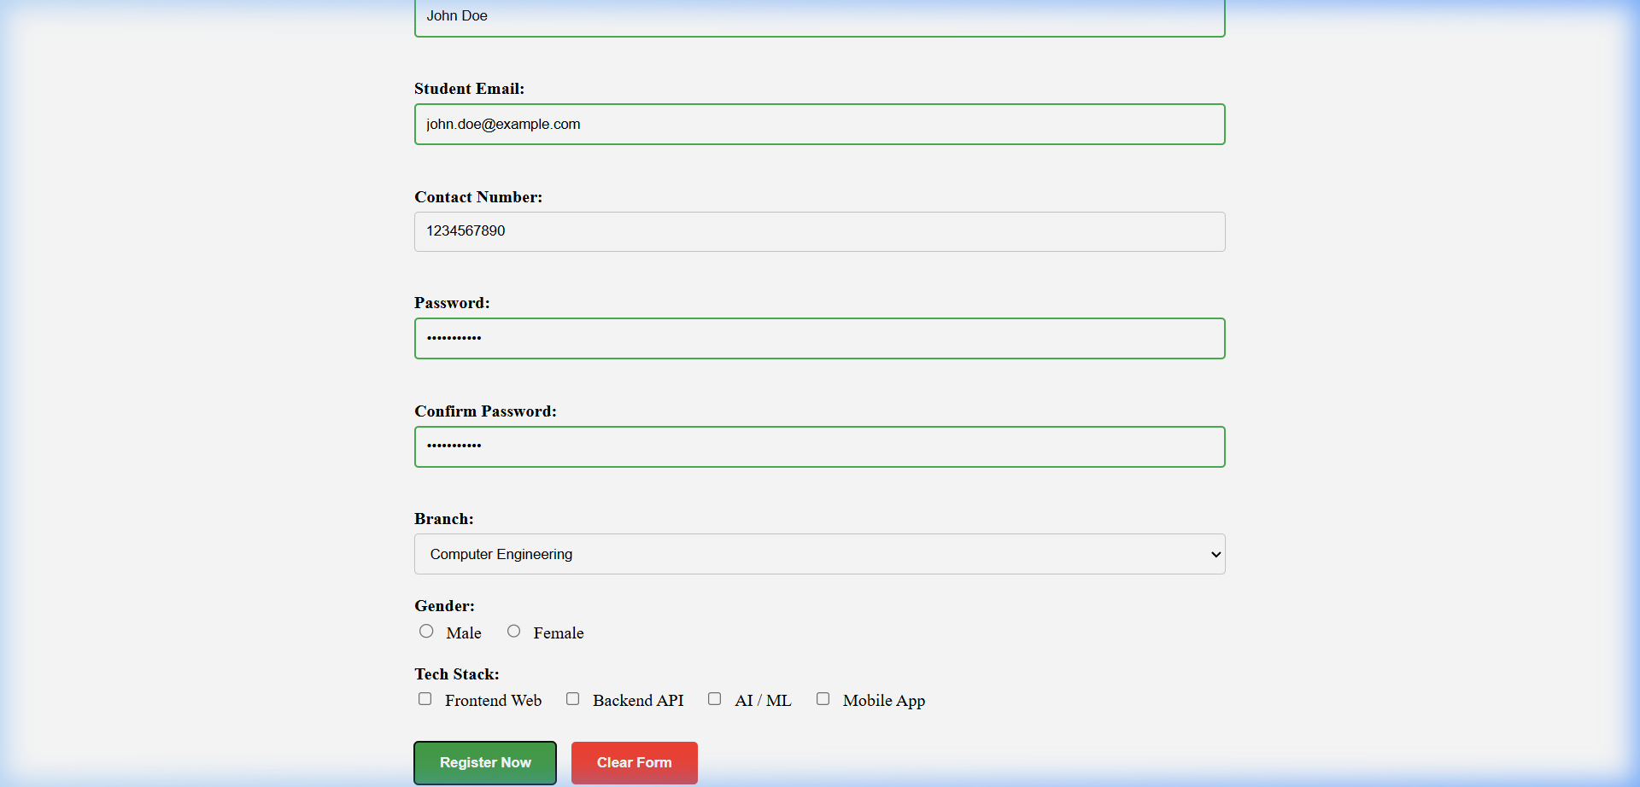

Post Lab Subjective/Objective type Questions:
- What are potential downsides of relying solely on client-side validation?
ANS: Relying exclusively on client-side validation introduces several risks:
- Security Bypassing: Users can easily disable JavaScript in their browser or use tools like Postman to send malicious data directly to the server, bypassing all client-side checks.
- Data Integrity: Without server-side validation, the database could end up with inconsistent or corrupted data if the client-side logic is bypassed or fails.
- Inconsistency: Different clients (e.g., a mobile app vs. a web browser) might implement validation differently, leading to inconsistent data entries if the server doesn't enforce a single source of truth.

- How would you modify your validation logic to accommodate accessibility for users with disabilities?
ANS: To make validation accessible, the following practices should be implemented:
- ARIA Attributes: Use aria-invalid="true" on fields with errors and aria-describedby to link the input field to its corresponding error message.
- Screen Reader Alerts: Use role="alert" or aria-live="polite" on error message containers so screen readers announce the error immediately when it appears.
- Keyboard Navigation: Ensure that users can navigate through the form and that focus is automatically moved to the first error field upon a failed submission.
- Color Independence: Do not rely on color alone (e.g., a red border) to indicate an error; always provide a text-based error message.

- What strategies could you use to manage different validation scenarios for various form types (e.g., login, registration)?
ANS: Managing multiple form types can be handled through:
- Modular Validation Functions: Create a library of reusable validation rules (e.g., isEmail(), isStrongPassword()) that can be imported into different forms.
- Data-Attribute Driven Validation: Use HTML5 data attributes (e.g., data-validate="email") to define validation rules directly in the HTML, and have a generic script parse these to apply logic.
- Schema-Based Validation: For more complex apps, using a schema validation library (like Zod or Joi) allows you to define a single "contract" for each form type that handles both client and server-side validation.

- How can you ensure that your validation mechanisms are up to date.
ANS: To keep validation current:
- Regular Updates to Regex: Periodically review and update regular expressions for complex types like email or phone numbers to match changing standards.
- Use Standard Libraries: Instead of writing custom logic for everything, use well-maintained libraries (like validator.js) that are updated by the community to handle edge cases and security fixes.
- Sync with Backend: Ensure that client-side rules are always a subset of server-side rules. If the database schema changes (e.g., a field length increases), the client-side validation should be updated simultaneously.
- User Testing & Feedback: Monitor user error logs to identify common validation hurdles or false positives that might indicate outdated logic.

Conclusion and Discussion:
Javascript is the main thing
CODE: https://github.com/PrathameshSJ/wpl-lab
Vedant: It works so I got like no problems with it, I like it actually
Navjyot: u could add a bit of styling to it
Akhil: try adding dark theme

