Course Name: | Web Programming Laboratory (216U01L405) | Semester: | IV
Date of Performance: | 23/01/2026 | DIV/ Batch No: | B2
Student Name: | Prathamesh Sanjeev Jadhav | Roll No: | 16010124109

Experiment No: 1
Title: Design and Development of a Web Portal using HTML5

Aim of the Experiment: To design and develop a multi-page, case-study-based web portal using HTML5, demonstrating proper document structure, semantic elements, formatting, lists, links, images, tables.

Objectives of the Experiment:
- Develop structured and semantic HTML5 documents
- Create interactive and media-rich web pages
- Apply real-world problem context to web development
- Build a basic but complete front-end web portal

COs to be achieved:
CO1: Design dynamic web pages using various HTML tags.

Books/ Journals/ Websites references:
- Students should write

Theory:
Students should write about HTML 5 (citation needed for content taken (IEEE or APA7 style))

Problem statement: “College Event & Student Services Web Portal” A college wants to develop a basic HTML5-based web portal to showcase events, registrations, information, and services for students. Each task contributes one page or feature of this portal
Task:
Task 1: Home Page – HTML5 Document Structure & Global Attributes
Use Case:
Design the Home Page of the College Event Portal.
Requirements:
- Use proper HTML5 document structure
- Display college name, logo text, and academic year
- Use global attributes (id, class, title, style)
- Add a tooltip on the college name
Deliverable: index.html
Skills Tested: Document structure, global attributes

Task 2: Event Description Page – Formatting & Text-Level Tags
Use Case:
Create a page describing an Annual TechFest.
Requirements:
- Highlight event name using <strong> and <mark>
- Use <em> for themes and <small> for disclaimers
- Use <sup> and <sub> for dates and versions
- Use <abbr> for technical terms
Deliverable: event-details.html
Skills Tested: Formatting & text-level tags

Task 3: About Department Page – Block vs Inline Formatting
Use Case:
Design an About Computer Engineering Department page.
Requirements:
- Use <div> sections for Vision, Mission, Facilities
- Use <blockquote> for HoD’s message
- Inline formatting inside paragraphs
- Apply background colors to block sections
Deliverable: about-dept.html
Skills Tested: Block-level and inline elements

Task 4: Student Clubs Page – Lists & Nested Lists
Use Case:
Display Student Clubs and Activities.
Requirements:
- Ordered list for technical clubs
- Unordered list for cultural clubs
- Nested list showing events under each club
- Description list explaining club acronyms
Deliverable: clubs.html
Skills Tested: List tags

Task 5: Navigation Page – Hyperlinks
Use Case:
Create a Navigation Menu for the portal.
Requirements:
- Link to all internal pages created so far
- External link to university website
- Email link to event coordinator
- Telephone link for student helpdesk
Deliverable: navigation.html
Skills Tested: Hyperlink tags

Task 6: Campus Map – Image & Image Map
Use Case:
Provide an interactive Campus Map.
Requirements:
- Display campus image
- Create image map with clickable areas:
  - Auditorium
  - Library
- Each area opens a relevant page or link
Deliverable: campus-map.html
Skills Tested: Image and image maps

Task 7: Result Summary Page – Tables
Use Case:
Display Event Competition Results.
Requirements:
- Table showing Team Name, Event, Position, Score
- Use <caption>, <thead>, <tbody>, <tfoot>
- Merge header cells using colspan
Deliverable: results.html
Skills Tested: Table tags

Task 8: Event Registration – Forms
Use Case:
Create an Online Event Registration Form.
Requirements:
- Student name, email, roll number
- Event selection (dropdown)
- Gender (radio)
- Skills (checkbox)
- Submit and reset buttons
Deliverable: register.html
Skills Tested: Form tags

Task 09: Media & Frames – Executable Content
Use Case:
Create a Media Gallery & Information Page.
Requirements:
- Embed previous year event video using <video>
- Add background music using <audio>
- Embed Google Map or college site using <iframe>
- Use <noscript> message
Deliverable: media.html
Skills Tested: Frames & executable tags

Code :
Drive Link of all Code: https://drive.google.com/drive/folders/1ARbPvS39UZ_Xyx5PT0KFZmpEUOyu3rr2?usp=sharing

Task 1: Home Page – HTML5 Document Structure & Global Attributes
Deliverable: index.html
<!DOCTYPE html>
<html>
<head>
<title>College Event Portal</title>
</head>
<body>

<div id="home" class="container" style="text-align:center;">

<img src="KJSCE.webp" alt="logo">

<h2 class="logo" title="Official College Event Portal">COLLEGE EVENT PORTAL</h2>

<h1 id="clgname" title="Welcome to KJSSE">K. J. Somaiya School of Engineering</h1>

<p class="year">Academic Year: 2025 – 2026</p>

</div>

</body>
</html>

Task 2: Event Description Page – Formatting & Text-Level Tags
Deliverable: event-details.html
<!DOCTYPE html>
<html>
<head>
<title>Event Details</title>
</head>
<body>

<table style="width:100%">
<tr>
<td>
<img src="KJSCE.webp" alt="logo" style="text-align:left;">
</td>

<td style="width:100%">
<div id="home" class="container" style="text-align:center;">
<h1><strong><mark>Abhiyantriki</mark></strong></h1>

<p><strong><mark>Abhiyantriki</mark></strong> is the biggest technical event of our college.</p>

<p>The main theme of the event is <em>Innovation and Future Technology</em>.</p>

<p>The event will be held on 15<sup>th</sup> August 2026.</p>

<p>This is version 2<sub>0</sub> of the TechFest.</p>

<p>Workshops will be conducted on <abbr title="Artificial Intelligence">AI</abbr>, <abbr title="Internet of Things">IoT</abbr>, and <abbr title="Machine Learning">ML</abbr>.</p>

<p><small>Event schedule may change without prior notice.</small></p>
</td>
</tr>
</table>

<img src="campus.jpg" alt="Campus Photo" style="width:100%;">
</div>
</body>
</html>

Task 3: About Department Page – Block vs Inline Formatting
Deliverable: about-dept.html
<!DOCTYPE html>
<html lang="en">

<head>
<meta charset="UTF-8">
<title>About Cardiology</title>
</head>

<body>
<h1>Department of Cardiology</h1>
<section>
<h3>Message from the Chief</h3>
<blockquote>
"The heart is the engine of life, and we are here to keep it running smoothly."
</blockquote>
</section>
<div>
<h3>Vision</h3>
<p>To be a <b>global leader</b> in cardiac care.</p>
</div>
<div>
<h3>Mission</h3>
<p>To provide <i>affordable</i> and <b>advanced</b> heart treatments.</p>
</div>
<div>
<h3>Facilities</h3>
<p>Angiography, Pacemaker Implantation, 24/7 ECG monitoring.</p>
</div>
</body>

</html>

Task 4: Student Clubs Page – Lists & Nested Lists
Deliverable: clubs.html
<!DOCTYPE html>
<html lang="en">

<head>
<meta charset="UTF-8">
<title>Doctors & Departments</title>
</head>

<body>
<h1>Our Departments</h1>
<h3>Medical Departments</h3>
<ol type="1">
<li>
Cardiology
<ul>
<li>Dr. A. Sharma</li>
<li>Dr. B. Patel</li>
</ul>
</li>
<li>
Neurology
<ul>
<li>Dr. C. Rao</li>
</ul>
</li>
<li>Orthopedics</li>
</ol>
<h3>Support Services</h3>
<ul type="square">
<li>Ambulance</li>
<li>Pharmacy</li>
<li>Blood Bank</li>
</ul>
<h3>Department Abbreviations</h3>
<dl>
<dt>OPD</dt>
<dd>Out Patient Department For routine checkups.</dd>
<dt>ENT</dt>
<dd>Ear, Nose, and Throat specialists.</dd>
</dl>
</body>

</html>

Task 5: Navigation Page – Hyperlinks
Deliverable: navigation.html
<!DOCTYPE html>
<html lang="en">

<head>
<meta charset="UTF-8">
<title>Site Navigation</title>
</head>

<body>
<h1>Portal Navigation</h1>
<h3>Internal Links</h3>
<nav>
<ul>
<li><a href="index.html">Home</a></li>
<li><a href="services.html">Services</a></li>
<li><a href="about-department.html">About Cardiology</a></li>
<li><a href="doctors.html">Doctors & Departments</a></li>
<li><a href="hospital-map.html">Hospital Layout</a></li>
<li><a href="appointments.html">Appointments List</a></li>
<li><a href="book-appointment.html">Book Appointment</a></li>
<li><a href="media.html">Media Page</a></li>
</ul>
</nav>
<h3>External Resources</h3>
<ul>
<li><a href="https://www.mohfw.gov.in/" target="_blank">Ministry of Health (Govt)</a></ li>
</ul>
<h3>Contact Us</h3>
<ul>
<li>Email: <a href="mailto: appointment@somaiyahospital.
com">appointment@somaiyahospital.com</a></li>
<li>Emergency: <a href="tel:+911234567890">+91 12345 67890</a></li>
</ul>
</body>

</html>

Task 6: Campus Map – Image & Image Map
Deliverable: campus-map.html
<!DOCTYPE html>
<html lang="en">

<head>
<meta charset="UTF-8">
<title>Hospital Map</title>
</head>

<body>
<h1>Interactive Hospital Layout</h1>
<p>Click on the areas in the image (Left side for Emergency, Right side for Pharmacy).</p>
<img src="https://i.pinimg.com/736x/83/c9/22/83c922df6ceefd6e98bc5775ee57edff.jpg" alt="Hospital Layout"
usemap="#hospitalmap" width="600" height="400">
<map name="hospitalmap">
<area shape="rect" coords="0,0,300,400" href="services.html" alt="Emergency Ward"
title="Go to Emergency Services">
<area shape="rect" coords="300,0,600,400" href="doctors.html" alt="Pharmacy" title="Go to Pharmacy Info">
</map>
</body>

</html>

Task 7: Result Summary Page – Tables
Deliverable: results.html
<!DOCTYPE html>
<html lang="en">

<head>
<meta charset="UTF-8">
<title>Daily Appointments</title>
</head>

<body>
<h1>Daily Appointment Summary</h1>
<table border="1">
<caption>List of Today's Scheduled Visits</caption>
<thead>
<tr>
<th colspan="4">February 24, 2025</th>
</tr>
<tr>
<th>Patient Name</th>
<th>Doctor</th>
<th>Time</th>
<th>Status</th>
</tr>
</thead>
<tbody>
<tr>
<td>John Doe</td>
<td>Dr. Sharma</td>
<td>10:00 AM</td>
<td>Completed</td>
</tr>
<tr>
<td>Jane Smith</td>
<td>Dr. Patel</td>
<td>11:30 AM</td>
<td>Waiting</td>
</tr>
</tbody>
<tfoot>
<tr>
<tfoot>
<tr>
<td colspan="4">Total Appointments: 2</td>
</tr>
</tfoot>
</table>
</body>

</html>

Task 8: Event Registration – Forms
Deliverable: register.html
<!DOCTYPE html>
<html lang="en">

<head>
<meta charset="UTF-8">
<title>Book Appointment</title>
</head>

<body>
<h1>Book an Appointment</h1>
<form action="submit appointment.php" method="post">
<label for="pname">Patient Name: </label><br>
<input type="text" id="pname" name="pname" required><br><br>
<label for="email">Email:</label><br>
<input type="email" id="email" name="email" required><br><br>
<label for="phone">Contact Number: </label><br>
<input type="tel" id="phone" name="phone"><br><br>
<label for="dept">Department: </label><br>
<select id="dept" name="dept">
<option value="cardio">Cardiology</option>
<option value="neuro">Neurology</option>
<option value="ortho">Orthopedics</option>
</select><br><br>
<label>Gender: </label><br>
<input type="radio" id="male" name="gender" value="male">
<label for="male">Male</label>
<input type="radio" id="female" name="gender" value="female">
<label for="female">Female</label><br><br>
<label>Symptoms:</label><br>
<input type="checkbox" id="fever" name="symptom" value="fever">
<label for="fever">Fever</label>
<input type="checkbox" id="cough" name="symptom" value="cough">
<label for="cough">Cough</label><br><br>
<label for="fever">Fever</label>
<input type="checkbox" id="cough" name="symptom" value="cough">
<label for="cough">Cough</label><br><br>
<input type="submit" value="Book Now">
<input type="reset" value="Clear Form">
</form>
</body>

</html>

Task 09: Media & Frames – Executable Content
Deliverable: media.html
<!DOCTYPE html>
<html lang="en">

<head>
<meta charset="UTF-8">
<title>Media Gallery</title>
</head>

<body>
<h1>Hospital Media & Location</h1>
<h3>Introductory Video</h3>
<video width="400" controls>
<source src="https://www.w3schools.com/html/mov_bbb.mp4" type="video/mp4">
Your browser does not support the video tag.
</video>
<h3>Audio</h3>
<audio controls>
<source src="https://www.w3schools.com/html/horse.mp3" type="audio/mpeg">
Your browser does not support the audio element.
</audio>
<h3>Our Location</h3>
<iframe
src="https://www.google.com/maps/embed?pb=!1m18!1m12!1m3!1d3770.819793138379!2d72.89728631490104!3d19.071661987090336!2m3!1f0!2f0!3f0!3m2!1i1024!2i768!4f13.1!3m3!1m2!1s0x3be7c627a20baf93%3A0xeb664393b589412e!2sK.%20J.%20Somaiya%20College%20of%20Engineering!5e0!3m2!1sen!2sin!4v1645000000000!5m2!1sen!2sin"
width="400" height="300" loading="lazy">
</iframe>
<noscript>
<p>Your browser does not support JavaScript or it is disabled. Some
features may not work.</p>
</noscript>
</body>

</html>

Output / Screenshot:
Drive Link of all Code: https://drive.google.com/drive/folders/1ARbPvS39UZ_Xyx5PT0KFZmpEUOyu3rr2?usp=sharing

Task 1: Home Page – HTML5 Document Structure & Global Attributes
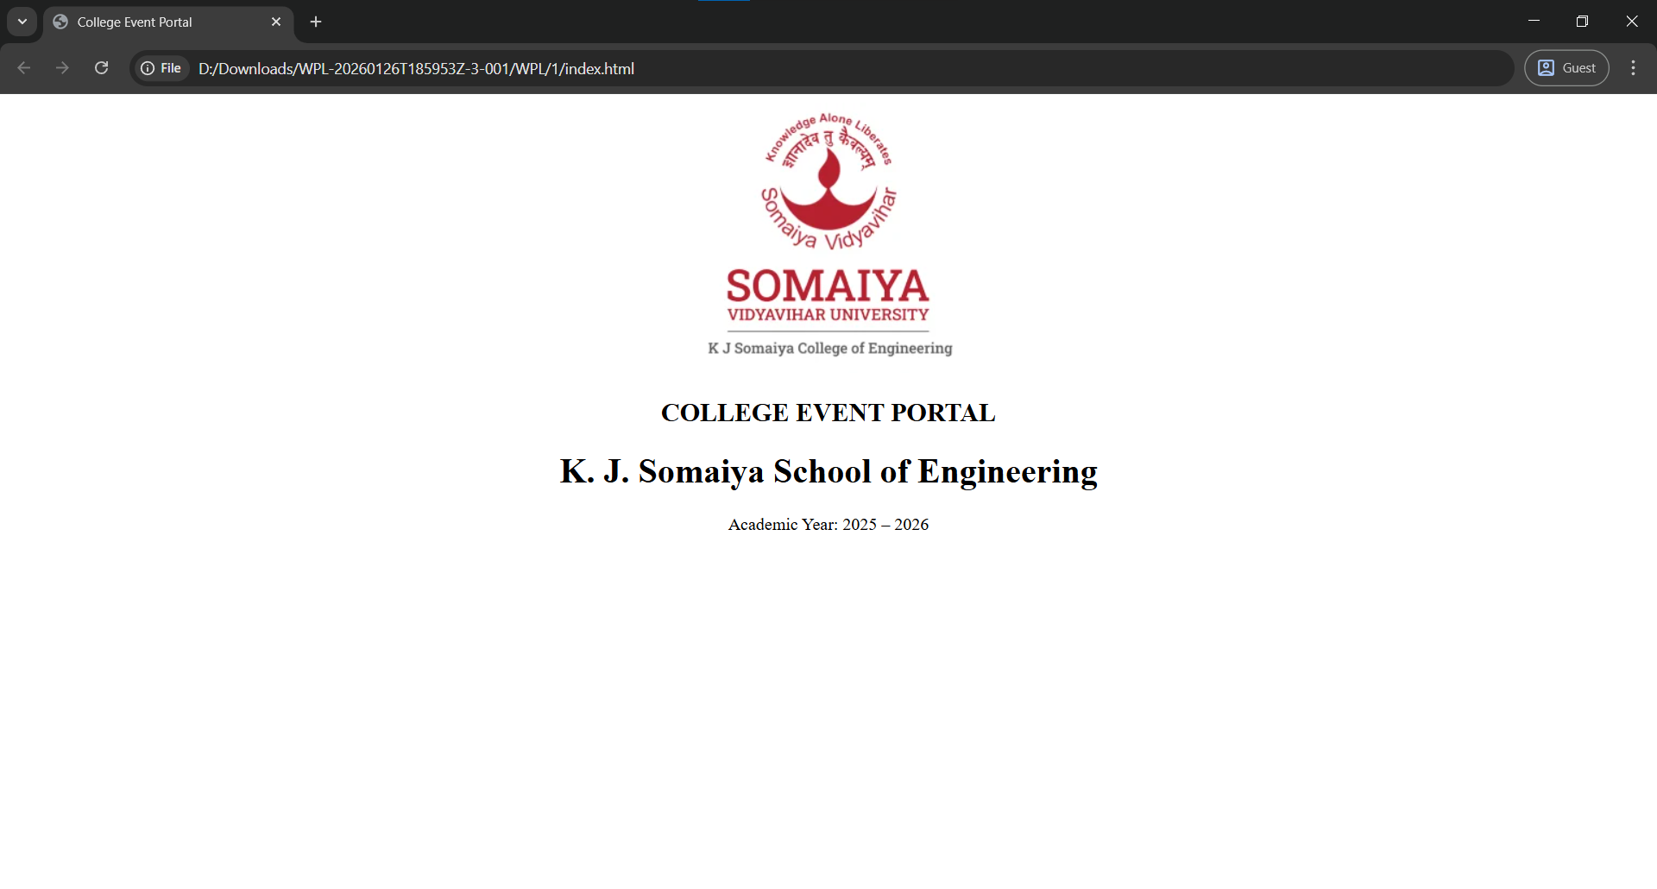

Task 2: Event Description Page – Formatting & Text-Level Tags
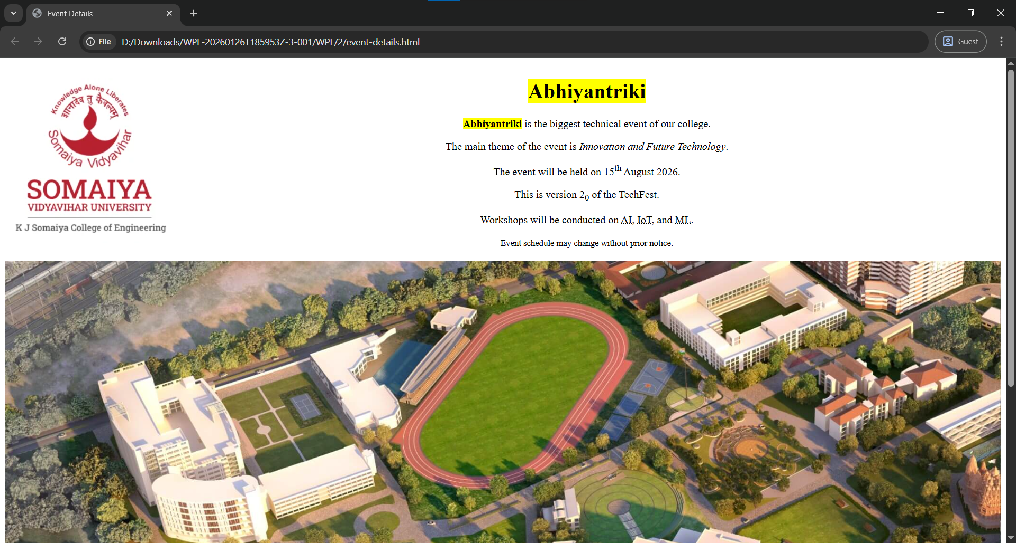

Task 3: About Department Page – Block vs Inline Formatting
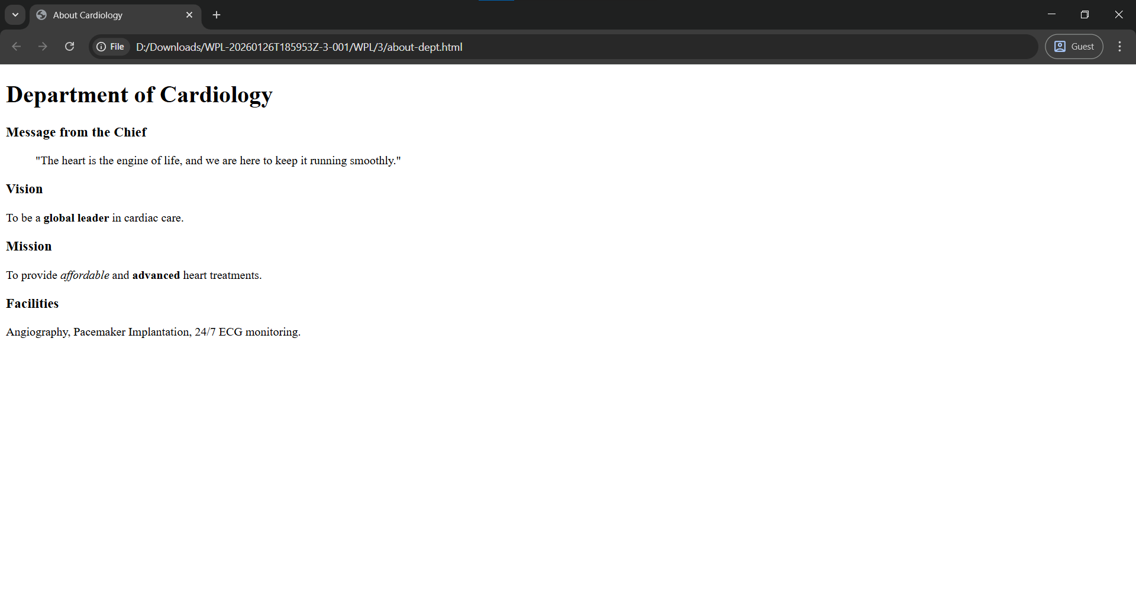

Task 4: Student Clubs Page – Lists & Nested Lists
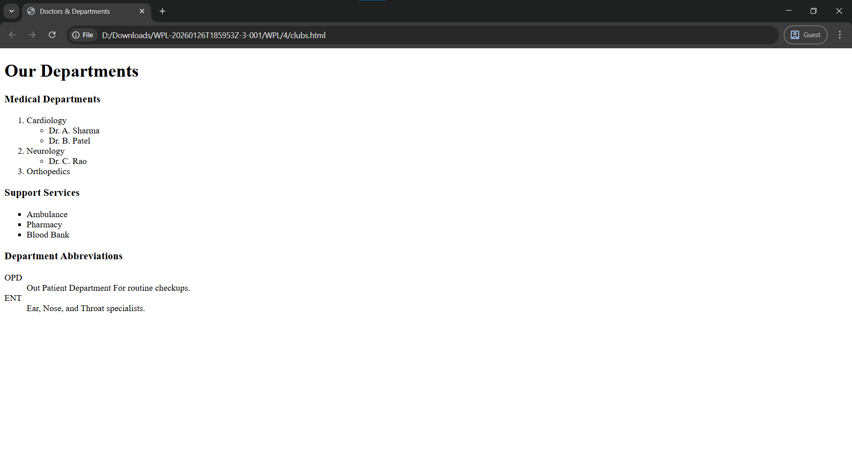

Task 5: Navigation Page – Hyperlinks
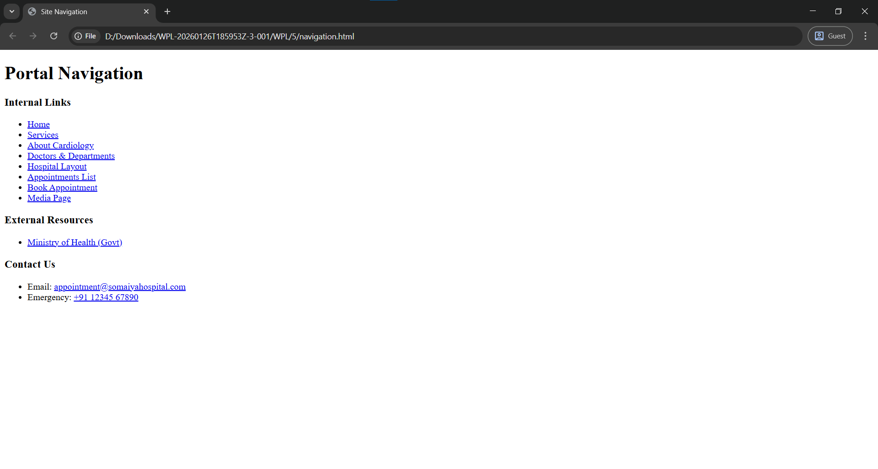

Task 6: Campus Map – Image & Image Map
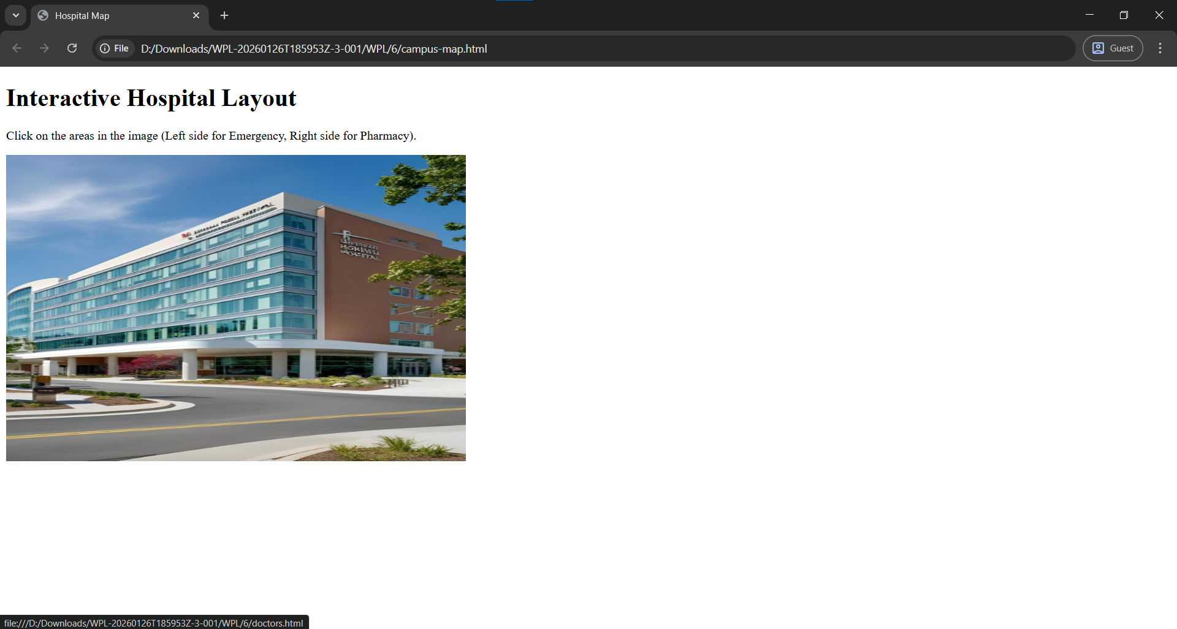

Task 7: Result Summary Page – Tables
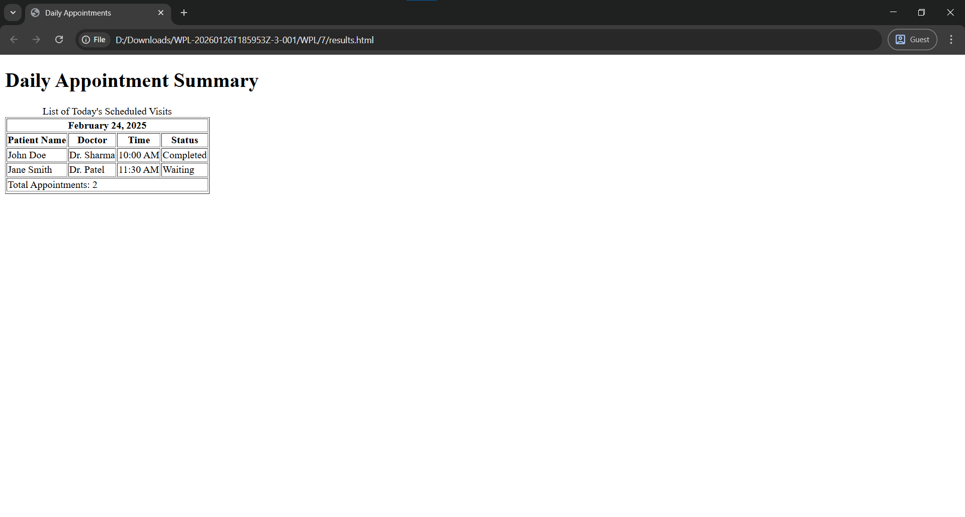

Task 8: Event Registration – Forms
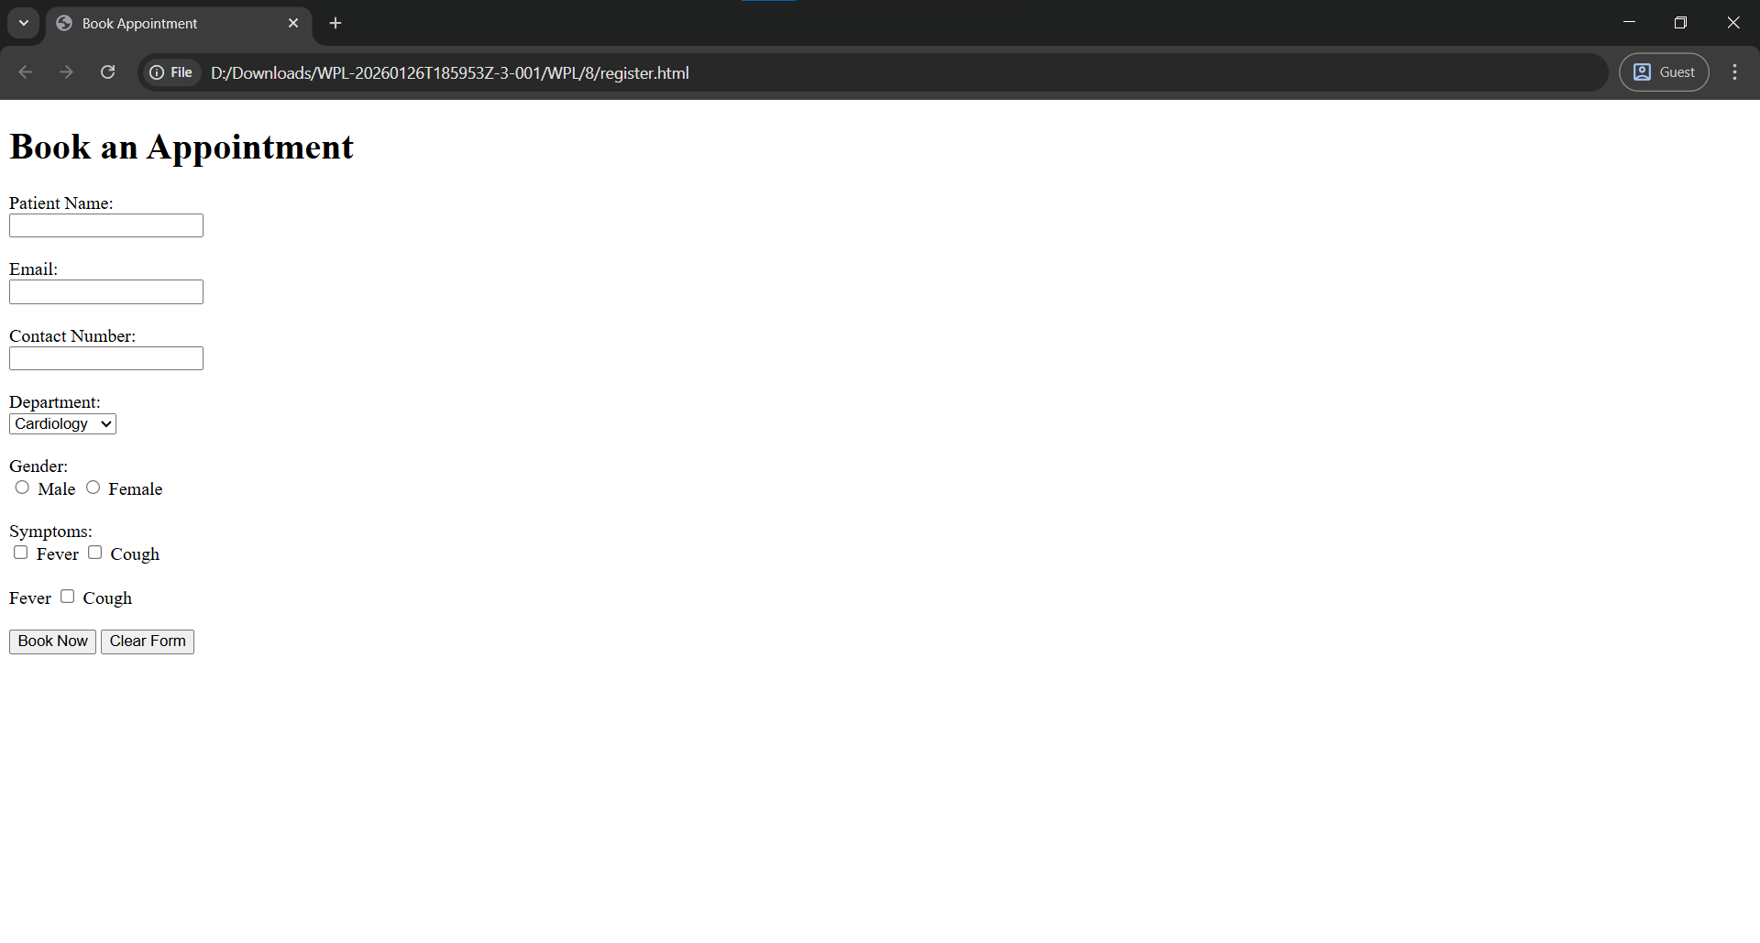

Task 09: Media & Frames – Executable Content
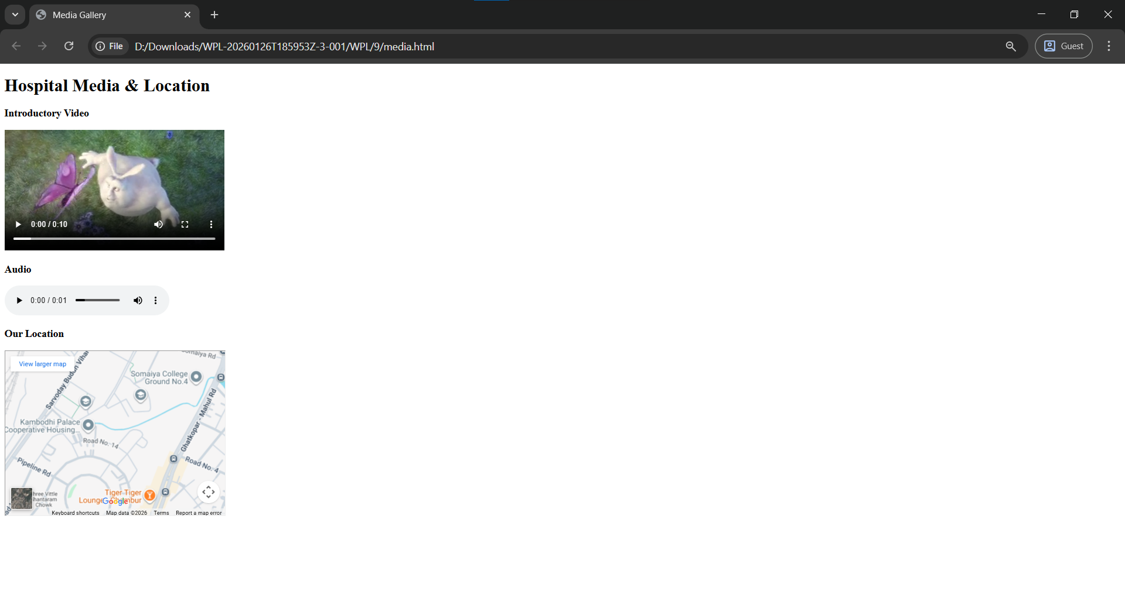

Post Lab Subjective/Objective type Questions:
- Write HTML code to create a hyperlink that opens in a new tab.

Code: <a href="https://www.somelink.com" target="_blank">Visit Page</a>
The target=”_blank” makes it so clicking the link opens in a new tab.

- Differentiate between block-level and inline elements with examples.
Ans.
- Block-level Elements:

- Always start on a new line
- Take up full width available
- Can contain inline & block elements
- Examples: <div>, <p>, <h1>, <section>

- Inline Elements

- Do not start on a new line
- Take only required width
- Can contain only text or inline elements
- Examples: <span>, <a>, <strong>, <img>

Cited from:WHATWG, HTML5: Markup section, HTML Living Standard, WHATWG, 2025.

- Why are semantic tags preferred over <div> tags?
Ans:
Semantic tags clearly describe their meaning and purpose.

Advantages:
- Improve readability of code
- Better SEO (search engines understand content better)
- Improve accessibility for screen readers
- Make code easier to maintain

Examples of semantic tags: <header>, <nav>, <section>, <article>, <footer>
Unlike <div>, which has no meaning: <div>Content</div>

Cited from:WHATWG, HTML5: Markup section, HTML Living Standard, WHATWG, 2025.

- Why is <iframe> preferred over <frame> in modern HTML?
Ans:
- <frame> is obsolete in HTML5
- <iframe> is supported in HTML5
- <iframe> allows embedding content inside normal HTML structure
- Better compatibility with CSS, JavaScript, and responsive design
Cited From: HTML Frame Element, Wikipedia, 2025.
Available: https://en.wikipedia.org/wiki/Frame_(World_Wide_Web) (accessed Jan 2026)

- Evaluate the importance of using alt attribute in images.
Ans:
The alt attribute provides alternative text for images.

Importance:
- Improves accessibility for visually impaired users
- Displays text if image fails to load
- Helps search engines understand image content

- Suggest two additional features that can improve the given web portal and explain how HTML5 supports them.
Ans:
- Feature 1: Video/Audio Content, Improves user engagement (tutorials, demos)

HTML5 Support:
<video controls>
<source src="intro.mp4" type="video/mp4">
</video>
No external plugins required.

- Feature 2: User Location or Interactive Forms, Useful for location-based services or better user input

HTML5 Support: Geolocation API

New form input types (email, date, range)
<input type="email" placeholder="Enter your email">
Provides built-in validation and better UX.

Conclusion and Discussion:
Drive Link of all Code: https://drive.google.com/drive/folders/1ARbPvS39UZ_Xyx5PT0KFZmpEUOyu3rr2?usp=sharing

(students should write in your words): HTML has a lot of things that can be used to make beautiful and functional Webpages
(Also take feedback from fellow classmates and faculty to add here)
I Liked the first page where all the elements are in the middle and the media page where all elements are in one line

