Experiment No: 3
Course Name: | Web Programming Laboratory (216U01L405) | Semester: | IV
Date of Performance: | 05/02/2026 | DIV/ Batch No: | B2
Student Name: | Prathamesh Sanjeev Jadhav | Roll No: | 16010124109

Title: Develop a JavaScript program that dynamically manipulates HTML elements in the DOM

Aim of the Experiment:
- To create a web application that provides an interactive user experience by dynamically updating content and structure of the webpage in response to user actions.
- To enhance the understanding of DOM manipulation using JavaScript, allowing greater flexibility in web design.

Objectives for the Experiment:
- Implement Event Listeners:
  - Attach event listeners to user interface elements (e.g., buttons) to trigger JavaScript functions.
- Manipulate DOM Elements:
  - Use JavaScript to dynamically add, remove, and modify HTML elements based on user interactions.
  - Change attributes, styles, and inner content of elements.
- Create Functions:
  - Develop specific JavaScript functions that handle different types of interactions:
    - Adding new elements (e.g., a new item to a list).
    - Removing existing elements (e.g., deleting a list item).
    - Modifying properties (e.g., changing text color or visibility).
- Optimize User Experience:
  - Implement features like form validation and feedback messages based on user inputs.
- Ensure Compatibility:
  - Test and ensure that the JavaScript works across different browsers.

COs to be achieved:
Design dynamic web pages using various HTML tags.
Use CSS to prepare the layout of web pages.
Apply JavaScript for validation in client-side programming.

Books/ Journals/ Websites references:
- Students should write

Theory:
Students should write about CSS3 (citation needed for content taken (IEEE or APA7 style))

Problem statement: “College Event & Student Services Web Portal” A college wants to develop a basic HTML5-based web portal to showcase events, registrations, information, and services for students. Each task contributes one page or feature of this portal. Enhanced the portal using CSS3 and Java script .
Task 1: JavaScript Initialization & DOM Access
Page: index.html (Home Page)
Task:
Write JavaScript to dynamically display:
- Current date
- Welcome message using student name
JS Concepts:
- <script> / external JS
- DOM access (getElementById, querySelector)
Task 2: Variables, Data Types & Operators
Page: event-details.html
Task:
Calculate and display:
- Total number of available seats
- Remaining seats after registrations
JS Concepts:
- let, const
- Number, string, boolean
- Arithmetic and comparison operators
Task 3: Control Flow – Event Category Selection
Page: event-details.html
Task:
Use if–else or switch to:
- Display event category (Technical / Cultural / Sports)
- Show different messages based on category
JS Concepts:
- Control flow statements
Task 4: Arrays – Event List Management
Page: clubs.html
Task:
Store event names in an array and:
- Display them dynamically as a list
- Highlight featured events
JS Concepts:
- Arrays
- Looping (for, forEach)
Task 5: Functions – Reusable Logic
Page: clubs.html
Task:
Create reusable functions to:
- Display events
- Count total events
JS Concepts:
- Function declaration
- Arrow functions
Task 6: DOM Manipulation – Show/Hide Content
Page: about-dept.html
Task:
Add buttons to:
- Show/Hide Vision and Mission sections
- Toggle HoD message
JS Concepts:
- DOM manipulation
- style.display

Task 7: Event Handling – User Interaction
Page: navigation.html
Task:
Add JavaScript to:
- Highlight menu item on hover
- Display clicked page name
JS Concepts:
- addEventListener
- Mouse events

Code:
Index.html:
<!DOCTYPE html>
<html>

<head>
<title>College Event Portal</title>
<link rel="stylesheet" href="style.css">
</head>

<body>

<div id="home" class="container" style="text-align:center;">

<img src="KJSCE.webp" alt="logo">

<h2 class="logo" title="Official College Event Portal">COLLEGE EVENT PORTAL</h2>

<h1 id="clgname" title="Welcome to KJSSE">K. J. Somaiya School of Engineering</h1>

<h2 class="welcome-msg" id="msg"></h2>
<p class="date" id="dateDisplay"></p>

<p class="year">Academic Year: 2025 – 2026</p>

</div>

<script>
// Task 1: JavaScript Initialization & DOM Access
let studentName = prompt("Please enter your name:", "Student");
if (!studentName) studentName = "Student";

document.getElementById("msg").innerText = "Welcome, " + studentName + "!";

let today = new Date();
document.getElementById("dateDisplay").innerText = "Current Date: " + today.toDateString();
</script>

</body>

</html>

Event-details.html:
<!DOCTYPE html>
<html>

<head>
<title>Event Details</title>
<link rel="stylesheet" href="event.css">
</head>

<body>

<table style="width:100%">
<tr>
<td>
<img src="KJSCE.webp" alt="logo" style="text-align:left;">
</td>

<td style="width:100%">
<div id="home" class="container" style="text-align:center;">
<h1><strong><mark>Abhiyantriki</mark></strong></h1>

<p><strong><mark>Abhiyantriki</mark></strong> is the biggest technical event of our college.</p>

<p>The main theme of the event is <em>Innovation and Future Technology</em>.</p>

<p>The event will be held on 15<sup>th</sup> August 2026.</p>

<p>This is version 2<sub>0</sub> of the TechFest.</p>

<p>Workshops will be conducted on <abbr title="Artificial Intelligence">AI</abbr>, <abbr
title="Internet of Things">IoT</abbr>, and <abbr title="Machine Learning">ML</abbr>.</p>

<p><small>Event schedule may change without prior notice.</small></p>

<div id="category-selector"
style="margin-top: 20px; text-align: left; background: #f9f9f9; padding: 10px; border-radius: 5px;">
<label for="eventCategory">Select Event Category:</label>
<select id="eventCategory" onchange="showCategoryMessage()">
<option value="">--Select One--</option>
<option value="Technical">Technical</option>
<option value="Cultural">Cultural</option>
<option value="Sports">Sports</option>
</select>
<p id="catMessage" style="font-weight: bold; color: blue; margin-top: 10px;"></p>
<hr>
<h3>Seat Availability</h3>
<p id="seatInfo"></p>
</div>

</td>
</tr>
</table>

<img src="campus.jpg" alt="Campus Photo" style="width:100%;">
</div>

<script>
// Task 2: Variables, Data Types & Operators
const totalSeats = 250;
let registeredStudents = 145;
let remainingSeats = totalSeats - registeredStudents;

let isFull = remainingSeats <= 0;

let seatText = `Total Seats: ${totalSeats} <br> Registrations: ${registeredStudents} <br> Remaining Seats: ${remainingSeats}`;
if (isFull) {
seatText += `<br> <span style='color:red;'>Registrations Closed!</span>`;
}
document.getElementById("seatInfo").innerHTML = seatText;

// Task 3: Control Flow – Event Category Selection
function showCategoryMessage() {
let cat = document.getElementById("eventCategory").value;
let msgField = document.getElementById("catMessage");

switch (cat) {
case "Technical":
msgField.innerText = "Get ready for Hackathons and Tech Talks!";
msgField.style.color = "blue";
break;
case "Cultural":
msgField.innerText = "Enjoy the Dance, Music, and Drama events!";
msgField.style.color = "purple";
break;
case "Sports":
msgField.innerText = "Show your athleticism on the field!";
msgField.style.color = "green";
break;
default:
msgField.innerText = "";
}
}
</script>
</body>

</html>
Aboutdept.html:
<!DOCTYPE html>
<html lang="en">

<head>
<meta charset="UTF-8">
<title>About Computer Engineering</title>
<link rel="stylesheet" href="boxmodel.css">
</head>

<body>
<h1>Department of Computer Engineering</h1>

<div style="margin-bottom: 20px;">
<button onclick="toggleSection('hod-message', this)">Hide HOD Message</button>
<button onclick="toggleSection('vision-mission', this)">Hide Vision & Mission</button>
</div>

<section id="hod-message">
<h3>Message from the HOD</h3>
<blockquote>
"Technology is the engine of innovation, and we are here to build the future."
</blockquote>
</section>

<div id="vision-mission">
<div>
<h3>Vision</h3>
<p>To be a <b>global leader</b> in computer science education and research.</p>
</div>
<div>
<h3>Mission</h3>
<p>To provide <i>high-quality</i> and <b>industry-oriented</b> technical education.</p>
</div>
</div>

<div>
<h3>Facilities</h3>
<p>High-Performance Computing Lab, AI & Robotics Center, 24/7 Innovation Hub.</p>
</div>

<script>
// Task 6: DOM Manipulation – Show/Hide Content
function toggleSection(sectionId, btn) {
let section = document.getElementById(sectionId);

if (section.style.display === "none") {
section.style.display = "block";
btn.innerText = "Hide " + (sectionId === 'hod-message' ? "HOD Message" : "Vision & Mission");
} else {
section.style.display = "none";
btn.innerText = "Show " + (sectionId === 'hod-message' ? "HOD Message" : "Vision & Mission");
}
}
</script>
</body>

</html>

Clubs.html:
<!DOCTYPE html>
<html lang="en">

<head>
<meta charset="UTF-8">
<title>Departments & Clubs</title>
<link rel="stylesheet" href="clubs.css">
</head>

<body>
<h1>Our Departments and Clubs</h1>
<h3>Engineering Departments</h3>
<ol type="1">
<li>
Computer Engineering
<ul>
<li>Prof. A. Sharma</li>
<li>Prof. B. Patel</li>
</ul>
</li>
<li>
Information Technology
<ul>
<li>Prof. C. Rao</li>
</ul>
</li>
<li>Mechanical Engineering</li>
</ol>
<h3>Student Clubs and Events</h3>
<ul type="square" id="clubList">
</ul>
<p id="eventCount" style="font-weight: bold; margin-top: 10px;"></p>

<h3>Department Abbreviations</h3>
<dl>
<dt>CE</dt>
<dd>Computer Engineering Department.</dd>
<dt>IT</dt>
<dd>Information Technology Department.</dd>
</dl>

<script>
// Task 4: Arrays - Event List Management
let events = ["RoboWars (Featured)", "CodeFest (Featured)", "AI Seminar", "Bridge Building", "Debate"];

// Task 5: Functions - Reusable Logic
function displayEvents() {
let ul = document.getElementById("clubList");
ul.innerHTML = ""; // Clear existing

events.forEach(event => {
let li = document.createElement("li");
li.innerText = event;

// Highlight featured events using if condition
if (event.includes("Featured")) {
li.style.fontWeight = "bold";
li.style.color = "#d32f2f";
}

ul.appendChild(li);
});
}

const countEvents = () => {
let countLabel = document.getElementById("eventCount");
countLabel.innerText = "Total Registered Events: " + events.length;
};

// Call functions to run logic
displayEvents();
countEvents();
</script>
</body>

</html>
Navigation.html:
<!DOCTYPE html>
<html lang="en">

<head>
<meta charset="UTF-8">
<title>Site Navigation</title>
<link rel="stylesheet" href="nav.css">
</head>

<body>
<h1>Portal Navigation</h1>
<h3>Internal Links</h3>
<nav>
<ul>
<li><a href="../1/index.html">Home</a></li>
<li><a href="../2/event-details.html">Event Details</a></li>
<li><a href="../3/about-dept.html">About CE Dept</a></li>
<li><a href="../4/clubs.html">Departments & Clubs</a></li>
<li><a href="../6/campus-map.html">Campus Layout</a></li>
<li><a href="../7/results.html">Exam Results List</a></li>
<li><a href="../8/register.html">Hackathon Registration</a></li>
<li><a href="../9/media.html">Media Page</a></li>
</ul>
</nav>
<h3>External Resources</h3>
<ul>
<li><a href="https://www.aicte-india.org/" target="_blank">AICTE (Govt)</a></li>
</ul>
<h3>Contact Us</h3>
<ul>
<li>Email: <a href="mailto:contact@enggcollege.edu">contact@enggcollege.edu</a></li>
<li>Helpdesk: <a href="tel:+911234567890">+91 12345 67890</a></li>
</ul>

<div id="interactionMsg" style="margin-top:20px; font-weight: bold; color: #ff5722;"></div>

<script>
// Task 7: Event Handling – User Interaction
document.addEventListener("DOMContentLoaded", () => {
const navLinks = document.querySelectorAll("nav a");
const msgBox = document.getElementById("interactionMsg");

navLinks.forEach(link => {
// Highlight menu item on hover
link.addEventListener("mouseover", (e) => {
e.target.style.backgroundColor = "#ffeb3b";
e.target.style.color = "#000";
e.target.style.padding = "5px";
e.target.style.borderRadius = "3px";
e.target.style.transition = "0.3s";
});

link.addEventListener("mouseout", (e) => {
e.target.style.backgroundColor = "";
e.target.style.color = "";
e.target.style.padding = "";
});

// Display clicked page name
link.addEventListener("click", (e) => {
// Prevent default to show the message briefly if needed,
// though for a real nav we would just show alert or let it navigate
// e.preventDefault();
msgBox.innerText = "You are navigating to: " + e.target.innerText;
});
});
});
</script>
</body>

</html>

Output / Screenshot:
1
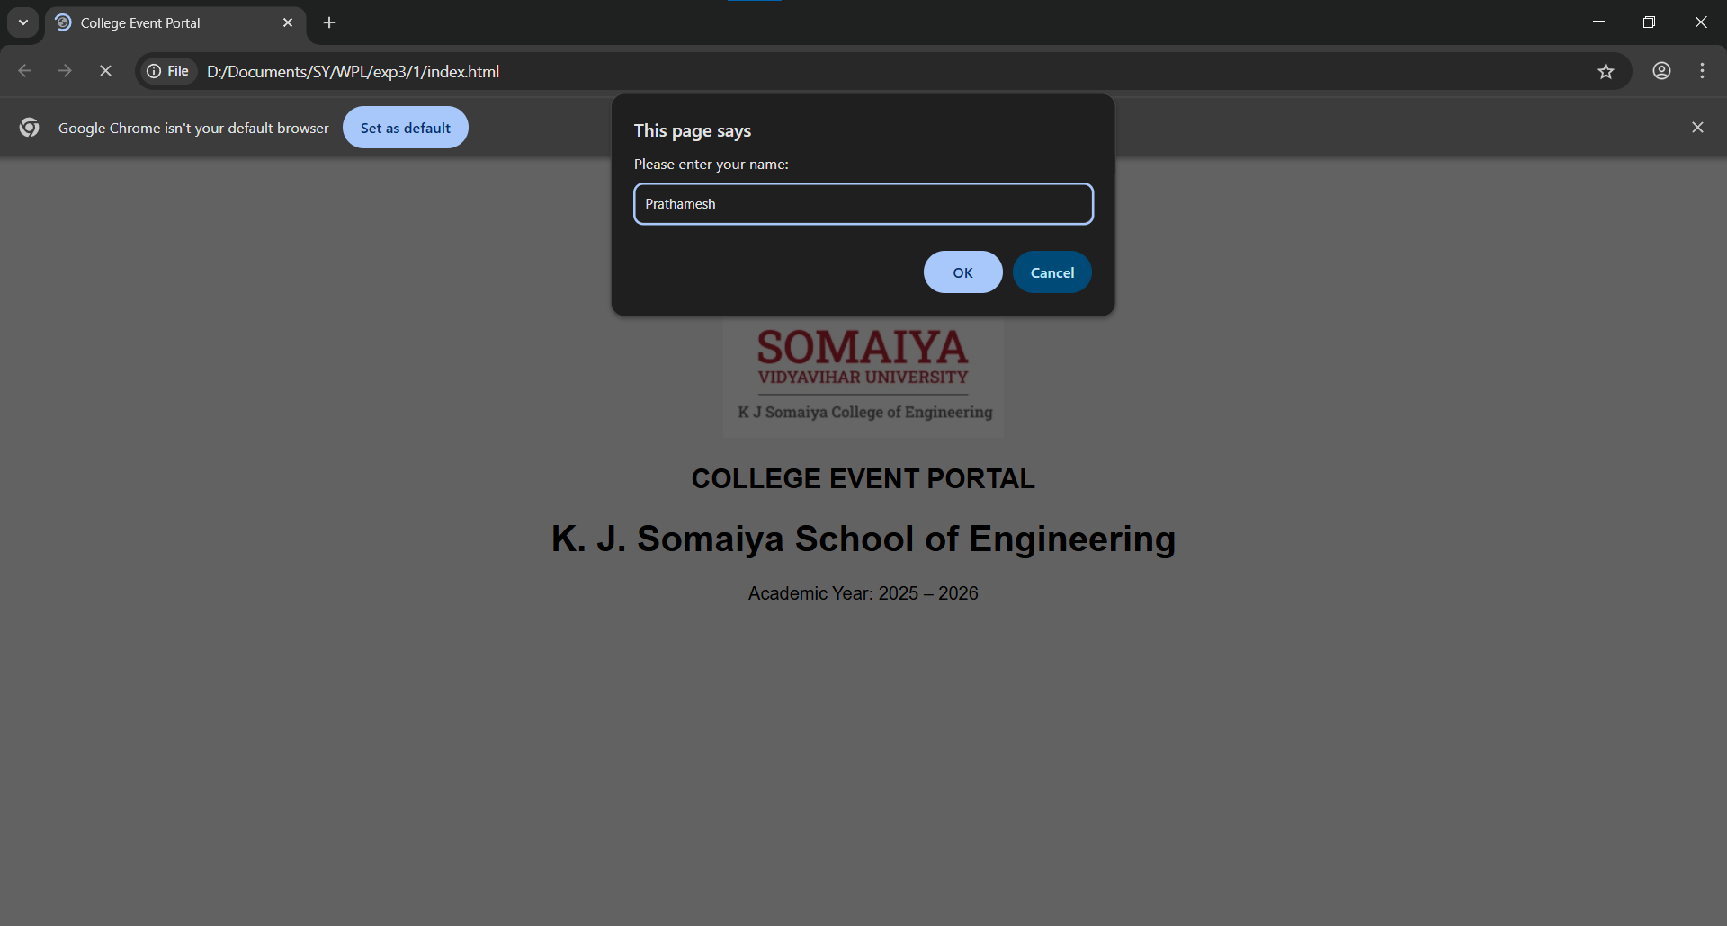
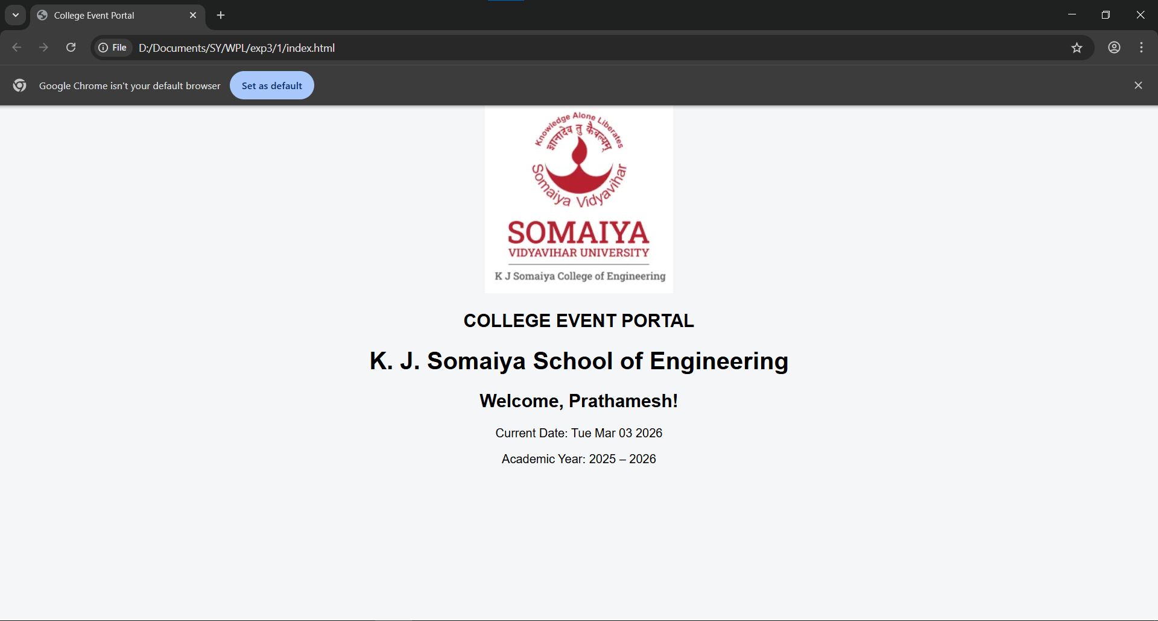
2
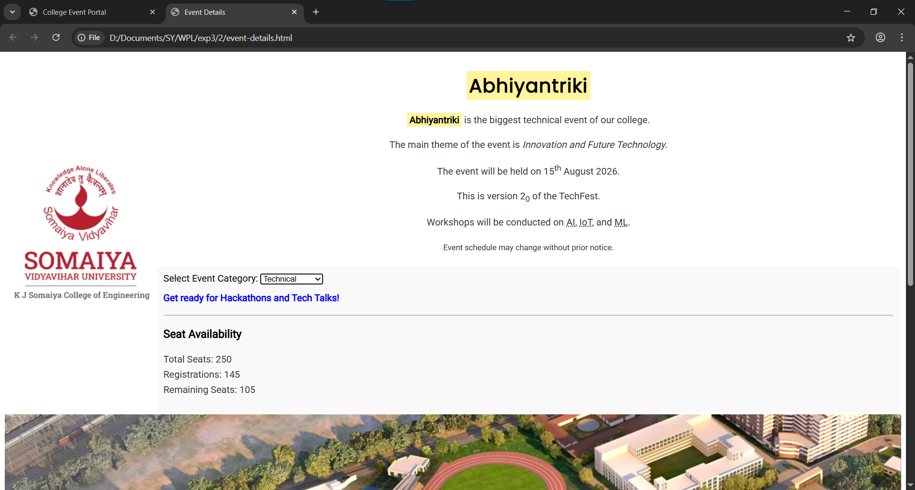
3
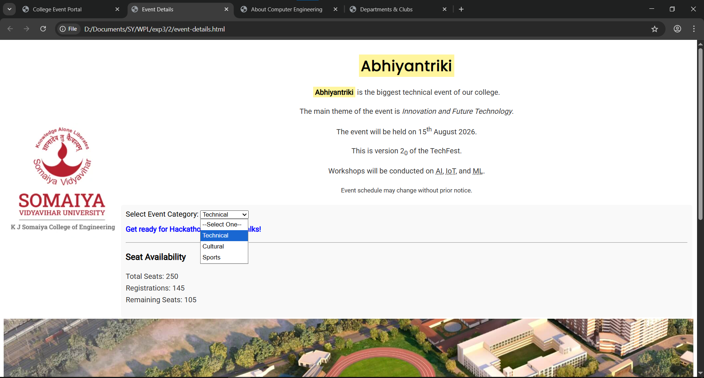

4
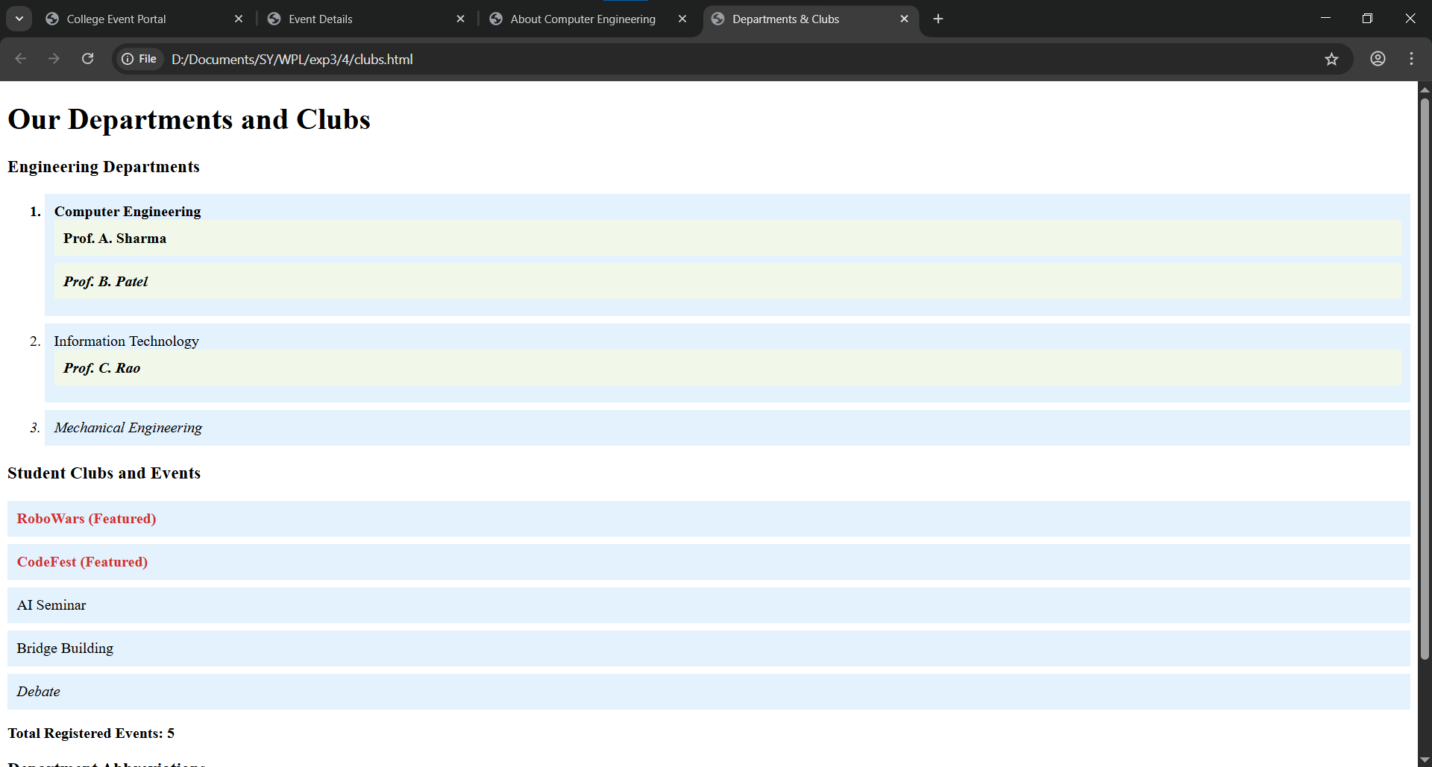
5

6
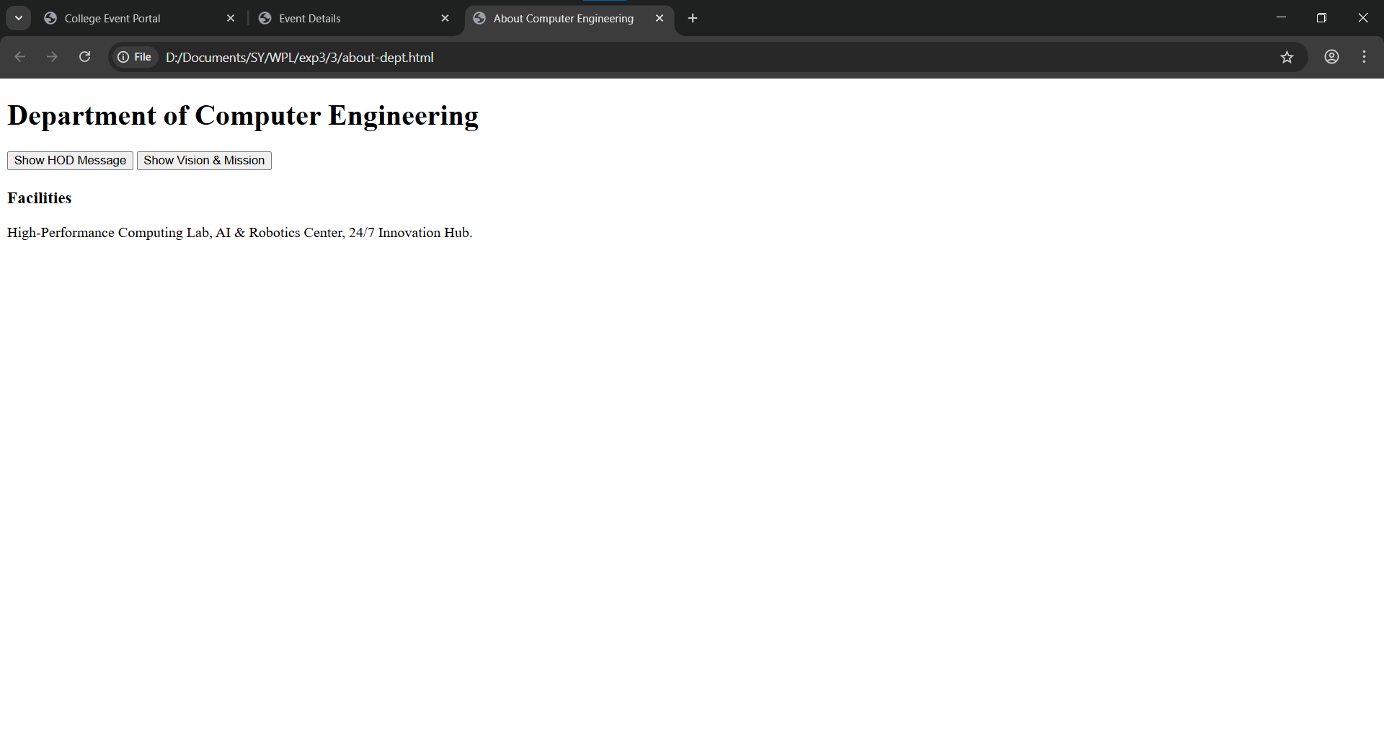
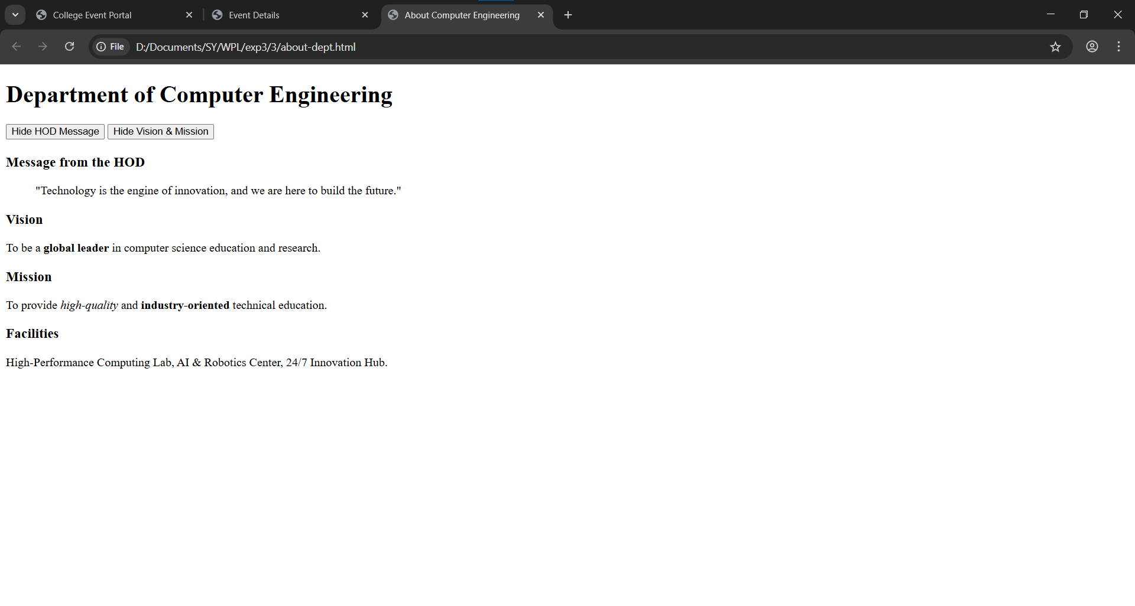
7
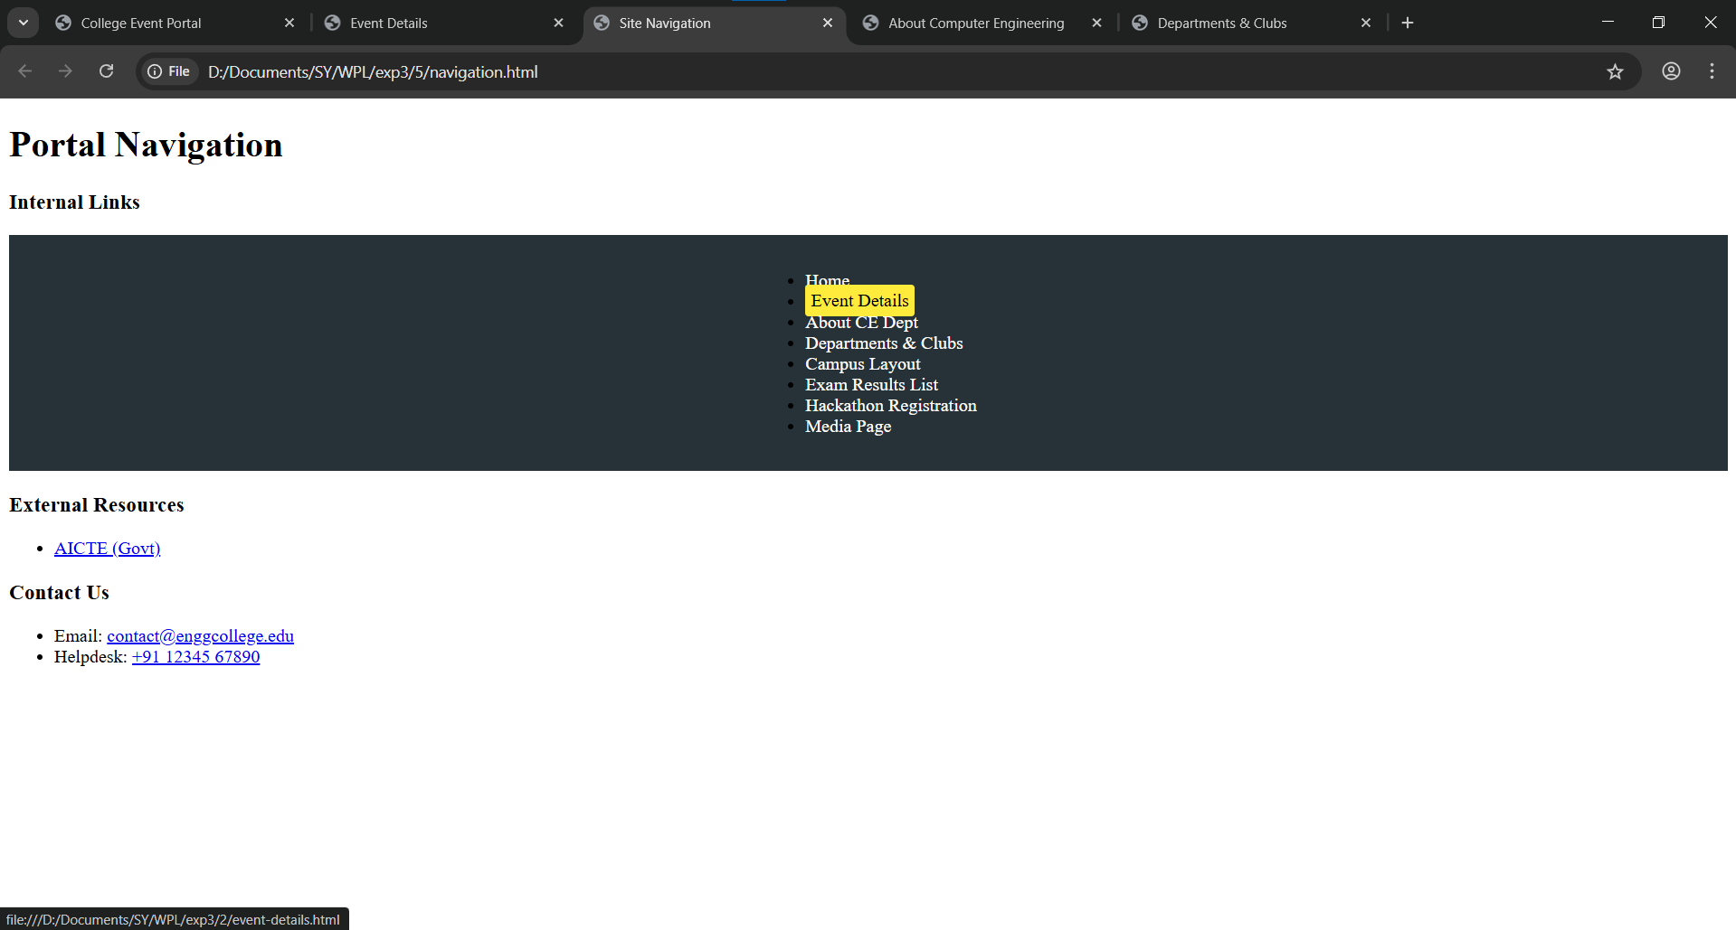

Post Lab Subjective/Objective type Questions:
- What are the differences between event bubbling and event capturing? Provide a code example that demonstrates both.
Ans: Event bubbling and event capturing are two different phases of event propagation in the DOM. When an event occurs on an element, it does not just stay on that element; it travels through the DOM tree. In the capturing phase, the event starts from the root (document) and travels down to the target element. In the bubbling phase, the event starts from the target element and travels back up to the root. By default, event listeners use bubbling (addEventListener with the third parameter set to false). If we want to use capturing, we set the third parameter to true. Capturing is useful when we want a parent to intercept an event before it reaches the child, whereas bubbling is useful when we want to handle events after they occur on the target element.

Example demonstrating both:
<div id="parent" style="padding:20px; background-color:lightblue;">
Parent
<button id="child">Click Me</button>
</div>

<script>
const parent = document.getElementById("parent");
const child = document.getElementById("child");

// Capturing phase
parent.addEventListener("click", function() {
console.log("Parent - Capturing");
}, true);

// Bubbling phase
parent.addEventListener("click", function() {
console.log("Parent - Bubbling");
}, false);

child.addEventListener("click", function() {
console.log("Child - Target");
});
</script>
When the button is clicked, the console will show the capturing message first, then the target, and finally the bubbling message.
- Describe how you could optimize DOM manipulation for better performance.
Ans: Optimizing DOM manipulation is important because frequent or inefficient updates to the DOM can slow down web applications. One common technique is minimizing direct DOM access by storing references to elements in variables instead of repeatedly querying them. Another important approach is batching DOM updates together instead of making multiple small changes, since each modification can trigger reflows and repaints. Using DocumentFragment to build elements in memory before appending them to the DOM also improves performance. Additionally, reducing layout thrashing by separating read and write operations (e.g., reading element dimensions before modifying styles) helps prevent unnecessary recalculations. Using CSS classes instead of inline styles and avoiding deep nested DOM structures also contribute to better performance. Overall, the key idea is to reduce the number of reflows, repaints, and direct manipulations.
- What are closures, and how can they be utilized in event handling in JavaScript?
Ans: A closure is a feature in JavaScript where a function retains access to its outer (lexical) scope even after the outer function has finished executing. This means inner functions can “remember” variables from their parent scope. Closures are powerful in event handling because they allow event listeners to access private variables without exposing them globally. For example, when attaching multiple event listeners inside a loop, closures ensure each handler retains the correct variable value. They are also useful for creating private counters, maintaining state, or configuring event behavior dynamically. By using closures, we can create more modular, secure, and maintainable code while keeping certain data hidden from the global scope.
- Explain the concept of delegation in event handling and provide a scenario where it might be beneficial.
Ans: Event delegation is a technique where instead of attaching event listeners to multiple child elements, we attach a single event listener to a common parent element and use event bubbling to detect which child triggered the event. This works because events bubble up from the target element to its ancestors. Inside the parent’s event handler, we can use event.target to identify the specific child element that was clicked. Delegation is beneficial when dealing with large lists or dynamically created elements. For example, in a to-do list application where items are frequently added or removed, attaching individual listeners to each item would be inefficient. Instead, attaching one listener to the <ul> element allows it to handle clicks for all current and future <li> items, improving performance and reducing memory usage.

Conclusion and Discussion:
(students should write in your words)
(Also get feedback from fellow classmates (minimum 3) and faculty to add here)
Vedant: I liked that u added my changes to your system but the colours are still to bland
Akhil: u basically did nothing in the last one
Navya: the colours are still a bit too bland

