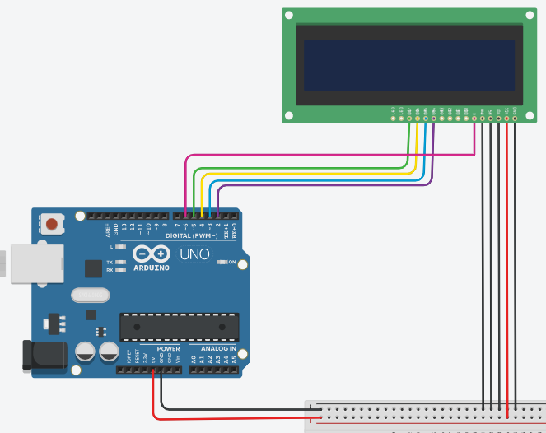

**Arduino uno R3**

**LCD display**

**12v DC**

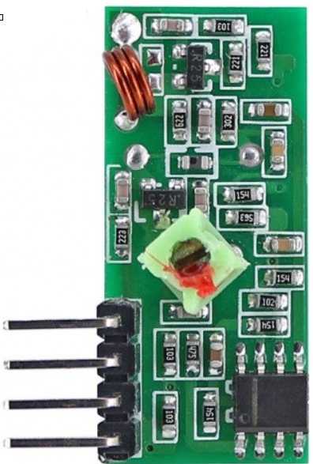

**RF module**

**Power supply**

**Transducer**

**PH SENSOR SKU SEN0161**

**Microcontroller Arduino uno**

**(ATmega 328p)**

**Temperature sensor**

**DS18B20**

**433 MHz transmitter module**

# **MQ-2 Smoke Gas Sensor**

# **Carbon Monoxide Sensor(MQ7)**

Indicator

**Buzzer**

**Liquid Crystal Display**

**(LCD)**

**Microcontroller Arduino uno**

**(AT mega 328p)**

**433 MHz receiver module**

Display device

**Power supply**

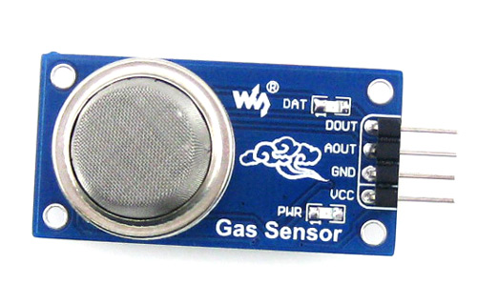

# **MQ-2 Smoke Gas Sensor**

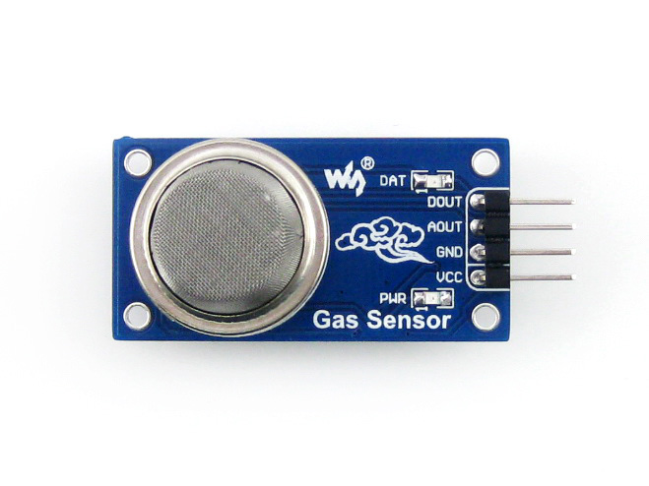 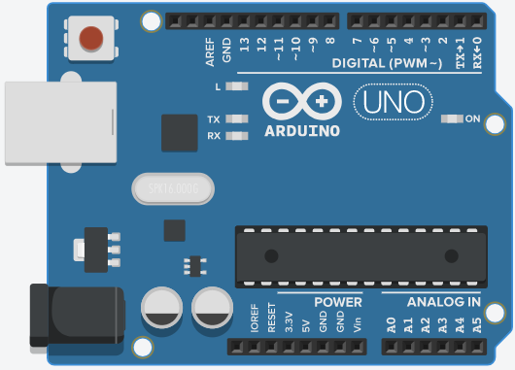 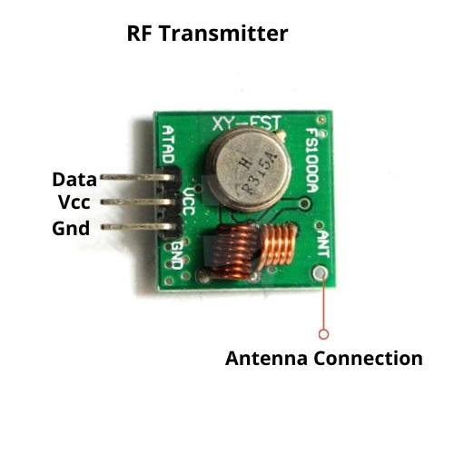

**433 MHz transmitter module**

**12 v DC**

# **Carbon Monoxide Sensor(MQ7)**



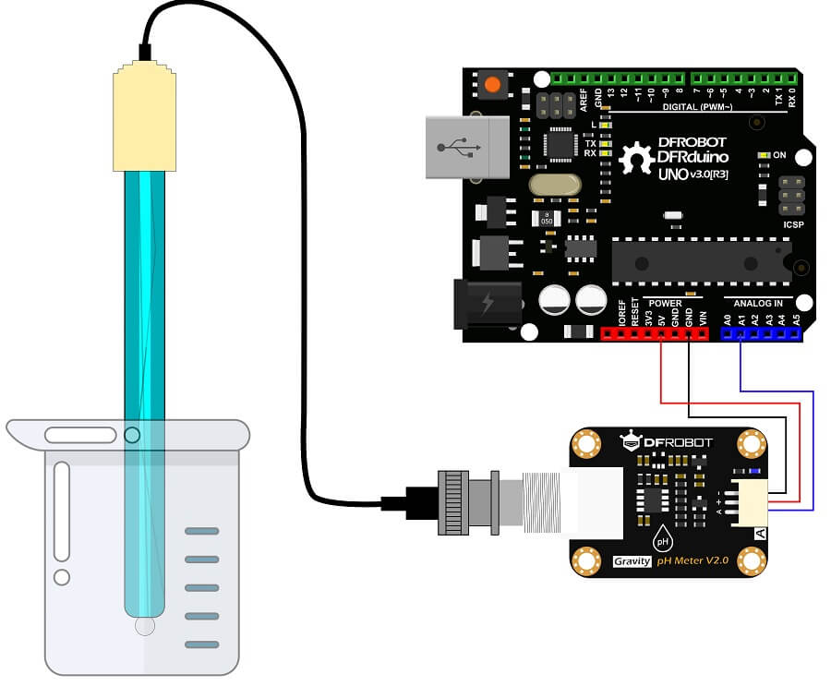

**Temperature sensor**

**DS18B20**

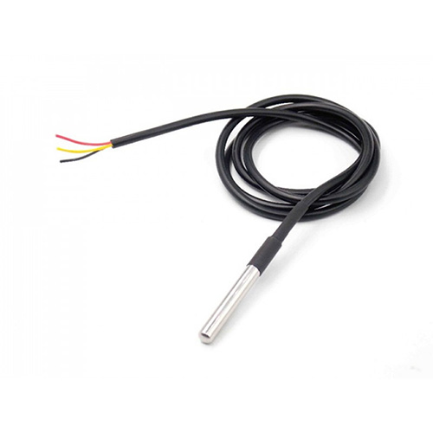

**PH SENSOR SKU SEN0161**

Links

1. <https://www.farnell.com/datasheets/1682209.pdf>

2. <https://www.elprocus.com/what-is-arduino-uno-r3-pin-diagram-specification-and-applications/>

3. <https://wiki.dfrobot.com/PH_meter_SKU__SEN0161_>

4. <https://www.application-datasheet.com/pdf/dfrobot/509083/sen0161.html>

5. [https://dlnmh9ip6v2uc.cloudfront.net/datasheets/Sensors/Temp/DS18B20.pdf](http://www.quick-teck.co.uk/ElectronicElement/eeList.php?typeId=97#title)

6. <https://lastminuteengineers.com/ds18b20-arduino-tutorial/>

7. <https://lastminuteengineers.com/mq2-gas-senser-arduino-tutorial/>

8. <https://components101.com/sensors/mq2-gas-sensor>

9. <https://microcontrollerslab.com/433mhz-rf-receiver-module-pinout-applications-arduino-examples/>

10. <https://components101.com/asset/sites/default/files/component_datasheet/433%20MHz%20RF%20Transmitter%20Module_0.pdf>

11. <https://www.elprocus.com/lcd-16x2-pin-configuration-and-its-working/#:~:text=The%20term%20LCD%20stands%20for,emitting%20diodes%20and%20seven%20segments>.

12. <https://www.elprocus.com/interface-lcd-liquid-crystal-display-using-arduino/>

13. <https://www.semiconductorforu.com/application-lcd-liquid-crystal-display/>

Include all libraries

#include <SPI.h> , #include <OneWire.h>, #include <DallasTemperature.h>

Read the PH value by calling the read_ph () function

PH = read_ph();

initialize the variables

float PH, Temperature, MQ7value,MQ2value;

String transmit ,transmit_msg;

Initialize ASK Object

rf_driver.init();

Initialize the function

float read_mq7(void); , float read_mq2(void); , float read_ph(void);, float get_temperature(void);

#define ONE_WIRE_BUS 0

OneWire oneWire(ONE_WIRE_BUS);

DallasTemperature sensors(&oneWire);

RH_ASK rf_driver;

**A**

**A**

Transmit the data character by character as per the mgs length

rf_driver.send((uint8_t *)msg_mq7, strlen(msg_mq7));

converte the data into string concinate the msg string and converted data to transmit

transmit = "MQ7 value " + transmit_msg;

Read the MQ7value by calling the read_mq7()function

MQ7value = read_mq7();

Transmit the data character by character as per the mgs length

rf_driver.send((uint8_t *)msg_temperature, strlen(msg_temperature));

converte the data into string concinate the msg string and converted data to transmit

transmit = "temperature value " + transmit_msg;

Read the Temperature value by calling the get_temperature() function

Temperature = get_temperature()

Transmit the data character by character as per the mgs length

rf_driver.send((uint8_t *)msg_ph, strlen(msg_ph));

converte the data into string concinate the msg string and converted data to transmit

transmit = "PH value " + transmit_msg;

Transmit the data character by character as per the mgs length

rf_driver.send((uint8_t *)msg_mq2, strlen(msg_mq2));

converte the data into string concinate the msg string and converted data to transmit

transmit = "MQ2 value " + transmit_msg;

Read the MQ2value by calling the read_mq2()function

MQ7value = read_mq7();

**Electroplating bath site**

**Office premises**

LCD display

Microcontroller and RF module

MQ7

MQ2

Microcontroller and RF module

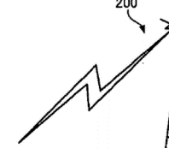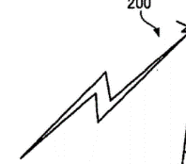

 Buzzer

**Electroplating bath**

Temperature sensor

Electrolyte solution

PH sensor

Buzzer