**End Module Exam**

#1. Write a R program to create a sequence of numbers from 20 to 50 and find the mean

#of numbers from 20 to 60 and sum of numbers from 51 to 91.

**print("a sequence of numbers from 20 to 50 is : ")**

**print(seq(20,50))**

**print("mean of numbers from 20 to 60 is : ")**

**print(mean(20:60))**

**print("sum of numbers from 51 to 91 is : ")**

**print(sum(51:91))**

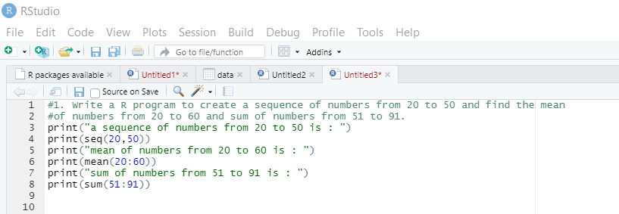

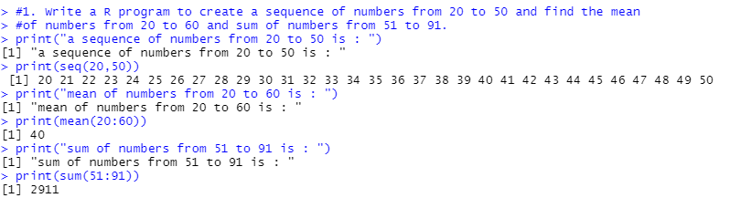

#2. Write a R program to print the numbers from 1 to 100 and print "Fizz" for multiples of 3, print "Buzz" for multiples of 5, and print "FizzBuzz" for multiples of both

**for (n in 1:100) {**

**if(n%%3==0 & n%%5==0) {print("FizzBuzz")}**

**else if (n%%3==0){print("Fizz")}**

**else if (n%%5==0){print("Buzz")}**

**else print(n)**

**}**

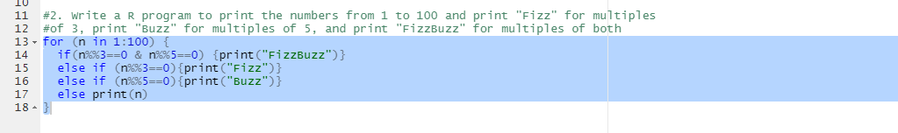

**output**

