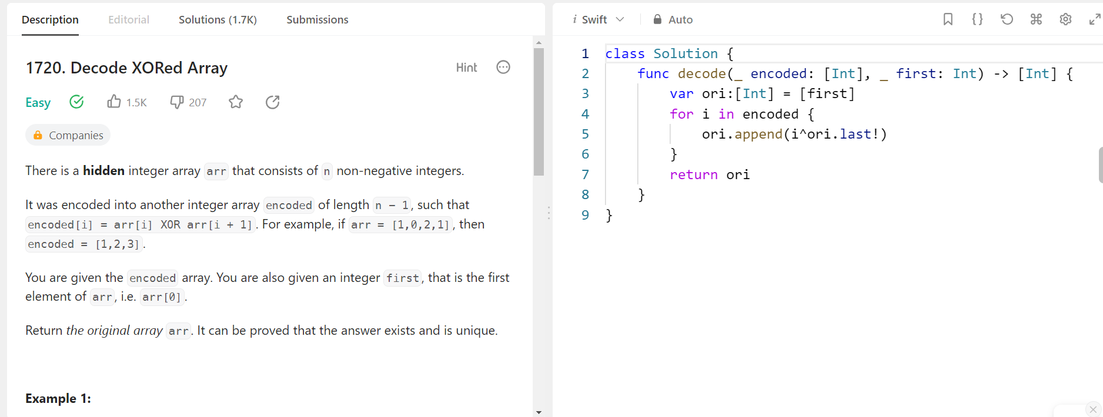

Code

class Solution {

func decode(_ encoded: [Int], _ first: Int) -> [Int] {

var ori:[Int] = [first]

for i in encoded {

ori.append(i^ori.last!)

}

return ori

}

}