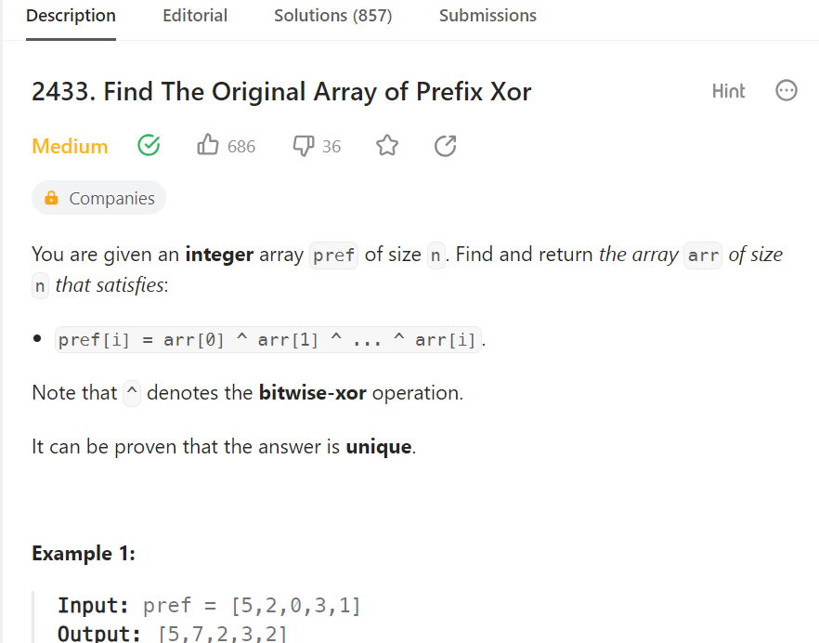

Code

class Solution {

func findArray(_ pref: [Int]) -> [Int] {

if pref.count == 1 {

return pref

}

var res:[Int] = [pref[0]]

for i in (1..<pref.count) {

res.append(pref[i-1]^pref[i])

}

return res

}

}