DriveTrust AI
AI-Assisted Two-Wheeler Driving Behaviour Platform
Consolidated Project Document — Scope, Architecture, AI Pipeline, Backend & Build Plan
Version 1.0 · Pilot Scope Locked
Prepared for internal team review

1. Executive Summary
DriveTrust AI is an AI-assisted driving-behaviour detection and reporting platform for two-wheeler riders. A driver-facing mobile app captures evidence, an AI pipeline analyses it for road-safety violations, a Supabase-backed service persists results and maintains a per-driver Trust Score, and a React admin dashboard lets an authorised reviewer confirm flags and issue advisory notices.
This document consolidates every decision made to date into one coherent specification: the locked project scope, the system architecture, the full detection list, the AI model pipeline, the database and API design, the phased build plan, the budget, and the deployment approach. Earlier drafts of this project described three different framings (a citizen-reporting app, an insurance dashcam product, and a backend proof-of-concept) with contradicting assumptions about vehicle type and camera setup. Section 2 resolves that contradiction and is the authoritative scope for v1.

2. Locked Project Scope (v1 Pilot)
The pilot targets two-wheeler riders only. This single decision resolves the vehicle-type contradiction between the original helmet-detection codebase and the later car-dashcam framing, and it means the existing trained model can be reused for two separate checks instead of requiring new data collection.

2.1 What v1 includes
- Vehicle type: two-wheelers only (motorcycles/scooters).
- Front camera: checks whether the phone-holder (rider submitting evidence) is wearing a helmet, using the existing helmet detection model.
- Back/road camera: checks whether other riders on the road are wearing helmets, counts riders for triple-riding, and reads number plates — the same existing model and pipeline, applied to road-facing footage.
- Capture mode: single clip or short video capture and manual submission — not a continuous always-on recording mode.
- AI output is an advisory flag for human review. It is never an automatic fine — the platform has no legal authority to issue one; only an authorised admin, after review, can confirm a flag and trigger a notice.
- Trust Score is a defined, numeric, insert-only history (see Section 8.3), not an undefined “simulated recommendation.”

2.2 What is explicitly out of scope for v1
- Insurance integration (premium/discount calculation) — future work.
- Car mode / seatbelt detection — future work, requires a new dataset and model.
- Continuous dual-camera dashcam mode with a rolling local buffer and automatic event triggers — future work (Section 11).
- Sensor-based self-driving analysis (harsh braking, cornering, speed via accelerometer/gyroscope) — depends on the continuous-capture mode above, deferred with it.
- Automated fine issuance, payment collection, or any action with real legal/financial consequence without human confirmation.
- Red-light violation and wrong-side/lane-crossing detection — require new datasets, not yet started.

3. System Architecture
The platform has four independent layers, each with a single responsibility. This separation lets the AI, backend, and frontend teams work in parallel without blocking one another.
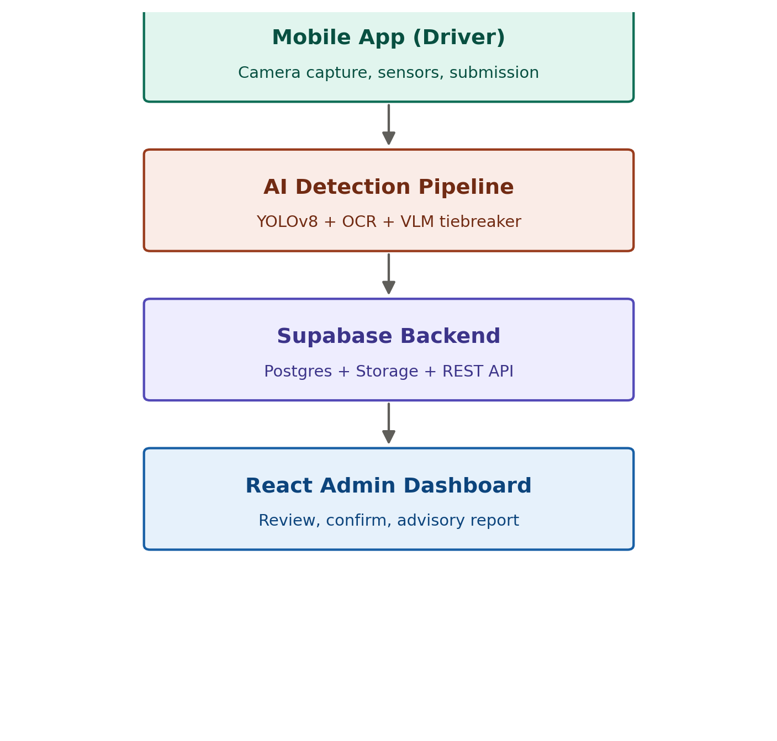
Figure 1 — DriveTrust AI ecosystem overview

3.1 Layer responsibilities
Layer | Responsibility
Mobile app (driver) | Captures evidence (photo/video), collects category input, submits to the backend API.
AI detection pipeline | Runs YOLOv8 detection, plate OCR, rule-based scoring, and a VLM tiebreaker for ambiguous cases.
Supabase backend | Managed Postgres database, private Storage for evidence media, and the data layer behind the REST API.
React admin dashboard | Report queue, evidence review, trust-score history, and the confirm/reject action that produces an advisory notice.

4. Detection List
Every detection the system performs in v1, grouped by where it runs. Items marked (future) are designed but intentionally deferred per Section 2.2.

4.1 Road monitoring — back/road camera
- Helmet worn / no helmet, for other riders in frame.
- Rider count and triple-riding (3+ riders on one two-wheeler).
- Number plate detection and OCR reading (identity match — not itself a violation).
- Red-light violation (future).
- Wrong-side driving / lane crossing (future).

4.2 Self-check — front camera
- Helmet worn / no helmet, for the phone-holder submitting the evidence — reuses the same trained model as 4.1, pointed at the rider instead of the road.

4.3 Ambiguous-case resolution
- VLM tiebreaker (Gemini): reviews the full evidence clip only when the rule engine's confidence lands in the needs_review band. It does not detect new violation types — it confirms or downgrades what the rule engine already flagged as uncertain.

4.4 Deferred to future phases
- Seatbelt worn / not worn — car mode only, needs a new dataset.
- Harsh braking, sudden acceleration, sharp cornering — sensor-based, needs continuous capture mode.
- Speed relative to posted limit — needs GPS + continuous capture mode.

5. AI Model Ingestion Pipeline
What happens to one submitted clip, in order, from upload to a final report:
- Frame extraction — sample the incoming video at a fixed interval.
- YOLO detection — person/motorcycle, helmet, and plate models run on every sampled frame (a 4th model, front-cam self-helmet-check, reuses the same helmet model).
- Vehicle tracking — ByteTrack assigns a persistent ID across frames so the same vehicle is not counted twice within a clip.
- Rule engine — produces a per-frame verdict: rider count, helmet association, triple-riding flag.
- OCR — the plate detection crop is passed to EasyOCR and validated against the Indian plate format.
- Verification / aggregation — per-frame verdicts are combined into one clip-level severity score and a status tier: auto_flagged, needs_review, or insufficient_evidence.
- VLM tiebreaker — fires only when status = needs_review; the whole clip is sent to Gemini for a final call.
- Report generation — final JSON report, evidence frames, and a trust_score_delta are written and passed to the backend.
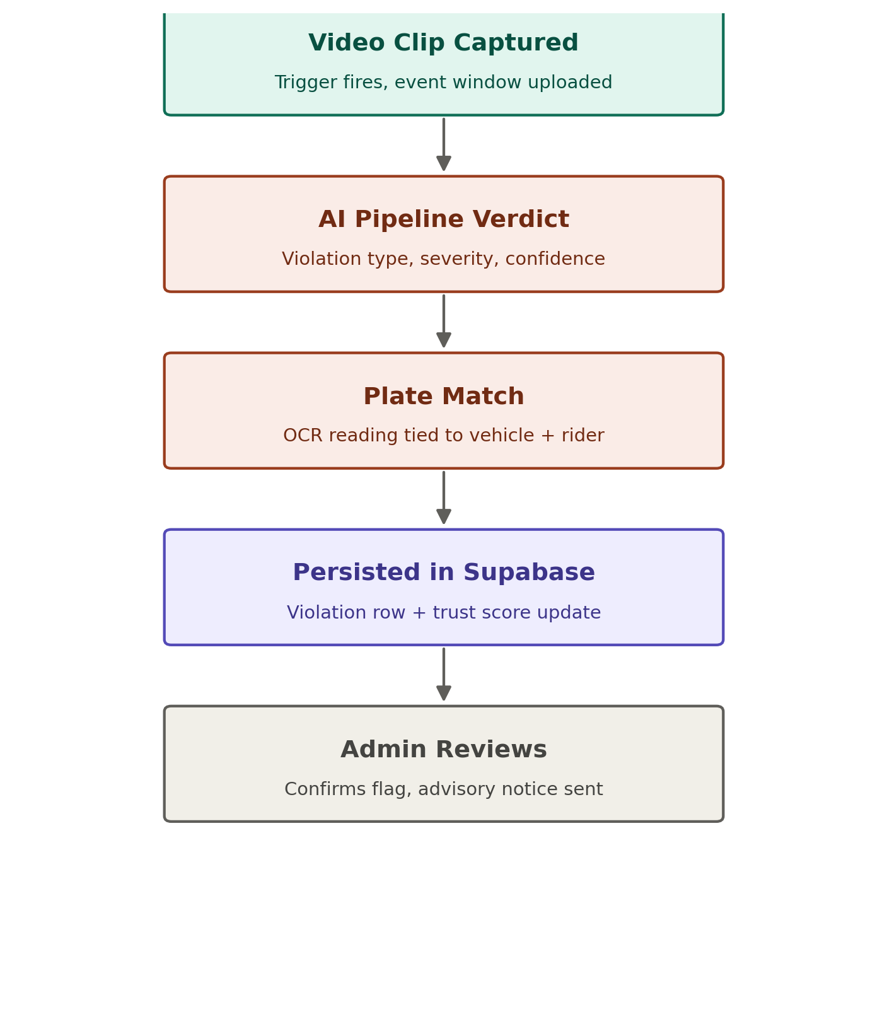
Figure 2 — Detection-to-advisory flow for a single event

5.1 Current build status
Detection | Model | Dataset | Status
Person, motorcycle | yolov8n.pt (COCO pretrained) | None needed | Done
Helmet / no-helmet (road + self) | helmet_model.pt | Roboflow helmet dataset | Trained
License plate | ampr.pt | External (already trained) | Trained
Vehicle tracking | ByteTrack (algorithmic) | None needed | Not integrated
Ambiguous-case tiebreak | Gemini VLM (API) | N/A — API-based | Not integrated

6. Future Capture Mode: Continuous Dashcam (Reference Only)
Deferred per Section 2.2, but specified here so the storage and bandwidth design is not lost. If/when the platform moves to a continuous phone-as-dashcam mode with a rolling local buffer:
Stream | Resolution | Bitrate | 30s size
Back camera (road) | 1080p H.264 | ~6 Mbps | ~22.5 MB
Front camera (driver) | 720p H.264 @15fps | ~1.5 Mbps | ~5.6 MB
Combined (rolling buffer) | — | — | ~28 MB / 30s
The rolling buffer overwrites itself continuously and never leaves the device. Only a flagged event window (5–10 minutes, both cameras) is compressed (H.265, reduced bitrate) and uploaded — approximately 65–75 MB for a 5-minute clip and 130–150 MB for a 10-minute clip, versus ~560 MB uncompressed.

7. Technology Stack
Layer | Technology | Notes
Mobile app | Android (Flutter or native) | Camera capture, submission flow, category selection.
AI pipeline | Python, YOLOv8 (Ultralytics), OpenCV, EasyOCR, ByteTrack | Existing RakshaRide codebase, extended.
VLM tiebreaker | Gemini API (Flash / Flash-Lite) | Ambiguous-case review only; API-based, no local GPU needed.
Backend API | FastAPI (Python) | Sits between clients and Supabase; holds the service-role key.
Database & storage | Supabase (PostgreSQL + Storage) | Managed Postgres, private bucket for evidence media.
Admin dashboard | React | Report queue, review, trust-score history, dashboard stats.
Local training hardware | RTX 3060 6GB laptop (140W TGP) | Sufficient for YOLOv8n/s fine-tuning and inference testing.

8. Backend: Database and API Design

8.1 Core tables (Supabase / PostgreSQL)
Table | Purpose
users | Application users.
drivers | Driver/rider information.
vehicles | Vehicle details, keyed by number plate — the field the AI pipeline's OCR output matches against.
reports | Submitted evidence reports; created first with status pending.
violations | AI-detected violations linked to a report; ai_response stored as JSONB.
trust_score_history | Insert-only log of every score change — never an UPDATE. Current score = latest row.
notifications | Advisory notices sent to drivers after admin confirmation.
audit_log | Report creation, violation generation, score updates, and admin actions.

8.2 REST API endpoints
Method | Endpoint | Purpose
POST | /reports | Create a new driving report.
GET | /reports/{id} | Retrieve report details.
POST | /violations | Store AI-generated violations.
GET | /drivers/{id} | Retrieve driver information.
GET | /drivers/{id}/trust-score | Retrieve the current trust score (latest history row).
GET | /dashboard/stats | Retrieve aggregated dashboard statistics.

8.3 Trust Score model
Every score change is a new row in trust_score_history (driver_id, delta, new_score, timestamp, reason) rather than an overwrite of a single value. Reference starting formula, to be tuned against the validation set in Section 12:
- −15 points for each confirmed no-helmet violation.
- −25 points for each confirmed triple-riding violation.
- +2 points per consecutive clean-report day, with a decay-back-up mechanic capped at the starting score.
Access pattern: FastAPI holds the Supabase service-role key and is the only component with direct database access. Both the mobile app and the admin dashboard talk to FastAPI, never to Supabase directly — this keeps Auth/RLS additions (Section 11) from requiring any client-side rework later.

9. End-to-End Flow: One Report, Start to Finish
- Driver captures evidence in the mobile app and submits it.
- FastAPI creates a reports row (status: pending) and hands the clip to the AI pipeline.
- The AI pipeline (Section 5) returns a verdict: violation type, severity, confidence, and a plate reading.
- The plate reading matches an existing vehicles row, or creates one.
- FastAPI writes a violations row and a trust_score_history row, and updates the report status.
- An audit_log entry is recorded for each of the above writes.
- The React admin dashboard displays the report in the review queue.
- An admin reviews the evidence and either confirms (triggers a notifications row / advisory) or rejects the flag (logged with a reason).

10. Phased Build Plan
Requested build order: admin and mobile app first, then backend, then AI model — made workable by freezing the API contract (Phase 1) before any screen is built, so mobile and admin can be developed against a fixed mock and swapped to the real backend later without rework.
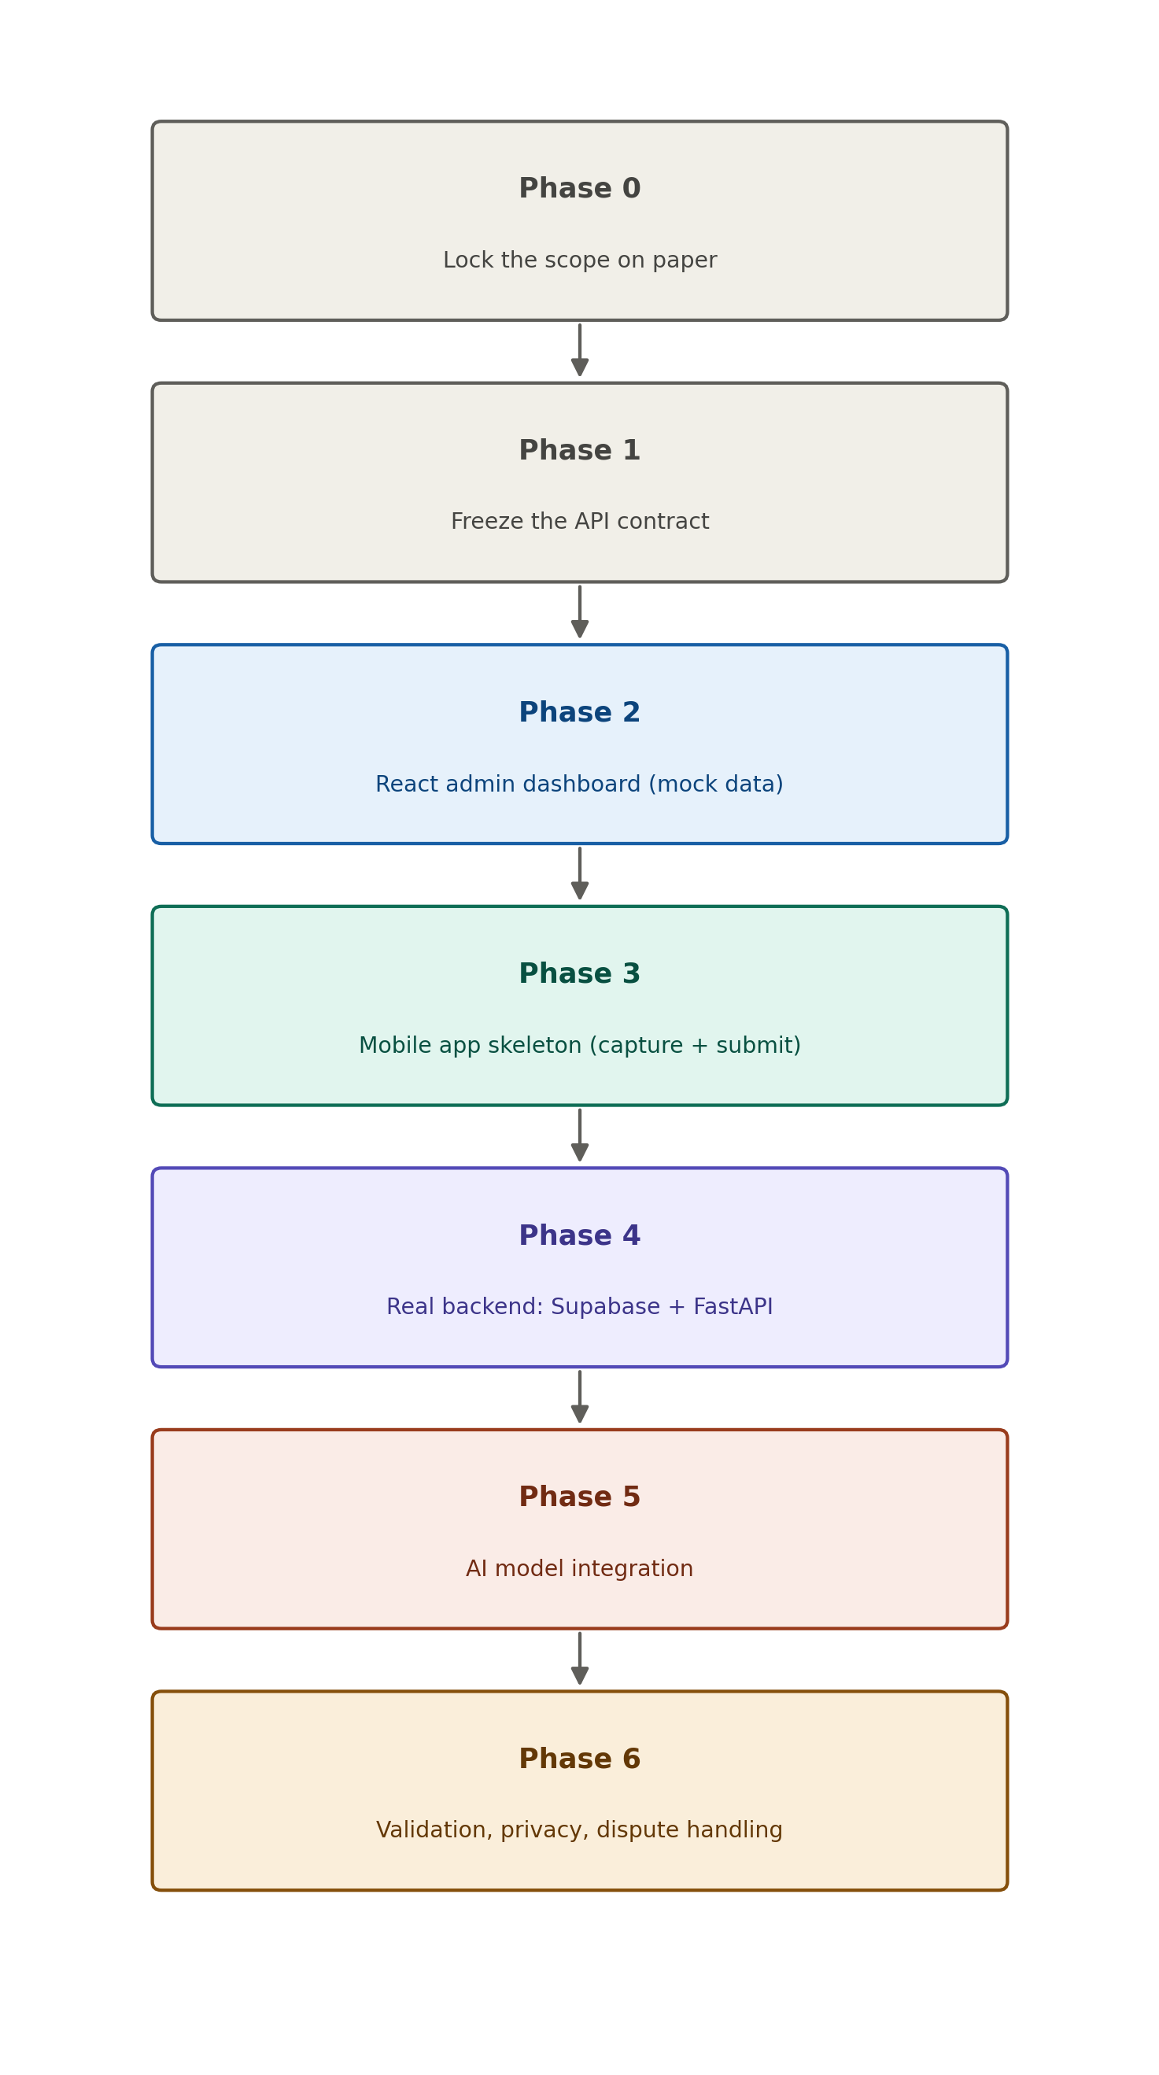
Figure 3 — Seven-phase build order
Phase | Deliverable | Closes which gap
0 — Lock scope | Written scope doc: vehicle type, camera roles, trust-score formula, explicit non-goals. | Identity contradiction; undefined fine authority; undefined trust score.
1 — Freeze contract | Fixed JSON report/violation shape and endpoint list. | Lets mobile/admin build in parallel without later rework.
2 — Admin dashboard | React app against mock data: queue, review, trust-score history, stats. | Deliverable Anushka can start immediately.
3 — Mobile app skeleton | Capture, category selection, submission — against the mock contract. | Avoids over-scoping into full dashcam mode too early.
4 — Real backend | 8-table Supabase schema + FastAPI endpoints; mobile/admin swapped from mock to real. | Backend and database requirement.
5 — AI model integration | RakshaRide pipeline wired behind POST /violations; ByteTrack + VLM tiebreaker added. | Connects the already-built detection code to the live system.
6 — Validation & privacy | Labeled test set with precision/recall; consent notice; retention policy; dispute path. | No ground-truth validation; no privacy/legal treatment; no appeal path.

11. Post-Pilot Roadmap
- Continuous dual-camera dashcam mode with rolling local buffer and event-triggered upload (Section 6).
- Sensor-based self-driving analysis (harsh braking, cornering, speed).
- Car mode with seatbelt detection (new dataset + model).
- Insurance integration: premium/discount recommendation engine.
- Red-light and wrong-side-driving detection (new datasets).
- Google/Apple/Microsoft OAuth login and Row Level Security via Supabase Auth.
- Realtime dashboard updates, Edge Functions for notifications, pg_cron for evidence archiving.

12. Validation, Privacy, and Dispute Handling

12.1 Validation
Build a small labeled test set of known-violation and known-clean clips before trusting the severity formula. Report precision and recall against it; tune the formula and trust-score weights against real numbers instead of untested assumptions.

12.2 Privacy
- Consent notice in the mobile app before capture begins.
- Retention policy: delete raw evidence clips after a fixed window (e.g. 30 days) unless the report is confirmed and under active review.
- Evidence media stored in a private Storage bucket; only the object URL is written to Postgres, never public by default.

12.3 Dispute handling
A driver flagged in error needs a path to contest it. Minimum viable version for v1: the admin who reviews a report can revert a confirmed flag, with a required logged reason in audit_log — this is a process gap in the original plan, not an afterthought.

13. Deployment Plan
Proposed approach for a pilot-scale deployment, consistent with the technology stack already chosen. This is a plan, to be executed in Phase 4 onward — not yet implemented.
Component | Deployment approach
Supabase (DB + Storage) | Managed Supabase project (free tier for pilot); upgrade to a paid tier only if storage/traffic limits are hit during real testing.
FastAPI backend | Container deployed to a low-cost host (e.g. Render, Railway, or Fly.io free/starter tier) connected to Supabase via the service-role key stored as an environment secret.
React admin dashboard | Static build deployed to Vercel or Netlify, pointed at the FastAPI backend URL.
Mobile app | Distributed as a direct APK or via Google Play internal testing track during the pilot, before any public release.
AI pipeline | Runs as part of the FastAPI service (or a separate worker process) on the same host; VLM calls go out to the Gemini API, no local GPU required in production.
Secrets management | API keys and the Supabase service-role key kept as host-level environment variables, never committed to the repository or shipped to any client.
This keeps pilot infrastructure cost close to zero, matching the ₹20–30k budget being spent on local GPU-adjacent needs and short-term cloud bursts rather than always-on hosting (Section 14).

14. Budget (₹20,000–₹30,000)
Reference hardware: laptop with RTX 3060 6GB VRAM (140W TGP), 16GB DDR5 RAM — sufficient for local YOLOv8n/s fine-tuning and inference; cloud GPU is not required for v1.
Item | Purpose | Approx. cost
Supabase paid tier | Only if free tier storage (~1GB) is outgrown during real testing. | ₹2,000–₹2,500 / month
Gemini API (VLM) | Flash-Lite tier; prototype-scale testing is likely single-digit dollars, often covered by the free tier. | ₹500–1,000 buffer
Colab Pro (contingency) | Only if a larger model or a big batch job is needed faster than the local GPU allows. | ₹800–1,000 / month (contingency only)
Domain / dashboard hosting | If a live demo URL is wanted for the React dashboard. | ₹500–1,000 / year

15. Team & Responsibilities
Member | Responsibility
Prathamesh Dahe | Mobile app development (capture + submission flow); assists with AI model integration.
Harsh Pal | AI model development — helmet, triple-riding, and plate detection pipeline; VLM tiebreaker integration.
Manamrit Singh | Database and backend development — Supabase schema, FastAPI, data flow between app and dashboard.
Anushka Srivastava | Admin web dashboard — report review, flag management, advisory notice issuance.

16. Disclaimer
This document describes a pilot proof-of-concept. All AI-generated outputs are advisory recommendations for human review and do not constitute an enforcement decision, a legal fine, or a final determination of any violation. Any deployment beyond an internal pilot requires a review of applicable data-protection and traffic-enforcement law before proceeding.

End of document.

