3 e. Build a decentralized application (DApp) using Angular for the front end and Truffle along with Ganache CLI for the back end.

Step 1:  
**First Dapp Environment:  
1. Setup the environment**

**Basically, dApp requires nodejs, truffle and ganache installed on your system.**

**Node.js — An open-source JavaScript runtime environment used to execute JavaScript code outside a web browser.**

**Truffle — The most popular development framework for Ethereum.**

**Ganache — Provides a local network that shows different test / real blockchain accounts and transactions on the IDE/console. It is a part of the Truffle suite.**

**Solc — JavaScript bindings for the**[**Solidity compiler**](https://github.com/ethereum/solidity)**.**

1. **Installing truffle: npm install -g truffle**

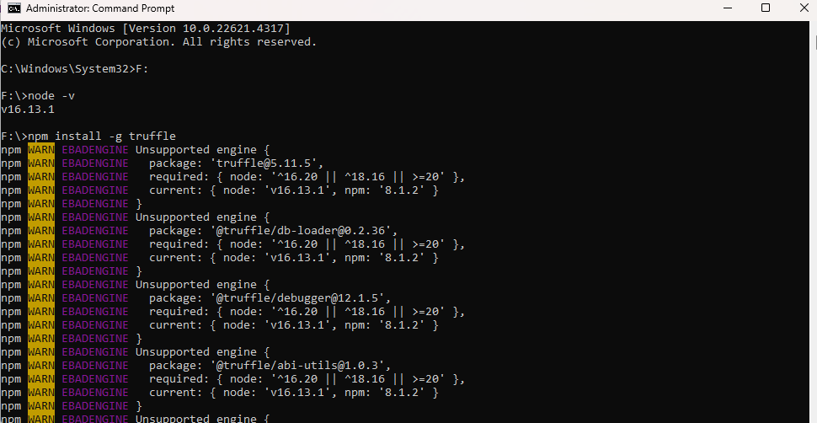

1. **Install: npm install -g solc**

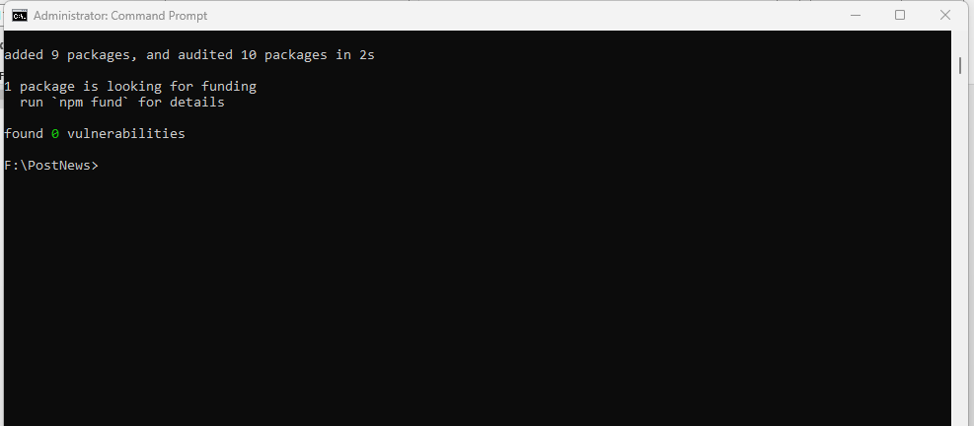

1. **Now we need to get one sample code base install for working ahead, use below command: truffle unbox pet-shop**

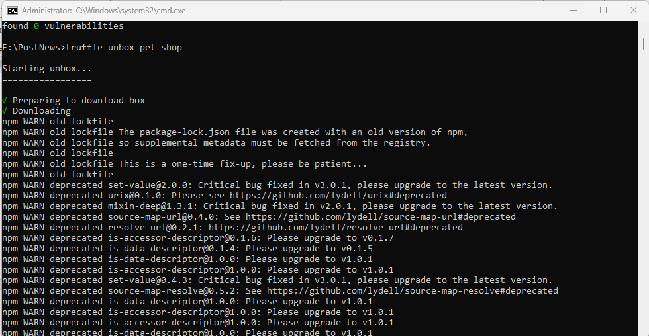

1. **This will set up the following basic structure in your folder:**

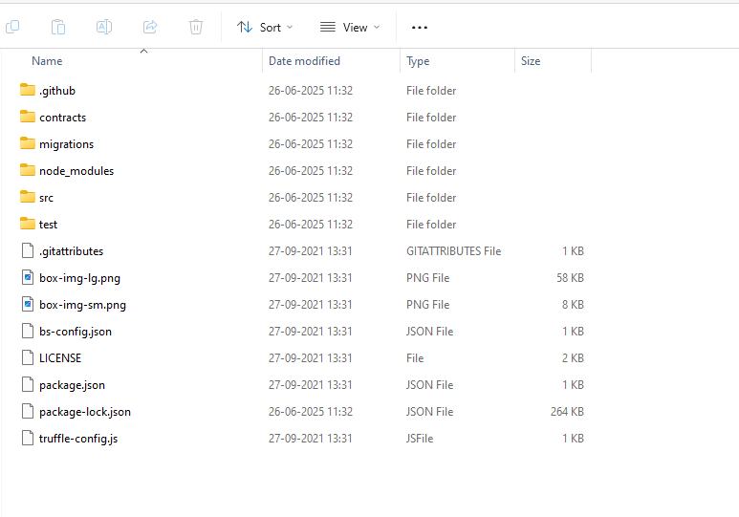

1. **Add new file in contracts: “news.sol”**

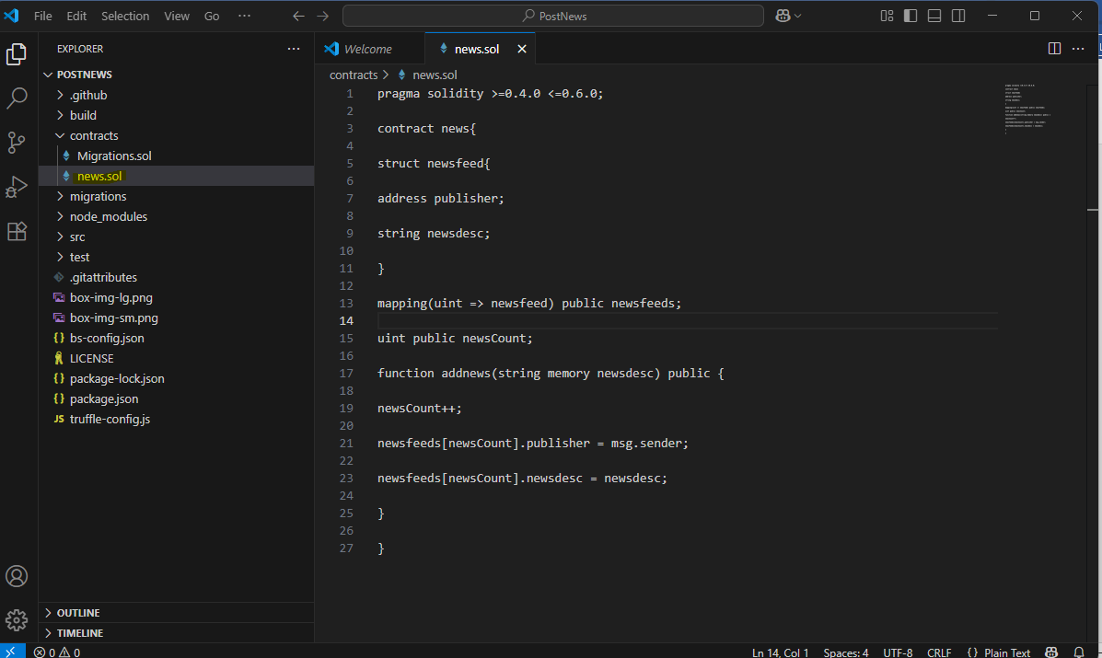

**Add below code:  
pragma solidity >=0.4.0 <=0.6.0;**

**contract news{**

**struct newsfeed{**

**address publisher;**

**string newsdesc;**

**}**

**mapping(uint => newsfeed) public newsfeeds;**

**uint public newsCount;**

**function addnews(string memory newsdesc) public {**

**newsCount++;**

**newsfeeds[newsCount].publisher = msg.sender;**

**newsfeeds[newsCount].newsdesc = newsdesc;**

**}**

**}**

**Compile the same in truffle: truffle compile**

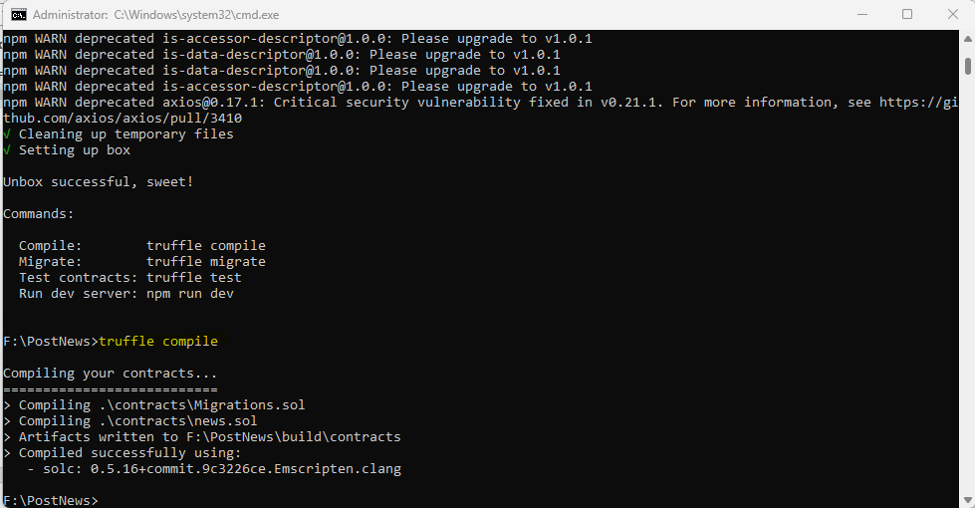

1. **Run Ganache: Note the ip and port i.e. http://127.0.0.1:7545**

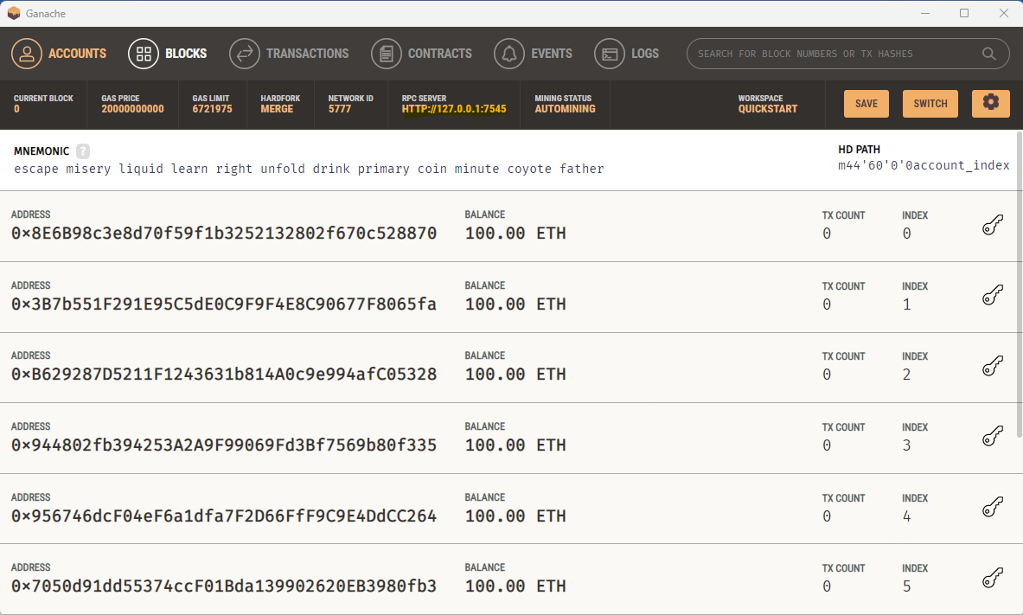

1. **Create file “2_deploy_contracts.js” inside Migration folder:**

var news = artifacts.require(“./news.sol”);

module.exports = function(deployer) {

deployer.deploy(news);

};

In the console ***truffle migrate***

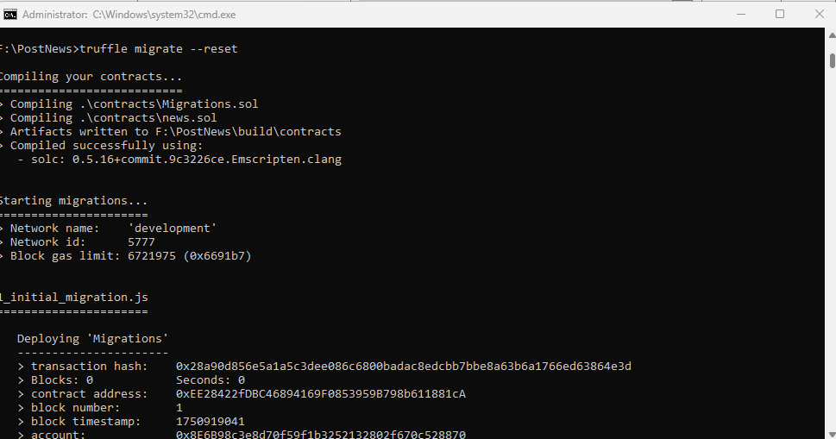

1. **Developing Client-side application to interact with contract**

Go to your index.html file and paste the following code:

<!DOCTYPE html>

<html lang="en">

  <head>

    <meta charset="utf-8">

    <meta http-equiv="X-UA-Compatible" content="IE=edge">

    <meta name="viewport" content="width=device-width, initial-scale=1">

    <!-- The above 3 meta tags *must* come first in the head; any other head content must come *after* these tags -->

    <title>Decentralized Newsfeed</title>

    <!-- Bootstrap -->

    <link href="css/bootstrap.min.css" rel="stylesheet">

    <!-- HTML5 shim and Respond.js for IE8 support of HTML5 elements and media queries -->

    <!-- WARNING: Respond.js doesn't work if you view the page via file:// -->

    <!--[if lt IE 9]>

      <script src="https://oss.maxcdn.com/html5shiv/3.7.3/html5shiv.min.js"></script>

      <script src="https://oss.maxcdn.com/respond/1.4.2/respond.min.js"></script>

    <![endif]-->

  </head>

  <body>

    <div class="container">

      <div class="row">

        <div class="col-xs-12 col-sm-8 col-sm-push-2">

          <h1 class="text-center">Decentralized Newsfeed</h1>

          <hr/>

          <br/>

        </div>

      </div>

      <div id="newsRow" class="row">

        <!-- PETS LOAD HERE -->

      </div>

      <!-- <button class="btn btn-default" type="button" class="aaaaaddProd">Add Product</button> -->

     <!-- Button trigger modal -->

  <button type="button" style="align:center;" class="btn btn-primary" data-toggle="modal" data-target="#exampleModalCenter">

    Add News

  </button>

    </div>

  <!-- Modal -->

  <div class="modal fade" id="exampleModalCenter" tabindex="-1" role="dialog" aria-labelledby="exampleModalCenterTitle" aria-hidden="true">

    <div class="modal-dialog modal-dialog-centered" role="document">

      <!-- Modal Content-->

      <div class="modal-content">

        <!--Modal Header-->

        <div class="modal-header">

          <h5 class="modal-title" id="exampleModalCenterTitle">Add News</h5>

          <button type="button" class="close" data-dismiss="modal" aria-label="Close">

            <span aria-hidden="true">&times;</span>

          </button>

        </div>

        <!--Modal Body-->

        <div class="modal-body">

            <form>

                <div class="form-group">

                  <textarea class="form-control postbox" id="post" placeholder="Add you story Here..." rows="5"></textarea>

                </div>

                <button type="submit" data-dismiss="modal" class="btn btn-primary addNews">Post News</button>

              </form>

        </div>

        <div class="modal-footer">

          <button type="button" class="btn btn-secondary" data-dismiss="modal">Close</button>

        </div>

      </div>

    </div>

  </div>

    <div id="postTemplate" style="display: none;">

      <div class="col-md-12">

        <div class="panel panel-default panel-pet">

          <div class="panel-heading">

            <strong>Publisher Address</strong> <h3 class="panel-title"> Account Address </h3>

          </div>

          <div class="panel-body">

            <strong>Descrition</strong>: <span class="desc"> </span><br/>

          </div>

        </div>

      </div>

    </div>

    <!-- jQuery (necessary for Bootstrap's JavaScript plugins) -->

    <script src="https://ajax.googleapis.com/ajax/libs/jquery/1.12.4/jquery.min.js"></script>

    <!-- Include all compiled plugins (below), or include individual files as needed -->

    <script src="js/bootstrap.min.js"></script>

    <script src="js/web3.min.js"></script>

    <script src="js/truffle-contract.js"></script>

    <script src="js/app.js"></script>

  </body>

</html>

1. Create File “app.js” inside src and paste below code:

App = {

web3Provider: null,

contracts: {},

initWeb3: async function() {

// Modern dapp browsers...

if (window.ethereum) {

App.web3Provider = window.ethereum;

try {

// Request account access

await window.ethereum.enable();

} catch (error) {

// User denied account access...

console.error("User denied account access")

}

}

// Legacy dapp browsers...

else if (window.web3) {

App.web3Provider = window.web3.currentProvider;

}

// If no injected web3 instance is detected, fall back to Ganache

else {

App.web3Provider = new Web3.providers.HttpProvider('http://localhost:7545');

}

// App.web3Provider = new Web3.providers.HttpProvider('http://localhost:8545');

web3 = new Web3(App.web3Provider);

return App.initContract();

},

initContract: function() {

$.getJSON('news.json', function(data) {

// Get the necessary contract artifact file and instantiate it with truffle-contract

App.contracts.news = TruffleContract(data);

// Set the provider for our contract

App.contracts.news.setProvider(App.web3Provider);

// Use our contract to retrieve and mark the adopted pets

// return App.markAdopted();

return App.init();

});

// return App.bindEvents();

return App.AddNewsButton();

},

init: async function() {

// Load Products.

var postInstance;

App.contracts.news.deployed().then(function(instance){

postInstance = instance;

return postInstance.newsCount();

}).then(function(result){

var counts = result.c[0];

console.log("Total News : "+counts);

for (var i = 1; i <= counts; i ++) {

postInstance.newsfeeds(i).then(function(result)

{

console.log("Publisher Address:" +result[0]);

console.log("News:" +result[1]);

var newsRow = $('#newsRow');

var postTemplate = $('#postTemplate');

postTemplate.find('.panel-title').text(result[0]);

postTemplate.find('.desc').text(result[1]);

newsRow.append(postTemplate.html());

});

}

});

},

AddNewsButton: function() {

$(document).on('click', '.addNews', App.AddNews);

},

AddNews:function(event){

var post = document.getElementById('post').value

var postInstance;

App.contracts.news.deployed().then(function(instance){

postInstance = instance;

return postInstance.addnews(post);

});

console.log("News posted");

},

};

$(function() {

$(window).load(function() {

App.initWeb3();

});

});

1. Run metamask: Add ganache network in the metamask

URL for help: https://www.geeksforgeeks.org/installation-guide/how-to-set-up-ganche-with-metamask/

11. Now in your console type *“npm run dev”* to run your dapp.

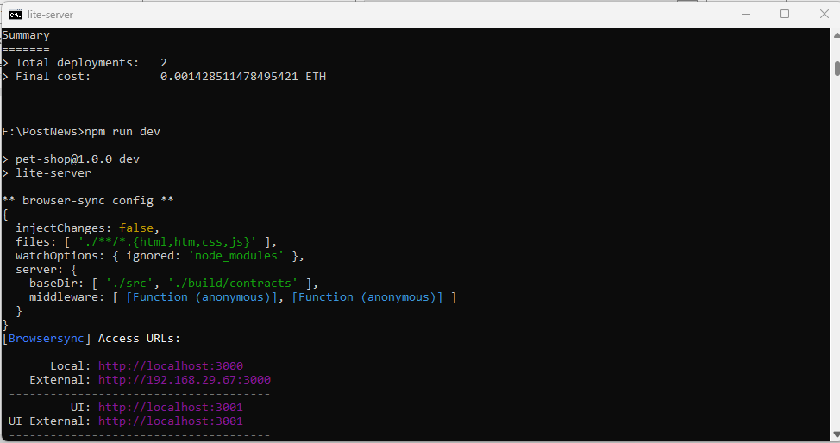

Your App will run:

